1

**(Static)**

Moment of a Couple

Defined as :

* Two parallel forces having the same magnitude. F=F
* Parallel lines of action
* Opposite directions.
* Separated by perpendicular distance.

M = Fd

Couple on a rigid body produce rotation or torsion.

let the couple is 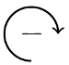 in the clockwise ward

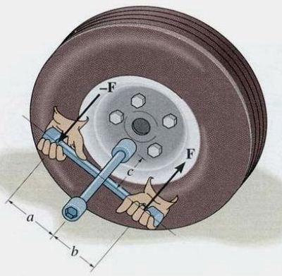

Mo = F (a+d)-Fa= Fd

**Force – Couple Systems**

* The force can be moved to any point along its line of action(transmissibility).
* when we move the force to point not lying on its line of action, generate a couple known as force-couple system. The force replaced by force and couple.



→ →

**Example 1:**

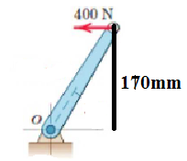Replace the horizontal force 400 N acting on the lever by an equivalent system consisting of a force and couple at *O*

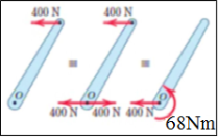**Solution:**

Mo = F*d (N.m)

F=400N , d=170mm $\frac{1}{1000}$* =0.17

Mo= (400) * 0.17 = 68 N.m

**Example** 2:

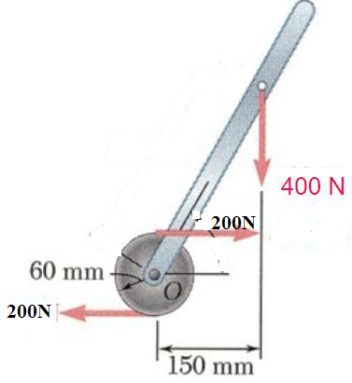Determine the moment of the force and couple shown in the figure below .

**Solution:**

For couple : F1=F2=200N , d==0.06m

Momentof the couple = 200 * (2)*(0.06)= 24 N.m (CW)

For the force : F3=400N

Momentof the force = 400 *(0.15)= 60 N.m (CW)

**Example 3:**

For the compression member shown in the figure, replace the force P = 200 N by an equivalent load and a couple.

**Solution:**

𝑀𝑐𝑜𝑢𝑝𝑙𝑒=𝐹∙𝑑=200×2=400 𝑁.𝑚𝑚

→

**Example 4:**

Determine the resultant moment of the three couples acting on the plate.

**Solution** : let couple is  in the clockwise ward

 M=∑ F . D = 100 kN x 3m –200kN x 2m+50kN x 4m = 300-400+200 =100Kn.m 