**كلية العلوم**

**قــســــــــــم الانـــظــــمــــة الــــطـبـيـة الـــذكــــــيـــة**

**Intelligent Medical Systems Department**

**محاضرة نظري وعملي لمنع وصول بيانات من راوتر الى اخر**

**Class: Third**

**Lecturer:** **Prof. Dr. Mehdi Ebady Manaa**

**Lecture: Implementing ACLs in Cisco Routers (Topology Scenario)**

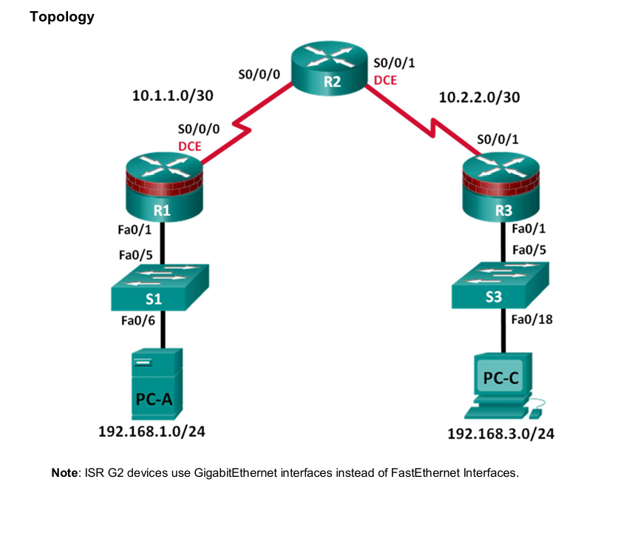

In this lesson, we explore how to implement Access Control Lists (ACLs) in a given network topology. The goal is to block all traffic from PC-A (192.168.1.0/24) to PC-C (192.168.3.0/24) using extended ACLs on Router R1 and Router R2.

# Then;

- Understand and configure extended ACLs.  
- Block specific inter-network traffic.  
- Apply ACLs in the correct direction and interface.  
- Verify and test ACL functionality.

# Topology details

Key IP Networks:  
- PC-A: 192.168.1.0/24  
- PC-C: 192.168.3.0/24  
- Serial Link (R1-R2): 10.1.1.0/30  
- Serial Link (R2-R3): 10.2.2.0/30

# Access Control List (ACL) Concept

An Access Control List is a set of rules that either permit or deny traffic. Extended ACLs allow filtering by source and destination IP, protocol, and port.

## Configuration on R1

1. Enter global configuration mode:  
 R1> enable  
 R1# configure terminal  
  
2. Create ACL 100 to block traffic from PC-A to PC-C:  
 R1(config)# access-list 100 deny ip 192.168.1.0 0.0.0.255 192.168.3.0 0.0.0.255  
 R1(config)# access-list 100 permit ip any any  
  
3. Apply the ACL to outbound traffic on the serial interface:  
 R1(config)# interface s0/0/0  
 R1(config-if)# ip access-group 100 out

**Where**

R1(config)# access-list 100 deny ip 192.168.1.0 0.0.0.255 192.168.3.0 0.0.0.255

access-list [ACL_NUMBER] [permit|deny] [PROTOCOL] [SOURCE_IP] [WILDCARD_MASK] [DEST_IP] [WILDCARD_MASK]

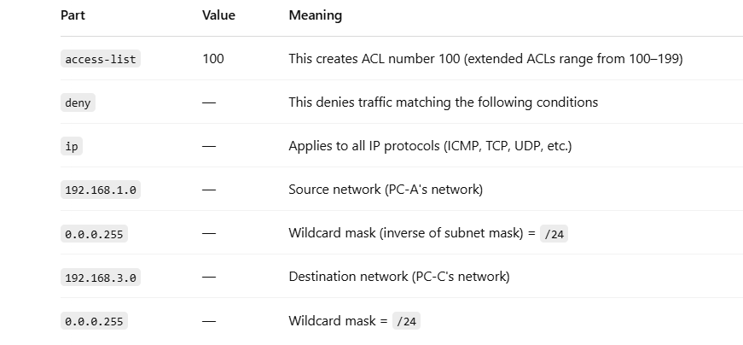

## Configuration on R2 (Optional Backup ACL)

1. Enter configuration mode:  
 R2> enable  
 R2# configure terminal  
  
2. Create ACL 110:  
 R2(config)# access-list 110 deny ip 192.168.1.0 0.0.0.255 192.168.3.0 0.0.0.255  
 R2(config)# access-list 110 permit ip any any  
  
3. Apply the ACL to inbound traffic:  
 R2(config)# interface s0/0/1  
 R2(config-if)# ip access-group 110 in

# Testing the Configuration

On PC-A, try to ping PC-C:  
 PC-A> ping 192.168.3.x  
  
Expected result: Request timed out (due to ACL).  
  
Try pinging other routers or PCs not affected by ACL to ensure traffic is still allowed.

You have successfully:???