**Radiology**

Digital imaging

Digital imaging is a radiographic technique that utilize a wired or wireless hard sensor or phosphor plate sensors instead of conventional film.

Digital imaging incorporate computer technology in the computers to capture, display, enhancement and storage of radiographic image

## Components of a Digital Radiographic System

* **Source of radiation** most of the systems use a conventional X- ray unit
* **Image receptor** it measures the photon intensity of the x-ray beam and convert it into electrical signal (analog signal). Then by using Analog to digital converter (ADC) or digitizer this electrical signal is converted to digital signal ( binary number system) recognizable by the computer.
* **Data processing unit** is consisting of computer and output device as computer monitor, laptop or flat panel, printer.

## Methods of Acquiring a Digital Image (types of digital system)

Digital images are acquired either **Directly** or **Indirectly using**:

# Solid-state technology:( Real time or corded system)

These systems employed conventional x ray generating equipment but the conventional film is replaced by either a CCD ( Charged Coupled Devise) or a CMOS (Complementary Metal Oxide Semiconductor) sensors.

The sensor consists of silicon crystals arranged in a network pattern and it converts the X ray energy into an (electrical charge) which once relayed to the computer, produced a digital image on the monitor immediately ( that why it named **real time**). The sensor is connected to the computer via a cable or cord (so called **corded** system).

Specially designed intraoral sensor holders similar to those used for conventional film, have been developed. When used clinically, the sensors need to be covered with a protective plastic barrier for infection control purposes. Different sized intraoral receptor (adult size and small size sensor for children) and larger extraoral receptors for both panoramic and cephalometric radiographs are required.

### Advantages of CCD and COMS:

* The image appears on the monitor instantaneously.
* Infection control is easier and quicker.

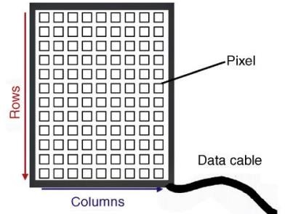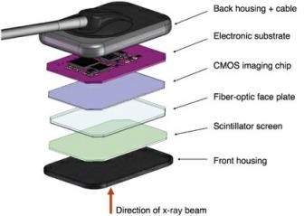

# Photostimulable phosphor technology (image plate, cordless system):

This technology consists of a phosphor-coated plate in which a latent image is formed after x-ray exposure. The latent image is converted indirectly to a digital image by a scanning device through stimulation by laser light. the conventional film is replaced by **photostimulable phosphor storage plate (PSPP)** which is flexible and re-usable.

The phosphor layer plates contain a layer of barium fluorohalide phosphor it absorbs and stores the X-ray energy. The image plate is then placed in a reader where it is scanned by a laser beam. The stored X-ray energy in the

phosphor layer is released as light (phosphorescence) which is detected by a photomultiplier, so the information is indirectly scanned and then displayed on the monitor. The time taken to read the plate depends on the system being used, and the size of the plate, but usually varies ( 1 – 5) minutes. A range of intraoral plate sizes are available identical in size to the conventional periapical and occlusal film packet. The intraoral plates are inserted into protective barrier envelopes and can then be used in conventional film holders.

### Advantages of PSPP:

* Detectors are thin and flexible, more comfortable for the patient, and easier for operator to use.
* Cheaper and reusable.

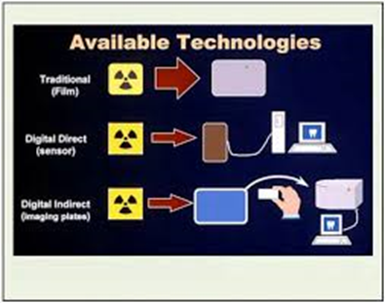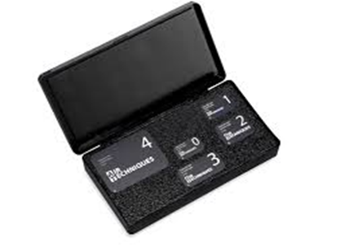

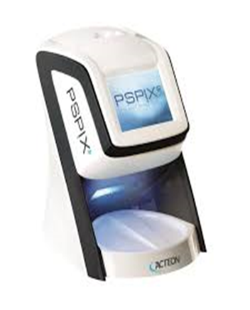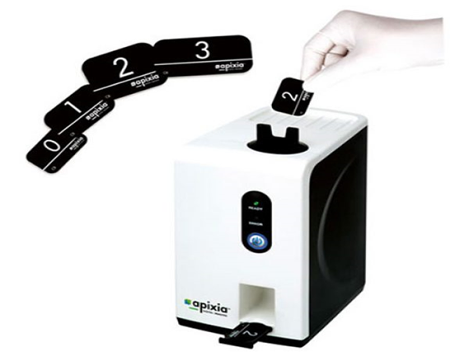

## Advantages of Digital Imaging Over Conventional Film-Based

### Radiography:

1. Lower dose of radiation required as both types of digital image receptors are much more efficient at recording photon energy than conventional films.
2. No need for conventional processing, thus avoiding all processing film faults and the hazards associated with handling the chemical solutions.
3. Easy storage and archiving of patient information
4. Easy transfer of images electronically (teleradiology).
5. Image enhancement and processing which include:
   * Inversion (reversal),
   * Alteration in contrast, brightness, sharpness, and colors (Pseudo- color)
   * embossing or pseudo 3-D,
   * Magnification,
   * Automated measurement,
   * image subtraction.

## Digital image subtraction

When two images of the same object are registered and then the image intensities of corresponding pixels are subtracted, the differences between images are produced. This technique requires two identical images exposed at different times then subtract one image from another, leaving only the changes that occur over time between the two intact.

It is useful in the diagnosis of (periodontal diseases, carious lesions, evaluation of small changes in the condylar position and assessment of dental implant).

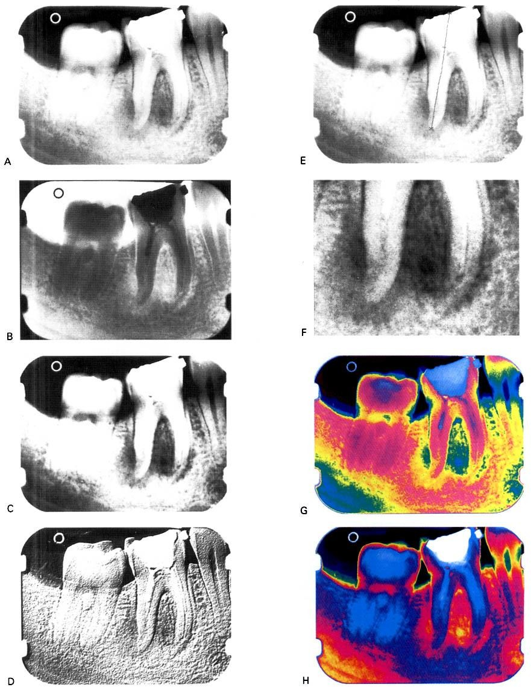

**A** Original image. **B** Inverted/reversed. **C** Altered contrast. **D** Embossed or pseudo 3-D. **E** Automated measurement. **F** Magnified **G** and **H** Pseudo-colored.

## Disadvantages of Digital Imaging:

1. Expensive, especially panoramic systems
2. Long-term storage of the large images required more storage space although this should be solved by saving them on CD-ROM
3. The connecting cable (or cord) can make intraoral placement of these system’s sensor difficult.
4. Loss of image quality and resolution on the hard copy-out when using thermal, laser or ink-jet printers
5. Image manipulation can be time-consuming and misleading to the inexperienced operators. It should be remembered that although enhancement may make images look aesthetically more pleasing, it may also cause clinical information to be lost & diagnoses compromised.
6. Although manufacturers provide safeguards to the original images within their own software, but it is relatively easy to access these images using cheap software and to change them.