Salivary gland imaging

**ANATOMY AND OUTLINE OF IMAGING**

The parotid, submandibular and sublingual glands are regarded as major salivary glands and have bilaterally symmetric lobes.

**The parotid gland** (the largest salivary gland) is situated at the parotid space.

The gland is divided into deep and superficial lobes by branches of the facial nerve.

The duct of salivary secretion is known as Stensen duct that runs anteriorly on the superficial portion of the masseter muscle and pierces the buccinator muscle.

**The submandibular gland** is located mainly in the so-called mandibular triangle.

The secretory duct is known as Wharton duct that runs on the surface of the mylohyoid muscle and opens at the anterior portion of the floor of the mouth.

**The sublingual gland** is located under the mucosal surface of the oral cavity and lies on the mylohyoid muscle.

The gland has many small ducts known as ‘ducts Bartholin’ that open directly on the mucosal surface of the floor of the mouth.

**Types of Salivary Gland Imaging**

**CONVENTIONAL RADIOGRAPHY**

Mainly views taken in CR are **occlusal, panoramic, and lateral oblique view and PA views.**

It is generally limited to detection of **sialoliths**, primarily in submandibular gland, Stensen duct and Wharton duct.

Sialoliths occur more frequently in **submandibular gland than in parotid gland**. **They can rarely be seen in sublingual or minor salivary gland.**

A sialolith of the submandibular gland usually appears **as a round, isolated radio-opaque mass beneath the inferior border of the mandible**.

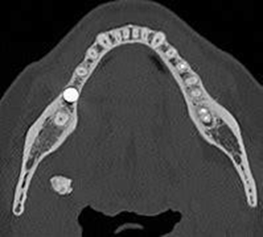 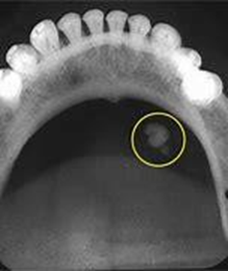 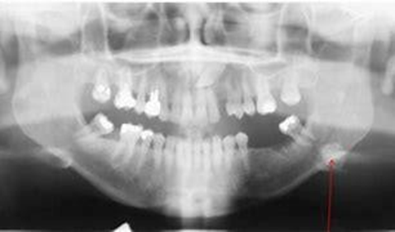

**SIALOGRAPHY**

Sialography is a radiographic procedure for detection and monitoring salivary gland disease; It is used to examine the ductal acinar system of major salivary gland **by injecting radio-opaque contrast medium into the gland to make it visible on radiographs.**

After injection of contrast agent, radiographs are taken on plane film.

**The lateral oblique** is best to delineate submandibular gland because it projects image below the ramus of jaw.

**Occlusal view is taken for sialoliths located in anterior portion of duct.**

For parotid gland**, anteroposterior (AP) and panoramic view can be taken.** After sialographic view is taken the catheter should be removed from duct orifice. Patient is instructed to chew gum or suck on lemon.

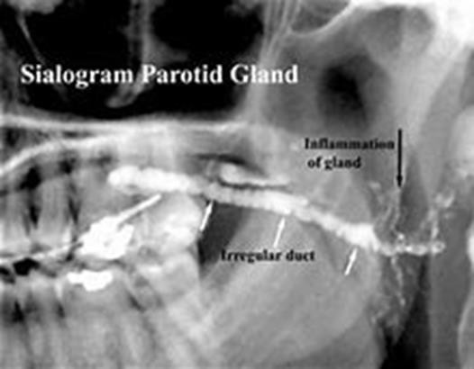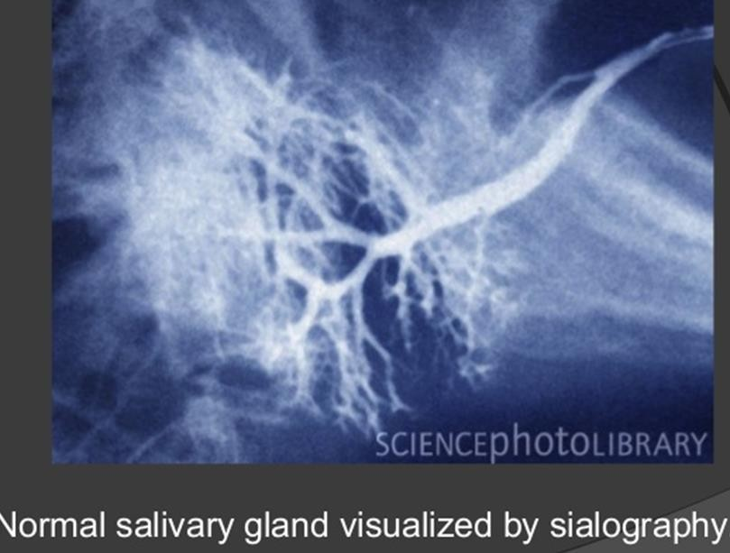

# COMPUTED TOMOGRAPHY

It is valuable in examining salivary gland, particularly after injection of contrast media, i.e. **CT sialography.** It is sensitive in determining the presence or absence of a mass as well as its extent with high anatomic detail.CT scan is able to demonstrate accurately the presence of salivary calculi

Normally parotid gland has increased fat content and is encased in dense capsule. On CT parotid gland appears more radiolucent than surrounding muscle and more radiopaque than adjacent fat. Parotid duct is not routinely seen on CT without contrast opacification. Submandibular gland is more radiopaque than parotid but of the same density as adejacent muscles. Sublingual appears as relatively lucent fatty structures.

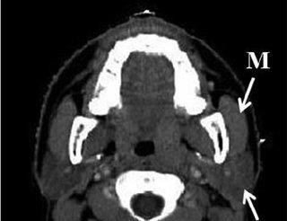 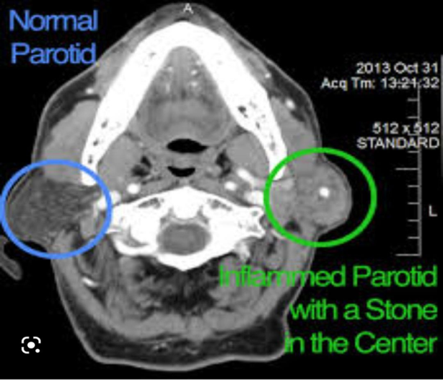

# MAGNETIC RESONANCE IMAGING

MRI, like CT, has several advantages over CR for disease localisation.

MRI is capable of detecting the origin, location, size, extent ,invasion of neighbouring structures, lymph node stagingand , number of tumoural lesions and defining the stage of the disease. MRI confidentially differentiates benign from malignant lesions and characterises some of benign nodules as lipoma, pleomorphic adenoma

# ULTRASONOGRAPHY

**Normal Appearance of Parotid Gland** :parotid gland appears as a homogeneous hyperechoic area.=(radiopaque)

**Submandibular Gland:** The normal submandibular gland also appears as a homogeneous hyperechoic area relative to the surrounding muscle.

# Doppler Sonography

**Intraglandular blood flow** can be demonstrated with Doppler sonography.

**Tempromandibular Joint projection ( TMJ)**

TMJ is the area where the mandible articulates with cranium. TMJ is consists of

1- **Bony components:** The condyle is the mandibular component of the TMJ . The articular component of the temporal bone is composed of the glenoid fossa posteriorly and the articular eminence anteriorly.

2- **Articular disc (meniscus):** is composed of avascular fibrous connective tissue, and is positioned between the condylar and temporal components of the joint divides the joint cavity into inferior and superior joint spaces, which are located below and above the disc, respectively.

3- **Retrodiscal tissues** (Posterior Disc Attachment): is consist of superior and inferior lamellae enclosing a region of loose vascular tissue, and this is often referred to as the **bilaminar zone.**

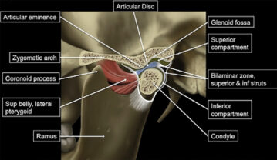

**Types of imaging techniques**

1. Plain radiographs (transcranial projection, transorbital projection, transpharyngeal projection)

2. Panoramic radiography (OPG)

3. Cone beam computed tomography (CBCT) and Multidetector computed tomography (MDCT)

4. MRI and ultrasonography (for soft tissue imaging)

**\*Plain radiography:**

1. **Transcranial-view:** it is one of the most popular plain imaging techniques to study the TMJ. The film cassette is positioned on the face on the side of interest and the central beam projected across the cranium from other side passing through the TMJ of interest either with Closed-mouth or Open- mouth position It used in visualization of changes in lateral aspect of the articulating surface, position and shape of condyle and fossa.

2. **Transorbital view:** is a frontal projection of the TMJ. the film cassette Position behind the patient’s head so that the central ray is projected infront of the patient through the orbit to the TMJ asking the patient to open the mouth. It demonstrate frontal view to the articulating surface ( condyle and articulator eminence) and the condylar neck.

3.**Transpharyngeal view:** It also called infracranial view, the film cassette is positioned next to TMJ of interest. the central X-ray directs below the base of the skull through the oropharynx to TMJ, before film exposure the patient opens the mouth wide. it demonstrate the angular process, diagnosis of fracture in the condyle and condylar neck, detection the alteration in condyle morphology.

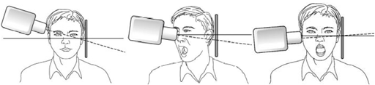

Transcranial view Transorbital view Transpharyngeal view

**Abnormalities of the TMJ**

1- Developmental abnormalities such as (condylar hypoplasia, condylar hyperplasia and coronoid hyperplasia, bifid condyle)

2- Soft tissue abnormalities such as disc displacement.

3- Remodeling and arthritic conditions

4- Trauma such as fracture, dislocation and effusion

5- Ankylosis such as bony and soft tissue ankylosis

6- Tumors (benign and malignant)

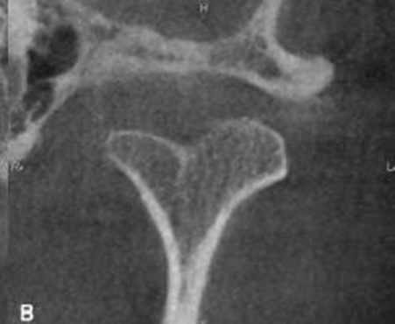 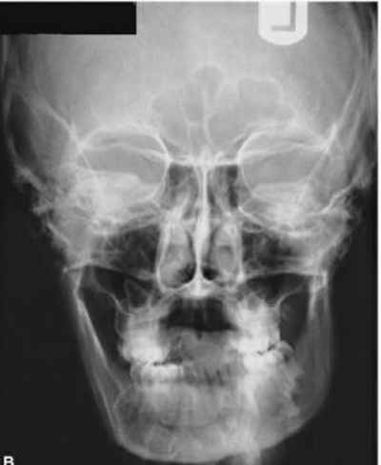

Bifid condyle PA view of right condylar hyperplasia