**Dental Implantology**

Dental implant: is a device made of alloplastic (foreign) material implanted into

the jaw bone beneath the mucosal layer to support a fixed or removable dental

prosthesis

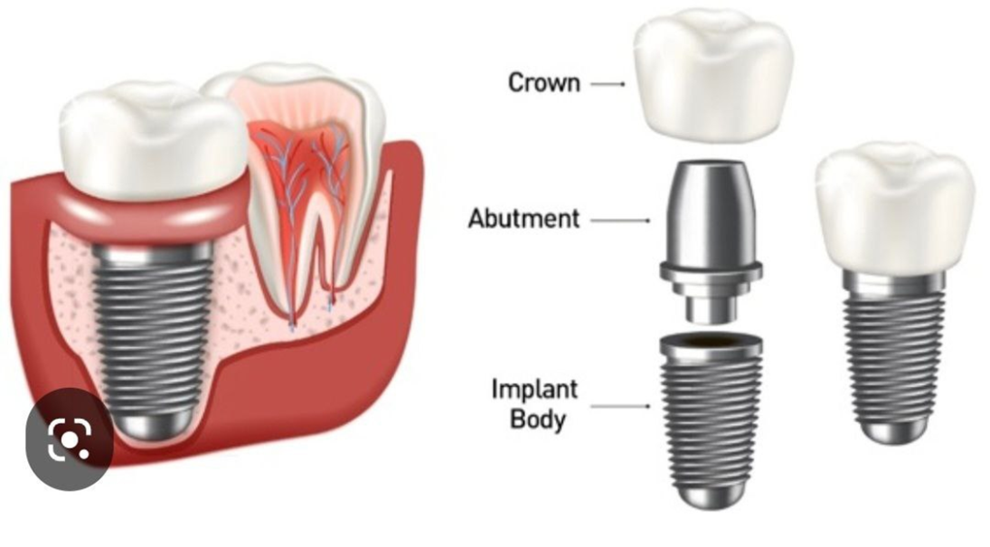

Imaging plays an important part in dental implant procedures

The imaging modalities vary from standard projections to more complex

radiographic techniques

\*\***Standard projections** include intra-oral (periapical, occlusal) and extra-oral

(panoramic, lateral oblique radiographs.

More **\*\*complex imaging techniques** includes computed tomography (CT), and cone

beam computed tomography (CBCT)

Multiple factors influence the selection of radiographic techniques for a particular

case including **cost, availability, radiation exposure, and patient's anatomy**

**The goals of imaging are**

1. To measure bone height and width (bone dimensions)

2. To assess bone quality

3. To determine the long axis of alveolar bone

4. To identify and localize internal anatomy

5. To detect any underlying pathology

**INTRAORAL RADIOGRAPHY**

**Intraoral radiography** used is either periapical or occlusal radiography

It is usually done to determine the vertical height of bone

Intraoral radiography is recommended for the use of single-tooth implants

***The disadvantages of intraoral periapical radiography

-There is limited area of exposure; it can be used only in case of single-tooth

implant

• -There is foreshortening and elongation of the image which results due to

anatomical variation

-It is very difficult to reproduce the same image as the technique is not

Standardized

**PANORAMIC RADIOGRAPH**

In comparison with the intraoral radiography, panoramic radiography has got

advantage of broader visualization of the image

But in case of panoramic radiography, sharpness and resolution is less

Panoramic radiography is also helpful in estimation of bone height and position

of inferior nerve canal. It is usually indicated when implant is planned for

more than one teeth

***Disadvantages with the panoramic radiography

It has got image size distortion (magnification)

Dimensional accuracy in the case of panoramic radiography is also limited

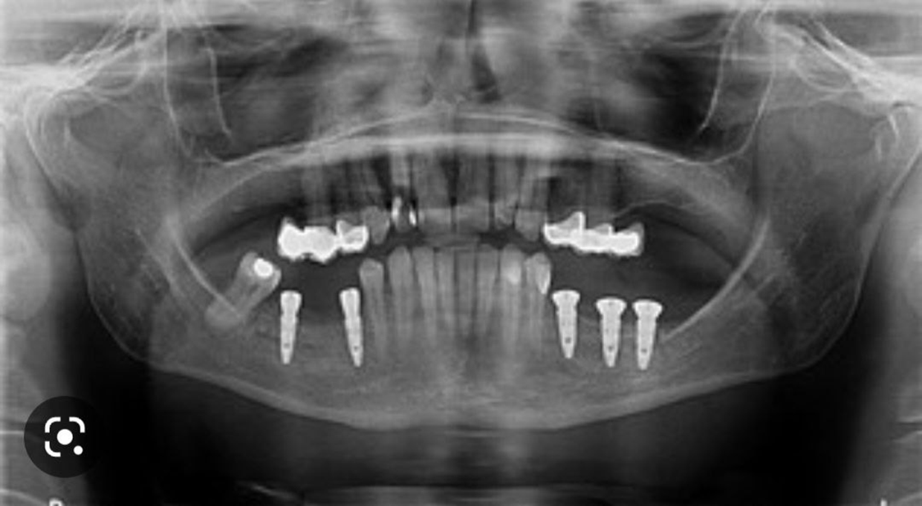

**CBCT imaging in dental implant**

CBCT is the most accurate radiographic means for dental implant planning

It allows for complete 3D evaluation of bone architecture with high accuracy and

can be used for standardized estimation of bone quality

According to the available literature, CBCT imaging is **not required** in cases

1. in which the clinical examination reveals sufficient bone height and width

2. Where standard radiographic examination reveals adequate bone height and

space for implant placement

**Imaging modality is useful in three phases**

**Phase 1 Pre-prosthetic implant imaging**

Imaging in this phase determines the quantity, quality, angulation of bone, relationship

of critical structures to prospective implant sites and the presence or absence of disease at the proposed surgical site.

**Phase 2** **Surgical and interventional implant imaging**

Imaging in this phase evaluates the

surgical sites during and immediately after surgery, assists in the optimal

positioning and orientation of dental implants, it also ensures appropriate

abutment positioning

**Phase 3 Post-prosthetic implant imaging**

This phase started after placement of the prosthesis and continues as long as

the implant remains in the jaw

Imaging in this phase provides long term evaluation of the prognosis of the dental implant. So it will show any defect in the implant's position and function including crestal bone level around implant . It also helps to routinely assess the bone adjacent to the dental implant to note any changes in bone volume

