Clippers

Diode Applications-2-

Clippers are networks that employ diodes to “clip” away a portion of an input signal without distorting the remaining part of the applied waveform. The half-wave rectifier is an example of the simplest form of diode clipper

1. **Series:**

## The series configuration is defined as one where the diode is in series with the load

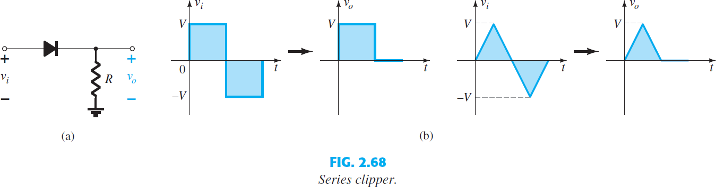

there are some things one can do to give the analysis some direction. First and most important:

# Take careful note of where the output voltage is defined.

1. **Try to develop an overall sense of the response by simply noting the “pressure” established by each supply and the effect it will have on the conventional current direction through the diode.**

## Keep in mind that we are dealing with an ideal diode for the moment, so the turn-on voltage is simply 0 V.

1. **Determine the applied voltage (transition voltage) that will result in a change of state for the diode from the “off” to the “on” state. EXAMPLE 2.18:** Determine the output waveform for the sinusoidal input of Fig. 2.74 .

***Solution:***

## **Step 1:** The output is again directly across the resistor R.

**Step 2:** The positive region of v i and the dc supply are both applying “pressure” to turn the diode on. The result is that we can safely assume the diode is in the “on” state for the entire range of positive voltages for v i . Once the supply goes negative, it would have to exceed the dc supply voltage of 5 V before it could turn the diode off.

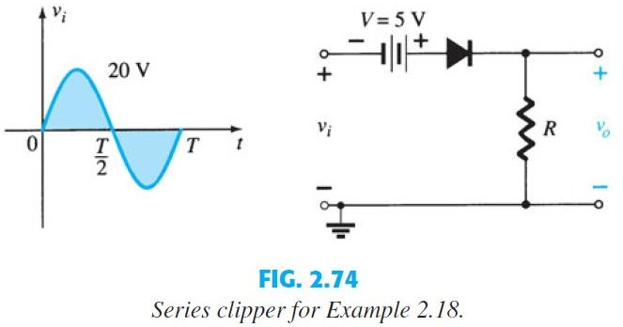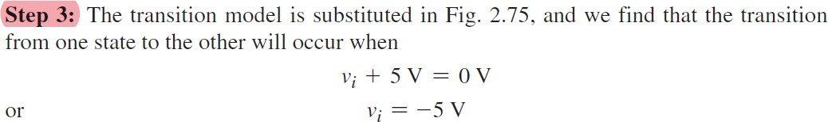

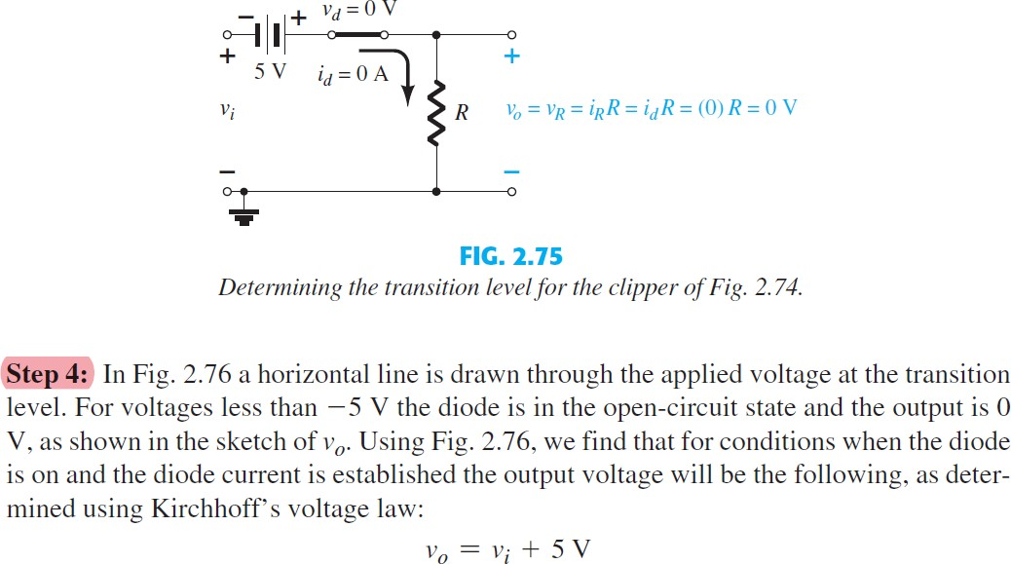

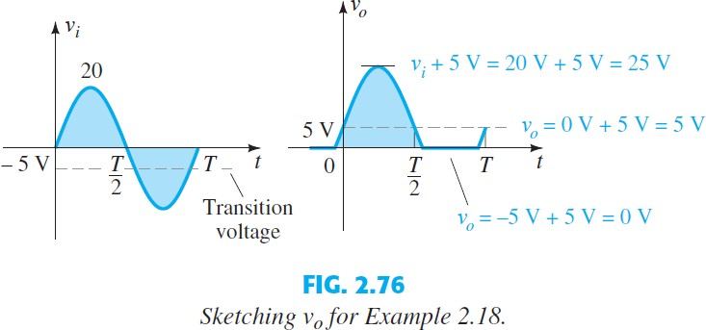

## **EXAMPLE 2.19** Find the output voltage for the network examined in Example 2.18 if the applied signal is the square wave of Fig. 2.77.

**Solution**: For vi = 20 V (0 T/2) the network of Fig. 2.78 results. The diode is in the short-circuit state, and vo = 20 V + 5 V = 25 V. For vi = -10 V the network of Fig. 2.79results, placing the diode in the off state, and vo = (IR R)

## = (0)R = 0 V. The resulting output voltage appears in Fig. 2.80.

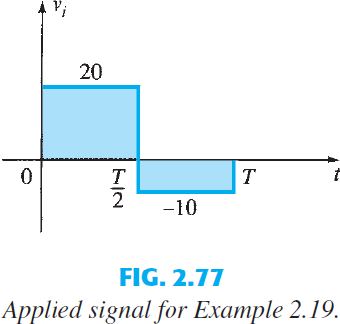

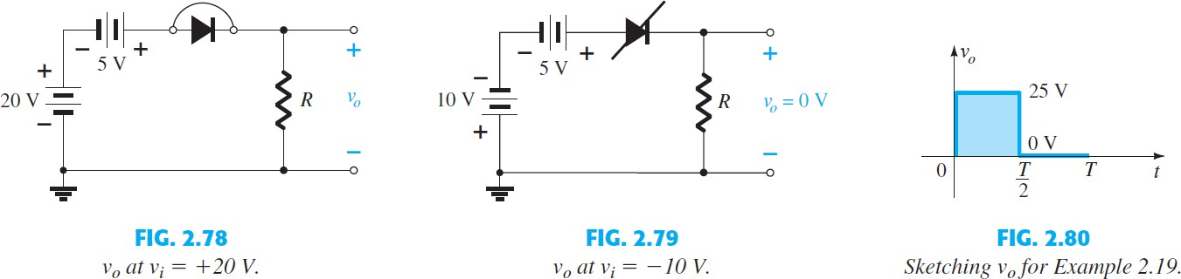

**Note** in Example 2.19 that the clipper not only clipped off 5 V from the total swing, but also raised the dc level of the signal by 5 V.

# 2. Parallel

## The network of Fig. 2.81 is the simplest of parallel diode configurations with the output for the same inputs of Fig. 2.68. The analysis of parallel configurations is very similar to that applied to series configurations, as demonstrated in the next example.

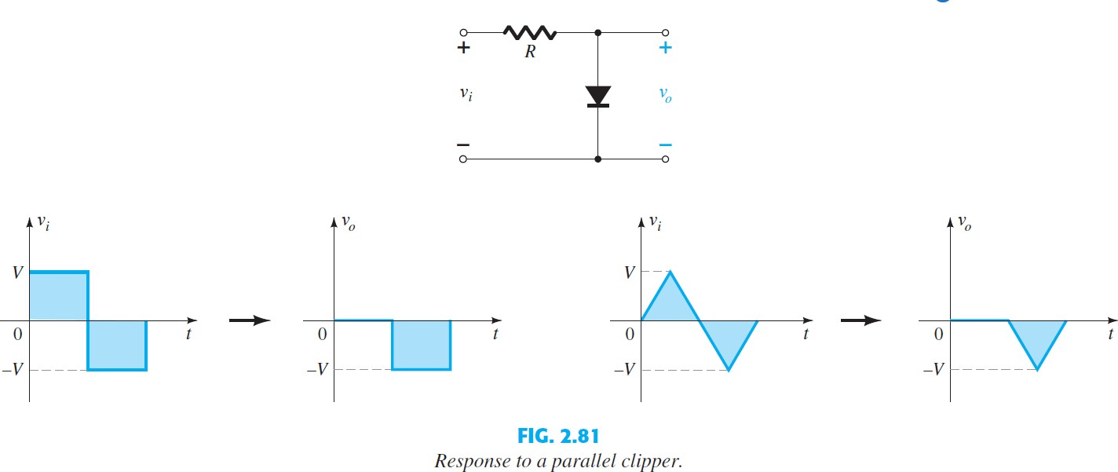

**EXAMPLE 2.20** Determine v o for the network of Fig. 2.82 .

**Solution:**

## Step 1: In this example the output is defined across the series combination of the 4-V supply and the diode, not across the resistor R.

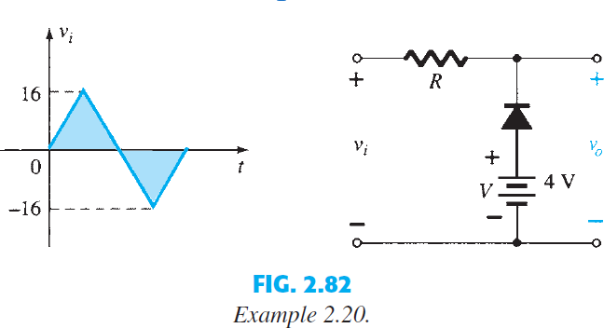

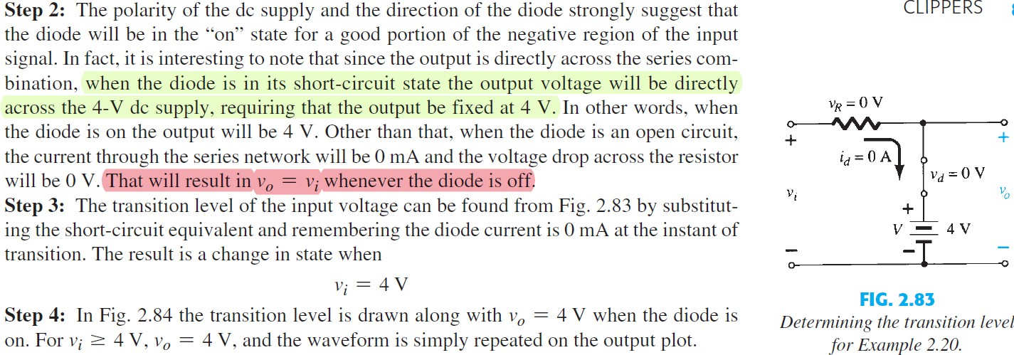

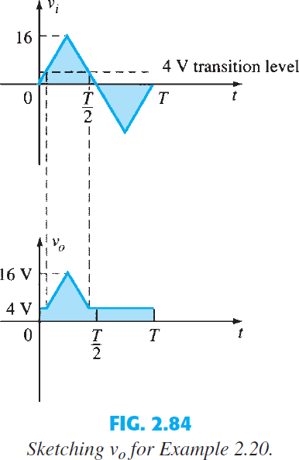 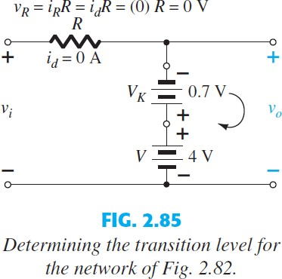

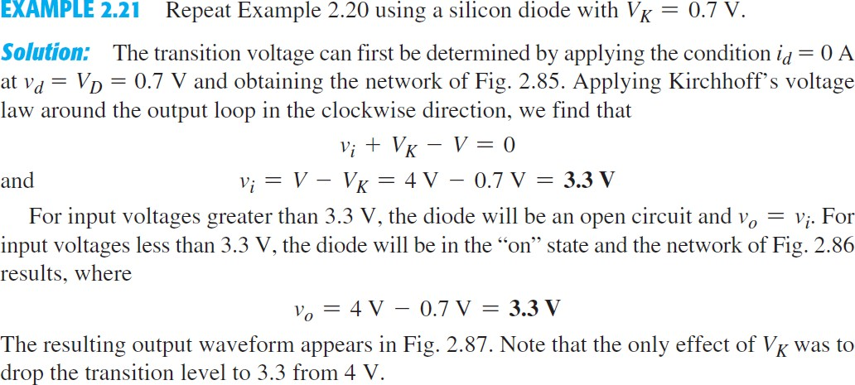

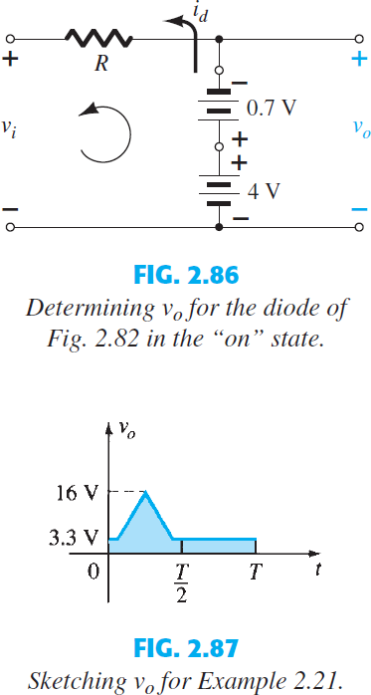

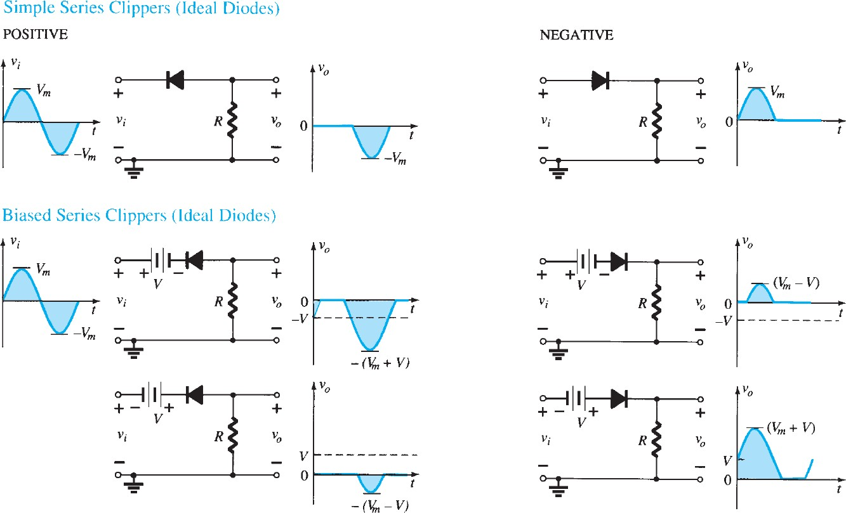

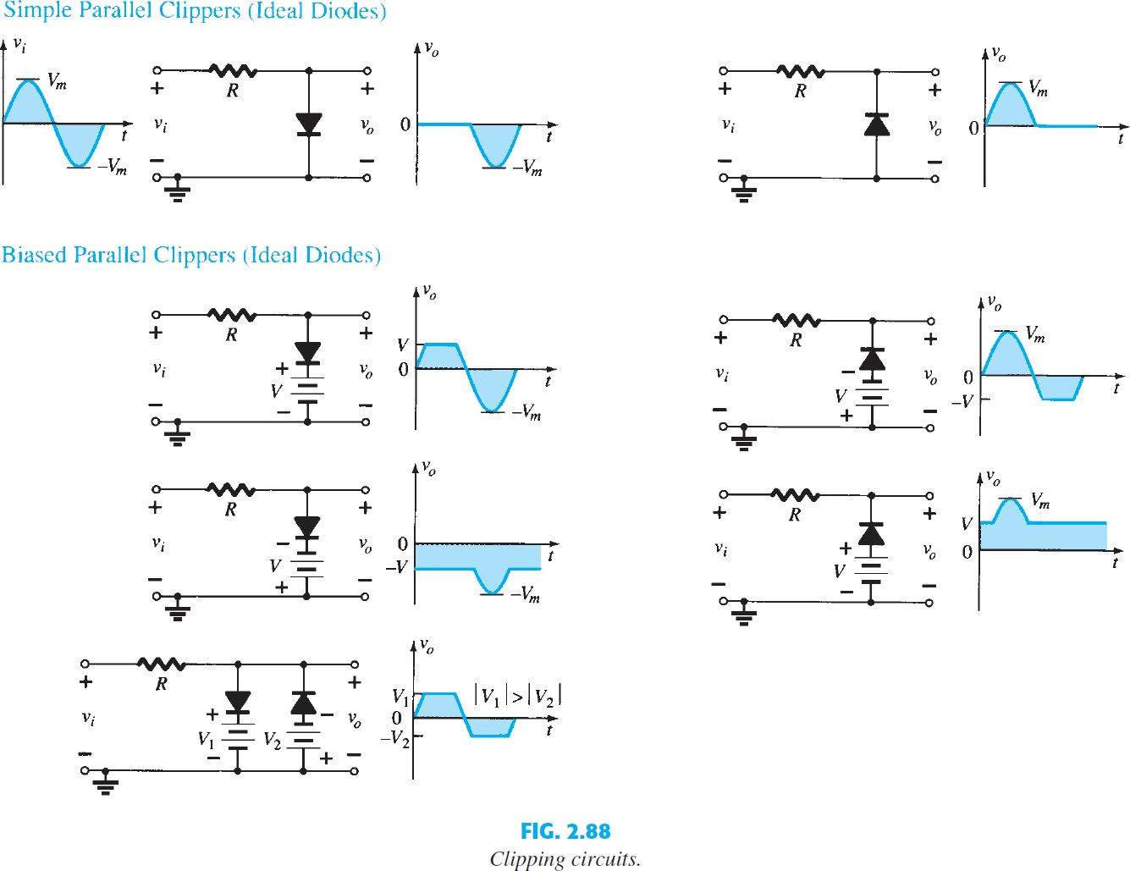

clamper

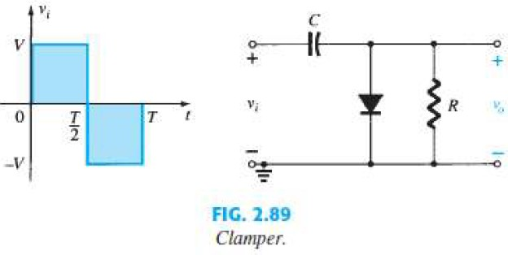A clamper is a network constructed of a diode, a resistor, and a capacitor that shifts a waveform to a different dc level without changing the appearance of the applied signal. Clamping networks have a capacitor connected directly from input to output with a resistive element in parallel with the output signal. The diode is also in parallel with the output signal but may or may not have a series dc supply as an added element.

There is a sequence of steps that can be applied to help make the analysis straightforward.

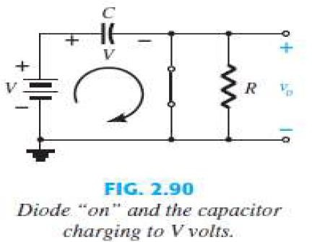Step 1: Start the analysis by examining the response of the portion of the input signal that will forward bias the diode.

Step 2: During the period that the diode is in the “on” state, assume that the capacitor will charge up instantaneously to a voltage level determined by the surrounding network.

Step 3: Assume that during the period when the diode is in the “off” state the capacitor holds on to its established voltage level.

Step 4: Throughout the analysis, maintain a continual awareness of the location and defined polarity for v o to ensure that the proper levels are obtained.

**EXAMPLE 2.22:** Determine v o for the network of Fig. 2.93 for the input indicated.

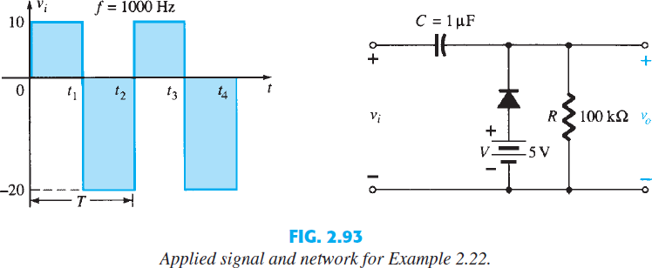

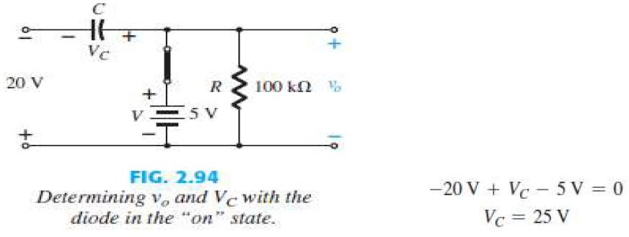**Solution:** Note that the frequency is 1000 Hz, resulting in a period of 1 ms and an interval of 0.5 ms between levels. The analysis will begin with the period t1 St2 of the input signal since the diode is in its short-circuit state. For this interval the network will appear as shown in Fig. 2.94 . The output is across R , but it is also directly across the 5-V battery if one follows the direct connection between the defined terminals for vo and the battery terminals. The result is v o =5 V for this interval. Applying voltage law around the input loop results in.

The capacitor will therefore charge up to 25 V. In this case the resistor R is not shorted out by the diode, but a Thévenin equivalent circuit of that portion of the network that includes the battery and the resistor will result in RTh = 0 with Eth = V = 5 V. For the period t2 t3 the network will appear as shown in Fig. 2.95 . The open-circuit equivalent for the diode removes the 5-V battery from having any effect on v o , and applying voltage law around the outside loop of the network

