Lecture 2

**Microsoft Office Word (Cont.)**

- **VII. Quick Access Toolbar**

Microsoft Word 2019 has a **Quick Access Toolbar**, so you can have quick access to your most used commands.

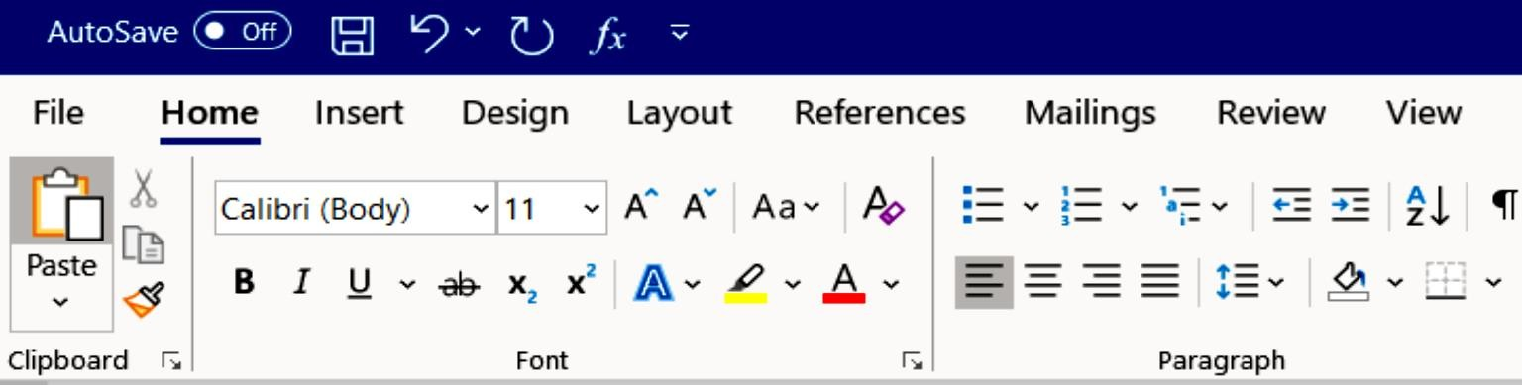

# A. Add Commands

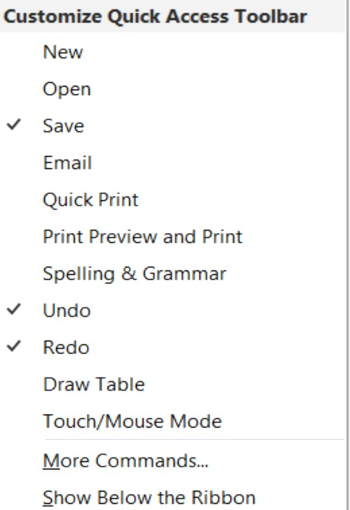

1. To add your most used commands to the **Quick Access Toolbar**, click on the drop- down arrow next to the **Quick Access Toolbar**.

# The Customize Quick Access Toolbar

option panel will appear.

1. Click on your desired command option to be placed on the **Quick Access Toolbar**.

# Non-Printing Characters

The **Show/Hide** button displays non-printing characters, including paragraph marks, spaces and tabs. This button works as a toggle switch: click it to turn the display of non-printing characters on and click it again to turn them off.

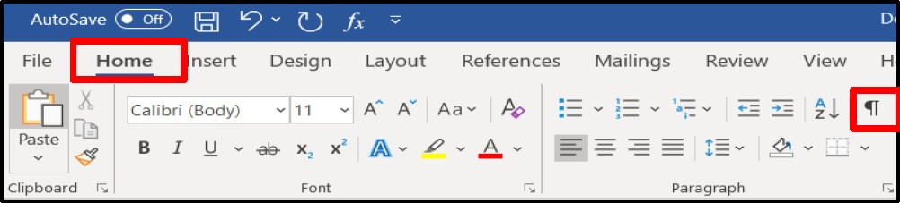

# A. Working with Show/Hide

1. On the **Home Ribbon** in the **Paragraph** group, click on the

**Show/Hide ** button to view paragraph marks. Paragraph, space, and tab marks will not appear on your printed documents.

1. On the **Home Ribbon** in the **Paragraph** group, click on the

**Show/Hide** button to hide paragraph marks.

# Practice Document

Create a document with name **Garden.docx** and open it.

# Save a Document

**A. Save** 1. Click on the **File** tab, then select the **Save As** option to save a document permanently to your hard drive or other storage device.

1. The **Save As** window will appear.

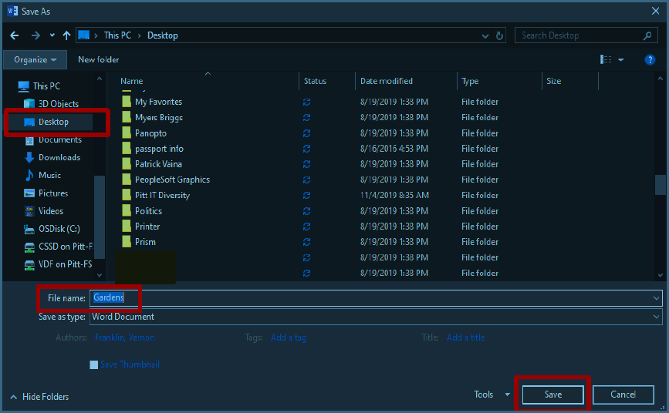

1. In the **Directory** sections on the left side of the window, click on the icon where you wish to save your document. *In this exercise click on the* ***Desktop****.*
2. In the **File Name** box, type your desired document name, and then click on the **Save** button.

# Select Text

You must select text before you can change the format. You can use the mouse to select text in a variety of ways which is explained in the table below.

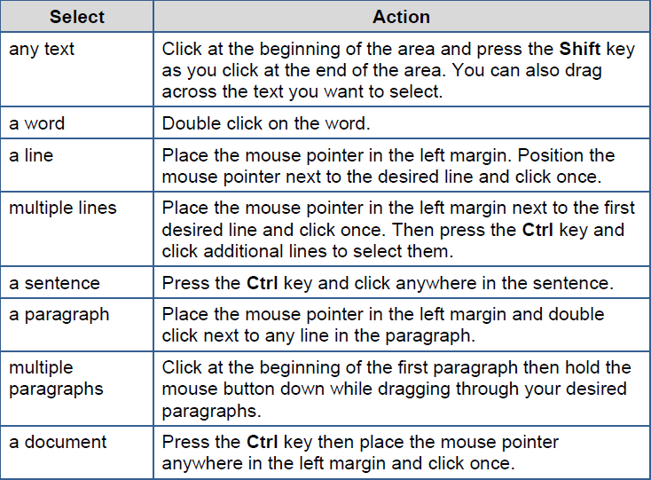

# Margins

Microsoft Word 2019 margins are defaulted to 1 inch for the top and bottom, and 1 inch for the left and right. To change your margins, use the **Margin** button found on the **Layout** ribbon.

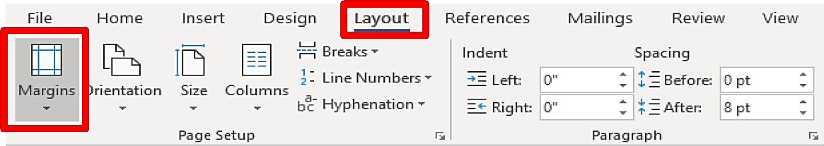

# A. Create Margins

1. 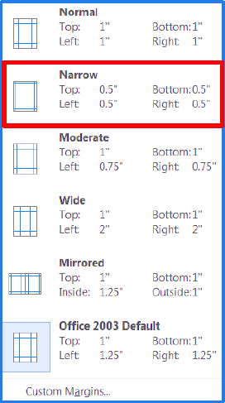Select the entire document text, by pressing the **Ctrl** key, then place the mouse pointer anywhere on the left margin, and then click once on the right mouse button.
2. Select the **Layout** tab.
3. In the **Page Setup** group, click on the

**Margins** button.

1. The predesigned margins panel will appear.
2. Change the margin by selecting the top margin button (top and bottom 0.5” – Left and Right 0.5”).

# Line Spacing

Microsoft Word 2019 defaults the line spacing to double space (2.0). Line spacing affects an entire paragraph or document. Use the **Line Spacing** button on the **Home Ribbon** to change line spacing.

# A. Add Spacing

1. Make sure the entire document is still selected.
2. Click on the **Home** tab. On the **Paragraph** group, click on the **Line Spacing** button, and then select 1.5.

