Lecture 4

**Microsoft Office Word (Cont.)**

# 19. Page Breaks and Section Breaks

**A.** Insert Page Break

Page Breaks and Section Breaks can be inserted anywhere within a document.

1. On the *Garden* practice document, place the Insertion point at the end of the last sentence in the last paragraph.

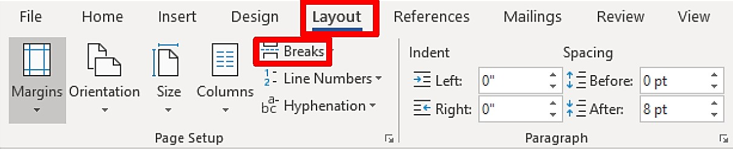

1. 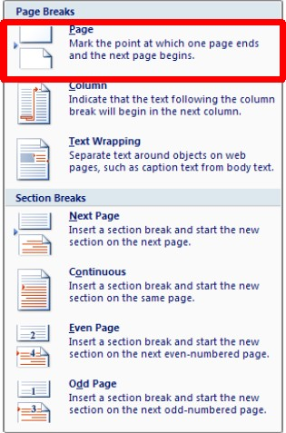Select the **Layout** tab, and then click on the

**Breaks** button.

1. A **Page Break** panel will appear with the Page and Section Break options.
2. Select the **Page** option. This will insert a page break that will place you on a new page in the document.

# 20. Tables

Tables offer a convenient way to display information that might otherwise be confusing and cluttered. Text is neatly formatted in a table without setting tab stops as shown below.

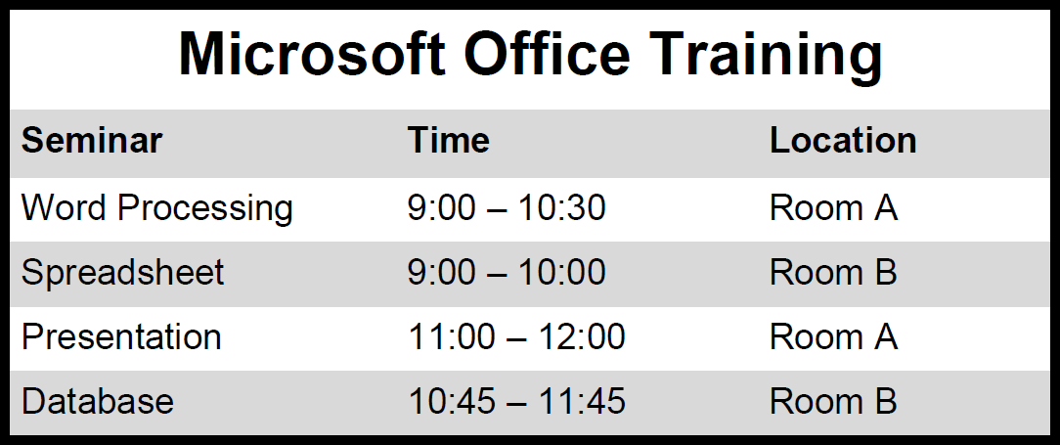

## A. Create a Table

The **Table Tools** tab only appears when a table is selected.

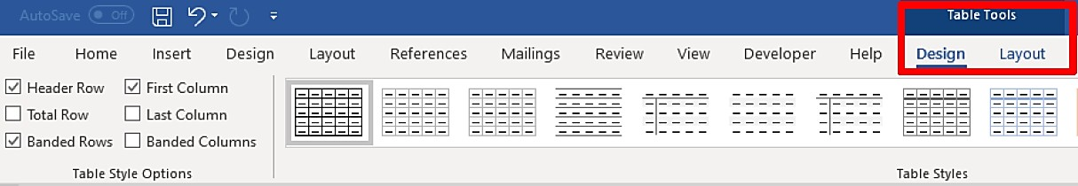

To create a table in Microsoft Word, click on the **Insert** ribbon. The

**Table** button is the only one option on the **Tables** group.

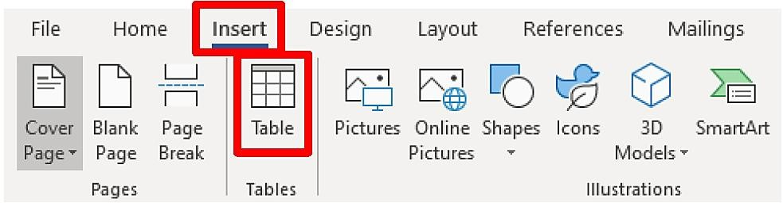

1. Click on the **Insert** ribbon, and then click on the **Table** button.
2. The **Table** panel will appear.

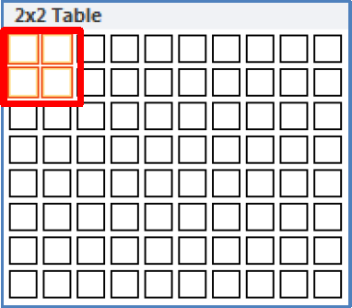

1. Select two rows and two columns as seen above. To insert a table onto your document, move the mouse pointer over the number of rows and columns you desire. The cell selection will be highlighted as you move the mouse. When the desired rows and columns are highlighted, click on the last cell.



1. Type the information in the table shown above. The insertion point will appear in the first cell of the table. Type text in the first cell, and then use the **Tab** key on the keyboard to move from one cell to the next.
2. After you type the information in the last cell, press the **Tab** key. Word automatically inserts a new blank row.

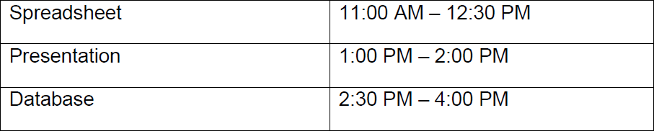

1. Type the text seen above as you insert new rows.

# Edit a Table

## Move within a Table

Moving the insertion point and selecting text in a table is very similar to the ways you do so for regular text in a document. However, there are some procedures that are unique to tables as illustrated below.

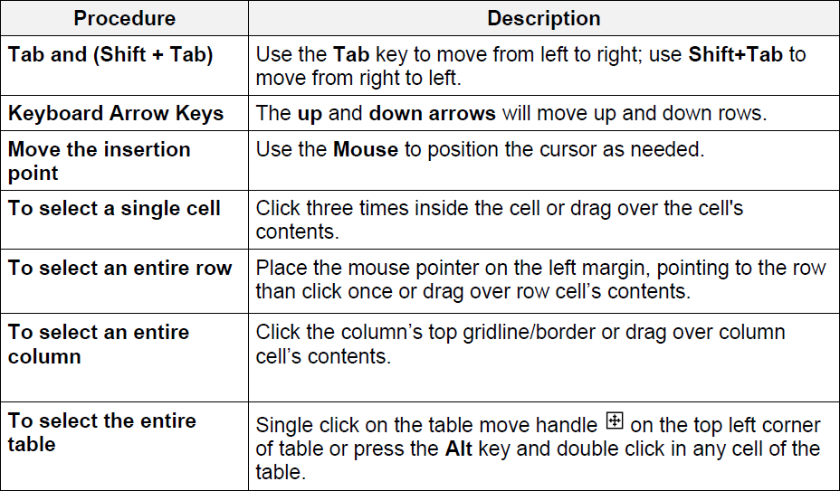

## Adjust Column Width

Columns in a new table are always the same width. It is often necessary to change the width of one or more columns in the table, so that text or data can be seen.



* + 1. Position the mouse pointer on the column boundary (right-side of the column – seen below). The mouse pointer appears as a double vertical line with left and right arrows. Hold down the left mouse button, and then drag the mouse pointer either left or right to change the width. Release the mouse button when you are satisfied with the new width.

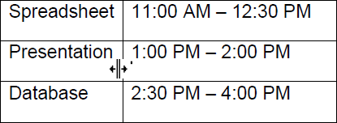

* + 1. **AutoFit** is a feature that will automatically adjust the column width to accommodate the widest text entry in the column. To **AutoFit** the entire table, place the mouse pointer at the left most column boundary, when the mouse pointer appears as a double vertical line with left and right arrows, then double click on the left mouse button.

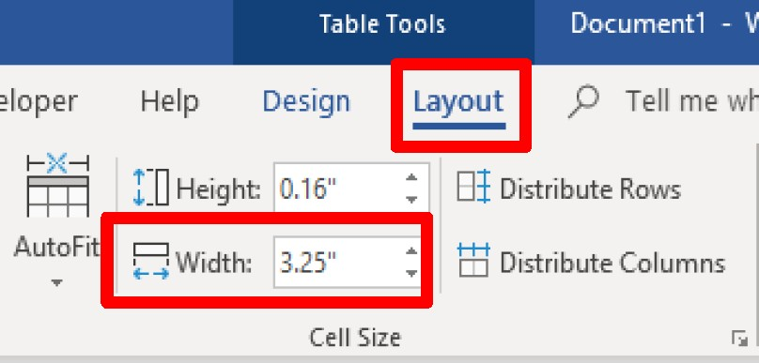

* + 1. Another method is to click in the cell within the column to be resized, then on **Table Tools**, click on the **Layout** tab**,** and in the **Width** box, click on the up (increase) or down (decrease) arrow to change the width.