Lecture 3

**Microsoft Office Word (Cont.)**

1. **Format a Document**

Formats can be applied to any text within your document. The formatting styles are the most common way to change the appearance of text in a document

# A. Apply Format

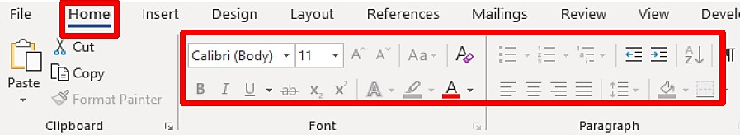

1. Select text, and then click on your desired format from the **Home**

ribbon.

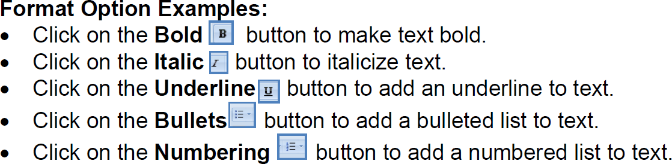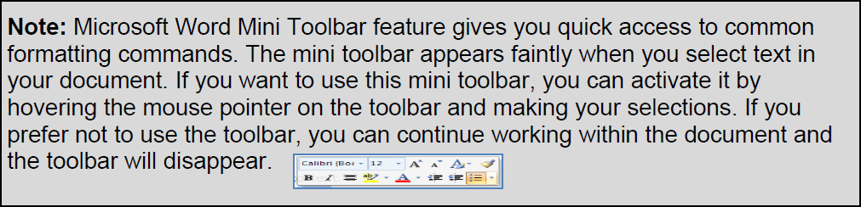

# Additional Font Options

Additional font options are available, such as font effects, special styles and previewing font changes. You can view additional options by clicking on the **Home** tab, and then click on the **Dialog box launcher** on the **Font** group.

# A. Add All Caps

1. Place the **Insertion point** before the first line of the document.
2. Type the text, **Roof top gardens**, and then press twice on the **Enter**

key.

1. Select your new title text, and then click on the **Bold** button.

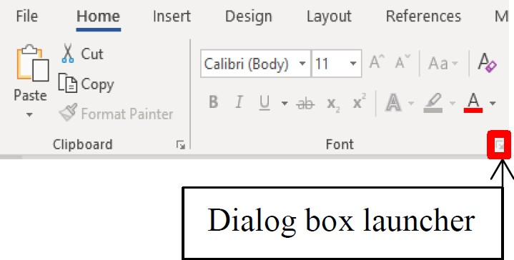

1. While the title text is still selected, click on the **Dialog box launcher**

on the **Font** group.

1. The **Font** window will appear.

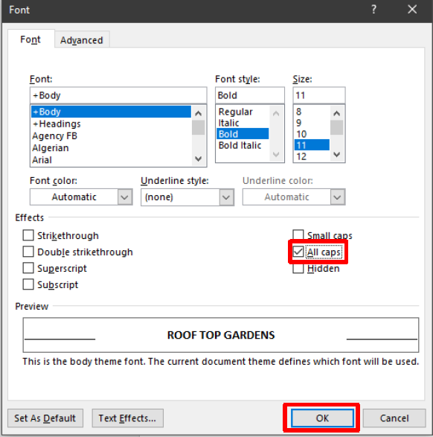

1. In the **Effects** area, click on the check box next to **All caps**, and then click on the **OK** button.



# Text Alignment

Microsoft Word 2019 aligns paragraphs four different ways relative to the left and right margins: left, center, right and justified. The Word 2019 default paragraph alignment is left. You can change paragraph alignment by clicking on an **Alignment** button, located on the **Home** ribbon on the **Paragraph** group.

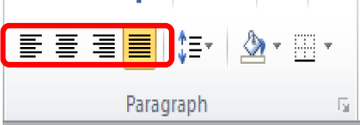

# Alignment Option Examples:

* First button - **Align Text Left**
* Second button - **Center Text**
* Third button - **Align Text Right**
* Fourth button - **Justify Text**

# A. Add Center Alignment

1. Select the title text, ***ROOF TOP GARDENS***, and then click on the

**Center** button.

# View Modes

Microsoft Word 2019 has five view modes.

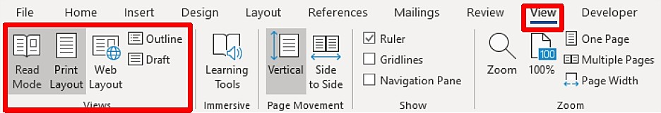

1. To select a view mode, click on the **View** tab.
2. 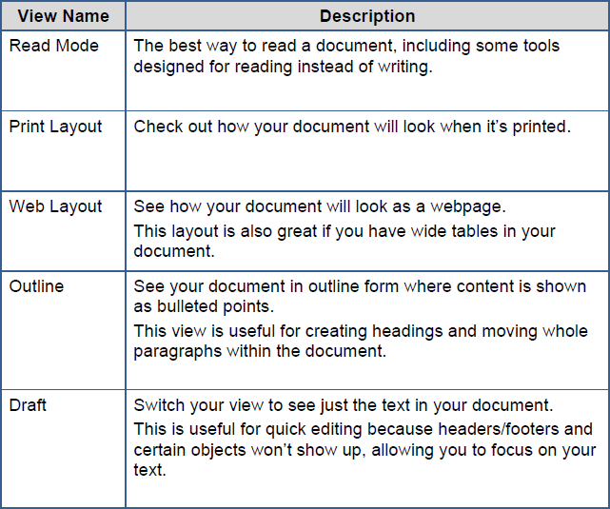In the **Document Views** group, select your desired view mode.

**5**

# Spelling and Grammar Checks

Microsoft Word 2019 automatically checks for incorrect spelling and grammar. As you type the document, Word uses **wavy red underlines** to indicate possible spelling errors and **wavy green underlines** to indicate possible grammatical errors. To correct an error, **right-click** on a word with a wavy underline, and then click on the correction from the option panel that you desire. You can also edit the error directly in the document if no suggestions are applicable.

# A. Make Error Corrections

1. In the first paragraph on the ***Garden*** practice document, place the mouse pointer over the misspelled text (***gardning***), click on the right mouse button, and then select the correction from the option panel.
2. In the second paragraph, place the mouse pointer over the misspelled text (***envirnment***), click on the right mouse button, and then select the correction from the option panel.
3. In the third paragraph, place the mouse pointer over the grammatical error text (***is***), click on the right mouse button, and then select the correction from the option panel.
4. In the third paragraph, place the mouse pointer over the repeated text (***on***), click on the right mouse button, and then select **Delete Repeated Word** from the option panel.

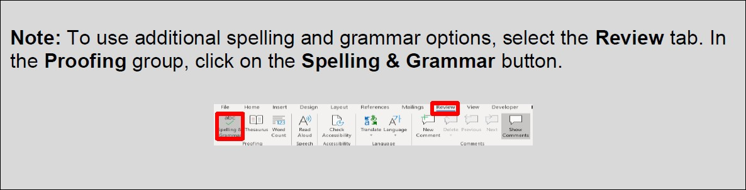

**6**