

**College of Health and Medical Technologies**

**Department of Radiology Technologies**

**Radiobiology**

**The first stage**

**Dr. Arshed AL-kafagi**

**Lecture No.3**

**Cell death after irradiation**

**Apoptosis**

* It is the process of programmed cell death.
* It is used during early development to eliminate unwanted cells
* In adults, **apoptosis** is used to rid the body of cells that have been damaged beyond repair.
* **Apoptosis** also plays a role in preventing cancer.
* If **apoptosis** is for some reason prevented, it can lead to uncontrolled cell division and the subsequent development of a **tumor**.

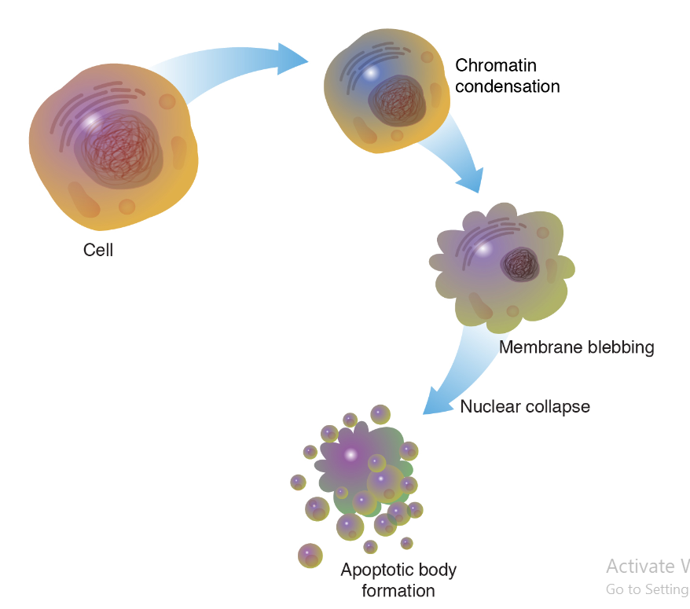

**Programmed cell death** (**PCD)**

* Sometimes referred to as **cellular suicide** is the [death](https://en.wikipedia.org/wiki/Death) of a [cell](https://en.wikipedia.org/wiki/Cell_(biology)) as a result of events inside of a cell, such as [**apoptosis**](https://en.wikipedia.org/wiki/Apoptosis) or [**autophagy**](https://en.wikipedia.org/wiki/Autophagy).
* **PCD** is carried out in a [biological process](https://en.wikipedia.org/wiki/Biological_process), which usually confers advantage during an organism's [lifecycle](https://en.wikipedia.org/wiki/Biological_life_cycle).

**Autophagy (or auto phagocytosis)**

* Is the natural, conserved degradation of the cell that removes unnecessary or dysfunctional components through a lysosome-dependent regulated mechanism.
* It allows the orderly degradation and recycling of cellular components.

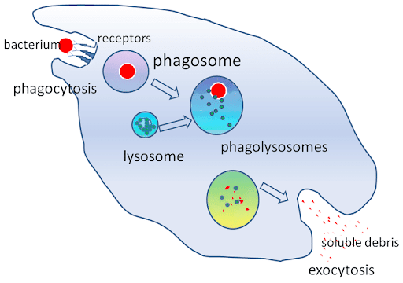

**Necrosis**

* **Necrosis** is the death of body tissue.
* It occurs when too little blood flows to the tissue.
* This can be from injury, **radiation**, or chemicals. **Necrosis** cannot be reversed.

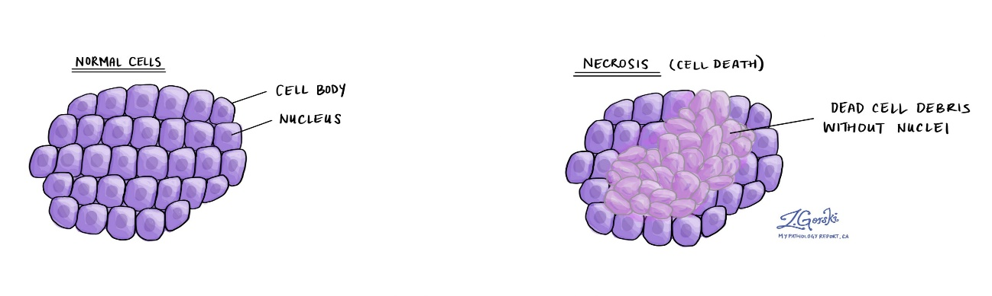

**Senescence**

* The process of growing old. In biology, **senescence** is a process by which a cell ages and permanently stops dividing but does not die.
* Over time, large numbers of old (or senescent) cells can build up in tissues throughout the body.
* **Senescent** cells are characterized by morphological and metabolic changes, chromatin reorganization, altered gene expression, and adoption of a pro-inflammatory phenotype
* **DNA** damage triggers the **DNA** repair machinery, **apoptosis**, or **senescence** depending on the extent of damage and physiological context.
* **Senescent** cells are characterized by a persistent DNA damage response (**DDR**)

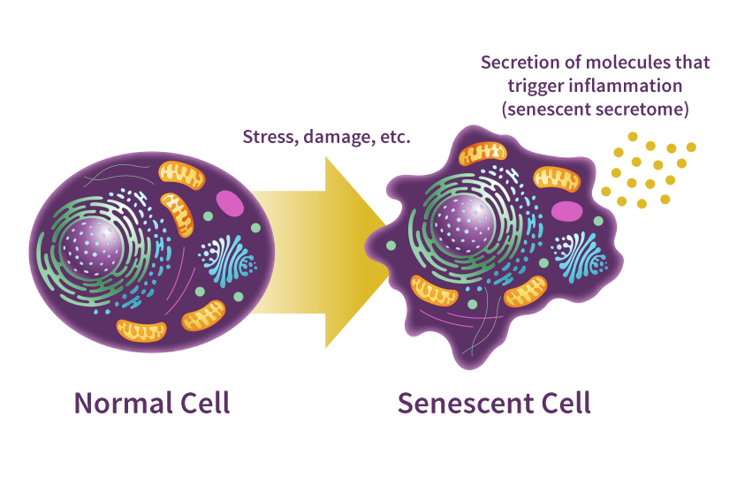

**Mitotic catastrophe (MC)**

* Has long been considered as a mode of cell death that results from premature or inappropriate entry of cells into **mitosis** and can be caused by **chemical** or **physical** stresses.
* It initially was depicted as the main form of cell death induced by **ionizing radiation.**
* **Mitotic** catastrophe results from **aberrant** mitosis and can produce giant, multinucleated **aneuploid** cells that remain metabolically active.
* **Mitotic** catastrophe is associated with deficiencies of the **G2** and **mitotic** spindle checkpoints that function to limit the abnormal division of cells with damaged **DNA** and **chromosomes**.

