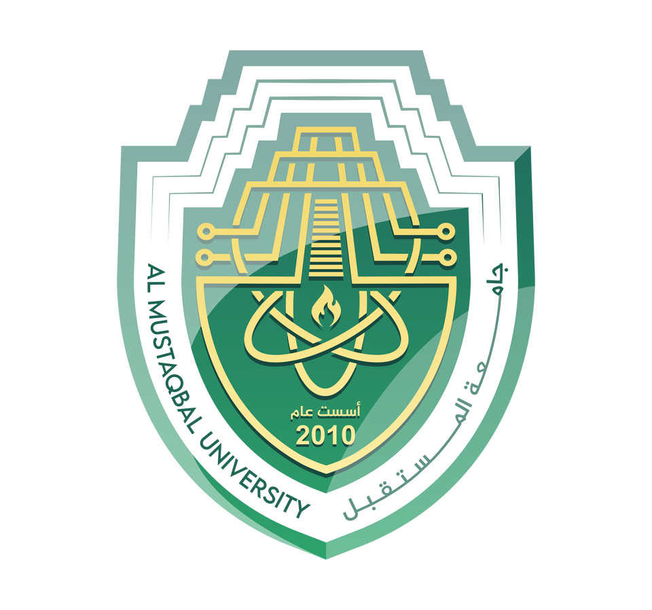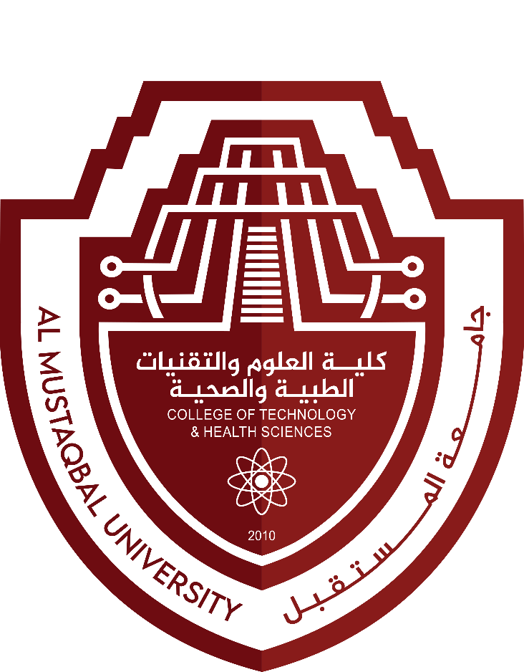

**College of Health and Medical Technologies**

**Department of Radiology Technologies**

**Radiobiology**

**The first stage**

**Dr. Arshed AL-kafagi**

**Molecular repair of DNA damage**

**Lecture No.4**

**UV light** is one of the major sources of damage to **DNA** and is also the most thoroughly studied form of DNA damage in terms of **repair mechanisms**. Its importance is illustrated by the fact that exposure **to solar UV** irradiation is the cause of almost all **skin cancer** in humans.

**Base excision repair (BER)** A mechanism of **DNA** repair in which single damaged bases are removed from a **DNA** molecule.

In **excision repair**, the damaged **DNA** is recognized and removed.

**BER** takes place by short-patch repair or long-patch repair that largely use different proteins downstream of the base excision. The repair process takes place in five core steps:

**(1) Excision of the base**

**(2) Incision**

**(3) End processing**

(4) **Repair synthesis**, including gap filling and ligation.

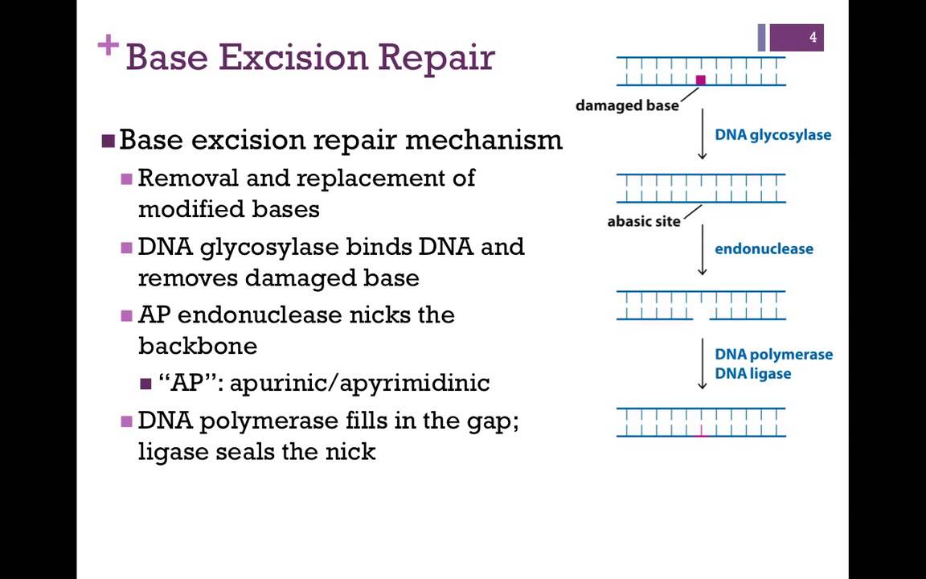

**Mutations** in the proteins of the **BER** pathways can lead to various types of **cancer**. For example, a **mutation** in the human **glycosylase OGG1** is associated with an increased risk for **lung** and **pancreatic** **cancers**.

The mechanisms of **DNA repair** can be divided into two general classes:

(1) **direct** reversal of the chemical reaction responsible for **DNA** damage, and

(2) **removal** of the damaged bases followed by their replacement with newly synthesized **DNA**.

**Genetic recombination** results in the exchange of genes between paired homologous chromosomes during **meiosis**.

**Recombination** is involved in rearrangements of specific **DNA** sequences that alter the expression and function of some genes during development and differentiation.

Thus, **recombination** plays important roles in the lives of individual cells and organisms, as well as contributing to the genetic diversity of the species.

**Homologous recombination (HR) is** a type of genetic recombination in which nucleotide sequences are exchanged between two similar or identical molecules of **DNA**.

**(HR)** is an essential mechanism for the repair of DNA double strand breaks (**DSBs**) and **ssDNA** gaps arising at damaged replication forks.

**HR** is a high-fidelity repair mechanism that uses an undamaged **DNA** template to accurately restore the sequence at the site of the **DSB**. **HR** is typically employed during the **S** and **G2** phases of the cell cycle when a sister chromatid is available as a template.

During the formation of egg and sperm cells (**meiosis**), paired chromosomes from the male and female parents align so that similar **DNA** sequences can cross over, or be exchanged, from one chromosome to the other. This exchanging of **DNA** is an important source of the genomic variation seen among offspring.

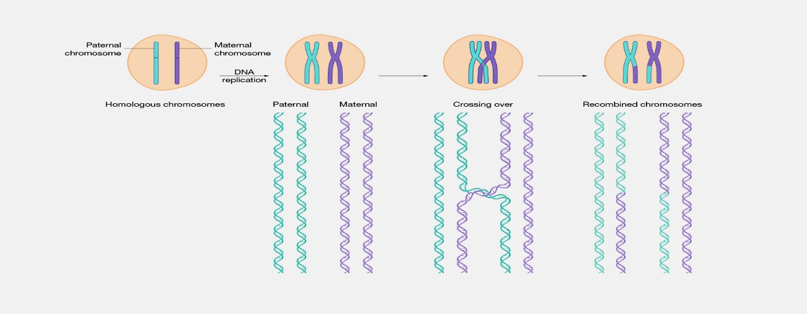

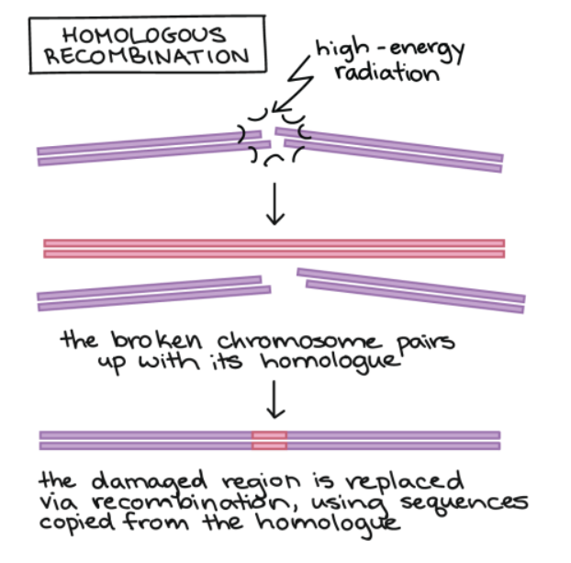

**Non-homologous recombination (NHR)** is a major pathway for the repair of chromosomal **double-strand** breaks in the **DNA** **of somatic cells**.

It is called "non-homologous" because the break ends are directly ligated without the need for a homologous template

**NHR** recombination occurs in regions where no large-scale sequence similarity is apparent, e.g. translocations between different **chromosomes** or deletions that remove several genes along a **chromosome**.

Non-Homologous End Joining (NHEJ): **NHEJ** is an error-prone repair mechanism that rejoins the broken ends of **DNA** strands without requiring a template. While **NHEJ** can efficiently repair **DSBs**, it often introduces small **insertions** or **deletions** at the repair site, leading to **mutations**.

