

**College of Health and Medical Technologies**

**Department of Radiology Technologies**

**Radiobiology**

**The first stage**

**Dr. Arshed AL-kafagi**

**Target theory**

**Lec No.5**

**Radiation target theory** refers to that ionizing radiation hits specific molecules or organelles in cells, resulting in **structural damage**, **gene mutation**, **chromosome breakag**e and other target effects of biological macromolecules.

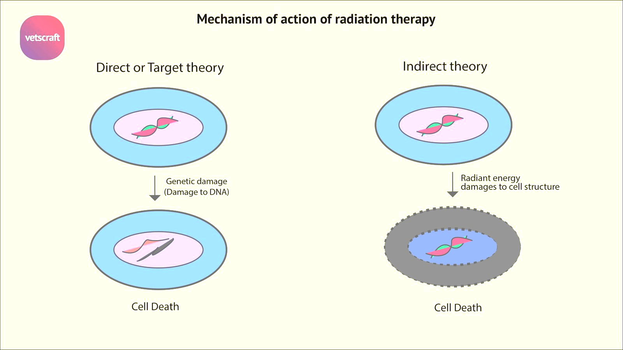

Based on the target theory, **DNA** was initially regarded as a main radiation target

It assumes that there are certain critical molecules or critical targets within cells that need to be hit or inactivated by the **radiation** to kill the cell.

**Single target–single hit:** Here, there is only **one targe**t in the cell that is associated with **cell death**, and **a single hit** on this target is adequate to inactivate the target.

• This is a valid assumption for viruses and some bacteria.

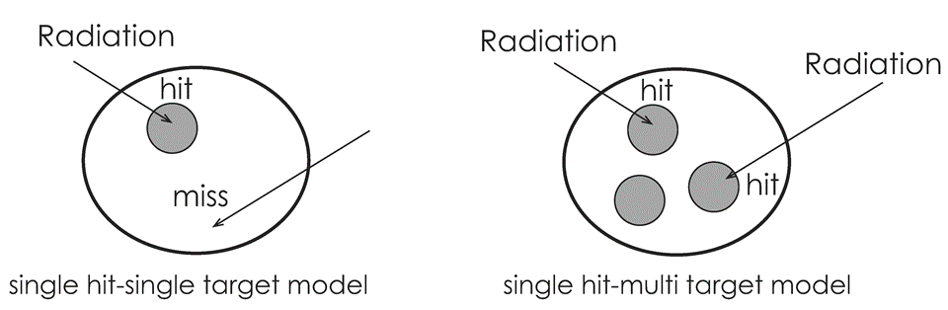

**Multiple target–single hit:** Here, there is **more than one** target per cell, and a **single hit** of any of these targets is required for **cell death**.

Not all targets are hit; some of them are killed, while others are damaged **by low doses**. This type of damage is called **sub lethal damage (SLD).**

Cells with **SLD** may repair themselves during inter-fractional periods. This is a valid assumption for **mammalian cell**s.

**Cell Survival Curves**

The number of cells in cell lines within cell cultures can increase in one of two ways: either **arithmetically** or **exponentially** (**geometrically**).

**Arithmetically:** The number of cells **increases** linearly (by a constant number) with each generation in an **arithmetic** increase.

In an **exponential increase**, the number of cells **doubles** with each generation.

So **exponential** growth is faster than **arithmetic** growth.

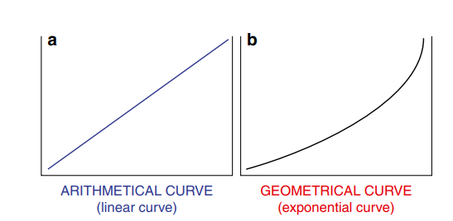

**Surviving fraction (SF):** The cells are not affected by the **radiation Curves** showing the relation between the **radiation dose** and **SF** are termed **cell survival curves**.

**Cell cycle effects**

When cell culture lines are exposed to radiation:

* some of them **lose** their capacity to divide and cannot form colonies (→ **reproductive cell death**).
* some only divide to a **small** degree and form small **colonies**.
* some divide **slowly** and form colonies over **longer periods**.
* some lose their capacity to divide but continue to grow and become **giant cells**, while still others degenerate and die.
* The remaining cells are not affected by the radiation, and they represent the surviving fraction (SF) after irradiation of the cell culture (→ SF).

**Radiation effect modification**

**1.Linear Energy Transfer (LET)**

* The **LET** increases as the charge on the ionizing radiation **increases** and its velocity **decreases**.
* Lethal effects **increase** as the **LET** **increases**.
* Since **high LET** radiation (particulate radiation) transfers more energy per unit length of material, the probability of causing **DNA** damage in a short period of time is **high**.

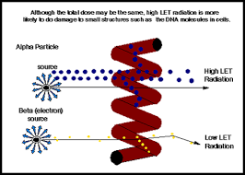

**low LET radiation**

**High LET radiation**

**2. Absorbed dose**

The basic quantity of **radiation** measurement in radiotherapy is the “**absorbed dose.**” This term defines the amount of energy absorbed from a **radiation** beam per unit mass of absorbent material.

**3. Dose Rate**

* Cell survival is **greater** for a delivered radiation dose if the **dose rate** is **decreased**. This is due to the proliferation of undamaged living cells and SLD repair during **radiotherapy**.
* This effect is very important in brachytherapy applications. The **dose rate** in external therapy is **100** cGy/min.
* **Low dose** rates are used in brachytherapy, and **high doses** can be given due to normal tissue repair and repopulation**.**

**4. Cell cycle.**

* The responses of cells in different phases to radiation vary.
* The most **radiosensitive** cell phases are **late G2** and **M**.
* The most radio-resistant cell phases are **late S** and **G1**.

**5.Repair of sub-lethal damage (SLDR) .**

* **SLD** is usually repaired **2–6 h** after the delivery of radiation.
* **SLD** is not fatal, but the second dose **increases** radio sensitivity.
* It can be lethal if there is an insufficient repair period between two fractions.
* Repair abilities differ among normal tissues and **tumors**.
* Inhibition of **SLDR** is the rationale for the additive effect of chemo- radiotherapy.

**6. Repair of potentially lethal damage (PLDR)**

* Some damage that is lethal during normal growth can be repaired under suboptimal conditions.
* The first human **DNA** repair gene to be discovered is located in the **18th** chromosome.
* **Mitomycin C**, which selectively affects hypoxic tumor cells, acts through this gene and inhibits **PLDR**.

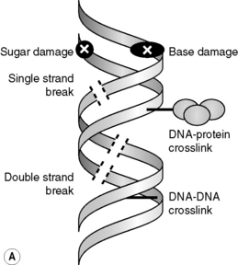

**7.Oxygenation.**

* Soluble oxygen in tissues **increases** the stability and toxicity of **free radicals**.
* The **increase** in the effect of radiation after **oxygenation** is defined as the oxygen enhancement ratio (**OER**).
* The maximum value of the **OER** is **3**.
* **Oxygenation** can modify the indirect effect of **free radicals**.

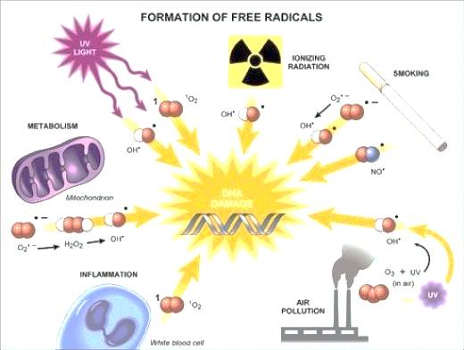

**8.Temperature.**

* Most cells are more sensitive to radiation at **high** temperatures.
* However, there are more chromosome aberrations at **low** temperatures (probably due to the suppression of the **DNA** repair process at **low** temperatures).

**9.Chemical agents**

* Radio protective agents :**Free radical** scavengers are radio protective agents.
* Radio sensitizers . **Oxygen** is the leading **radiosensitizer**.