1

**(Dynamic)**

**Kinematics of a Particle/ Rectilinear Kinematics: Continuous Motion**

**Kinematics of a Particle**

Dynamics includes:

1. **Kinematics**: يدرس شكل الحركة

Study the geometry of motion, relate يربطdisplacement, velocity, acceleration, and time, without reference دون الاشارةto the cause للمسبب of the motion.

1. **Kinetics:يدرس القوة المسببة للحركة**

Study or determine ايجادthe forces required القوة المطلوبةto produce للتسببa given motionفي الحركة, as well as mass of the bodyبالإضافة الى كتلة الجسم.

**Rectilinear Kinematics**: **الحركية المستقيمة Continuous Motion**

The kinematics of a particle is characterized by specifying particle's position, velocity, and acceleration**.**

**Distance**: is a positive scalar represents total length of path over which the particle travels.

**Displacement:** is a vector quantity defined as the change in its position.

For example, if the particle moves from one point to another, Fig. 12-1b, the displacement is :



Δs is positive when particle's final position is right of its initial position,

Δs is negative when final position is left of its initial position.

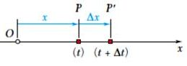**Velocity**: is the moving of particle through a displacement Δx during the time interval Δt, the average velocity of the particle during this time interval is:

v= $\frac{Δx}{Δt}$

Take smaller values of Δt,

then : v= $\lim_{Δt→0}{Δx/Δt}$ → v= $\frac{dx}{dt}$

The velocity v can be Positive or negative.

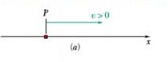Positive value of v → x increases, i.e., particle moves in positive direction (Fig. 11.3a).

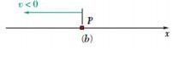Negative value of v → x decreases, i.e., particle moves in negative direction

**Acceleration**: Provided the velocity of the particle is known at two points, the average acceleration of the particle during the time interval Δt is defined as:



when the particle speed is decreasing(slowing down) , particle is said to be decelerating

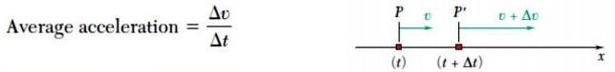

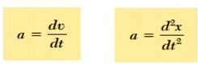

The acceleration can be positive or negative.

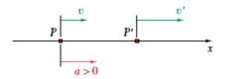A positive value → the velocity increases, particle is moving faster in positive direction (Fig. 11.5a)

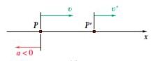A negative value → the velocity decreases; particle is moving more slowly in positive direction (Fig. 11.5c)

velocity is constant, the acceleration is zero, Δv = v - v = 0.

**Determination of Motion of Particles**

x=6t2-t3 t in second , x in meters

velocity at any time = differentiating of x with respect of t :

v== (6t2-t3) = 12t-3t2

Then v=12t-3t2

The acceleration (a) = Differentiating of x with respect of t

a== (12t-3t2) → a=12-6t

Example :

Particle moves along straight line, its position defined by the relation (x = t3 -6t2-15t + 40), where x is expressed in feet and t in seconds. Determine:

(a) the time at which the velocity will be zero,

(b) the position and distance traveled by the particle at that time,

(c) the acceleration of the particle at that time,

(d) the distance traveled by the particle from t = 4 s to t = 6 s.

Solution :

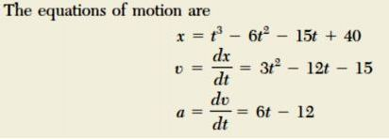

1. The time at which the velocity will be zero: i.e v=0

v=3t2-12t-15=0 → t2-4t-5=0 → (t+1)(t-5)=0 → t=-1 , t=5

take t=5 , t<5 v<0 and t>5 v>0

1. The position and distance traveled by the particle at that time

x= ? at t=5 and v=0

x = t3 -6t2-15t + 40

xt=5= (5)3-6*(5)2-15*(5)+40=125-6*(25) -75+40=-60ft

initial position at time=0 → xt=0= t3 -6t2-15t + 40=(0)3-6(0)2-15(0)+40=40→ xo =40ft

distance traveled = xt=5- xt=0=-60-40=-100ft in the negative direction

1. the acceleration of the particle at that time, i.e v=0 and t=5

v=3t2-12t-15 → a= = 6t-12 , t=5 → a=6(5)-12=30-12=+18ft/s2

**Example**:

The position of a particle is given by S = (2t^2 − 8t + 6)m, where t is in seconds. Determine the time when the velocity of the particle is zero, and the total distance travelled by the particle when t = 3 s.

Solution:

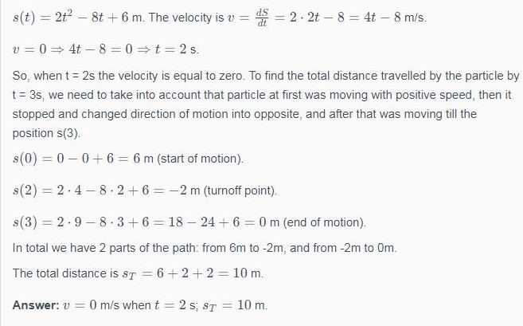

Integrate ac = dv/dt, assuming that initially v = vo when t = 0.



****Position as a Function of Time. Integrate v = ds/dt = vo + act, assuming that initially s = so when t = O.

****Velocity as a Function of Position. Either solve for t in Eq. 12-4 and substitute into Eq. 12-5, or integrate v dv = ac ds, assuming that initially v = vo at s = so

The equations: حساب السرعة والتعجيل من معادلة المسافة

X=A+Bt2 +t3 v= = 2Bt+3t2 , a=acceleration= $\frac{dv}{dt}$ =2B+6t

The equations: حساب المسافة والسرعة من معادلة التعجيل

1

1

a=acceleration==2t+5 v= =t2+ 5t = السرعة s= $\int_{0}^{1}{t^{2}}+5t$ dt= $\frac{t^{3}}{3}$ + $\frac{{5t}^{2}}{2}$ =المسافة

0

0

Example :

A particle travels along a straight line with a velocity v = (12 − 3t2 ) m/s, where t is in seconds. When t =1s, the particle is located 10 m to the left of the origin. Determine the acceleration when t = 4s, the displacement from t = 0 to t = 10 s, and the distance the particle travels during this time period.

Solution:

The acceleration is obtained by differentiating the given velocity function

a= = (12-3t2)=-6t

at t=4s , the acceleration is: a(4) = -6 * 4=-24 m/s2

v==12-3t2

Take the integration :

=

10

s(10)-s(0)=(12t-t3)

0

Δs=12 (10) – (10)3=120-1000=-880

Total distance of particle travels from t=0 to t=10, integrate the speed over this interval :

ST=3t2 )dt= -3t2)dt + -3t2)dt

10

2

=(12t-3t2) + (12t-3t2) = [12(2)-23]+[103-12(10)-23+12(2)]=912m

2

0