



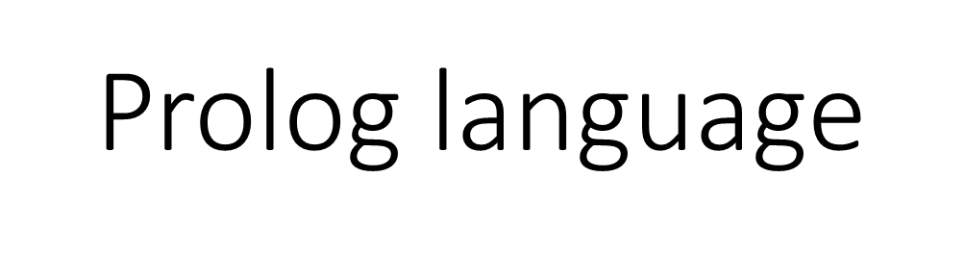

**Lec6**



**1. list in prolog**

**2. syntax of list**

**3. head and tail**

**1. list in prolog**

**In prolog, a list is an object that contains an arbitrary number of other**

**objects within it. Lists correspond roughly to array in other languages**

**but unlike array, a list dose not require you to how big it will be before**

**use it.**

**2. syntax of list**

**List always defined in the domains section of the program as follow:**

**Domains**

**list = integer\***

**• ‘*’ refer to list object which can be of length zero or un defined.**

**• The type of element list can be of any standard defined data**

**type like integer, char … ect or user defined data type explained**

**later.**

**• List element surrounded with square brackets and separated by**

**comma as follow: l = [1, 2, 3, 4].**

**• List consist of two parts head and tail , the head represent the**

**first element in the list and the tail represent the remainder (i.e**

**head is an element but tail is a list) . for the following list :**

**L = [1,2,3]**

**H = 1 T =[2,3]**

**H =2 T =[3]**

**H =3 T=[ ]**

**[ ] refer to empty list.**

**List can be written as [H|T] in the program, if the list is non**

**empty then this statement decompos the list into Head and tail**

**otherwise ( if the list is empty) this statement add element to**

**the list.**

**4. list and recursion**

**As maintained previous list consist of many element, therefore to**

**manipulate each element in the list we need recursive call to the list until**

**it become empty.**

**Example 1: program to print list element in one line.**

**Domains**

**L = integer\***

**Predicates**

**Print (L)**

**Clauses**

**Print ([ ]):-!.**

**Print ( [ H|T]):- write (H) , print (T).**

**Goal**

**Print ([1,4,6,8]).**

**Output:**

**1468**

**Example 2: program to find sum of integer list.**

**Domains**

**I= integer**

**L=i\***

**Predicates**

**Sum ( L I, I)**

**Clauses**

**Sum ( [ ],S,S):-!.**

**Sum( [H| T],S1,S):- S2 = S1+H , Sum (T,S2,S).**

**Goal**

**Sum ( [ 1,4,6,9],0 ,S).**

**Output**

**S = 20**

**33**

**Example 3: prolog program to spilt list into to list positive and negative**

**list.**

**Domains**

**L= integer\***

**Predicates**

**Spilt ( L,L,L)**

**Clauses**

**Spilt ( [ ],[ ],[ ]):-!.**

**Spilt ( [ H| T],[H|T1],L2):- H>= 0,!,spilt (T, T1,L2).**

**Spilt ([H|T],L1,[H|T2] ) :- spilt ( T,L1,T2).**

**Goal**

**Spilt ([-1,4,-9,8,0],L1,L2).**

**L1 = [4,9,0]**

**L2 = [-1,-9]**

**H.W**

**1. Write prolog program to find the union of two lists.**

**2. Write prolog program to find the intersection between two lists.**