1

**(Dynamic)**

**Absolute Dependent Motion Analysis of Two Particles**

In some types of problems the motion of one particle will depend on the

corresponding motion of another particle.

في بعض أنواع المسائل، تعتمد حركة جسيم على الحركة المقابلة لجسيم آخر.

location of the blocks are SA and SB.

Total cord length is LT, the two position coordinates are related by the equation:





The negative sign indicates that when block A has a velocity downward, i.e., in the direction of positive SA, it causes a corresponding upward velocity of block B; i.e., B moves in the negative SB direction.

In a similar manner, time differentiation of the velocities yields the

relation between the accelerations, i.e.,







I and h are constant during the motion, two time derivatives yield



Hence, when B moves downward (+SB), A moves to the left (-SA) with twice the motion.



Example 1:

Determine the speed of block A in Figure if block B has an upward speed of 6 ft/s.

Solution : Position-Coordinate Equation.

motion of B and E is the same,

The red colored segments of the cord in Fig. 12-38 remain at a constant length and do not have to be considered as the blocks move.

The remaining length of cord, I, is also constant and is related to the changing position coordinates SA and SB by the equation:



so that when VB = -6 ft/s (upward),



H.W

Example : 2

Determine the speed of block D if end A of the rope is pulled down with a speed of VA = 3 m/s.

Example 3

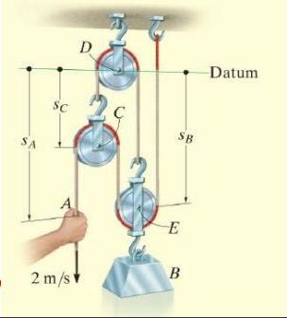Determine the speed of block B in Fig. if the end of the cord at A is pulled down with a speed of 2 m/s.

Solution :

