1

**(Dynamic)**

**Kinetics of a Particle: Work and Energy/ The Work of a Force**

**The Work of a Force**

A force F will do work on a particle only when the particle undergoes a displacement in the direction of the force. For example, if the force F in Fig. 1 causes the particle to move along the path s from position r to a new position r', the displacement is then:

dr = r' -r.

The magnitude of dr is ds, the length of the differential segment along the path. If the angle between the tails of dr and F is e, Figure 1 , then the work done by F is a scalar quantity, defined by:

By definition of the dot product this equation can also be written as:



**Work of a Variable Force Figure 1**

If the particle acted upon by the force F undergoes a finite displacement along its path from r1 to r2 or S1 to S2 , Fig. 2a, the work of force F is determined by integration, then:



The area under the graph represents the total work, Fig. 2b. Figure 2

**Work of a Constant Force Moving Along a Straight Line**

If the force Fe has a constant magnitude and acts at a constant angle θ from its straight-line path, Fig. 3a, then the component of Fe in the direction of displacement is always Fc cosθ. The work done by Fc when the particle is displaced from Sl to S2 is determined in which case:



**Figure 3**

**Work of a Spring Force**

If an elastic spring is elongated a distance ds, Fig. 5a, then the work done by the force that acts on the attached particle is dU = - Fsds = -ks ds. The work is negative since Fs acts in the opposite sense to ds. If the particle displaces from Sl to S2, the work of Fs is then



This work represents the trapezoidal area under the line Fs = ks, Fig. 4b.



Figure 4

Example :

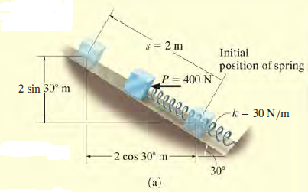The l0-kg block shown in Fig. a rests on the smooth incline. If the spring is originally stretched 0.5 m, determine the total work done by all the forces acting on the block when a horizontal force P = 400 N pushes the block up the plane s = 2 m.

**Horizontal Force P.**



**Spring Force Fs**



**Weight W.**

 Figure 5

Total Work

**Principle of Work and Energy**

Consider the particle in Fig. 6, which is located on the path defined relative to an inertial coordinate system. If the particle has a mass m and is subjected to a system of external forces represented by the resultant FR = ∑F, then the equation of motion for the particle in the tangential direction is ∑F1 = mat. Applying the kinematic equation a1 = v dv/ds and integrating both sides, assuming initially that the particle has a position s = s1 and a speed v = v1 , and later at s = S2 , v = v2 , we have:

Figure 6



∑ Ft = ∑ Fcosθ,





which states that the particle's initial kinetic energy plus the work done by all the forces acting on the particle as it moves from its initial to its final position is equal to the particle's final kinetic energy.