Lecture 2 Human Anatomy

Basic Structures: part1

# Skin

The skin is divided into two parts: the superficial part, the epidermis; and the deep part, the dermis. The epidermis is a stratified epithelium. On the palms of the hands and the soles of the feet, the epidermis is extremely thick, to withstand the wear and tear that occurs in these regions.

The dermis is composed of dense connective tissue containing many blood vessels, lymphatic vessels, and nerves. The dermis of the skin is connected to the underlying deep fascia or bones by the superficial fascia, otherwise known as subcutaneous tissue.

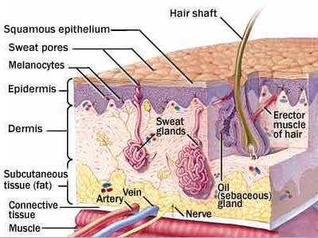The appendages of the skin are the nails, hair follicles, sebaceous glands, and sweat glands.

# Fasciae

The fasciae of the body can be divided into two types— superficial and deep— and lie between the skin and the underlying muscles and bones.

The **superficial fascia, or subcutaneous tissue**, is a mixture of loose areolar and adipose tissue that unites the dermis of the skin to the underlying deep fascia.

The **deep fascia** is a membranous layer of connective tissue that invests the muscles and other deep structures. In the neck, it forms well-defined layers and in the thorax and abdomen, it is merely a thin film of areolar tissue covering the muscles and aponeuroses.

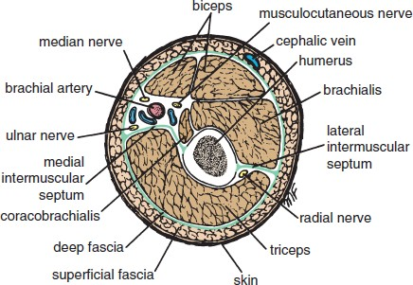

# Muscle

The three types of muscle are skeletal, smooth, and cardiac.

Skeletal Muscle

Skeletal muscles produce the movements of the skeleton; they are sometimes called **voluntary muscles** and are made up of striped muscle fibers. A skeletal muscle has two or more attachments. The attachment that moves the least is referred to as the **origin**, and the one that moves the most, the **insertion**. Under varying circumstances, the degree of mobility of the attachments may be reversed;therefore, the terms origin and insertion are interchangeable.

The fleshy part of the muscle is referred to as its **belly**. The ends of a muscle are attached to bones, cartilage, or ligaments by cords of fibrous tissue called

**tendons.** Occasionally, flattened muscles are attached by a thin but strong sheet of fibrous tissue called an **aponeurosis**. A **raphe** is an interdigitation of the tendinous ends of fibers of flat muscles.

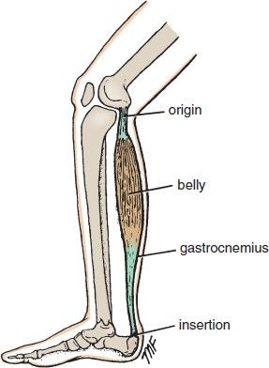

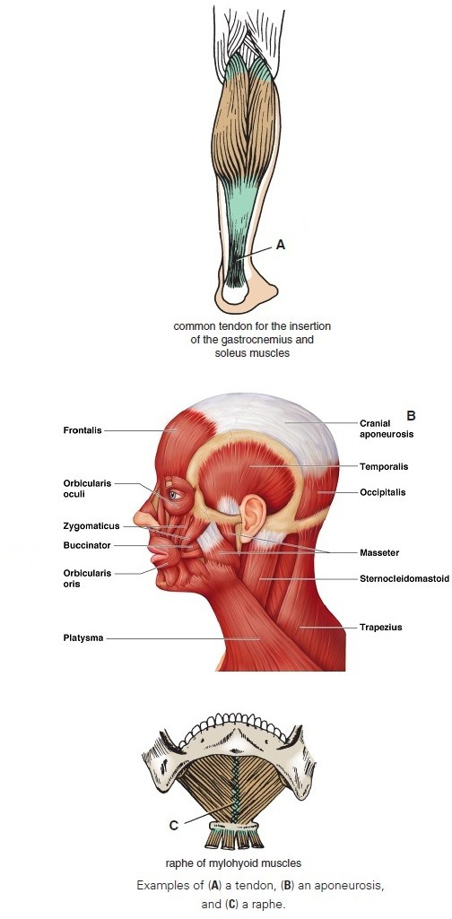

### Skeletal Muscle Action

All movements are the result of the coordinated action of many muscles. A muscle may work in the following four ways:

**Prime mover:** A muscle is a prime mover when it is the chief muscle or member of a chief group of muscles responsible for a particular movement. For example, the quadriceps femoris is a prime mover in the movement of extending the knee joint.

**Antagonist**: Any muscle that opposes the action of the prime mover is an antagonist. For example, the biceps femoris opposes the action of the quadriceps femoris when the knee joint is extended. Before aprime mover can contract, the antagonist muscle must be equally relaxed.

**Fixator**: A fixator contracts isometrically (i.e., contraction increases the tone but does not in itself produce movement)to stabilize the **origin** of the prime mover. For example, the muscles attaching the shoulder girdle to the trunk contract as fixators to allowthe deltoid to act on the shoulder joint.

**Synergist**: In many locations in the body, the prime mover muscle crosses several joints before it reaches the joint at which its main action takes place. To prevent unwanted movements in an intermediate joint, groups of muscles called **synergists** contract and stabilize the intermediate joints. For example, the flexor and extensor muscles of the carpus contract to fix the wrist joint, and this allowsthe long flexor and the extensor muscles of the fingers to work efficiently.

### Nerve Supply of Skeletal Muscle

The nerve trunk to a muscle is a mixed nerve, about60% is motor and 40% is sensory.

Smooth Muscle

Smooth muscle consists of long, spindle-shaped cells closely arranged in bundles or sheets. In the tubes of the body, it provides the motive power for propelling the contents through the lumen. In the digestive system, it also causes the ingested food to be thoroughly mixed with the digestive

juices.

In storage organs such as the urinary bladder and the uterus, the fibers are irregularly arranged and interlaced with one another. Their contraction is slow and sustained and brings about expulsion of the contents of the organs.

In the walls of the blood vessels, the smooth muscle fibers are arranged circularly and serve to modify the caliber of the lumen.

Depending on the organ, smooth muscle fibers may be made to contract by local stretching of the fibers, by nerve impulses from autonomic nerves, or by hormonal stimulation.

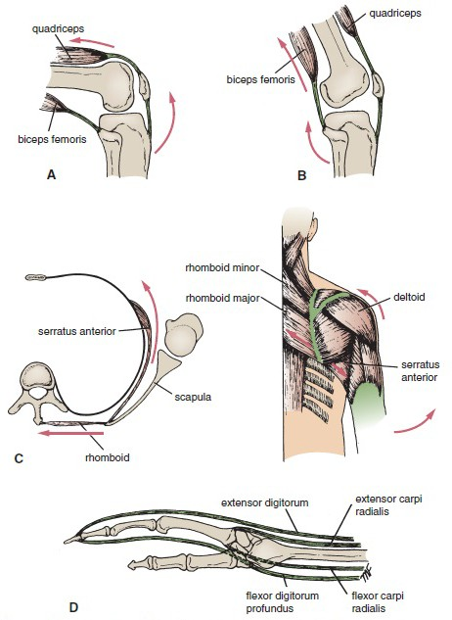

**A.** Quadriceps femoris extending the knee as a prime mover, and biceps femorisacting as an antagonist. **B.** Biceps femoris flexing the knee as a prime mover, and quadriceps acting as an antagonist.

**C.** Muscles around shoulder girdle fixing the scapula so that movement of abduction can take place at the shoulder joint.

**D.** Flexor and extensor muscles of the carpus acting as synergists and stabilizing the carpus so that long flexor and extensortendons can flex and extend the fingers.

Cardiac Muscle

Cardiac muscle consists of striated muscle fibers that branch and unite with each other. It forms the myocardium of the heart. Its fibers tend to be arranged in whorls and spirals, and they have the property of spontaneous and rhythmic contraction.

# Joints

A site where two or more bones come together, whether or not movement occurs between them, is called a joint.Joints are classified according to the tissues that lie betweenthe bones: fibrous joints, cartilaginous joints, and synovial joints.

Fibrous Joints

The articulating surfaces of the bones are joined by fibrous tissue, and thus very little movement is possible.Example: The sutures of the vault of the skull.

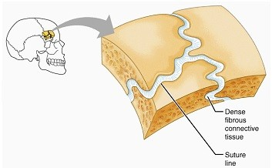

Cartilaginous Joints

Cartilaginous joints can be divided into two types: primary and secondary.

A primary cartilaginous joint is one in which the bones are united by a plate or a bar of hyaline cartilage,like, the union between the 1st rib and the manubrium sterni. No movement is possible.

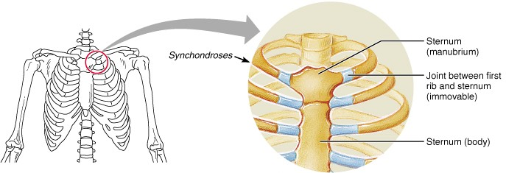

A secondary cartilaginous joint is one in which the bones are united by a plate of fibrocartilage and the articular surfaces of the bones are covered by a thin layer of hyaline cartilage like the joints between the vertebral bodies. A small amount of movement is possible.

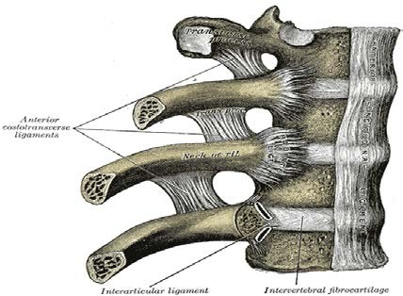

Synovial Joints

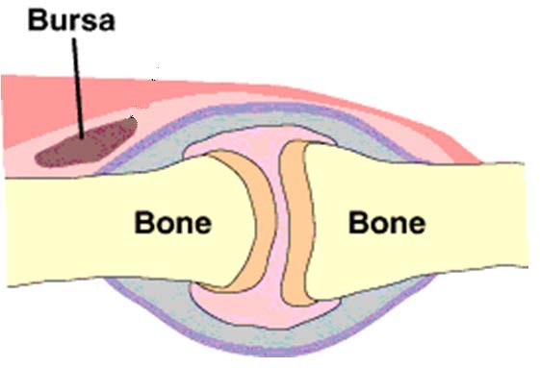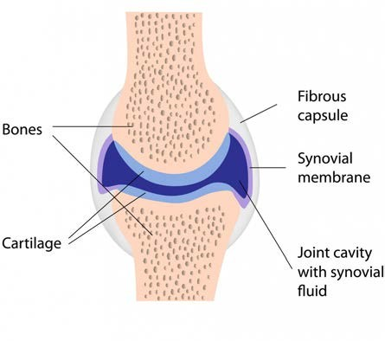The articular surfaces of the bones are covered by a thin layer of hyaline cartilage separated by a joint cavity. This arrangement permits a great degree of freedom of movement. The cavity of the joint is lined by **synovial membrane**, which extends from the margins of one articular surface to those of the other. The synovial membrane is protected on the outside by a tough fibrous membrane referred to as the **capsule of the joint**. The articular surfacesare lubricated by a viscous fluid called **synovial fluid**, which is produced by the synovial membrane. In certain synovial joints, for example, in the knee joint, discs or wedges of fibrocartilage are interposed between the articular surfaces of the bones. These are referred to as articular discs.

# Ligament:

A ligament is a cord or band of connective tissue uniting two structures. Commonly found in association with joints,ligaments are of two types. Most are composed of dense bundles of collagen fibers and are unstretchable under normal conditions. The second type is composed largely of elastic tissues and can therefore regain its original length after stretching.

# Bursae

A bursa is a lubricating device consisting of a closed fibrous sac lined with a delicate smooth membrane. Its walls are separated by a film of viscous fluid. Bursae are found wherever tendons rub against bones, ligaments, or other tendons. They are commonly found close to joints where the skin rubs against underlying bony structures, for example,the prepatellar bursa.

# Bone

Bone is a living tissue like other connective tissues, bone consists of cells, fibers, and matrix. It is hard because of the calcification of its extracellular matrix and possesses a degree of elasticity because of the presence of organic fibers.

Bone has a protective function; the skull and vertebral column, for example, protect the brain and spinal cord from injury; the sternum and ribs protect the thoracic and upper abdominal viscera. It serves as a lever,as seen in the long bones of the limbs, and as an important storage area for calcium salts. It houses and protects within its cavities the delicate blood-forming bone marrow. Bone exists in two forms: **compact (cortical)** and **cancellous (spongy).**Compact bone appears as a solid mass; cancellous bone consists of a branching network of *trabeculae*. The trabeculae are arranged in such a manner to resist the stresses and strains to which the bone is exposed.

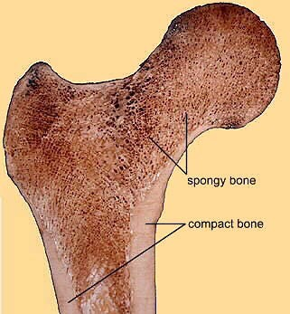

**Classification of Bones**

Bones may be classified regionally or according to their general shape.

##  - Regional Classification of Bones:

#### Axial skeleton80 bones

* + Skull

☒ Cranium 8

☒ Face 14

☒ Auditory ossicles 6

* + Hyoid 1
  + Vertebrae (including sacrum and coccyx) 26
  + Thoracic cage

☒ Sternum 1

☒ Ribs 24

#### Appendicular skeleton126 bones

* + Shoulder (**Pectoralgirdle**)girdles

☒ Clavicle 2

☒ Scapula 2

* + Upper extremities

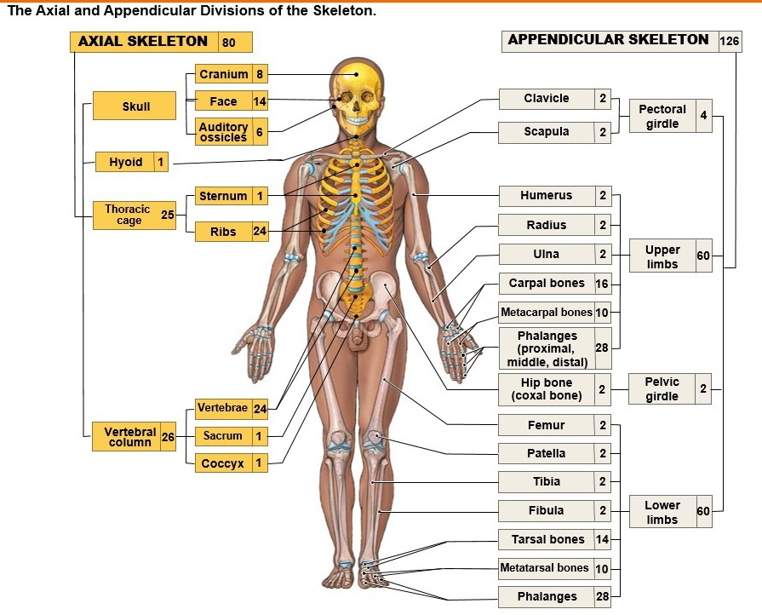☒ Humerus 2

☒ Radius 2

☒ Ulna 2

☒ Carpals 16

☒ Metacarpals 10

☒ Phalanges 28

* + Pelvic girdle

☒ Hip bone 2

* + Lower extremities

☒ Femur 2

☒ Patella 2

☒ Fibula 2

☒ Tibia 2

☒ Tarsals 14

☒ Metatarsals 10

☒ Phalanges 28

The adult human body contain 206 bones, 80 in axial skeleton and 126 in appendicular skeleton.

##  - Classification of Bones according to shape:

Bones are grouped as follows based on their general shape: long bones, short bones, flat bones, irregular bones, and sesamoid bones.

##### Long Bones:

Long bones are found in the limbs (e.g., the humerus, femur,metacarpals, metatarsals, and phalanges). Their length is greater than their breadth. They have a tubular shaft, the **diaphysis,** and usually an **epiphysis** at each end. The shaft has a central **marrow cavity** containing **bone marrow.** The outer part of the shaft is composed of compact bone that is covered by a connective tissue sheath, the **periosteum.**The ends of long bones are composed of cancellous bone surrounded by a thin layer of compact bone. The articular surfaces of the ends of the bones are covered by hyaline cartilage.

##### Short Bones

Short bones are found in the hand and foot (e.g., the scaphoid, lunate, talus, and calcaneum). They are roughly cuboidal in shape and are composed of cancellous bone surrounded by a thin layer of compact bone. Short bones are covered with periosteum, and the articular surfaces are covered by hyaline cartilage.

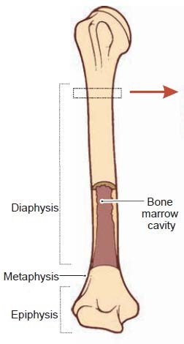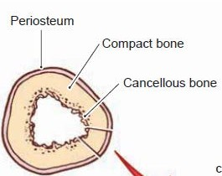

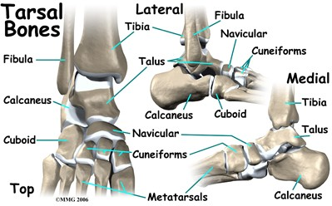

##### Flat Bones

Flat bones are found in the vault of the skull (e.g., the frontal and parietal bones). They are composed of thin inner and outer layers of compact bone, the **tables,** separated by a layer of cancellous bone, the **diploë.** The scapulae, although irregular, are included in this group.

##### Irregular Bones

Irregular bones include those not assigned to the previous groups (e.g., the bones of the skull, the vertebrae, and the pelvic bones).

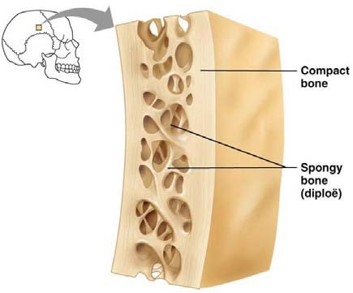They are composed of a thin shell of compact bone with an interior made up of cancellous bone.

##### Sesamoid Bones

Sesamoid bones are small nodules of bone that are found in certain tendons where they rub over bony surfaces. The greater part of a sesamoid bone is buried in the tendon,and the free surface is covered with cartilage. The largest sesamoid bone is the patella, which is located in the tendon

of the quadriceps femoris. The function of a sesamoid bone is to reduce friction on the tendon; it can also alter the direction of pull of a tendon.

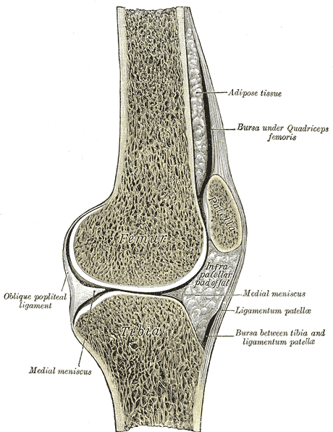

##### Development of Bone

Bone is developed by two processes: membranous and endochondral. In the first process, the bone is developed directly from a connective tissue membrane; in the second, a cartilaginous model is first laid down and is later replaced by bone.The bones of the vault of the skull are developed rapidly by the membranous method in the embryo, and this serves to protect the underlying developing brain.