Temporomandibular joint

The temporomandibular joint (TMJ) is a modified hinge type of synovial joint,

permitting gliding (translation) and a small degree of rotation (pivoting) in addition to

flexion (elevation) and extension (depression) movements typical for hinge joints. The

bony articular surfaces involved are the mandibular fossa and articular tubercle of

the temporal bone superiorly, and the head of the mandible (condylar process)

inferiorly (Fig. 1). Unlike most synovial joints, its articular surfaces are covered with

fibrous cartilage rather than hyaline cartilage and the joint cavity is divided by a

fibrocartilaginous articular disc into upper and lower cavities (Fig. 2A).

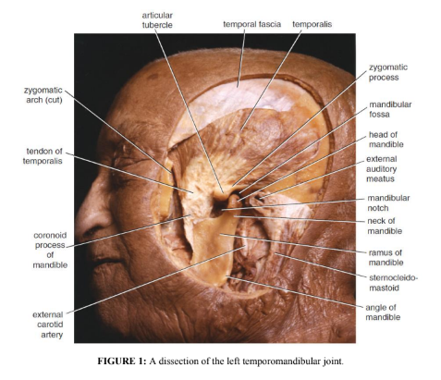

The Articular Disk

The articular disk (Fig. 2 A&B) is composed of dense fibrous connective tissue and is

non-vascularized and non-innervated, an adaptation that allows it to resist pressure.

Anatomically the disk can be divided into three general regions: the anterior band, the

central intermediate zone, and the posterior band (Fig. 3). The intermediate zone is

thinnest and is generally the area of function between the mandibular condyle and the

temporal bone.

Retrodiscal Tissue

Posteriorly the articular disk blends with a highly vascular, highly innervated structure

(the bilaminar zone), which is involved in the production of synovial fluid (Fig. 3). The

superior aspect of the retrodiskal tissue, termed the superior retrodiskal lamina,

contains elastic fibers attached to the tympanic plate and act as a restraint to disk

movement in extreme translator movements. The inferior aspect of the retrodiskal

tissue, termed the inferior retrodiskal lamina, consists of collagen fibers connected to

the posterior margin of the condyle and thought to serve to prevent extreme rotation of

the disk on the condyle in rotational movements.

Capsule

The capsule surrounds the joint and is attached above to the articular tubercle and the

margins of the mandibular fossa and below to the neck of the mandible. It permits side-

to-side motion, protrusion, and retrusion. The two bony articular surfaces are

completely separated by intervening fibrocartilage, the articular disc of the TMJ

(Meniscus), attached at its periphery to the internal aspect of the fibrous capsule. This

creates separate superior and inferior articular cavities, or compartments, lined by

separate superior and inferior synovial membranes.

Synovial Membrane

The synovial membrane is a thin, smooth, richly innervated vascular tissue (without an

epithelium) that lines the capsule (Fig. 4). Lining the inner aspect of all synovial joints,

including the TMJ, are two types of tissue: articular cartilage and synovium. The space

bound by these two structures is termed the synovial cavity, which is filled with

synovial fluid that contains a high concentration of hyaluronic acid that is thought to

be responsible for the fluid’s high viscosity. The synovium is capable of rapid and

complete regeneration following injury. Functions of the synovial fluid include

3

lubrication of the joint, phagocytosis of particulate debris, and nourishment of the

articular cartilage. The concentration of hyaluronic acid and hence the viscosity of the

synovial fluid is greater at the point of load, thus protecting the articular surfaces.

Ligaments

➢ The lateral temporomandibular ligament strengthens the lateral aspect of the

capsule, and its fibers run downward and backward from the tubercle (in the root

of zygoma) to the lateral surface of the neck of the mandible (Fig. 5). This ligament

limits the movement of the mandible in a posterior direction and thus protects the

external auditory meatus.

➢ The articular disc divides the joint into upper and lower cavities. It is an oval plate

of fibrocartilage that is attached circumferentially to the capsule. It is also attached

in front to the tendon of the lateral pterygoid muscle and by fibrous bands to the

head of the mandible. These bands ensure that the disc moves forward and

backward with the head of the mandible during protraction and retraction of the

mandible. The upper surface of the disc is concavo-convex from before backward

to fit the shape of the articular tubercle and the mandibular fossa; the lower surface

is concave to fit the head of the mandible (Fig. 3).

➢ The stylomandibular ligament lies behind and medial to the joint and extends

from the apex of the styloid process to the angle of the mandible (Fig. 5). This

ligament limits anterior protrusion of mandible.

➢ The sphenomandibular ligament lies on the medial side of the joint (Fig. 5). It is

a thin band that is attached above to the spine of the sphenoid bone and below to

the lingula of the mandible. This ligament may act as a pivot by providing tension

during opening and closing.

Nerve Supply

The nerve supply to the TMJ is predominantly from branches of the auriculotemporal

nerve with anterior contributions from the masseteric nerve and the posterior deep

temporal nerve (Fig. 2E).

Vascular Supply

The vascular supply of the TMJ arises primarily from branches of the superficial

temporal and maxillary arteries posteriorly and the masseteric artery anteriorly.

There is a rich plexus of veins in the posterior aspect of the joint, which alternately fill

4

and empty with protrusive and retrusive movements respectively, and which also

function in the production of synovial fluid.

Movements

TMJ movements are produced chiefly by the muscles of mastication (Table 1; See

also Fig. 4). The mandible can be depressed or elevated, protruded or retracted.

Rotation can also occur, as in chewing. In the position of rest, the teeth of the upper

and lower jaws are slightly apart. On closure of the jaws, the teeth come into contact.

Generally, depression of the mandible is produced by gravity. The suprahyoid and

infrahyoid muscles are primarily used to raise and depress the hyoid bone and larynx

(Fig. 4C). Indirectly they can also help depress the mandible, especially when opening

the mouth suddenly, against resistance, or when inverted (e.g., standing on one’s head).

The platysma can be similarly used.

Important Relations of the Temporomandibular Joint

Anteriorly: The mandibular notch and the masseteric nerve and artery.

Posteriorly: The tympanic plate of the external auditory meatus and the glenoid

process of the parotid gland

Laterally: The parotid gland, fascia, and skin.

Medially: The maxillary artery and vein and the auriculotemporal nerve.

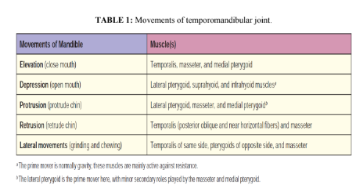

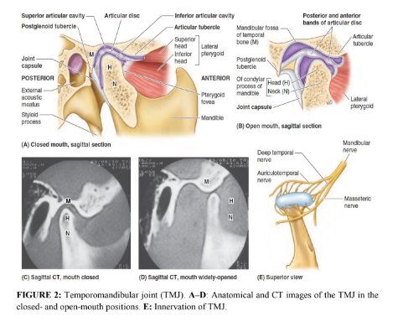

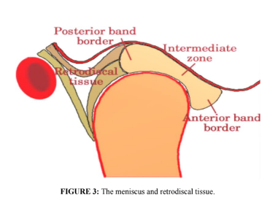

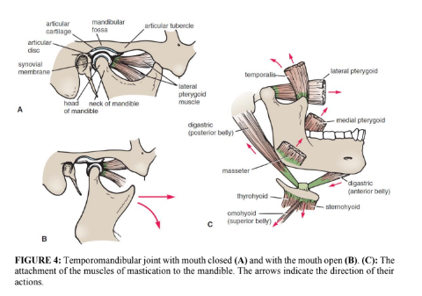

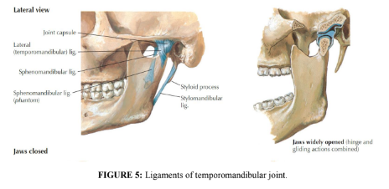

Clinical Notes

The temporomandibular joint lies immediately in front of the external auditory meatus.

The great strength of the lateral temporomandibular ligament prevents the head of the

mandible from passing backward and fracturing the tympanic plate when a severe blow

7

falls on the chin. The articular disc of the temporomandibular joint may become

partially detached from the capsule, and this results in its movement becoming noisy

and producing an audible click during movements at the joint.

Dislocation of TMJ

Sometimes during yawning or taking a large bite, excessive contraction of the lateral

pterygoids may cause the heads of the mandible to dislocate anteriorly (pass anterior

to the articular tubercles) (Fig. 6). In this position, the mandible remains depressed and

the person is unable to close his or her mouth and the condition can be quite painful.

Posterior dislocation is uncommon, being resisted by the presence of the postglenoid

tubercle and the strong intrinsic lateral ligament.

Reduction of the dislocation is easily achieved by pressing the gloved thumbs

downward on the lower molar teeth and pushing the jaw backward. The downward

pressure overcomes the tension of the temporalis and masseter muscles, and the

backward pressure overcomes the spasm of the lateral pterygoid muscles.

Surgery of TMJ

Because of the close relationship of the facial and auriculotemporal nerves to the TMJ,

care must be taken during surgical procedures to preserve both of them. Injury to these

nerves usually leads to laxity and instability of the TMJ.

Arthritis of TMJ

The TMJ may become inflamed from degenerative arthritis. Abnormal function of the

TMJ may result in structural problems such as dental occlusion and joint clicking

(crepitus). The clicking is thought to result from delayed anterior disc movements

during mandibular depression and elevation.

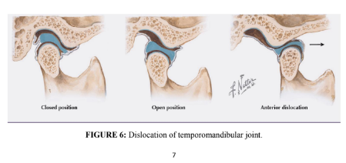

References

1. Snell RS. Clinical Anatomy by Regions. 9th edition. Philadelphia, PA:

Lippincott Williams & Wilkins, 2012.