GENERAL SURGERY LEC.7

Patient Safety

INTRODUCTION

Medicine will never be a risk-free enterprise. From the beginning of training, doctors are taught that errors are unacceptable and that the philosophy of primum non nocere (first, do no harm) should permeate all aspects of treatment. Yet, worldwide, despite all the improvements in treatment and investment in technologies, training and services, there remains the challenge of dealing with unsafe practices, incompetent healthcare professionals, poor governance of healthcare service delivery, errors in diagnosis and treatment and noncompliance with accepted standards.

THE PREVALENCE OF ADVERSE HEALTH CARE EVENTS :The aviation and nuclear industries have a much better safety record than healthcare. This became abundantly clear when, in 1999, the Institute of Medicine of the National Academy of Sciences released a report, that drew widespread attention to the alarming statistics that there were between 44 000 and

98 000 preventable deaths annually due to medical error in American hospitals with some 7000 preventable deaths related to medication errors alone. The World Health Organization estimates that, even in advanced hospital settings, one in ten patients receiving healthcare will suffer preventable harm Heinrich’s safety pyramid Developed in 1931, Heinrich’s safety pyramid theorized that unsafe acts or near misses lead to minor injuries and over time to a major injury. The accident pyramid proposes that for every 300 near misses there are 29 minor injuries and one major injury. Risk assessment, which is a step-in risk management that calculates the value of risk related to a situation or hazard, has shown us that, what prevents patients from being hurt, is not only by reducing the number of mistakes but rather by increasing the number of defenses set up against the consequences of mistakes. The key message is that near misses provide the best data about the reliability of safety systems. It is, therefore, most important to report near misses as well as adverse events to ensure that defenses against adverse events are built and sustained.

PATIENT SAFETY AND THE SURGEON Surgery is one of the most complex health interventions to deliver. More than 100 million people worldwide require surgical treatment every year for different reasons. Problems associated with surgical safety in developed countries account for half of the avoidable adverse events that result in death or disability. Cuschieri and others have described surgical coalface errors as those that can potentially be committed by surgeons during the care of their patients and include:

• diagnostic and management errors;

• resuscitation errors;

• prophylaxis errors;

• prescription/parenteral administration errors;

• situation awareness, identification and teamwork errors;

• technical and operative errors.

Checklists

Checklists in the operating theatre environment are now accepted as standard safety protocols since the ‘Safe Surgery Saves Lives’ Study Group at the World Health Organization published their results.

The use of a perioperative surgical safety checklist in eight hospitals around the world was associated with a reduction in major complications from 11.0 per cent before, to 7.0 per cent after the introduction of the checklist.

The surgical safety checklist identifies specific checks to be carried out at three obligatory time points (Figure below).

The items are not intended to be comprehensive and additions and modifications are encouraged. We now know that the benefits of standardization of surgical processes need not be limited to the operating room; several studies have shown that the majority of surgical errors (53–70%) occur outside the operating room, before or after surgery, and that a more substantial improvement in safety can be achieved by targeting the entire surgical pathway.

However, Checklists are simple reminders of what to do, and unless they are coupled with attitude change and efforts to remove barriers to actually using them, they will have limited impact. Finally, if one begins to believe that safety is simple and that all it requires is a checklist, there is a danger of abandoning other important efforts to achieve safer, higher quality care. 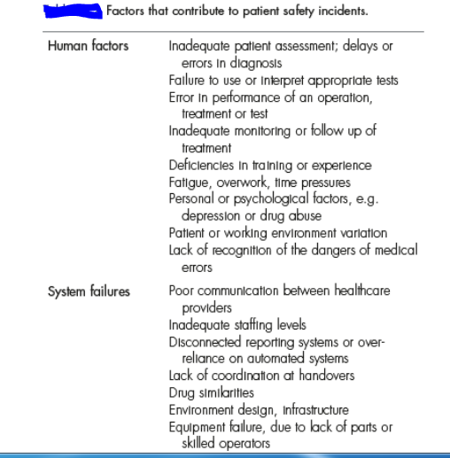

quality care.

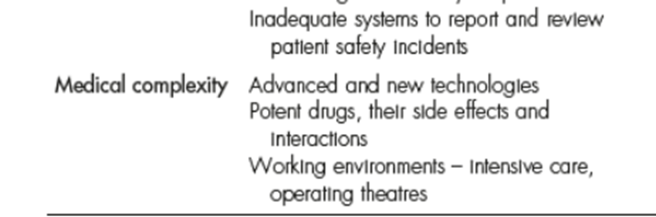

Technical and operative errors Failures in operative technique include:

• cognitive errors of judgment, such as failure or late conversion of a difficult laparoscopic procedure into an open one

• procedural, when the steps of an operation are not followed, or omitted

• executional, when, for example, too much force is used which may result in damage that may or may not have consequences

• misinterpretation, which is unique to minimal access surgery and is a function of the misreading of a two-dimensional image

• misuse of instrumentation, such as with energized dissection modalities, for example, diathermy

• missed iatrogenic injury either at the time of surgery or diagnosed late.

CARING FOR THE SECOND VICTIM The first victim of an adverse event is the patient and their family. Doctors do not purposely set out to injure patients but when it does happen due to an error, they may experience a range of emotions including distress, shame, guilt, fear and depression. To that extent they can be regarded as a ‘second victim’. Indeed, the wound to the second victim may at times be profound, leading to physical and psychological disturbances. These problems can last many months or years, especially in cases of severe disablement or death. Under such circumstances it is easy to see how a doctor’s distress can lead to further deficits in patient care. Coping with the impact of error can be challenging and the ‘second’ victim requires management. Doctors often find it difficult to admit to and cope with mistakes or resort to employee support systems. Dysfunctional coping strategies include denial, blaming others or refusal to discuss the issue.

