GENERAL SURGERY LEC.6

Day Case Surgery

Definition of terms used in ambulatory surgery :

• Outpatient surgery: not admitted to a ward facility.

• Procedure room surgery: surgery not requiring full sterile theatre facilities .

• Day or same-day surgery: admitted and discharged within the 12-hour day .

• Overnight stay: 23-hour admission with early morning discharge .

• Short-stay surgery: admission of up to 72 hours.

DAY SURGERY PATHWAY: Day surgery offers advantages for health-care delivery around the world and so rates have steadily increased in both developed and developing countries.

The increase in day surgery popularity is due to both patient preference and financial considerations. The removal of an overnight stay provides significant savings to the hospital. Day surgery is a patient pathway, not a surgical procedure and extends from first patient contact to final discharge.

SELECTION CRITERIA Stand-alone day surgery facilities can safely perform minor and intermediate procedures, but if they lack overnight beds then the surgery undertaken and the selection criteria will need to be conservative to minimize the risk of unplanned overnight admissions requiring transfer of the patient to the parent hospital.

Advanced day surgery procedures with an increased likelihood of an unplanned admission are best performed where overnight beds are available. Procedures which carry an increased intraoperative risk of complications and operations on more challenging patients are best managed in a hospital-integrated unit with the immediate availability of support services.

**Medical criteria** Age There is no upper age limit. Healthy patient physiological status is a better determinant of day surgery success.

Comorbidity Patients with significant respiratory or cardiovascular disease should be reviewed by an anesthetist before being accepted for day surgery.

Historically many patients who are fit but hypertensive have been incorrectly excluded from day surgery. Current published evidence does not support cancellation when blood pressure is below 180/110.

Obesity The body mass index (BMI) is calculated as weight in kilograms divided by the square of height in meters (kg/m2) and obesity is defined as a BMI >30.

Traditional guidelines are conservative about obesity due to fears of intra- and postoperative complications.

Although there is an increased incidence of non-serious respiratory complications intraoperatively and in the immediate postoperative recovery period, the course of these patients is otherwise uneventful.

They should, however, be managed by experienced medical and nursing staff.

Hypertension, congestive cardiac failure and sleep apnea are all more common in patients with morbid obesity, but in selected and optimized patients, a BMI up to 40 for surface procedures and 38 for laparoscopic procedures are acceptable in advanced units.

Social criteria Safe and comfortable discharge home requires the patient to be accompanied by a responsible and physically able adult to remain with them overnight.

Home circumstances require appropriate toilet facilities and the means of contacting the hospital should complications occur.

Surgical criteria Patients undergoing procedures up to 2 hours in duration can safely undergo day surgery with modern anesthetic techniques.

The degree of surgical trauma is an important determinant of success therefore entry to abdominal and thoracic cavities should be confined to minimal access techniques.

Whatever the procedure, the main requirement is that there is suitable control of pain and the ability to drink and eat in a reasonable timescale.

PREOPERATIVE ASSESSMENT The evaluation and optimization of a patient’s fitness for surgery is known as preoperative assessment and is best performed by a specialist nursing team with support from an anesthetist with an interest in day surgery.

The assessment should be performed early in the pathway to allow time to optimize health problems before surgery.

The consultation consists of a basic health screen to include the measurement of BMI, blood pressure and an assessment of past medical history with current medication recorded. Appropriate investigations are performed to ensure the patient is fit for surgery.

The patient should be given verbal and written information regarding admission, operation and discharge.

PERIOPERATIVE MANAGEMENT Scheduling Major procedures should be scheduled early on morning lists to allow maximum recovery time.

When the list is in the afternoon, the allocation of local or regional anesthetic cases later in the day helps reduce unplanned overnight admissions following general anesthesia.

When mixed lists of day and inpatient cases are planned, then day cases should go first. Where complex inpatient surgery is undertaken.

the mixing of day and inpatient cases is not advisable because complex case may be inappropriately delayed if the day case is scheduled first and conversely if the daycase patient is scheduled later, it may result in cancellation or an unplanned overnight admission for the day case.

analgesia and anesthesia

1- Multimodal analgesia with paracetamol and nonsteroidal anti-inflammatory drug (NSAID) (if not contraindicated) should be given preoperatively

2- Use long-acting local anesthetic infiltration of the surgical wound

3- Careful dosing of inhalational or intravenous agents should be used to maintain anesthesia

4- Avoid long-acting opioids, such as morphine, to reduce the incidence of sedation and postoperative nausea and vomiting (PONV)

Postoperative complications

The range of postoperative complications is no different from normal surgery. However, the fact that the patient will be discharged home within a few hours of surgery requires proactive monitoring after surgery. Nausea and vomiting are not uncommon and should be managed actively to maximize successful discharge (Figure below). Inadequate recovery from anesthesia, uncontrolled nausea and vomiting and inadequate pain control are the most common anesthetic Related causes of postoperative admission.  Although more serious complications are rare, heart attack, stroke, excessive bleeding, and even death have occurred in the outpatient setting. Some people may require hospital admission following surgery.

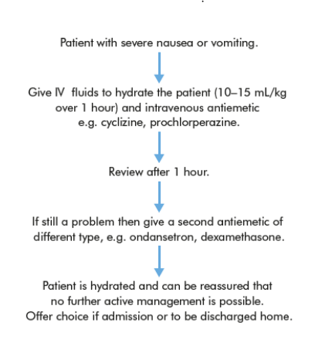

**Some of the most common surgical operations done in the**

**Day case surgery:**

**apendisectomy.**

**Breast biopsy. ...**

**Carotid endarterectomy. ...**

**Cataract surgery. ...**

**Cesarean section (also called a c-section). ...**

**Cholecystectomy.**

**Debridement of wound, burn, or infection.**

**Abscess.**