GENERAL ANATOMY Dr.ALI SALMAN

LEC.12 2ND Y.

The neck

Overview

The neck is the area of the body between the base of the cranium superiorly and the suprasternal notch and the clavicles inferiorly. The neck joins the head to the trunkand limbs, serving as a major conduit for structures passing between them. Many important structures are crowded together in the neck, such as muscles, arteries, veins, nerves, lymphatics, thyroid and parathyroid glands, trachea, larynx, esophagus, and vertebrae.

Carotid/jugular blood vessels are the major structures commonly injured in

penetrating wounds of the neck. The brachial plexuses of nerves originate in the neck and pass inferolaterally to enter the axillae and continue to supply the upper limbs.

Lymph from structures in the head and neck drains into cervical lymph nodes.

**Skin of the Neck**

The natural lines of cleavage of the skin (Wrinkle lines) are constant and run almost horizontally around the neck. This is important clinically because an incision along a cleavage line will heal as a narrow scar, whereas one that crosses the lines will heal as a wide or heaped-up scar.

**Fasciae of the Neck**

The neck is surrounded by a superficial cervical fascia that lies deep to the skin and

invests the platysma muscle (a muscle of facial expression). A second deep cervical fascia tightly invests the neck structures and is divided into three layers.

• Superficial Cervical Fascia

The superficial fascia of the neck forms a thin layer that encloses the platysma muscle.

Also embedded in it are the cutaneous nerves, the superficial veins, and the

superficial lymph nodes.

2

➢ Platysma

The platysma muscle is a thin but clinically important muscular sheet embedded in the

superficial fascia. It is described in Table 1.

➢ Cutaneous Nerves

The skin overlying the trapezius muscle on the back of the neck and the scalp as high

as the vertex is supplied segmentally by posterior rami of cervical nerves C2-C5 (Fig.

1).

The greater occipital nerve is a branch of the posterior ramus of the 2nd cervical nerve

(C2). The 1st cervical nerve has no cutaneous branch. The skin of the front and sides of

the neck is supplied by anterior rami of cervical nerves (C2-C4) through branches of

the cervical plexus. The branches emerge from beneath the posterior border of the

sternocleidomastoid (SCM) muscle (Fig. 1).

The lesser occipital nerve (C2) hooks around the accessory nerve and ascends along

the posterior border of the sternocleidomastoid muscle to supply the skin over the

lateral part of the occipital region and the medial surface of the auricle (Fig. 1).

The great auricular nerve (C2, 3) ascends across the sternocleidomastoid muscle and

divides into branches that supply the skin over the angle of the mandible, the parotid

gland, and on both surfaces of the auricle (Fig. 1).

The transverse cutaneous nerve (C2, 3) emerges from behind the middle of the

posterior border of the sternocleidomastoid muscle. It passes forward across that

muscle and divides into branches that supply the skin on the anterior and lateral

surfaces of the neck, from the body of the mandible to the sternum (Fig. 1).

The supraclavicular nerves (C3, 4) emerge from beneath the posterior border of the

sternocleidomastoid muscle and descend across the side of the neck. They pass onto

the chest wall and shoulder region, down to the level of the second rib (Fig. 1).

✓ The medial supraclavicular nerve crosses the medial end of the clavicle and

supplies the skin as far as the median plane.

✓ The intermediate supraclavicular nerve crosses the middle of the clavicle and

supplies the skin of the chest wall.

✓ The lateral supraclavicular nerve crosses the lateral end of the clavicle and

supplies the skin over the shoulder and the upper half of the deltoid muscle; this

nerve also supplies the posterior aspect of the shoulder as far down as the spine of

the scapula.

➢ Superficial Veins

External Jugular Vein

The external jugular vein begins just behind the angle of the mandible by the union of

the posterior auricular vein with the posterior division of the retromandibular vein (Fig.

2). It descends obliquely across the sternocleidomastoid muscle and, just above the

clavicle in the posterior triangle, pierces the deep fascia and drains into the subclavian

vein. It varies considerably in size, and its course extends from the angle of the

mandible to the middle of the clavicle.

Tributaries:

The external jugular vein (Fig. 2) has the following tributaries:

✓ Posterior auricular vein.

✓ Posterior division of the retromandibular vein.

✓ Posterior external jugular vein, a small vein that drains the posterior part of the

scalp and neck and joins the external jugular vein about halfway along its course.

✓ Transverse cervical vein.

✓ Suprascapular vein.

✓ Anterior jugular vein.

4

Anterior Jugular Vein

The anterior jugular vein begins just below the chin, by the union of several small veins

(Fig. 2). It runs down the neck close to the midline. Just above the suprasternal notch,

the veins of the two sides are united by a transverse trunk called the jugular arch. The

vein then turns sharply laterally and passes deep to the sternocleidomastoid muscle to

drain into the external jugular vein.

FIGURE 2: Major superficial veins of the face and neck.

➢ Superficial Lymph Nodes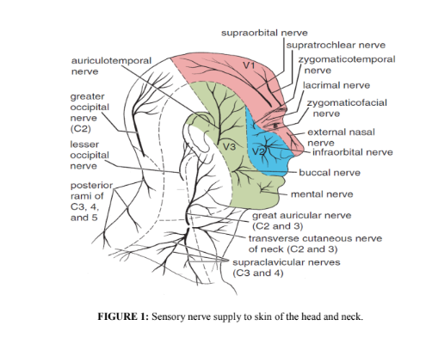

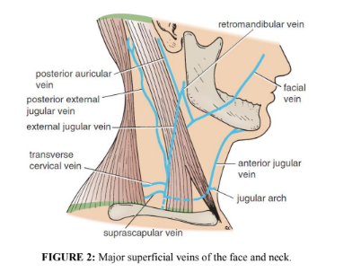

➢ Superficial Lymph Nodes

The superficial cervical lymph nodes lie along the external jugular vein superficial to

the sternocleidomastoid muscle. They receive lymph vessels from the occipital and

mastoid lymph nodes and drain into the deep cervical lymph nodes.

• Deep Cervical Fascia

The deep cervical fascia supports the muscles, the vessels, and the viscera of the neck.

In certain areas, it is condensed to form well-defined, fibrous sheets called the

investing layer, the pretracheal layer, and the prevertebral layer.

✓ Investing Layer

The investing layer is a thick layer that encircles the neck. It splits to enclose the

trapezius and the sternocleidomastoid muscles (Fig. 3; red fascia, Fig. 4).

5

✓ Pretracheal (visceral) Layer

The pretracheal layer is a thin layer that is attached above to the laryngeal cartilages

(Fig. 3). It surrounds the thyroid, the parathyroid glands, trachea, esophagus, and

the infrahyoid muscles. Posteriorly called the buccopharyngeal fascia because it

covers the buccinator and pharyngeal constrictor muscles (purple, blue, and green

fasciae, Fig. 4).

✓ Prevertebral Layer

The prevertebral layer is a thick tubular sheath, passes behind the pharynx and the

esophagus (Fig. 3), which invests the prevertebral muscles and vertebral column;

including the alar fascia anteriorly (orange fascia, Fig. 4). It extends laterally over

the first rib into the axilla to form the important axillary sheath.

❖ Carotid Sheath

The carotid sheath is a local condensation of the three layers (investing, pretracheal

and prevertebral) of the deep fascia that surround the common carotid arteries, the

internal jugular vein, the vagus nerve, and the deep cervical lymph nodes (Fig. 3).

❖ Axillary Sheath

As the subclavian artery and the brachial plexus emerge in the interval between the

scalenus anterior and the scalenus medius muscles, they carry with them a sheath of

the fascia, which extends into the axilla and is called the axillary sheath.

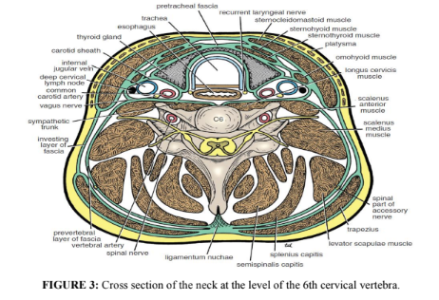

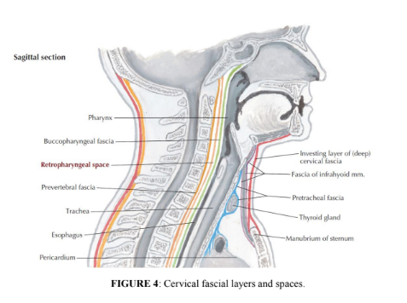

Cervical Ligaments

✓ Stylohyoid ligament: Connects the styloid process to the lesser cornu of the hyoid

bone.

✓ Stylomandibular ligament: Connects the styloid process to the angle of the

mandible.

✓ Sphenomandibular ligament: Connects the spine of the sphenoid bone to the

lingula of the mandible.

✓ Pterygomandibular ligament: Connects the hamular process of the medial

pterygoid plate to the posterior end of the mylohyoid line of the mandible. It gives

attachment to the superior constrictor and the buccinator muscles.

Muscles of the Neck

The superficial muscles of the side of the neck are described in Table 1 (Fig. 5). The

suprahyoid muscles raise the hyoid bone toward a stabilized mandible during

swallowing. The infrahyoid muscles depress the hyoid bone and larynx during

swallowing and vocalization. The suprahyoid, infrahyoid, anterior and lateral vertebral

muscles are also described in Table 1.

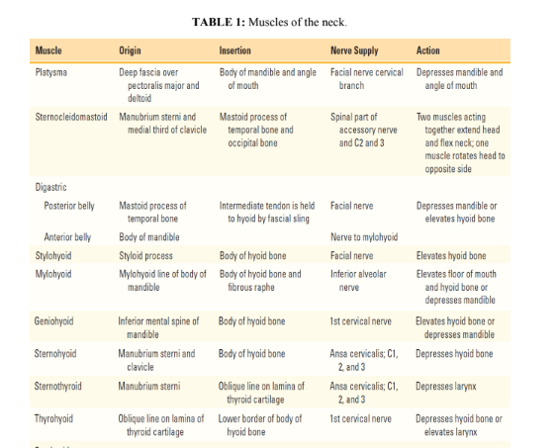

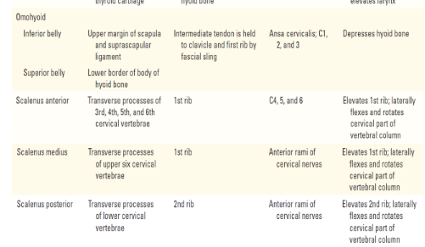

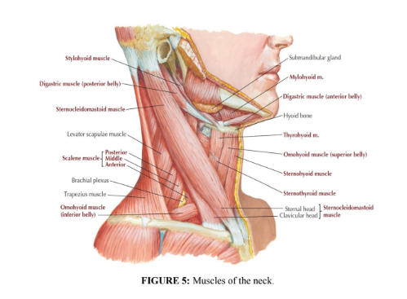

❖ Cervical Plexus

The (spinal) accessory nerve (CN XI) exits the jugular foramen and crosses the

posterior triangle, innervating the SCM and trapezius muscles (Fig. 6). However, the

cervical plexus, composed of the ventral rami of C1-C4, innervates most of the neck

muscles and provides sensory innervation to the anterior and lateral neck (Table 2).

Additional innervation includes:

• The mylohyoid nerve (CN V3) innervates the mylohyoid muscle and anterior belly

of the digastric muscle beneath the chin.

• The facial nerve (CN VII) innervates the platysma muscle through its cervical

branch.

• The glossopharyngeal nerve (CN IX) supplies the carotid body and sinus (visceral

sensory).

• The vagus nerve (CN X) supplies the larynx through its superior and recurrent

(inferior) laryngeal nerves.

• The hypoglossal nerve (CN XII) loops through the neck to innervate the tongue.

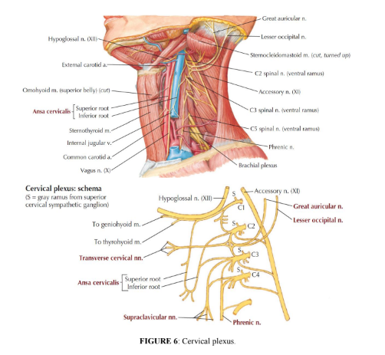

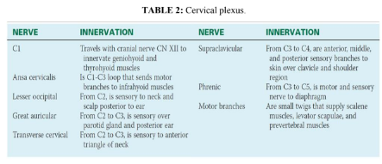

Bones of Neck

The skeleton of the neck is formed by the cervical vertebrae, hyoid bone, manubrium

of the sternum, and clavicles. These bones are parts of the axial skeleton except the

clavicles, which are part of the appendicular skeleton.

Blood Supply

The arterial supply to the neck is by the subclavian artery and some of the branches

of the external carotid artery, a branch of the common carotid artery.

Key Neck Muscles

The sternocleidomastoid muscle (Fig. 5) divides the neck into two major triangles, the

anterior and posterior triangles. The anterior border covers the carotid arteries, the

internal jugular vein, and the deep cervical lymph nodes; it also overlaps the thyroid

gland. The muscle is covered superficially by skin, fascia, the platysma muscle, and

the external jugular vein. The deep surface of the posterior border is related to the

cervical plexus of nerves, the phrenic nerve, and the upper part of the brachial plexus.

The origin, insertion, nerve supply, and action of the sternocleidomastoid muscle are

summarized in Table 1.

11

References

1. Snell RS. Clinical Anatomy by Regions. 9th edition. Philadelphia, PA:

Lippincott Williams & Wilkins, 2012.

2. Keith LM: Clinically Oriented Anatomy, 7th edition. Wolters Kluwer, 2014.

3. Hansen JT: Netter's Clinical Anatomy, 3rd edition. E-Book with Online Access.

Elsevier Health Sciences, 2014.