Renal Failure Physiology

Renal failure, also known as kidney failure, occurs when the kidneys lose their ability to filter waste and excess fluids from the blood. This can lead to a buildup of toxins in the body, causing a range of symptoms and complications.

Normal Kidney Function

The kidneys play a crucial role in maintaining homeostasis by:

- 1-Filtering waste products, such as urea, creatinine, and other toxins, from the blood

- 2-Regulating electrolytes, such as sodium, potassium, and calcium, in the body

- 3-Maintaining acid-base balance by adjusting the levels of hydrogen ions

- 4-Producing hormones, such as erythropoietin, which stimulates red blood cell production

Pathophysiology of Renal Failure:

Renal failure occurs when the kidneys are damaged or diseased, leading to a decline in their ability to perform their normal functions. This can be caused by

Pre –renal:

Decrease blood flow to the kidney. e.g.( shock)

Renal:

Damage to nephrons, the functional units of the kidney

- Inflammation and scarring in the kidney

Post renal:

Obstruction of the urinary tract(e.g. tumor in bladder)

Stages of Renal Failure :

Acute Kidney Injury (AK)::

sudden loss of kidney function, often caused by medications, toxins, or medical conditions

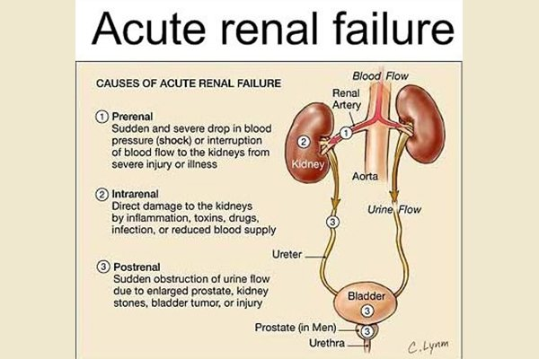

.

chronic Kidney Disease (CKD):

A gradual loss of kidney function over time, often caused by diabetes, hypertension, or other conditions.

End-Stage Renal Disease (ESRD)

The final stage of renal failure, where the kidneys are no longer able to function and dialysis or transplantation is required.

Physiological Consequences:

Renal failure can lead to a range of physiological consequences, including:

- Waste buildup: Accumulation of waste products in the blood, leading to uremia

Electrolyte imbalances: Disruptions in electrolyte balances, which can lead to muscle weakness, arrhythmias, and other complications

Fluid overload: Accumulation of excess fluids in the body, leading to edema, hypertension, and other complications

Anemia: Decreased production of erythropoietin, leading to anemia

Treatment

Treatment for renal failure depends on the underlying cause and stage of the disease.

Options may include:

Medications: To manage symptoms and slow disease progression

Dialysis: To remove waste products and excess fluids from the blood

Kidney transplantation: To replace a damaged or diseased kidney with a healthy one

Key Concepts

Renal failure occurs when the kidneys lose their ability to filter waste and excess fluids from the blood

The kidneys play a crucial role in maintaining homeostasis

Renal failure can lead to a range of physiological consequences, including waste buildup, electrolyte imbalances, fluid overload, and anemia

Treatment options include medications, dialysis, and kidney transplantation