2-Ac Bridge and Their Application: The ac bridge is a natural outgrowth of the dc bridge and in its basic form consists of four bridge arms, a source of excitation, and a null ac detector. For measurements at low frequencies, the power line may serve as the source of excitation; but at higher frequencies an oscillator generally supplies the excitation voltage. The null ac detector in its cheapest effective form consists of a pair of headphones or may be oscilloscope. The balance condition is reached when the detector response is zero or indicates null.

Then VAC = 0 and VZ1 = VZ2

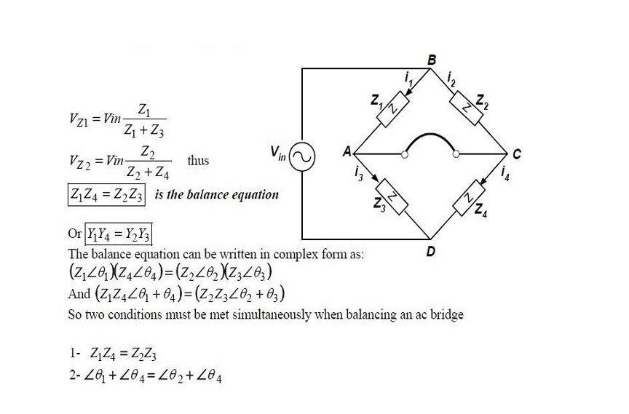

#### Review on AC Impedance

Alternating Current (AC) Impedance, denoted by ‘Z’, represents the opposition to the flow of AC current in an electrical circuit.

It’s a complex value comprised of real and imaginary parts, namely resistance ‘R’ and reactance ‘X’, respectively.

The AC impedance formula is represented as:

Z = R + j X

where:

‘**Z**’ is the total impedance of the circuit,

‘**R**’ is the resistive (real) component, and

‘**X**’ is the reactive (imaginary) component. Here, ‘j’ represents the imaginary unit in electrical engineering, equivalent to the square root of -1.

Furthermore, in AC circuits involving inductors and capacitors, the reactive component can be broken down into inductive reactance (XL) and capacitive reactance (XC).

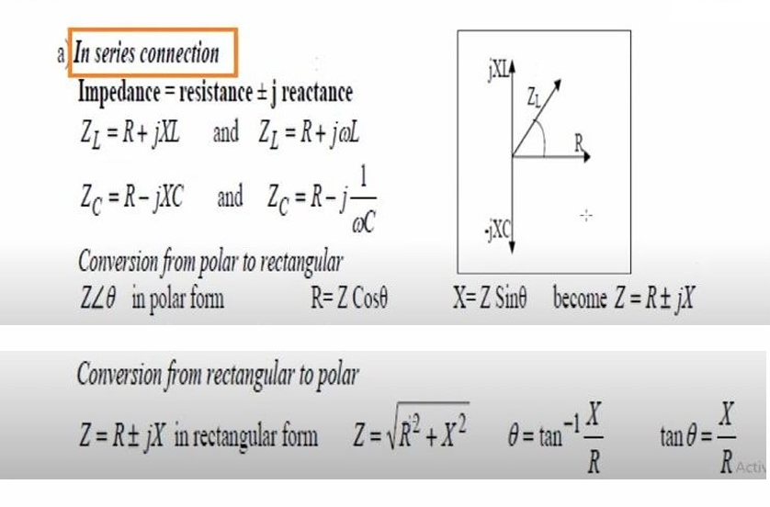

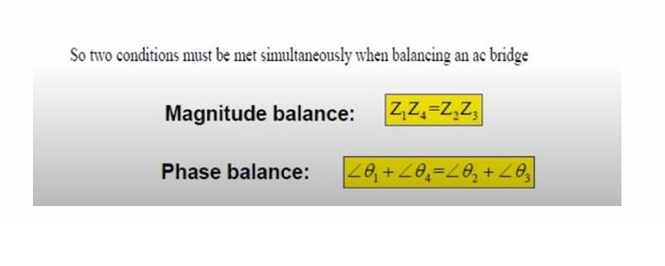

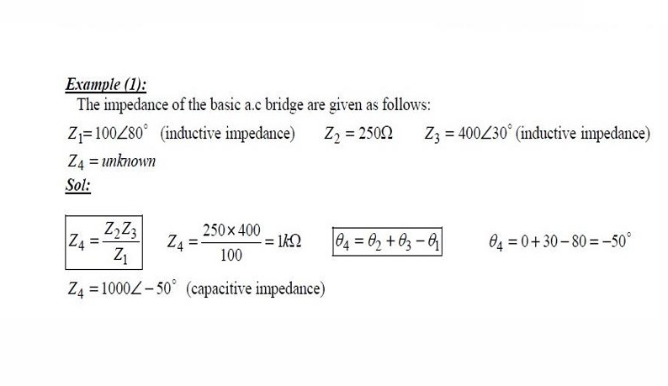

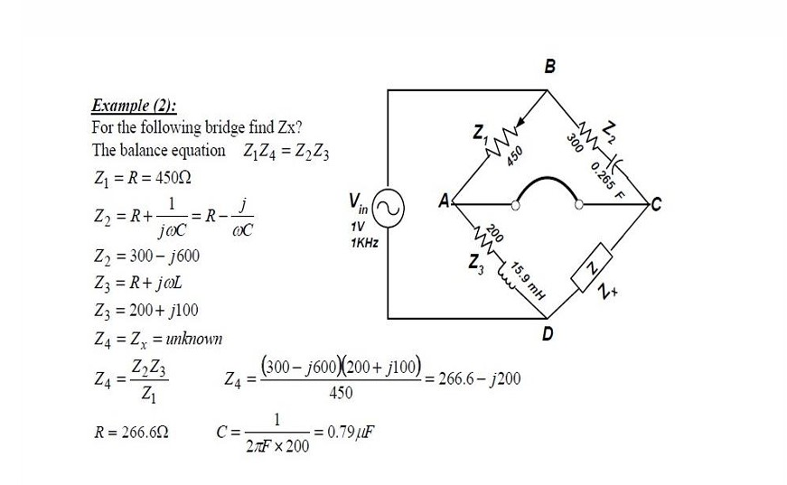

**Comparison Bridge:**

**There are two types of Comparison Bridge, Namely**

**1. Capacitance Comparison Bridge**

**2. Inductance Comparison Bridge**

1. **Capacitance Comparison Bridge:**

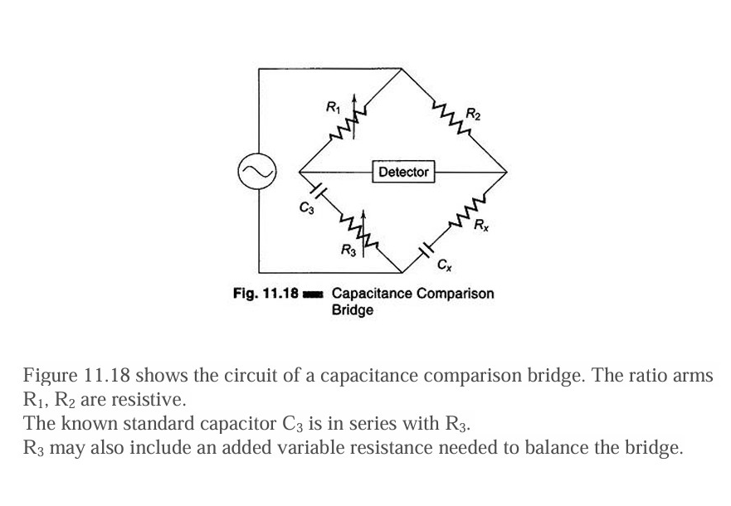

**Cx is the unknown capacitor and Rx is the small leakage resistance of the capacitor. In this case an unknown capacitor is compared with a standard capacitor and the value of the former, along with its leakage resistance, is obtained. Hence.**

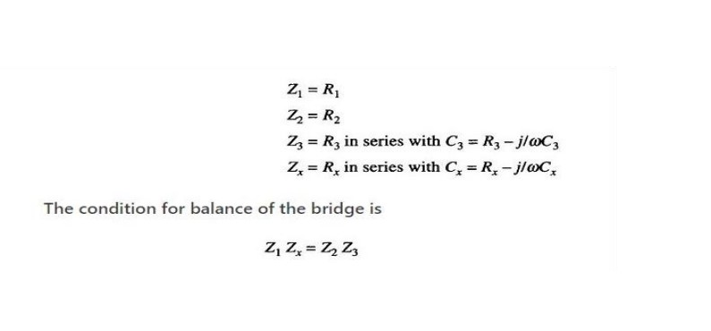

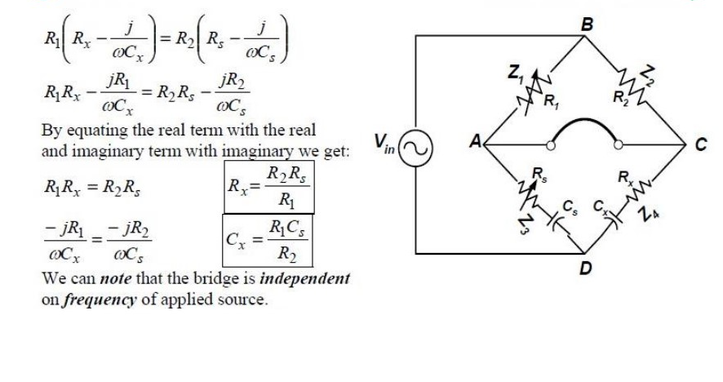

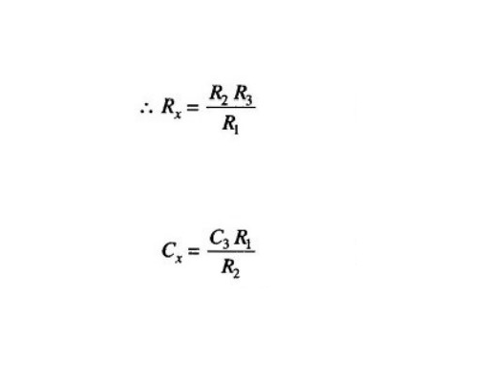

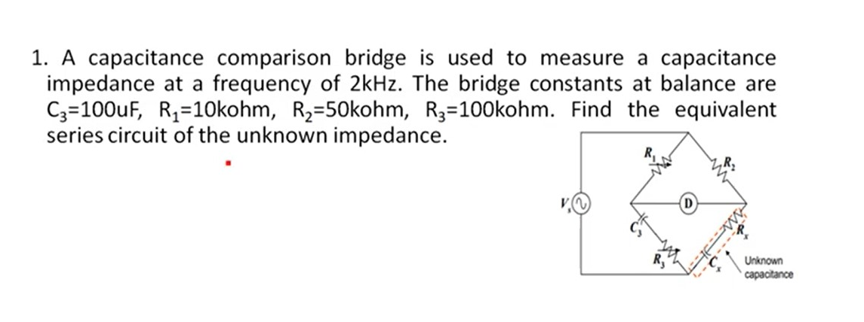

**2.Inductance Comparison Bridge:**

**Figure 11.20 gives a schematic diagram of an inductance comparison**

**bridges. In this, values of the unknown inductance Lx and its internal**

**resistance Rx are obtained by comparison with the standard inductor and**

**resistance, i.e. L3 and R3**

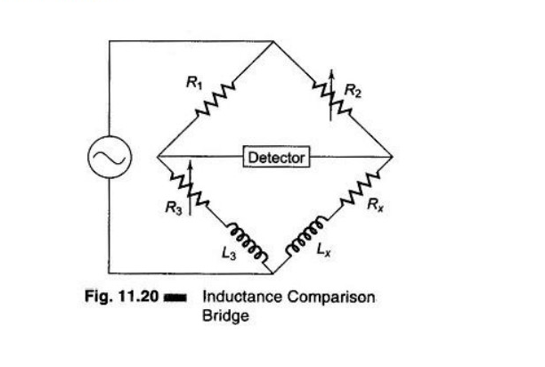

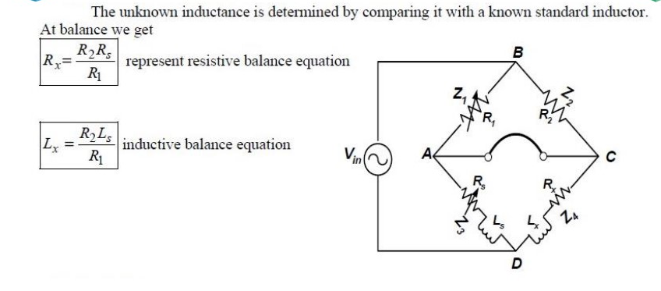

2\An **Inductance Comparison Bridge** is used to measure an **unknown inductive impedance** at a frequency of **3 kHz**. The bridge constants at balance are:

* **L₃ = 50 mH**
* **R₁ = 5 kΩ**
* **R₂ = 20 kΩ**
* **R₃ = 40 kΩ**

Find the **equivalent series circuit** of the unknown impedance.

### **Required:**

Determine the equivalent series values of the **unknown inductor**:

* **Lₓ (unknown inductance)**
* **Rₓ (series resistance of the unknown inductor)**

