

**Computer Fundamentals**

**Lecture 4**

**Input and output devices**

# What Is Input?

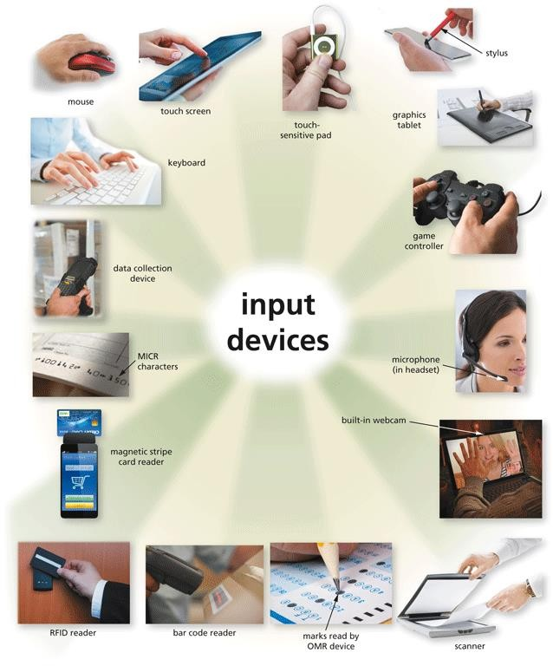

* **Input** refers to any data and instructions entered into the memory of a computer.

Commonly used input methods include:



What Is Input?



Keyboard

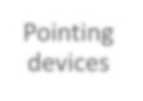

Pointing

devices



Touch screens



Pen input



Motion input



Voice input



Video input

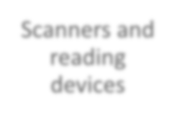

Scanners and reading devices

A **keyboard** is an input device that contains keys users press to enter



Keyboards

data and instructions into a computer or mobile device

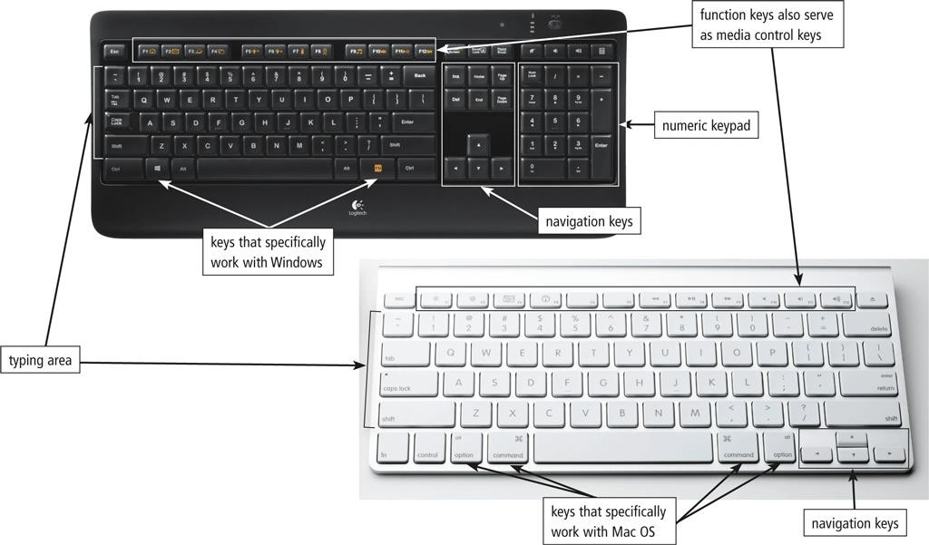

Most desktop computer keyboards have…



Keyboards

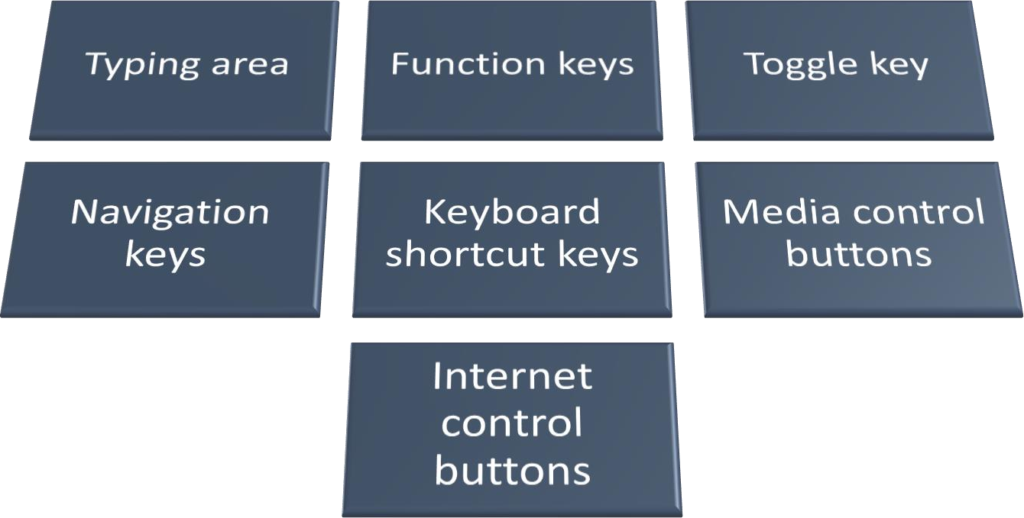

There are a variety of keyboard options for computers and mobile devices



Keyboards

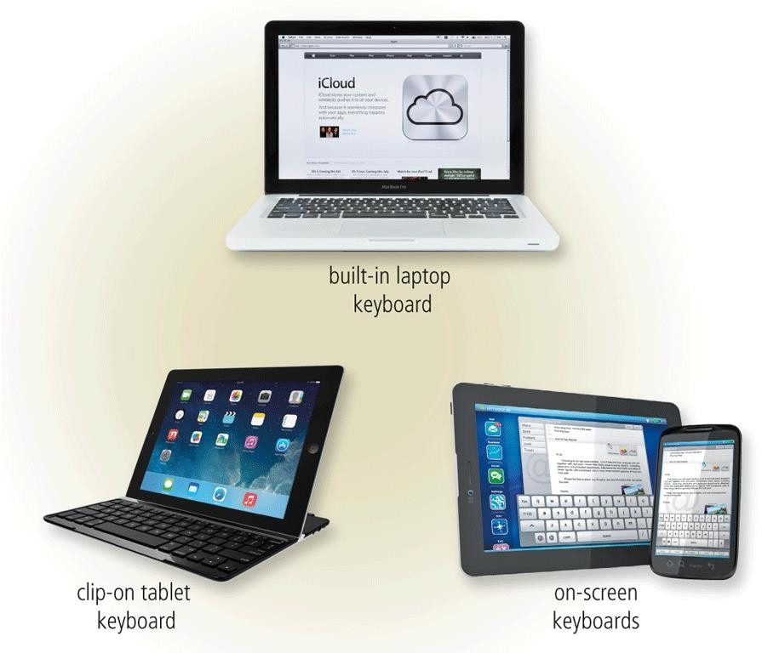

An ergonomic keyboard has a design that reduces the chance of repetitive strain injuries of wrist and hand



Keyboards

Ergonomics incorporates comfort, efficiency, and safety in the design of the workplace

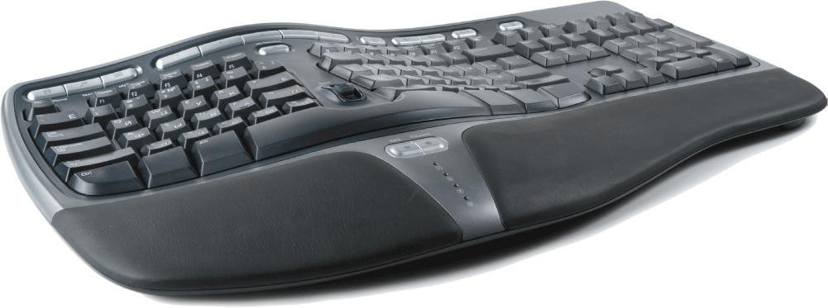



Pointing Devices

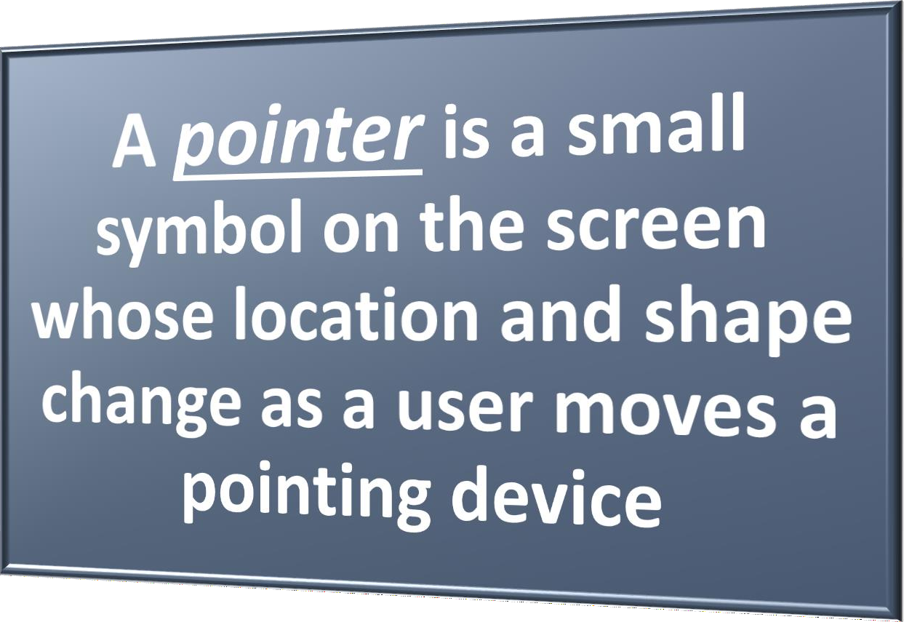

A **mouse** is a pointing device that fits under the palm of your hand comfortably



Pointing Devices

* Optical mouse, laser mouse, and touch mouse

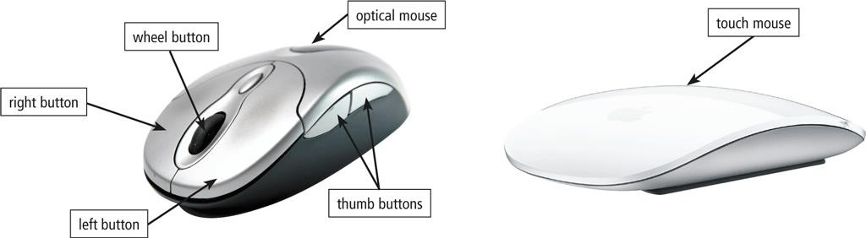

# Pointing Devices

* + A **touchpad** is a small, flat, rectangular pointing device that is sensitive to pressure and motion

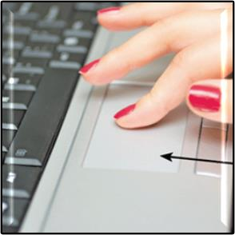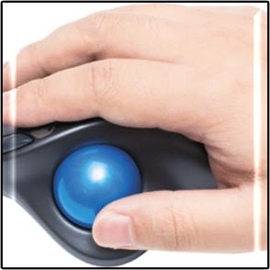

Touchpad

Trackball

* + A **trackball** is a stationary pointing device with a ball on its top or side

A **touch screen** is a touch-sensitive display



Touch Screens

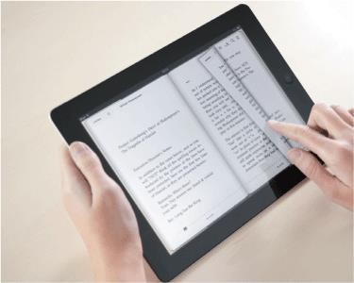

With **pen input**, you touch a **stylus** or **digital pen** on a flat surface to write, draw, or make selections



Pen Input

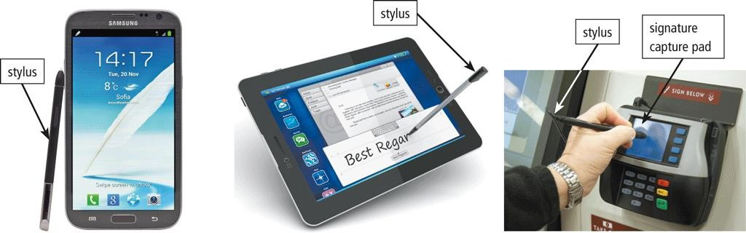

* 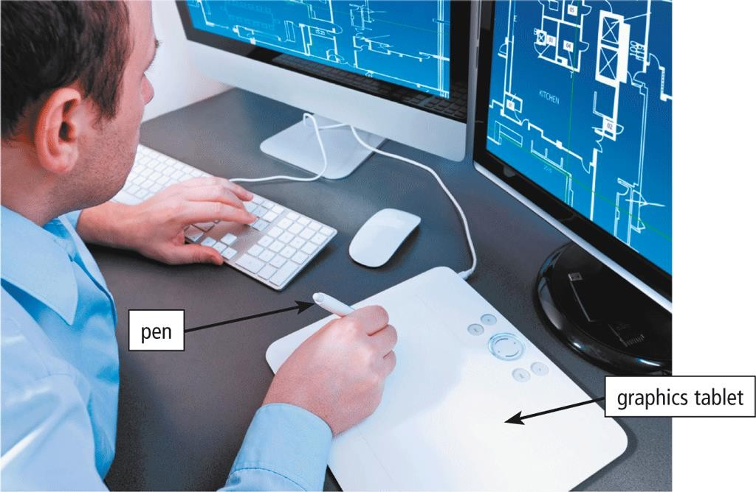A **graphics tablet**, also called a digitizer, is an electronic plastic board that detects and converts movements of a style or digital pen into signals that are sent to the computer



Pen Input

With motion input, sometimes called gesture recognition, users can guide on-screen elements using air gestures



Motion, Voice, and Video Input

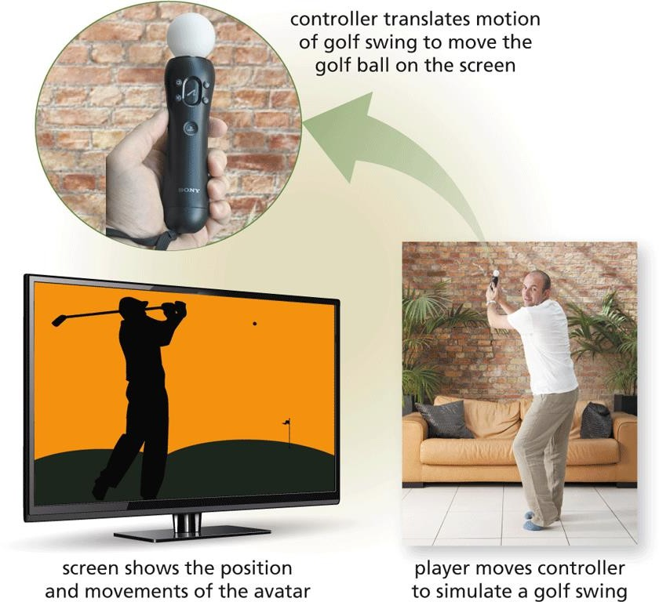

# Motion, Voice, and Video Input

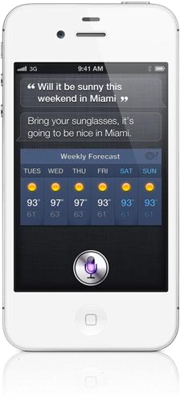

* Voice input is the process of entering input by speaking into a microphone
* **Voice recognition**, also called speech recognition, is the computer or mobile device’s capability of distinguishing spoken words

# Motion, Voice, and Video Input

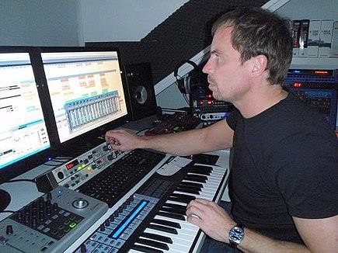

* Audio input is the process of entering any sound into the computer such as speech, music, and sound effects
* Music production software allows users to record, compose, mix, and edit music and sounds

Video input is the process of capturing full-motion images and storing



Motion, Voice, and Video Input

them on a computer or mobile device’s storage medium

Record video on a **digital video**

**(DV) camera**

Transfer video to a

computer or mobile device

A **webcam** is a type of DV camera that enables a user to:



Motion, Voice, and Video Input



Capture video and still images



Send email messages with video attachments



Broadcast live images or video over the Internet



Conduct videoconferences



Make **video calls**

A **videoconference** is a meeting that connects two or more people located in different geographic locations.



Motion, Voice, and Video Input

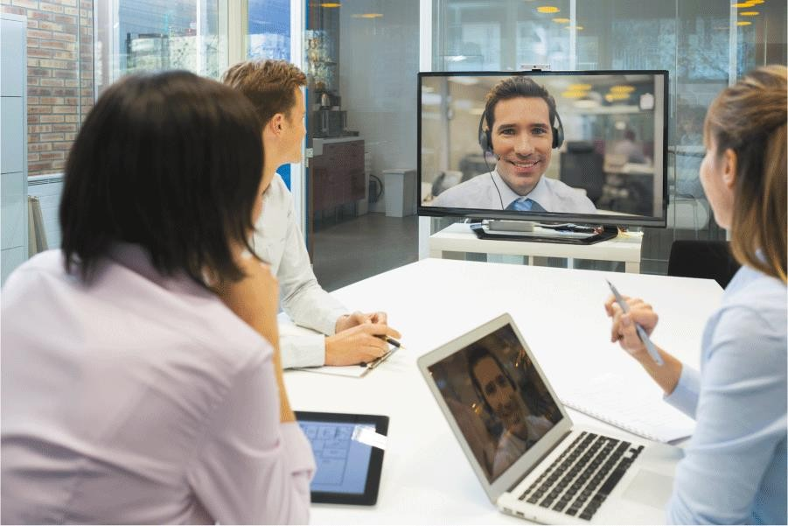

A **scanner** is a light-sensing input device that reads printed text and images and then converts the results into a form the computer can process



Scanners and Reading Devices

* Unlike a **copy machine**, a **flatbed scanner** creates a digital file of the document in memory instead of producing a physical paper copy.



Scanners and Reading Devices

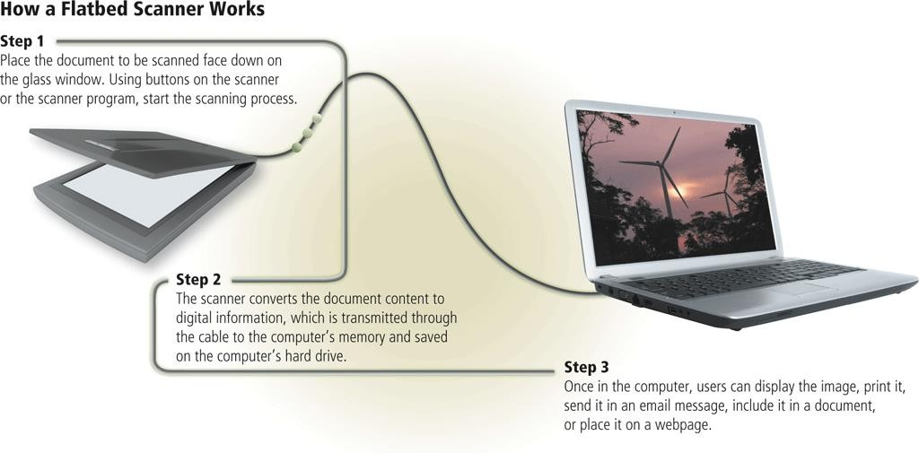

An **optical reader** is a device that uses a light source to scan characters, marks, and codes and then converts them into digital data that a computer can process



Scanners and Reading Devices

* **Optical character recognition (OCR)**
* **Optical mark recognition (OMR)**
  + 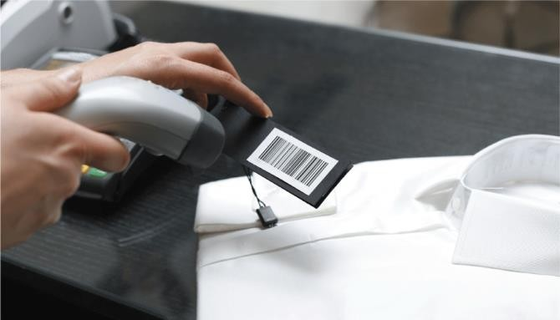A **bar code reader**, also called a bar code scanner uses laser beams to read **bar codes**



Scanners and Reading Devices

* + 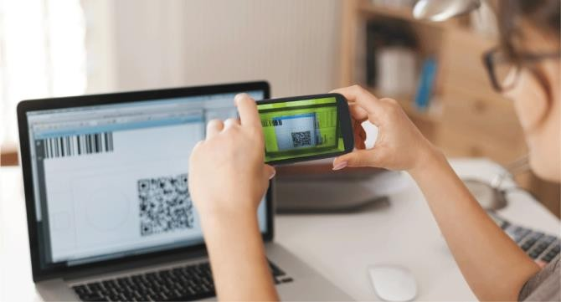A **QR code** stores information in both a vertical and horizontal direction

**RFID** (radio frequency identification) uses radio signals to



Scanners and Reading Devices

communicate with a tag placed in or attached to an object

An **RFID reader** reads information on the tag via radio waves RFID can track:



**Tracking times of runners in a marathon**



**Tracking location of people and other items**



**Checking lift**

**tickets of skiers**



**Managing**

**inventory**



**Gauging temperature and pressure of tires on a vehicle**



**Checking out library books**



**Providing access to rooms or buildings**



**Managing purchases**



**Tracking payment as vehicles pass through booths on tollway systems**

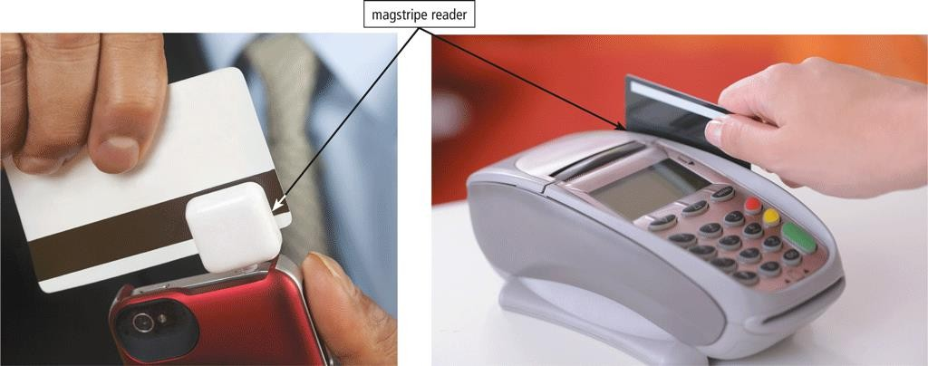**Magstripe readers** read the magnetic stripe on the back of cards such as:



Scanners and Reading Devices



Credit cards



Entertainment cards



Bank cards



Identification cards



Other similar cards

**MICR (magnetic ink character recognition)** devices read text printed



Scanners and Reading Devices

with magnetized ink

An MICR reader converts MICR characters into a form the computer can process

Banking industry uses MICR for check processing

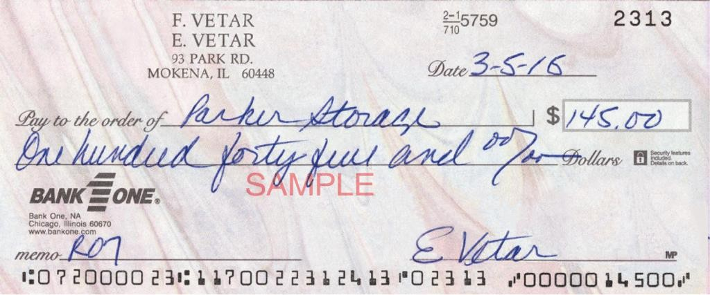

A **data collection device** obtains data directly at the location where the transaction or event takes place



Scanners and Reading Devices

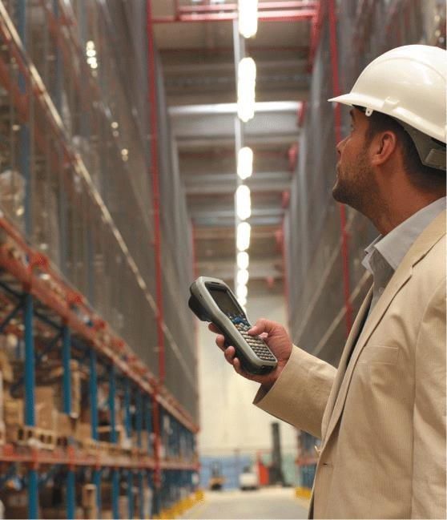

# What Is Output?

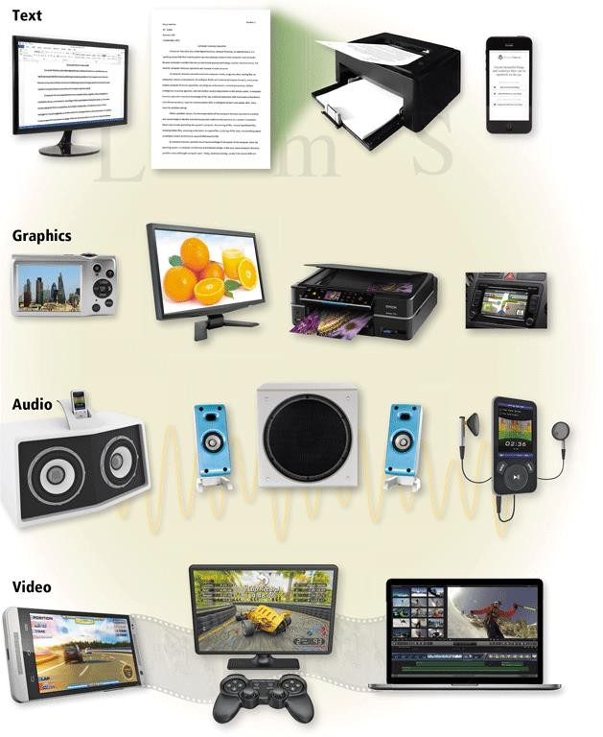

* **Output** is data that has been processed into a useful form

A **display** visually conveys text, graphics, and video information



Displays

A **monitor** is a display that is packaged as a separate peripheral device

* + 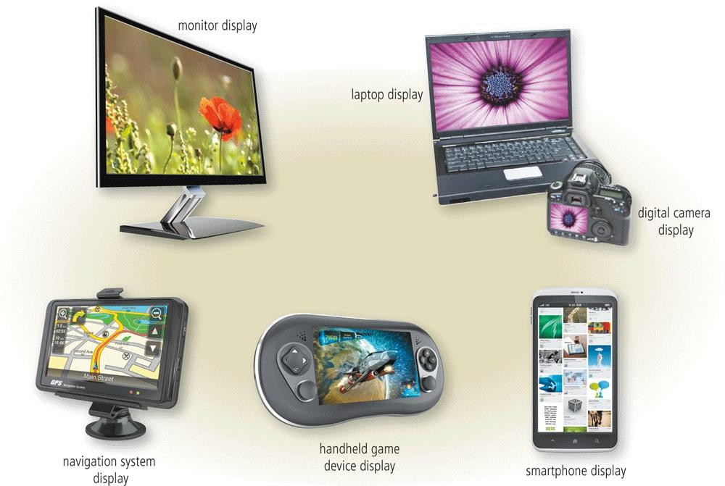**LCD** monitor

The quality of a display depends primarily on its:



Displays



**Resolution**



Response time



Brightness



Dot pitch



Contrast ratio

Today’s monitors use a digital signal to produce a picture



Displays

To display the highest quality images, the monitor should plug into:

* + A DVI port
  + An HDMI port
  + A DisplayPort
* 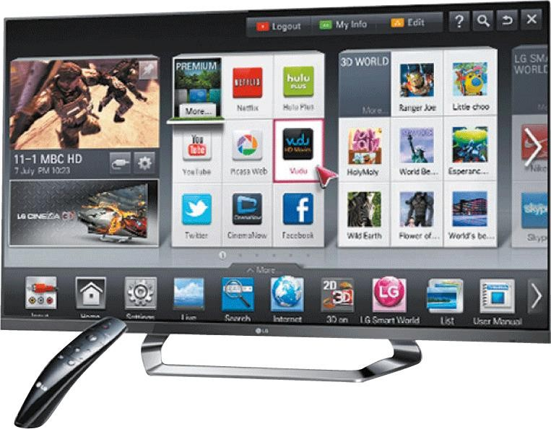Home users sometimes use a digital television (DTV) as a display



Displays

* **HDTV** is the most advanced form of digital television
* A Smart TV is an Internet-enabled HDTV

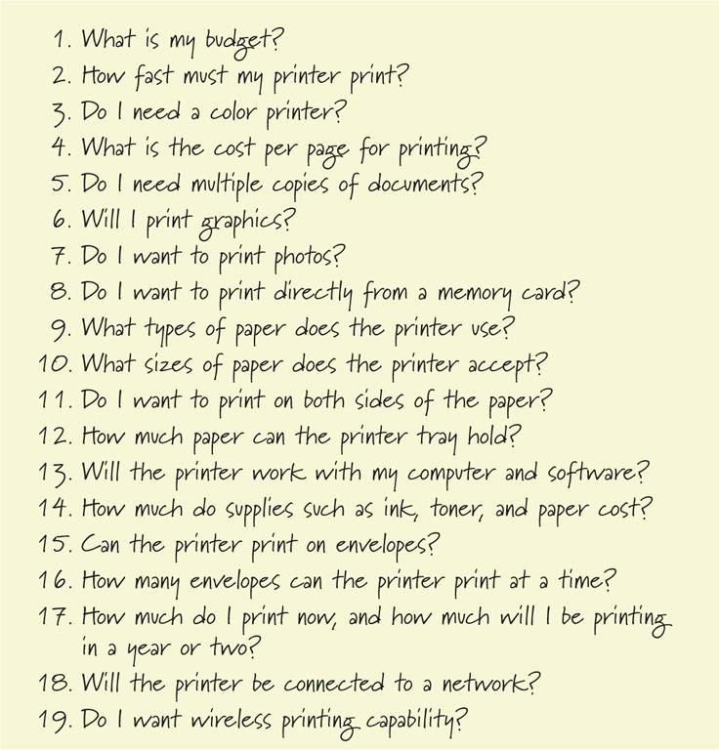

Printers

* A **printer**

produces text and graphics on a physical medium

* Before purchasing a printer, ask yourself a series of questions

A **nonimpact printer** forms characters and graphics on a piece of paper without actually contacting the paper



Printers



Ink-jet

printers



All-in-one

printers

Laser printers

Photo

printers



Thermal

printers

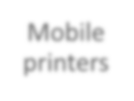

Mobile printers



Label printers



Large-format printers

Plotters

An **ink-jet printer** forms characters and graphics by spraying tiny drops of liquid ink onto a piece of paper



Printers

* + Color or black-and-white
  + Speed is measured by the number of pages per minute (ppm) it

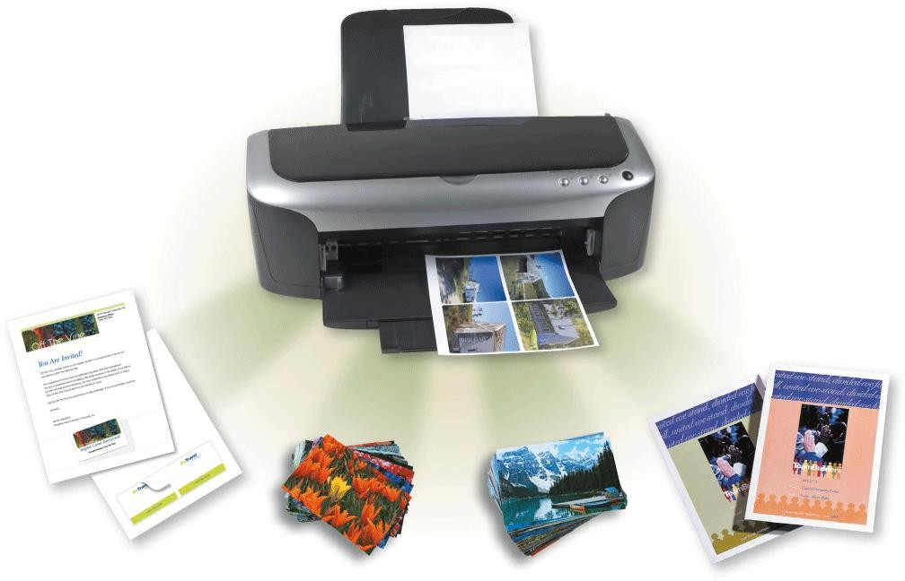can print

# Printers



A **photo printer** produces lab- quality photos

* Many use ink-jet technology
* PictBridge allows you to print photos directly from a digital camera
* Print from a memory card



Printers

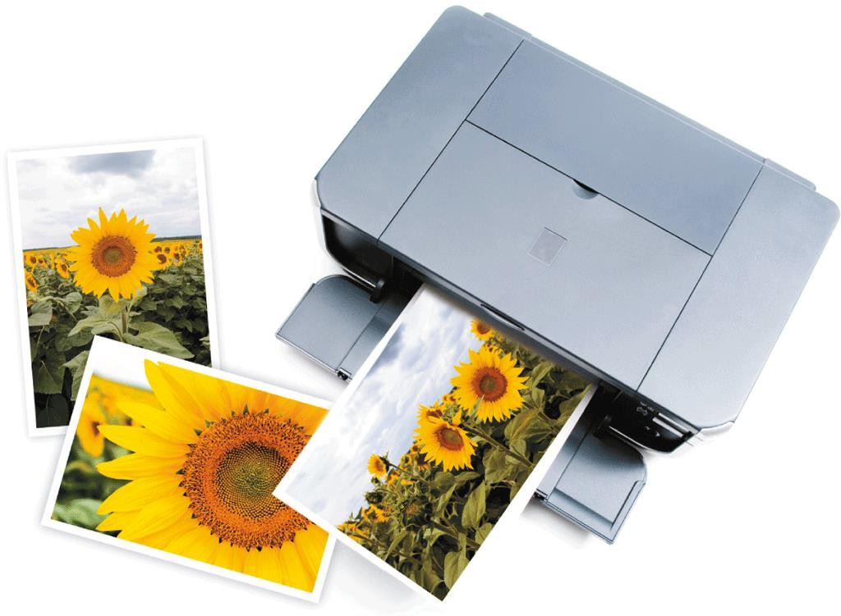



Printers

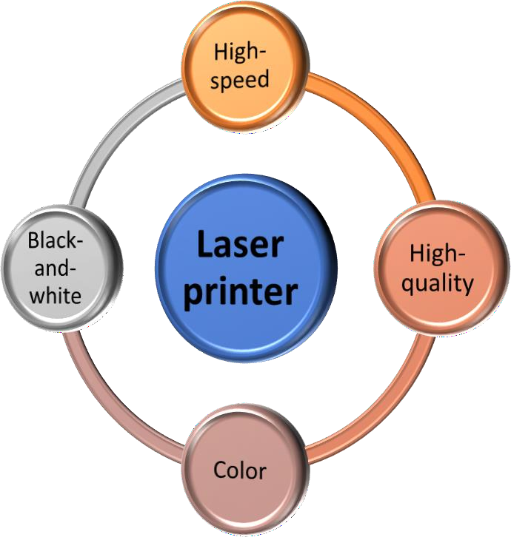 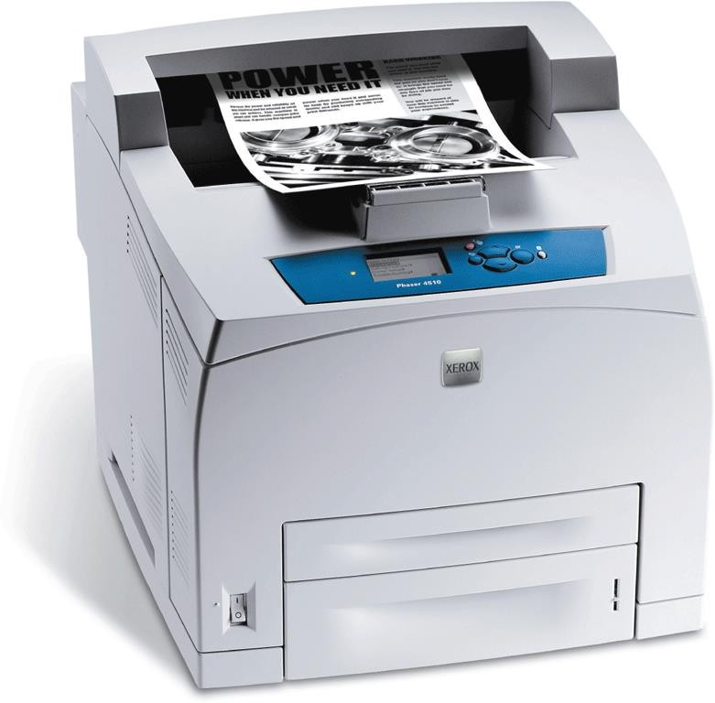

An **all-in-one printer** is a single device that prints, scans, copies, and in some cases, faxes



Printers

* + Also called a multifunction printer

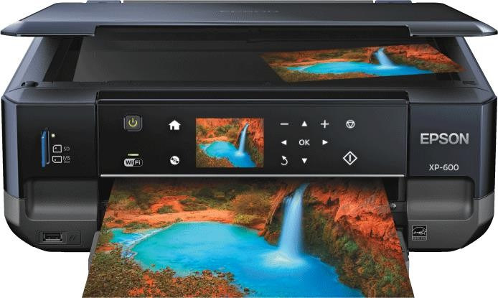

## A **3-D printer** uses a process called additive manufacturing to create an object by adding material to a three-dimensional object, one horizontal layer at a time



Printers

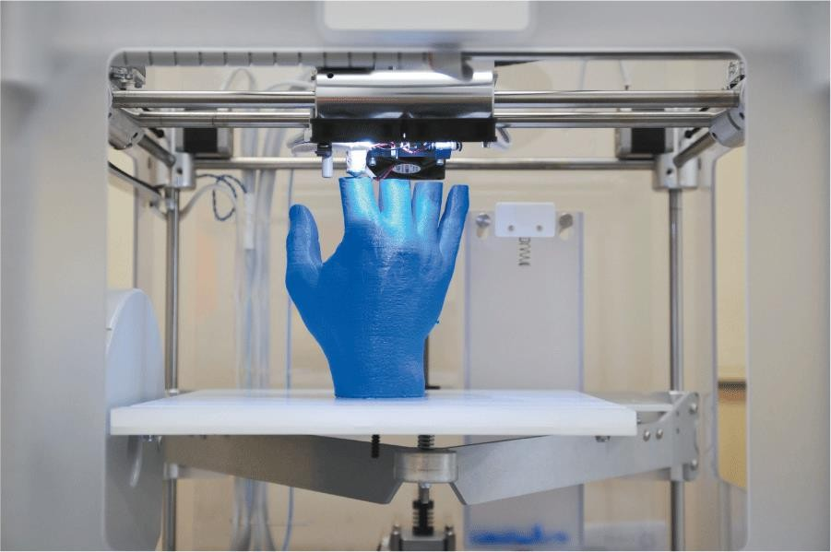

Al-Mustaqbal University, College of Engineering & **42**

# Printers



**43**

A **thermal printer** generates images by pushing electrically heated pins against the heat-sensitive paper

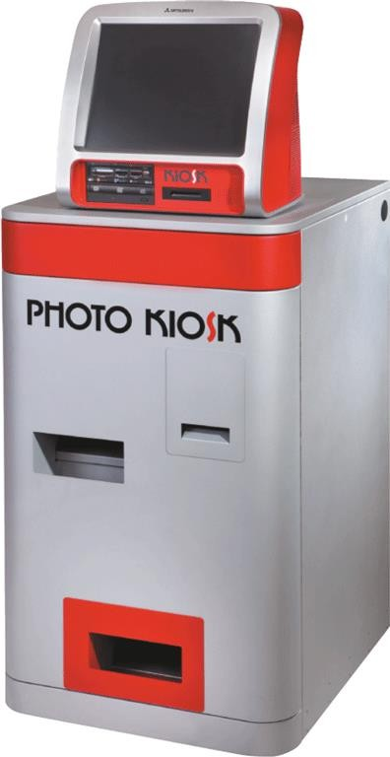

Dye- sublimation printer

Al-Mustaqbal University, College of Engineering &

## A **mobile printer** is a small, lightweight, battery-powered printer that allows a mobile user to print from a mobile device



Printers

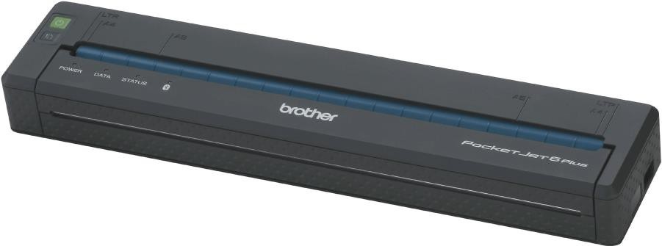

A **label printer** is a small printer that prints on an adhesive-type material that can be placed on a variety of items



Printers

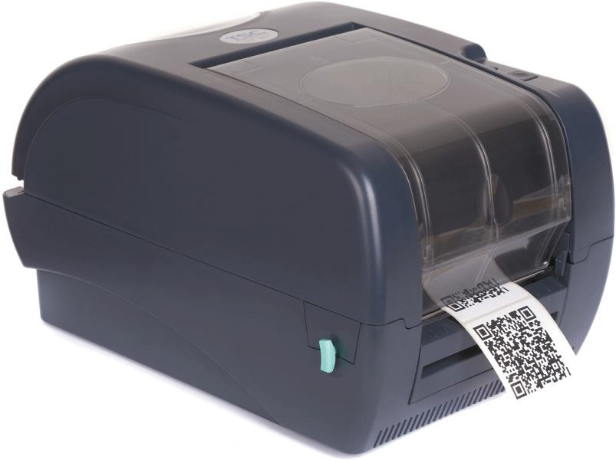

**Plotters** are used to produce high-quality drawings



Printers

**Large-format printers** create photo-realistic quality color prints

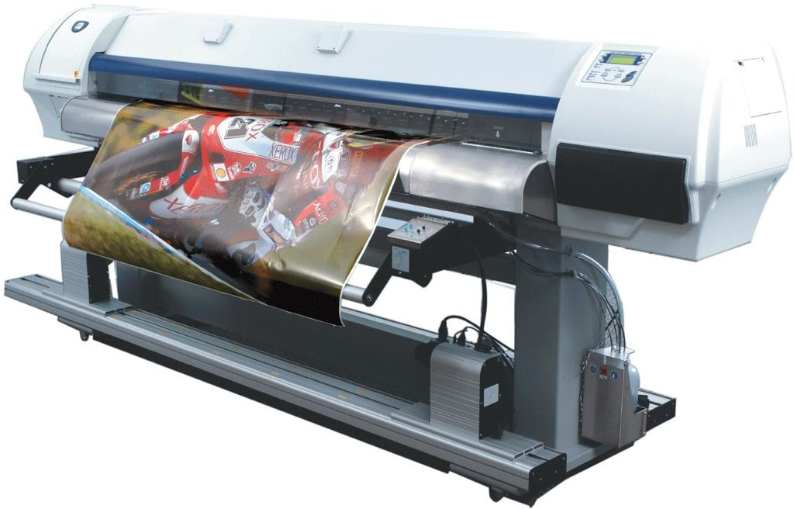

## **Impact printers** form characters and graphics on a piece of paper by striking a mechanism against an inked ribbon that physically contacts the paper



Printers

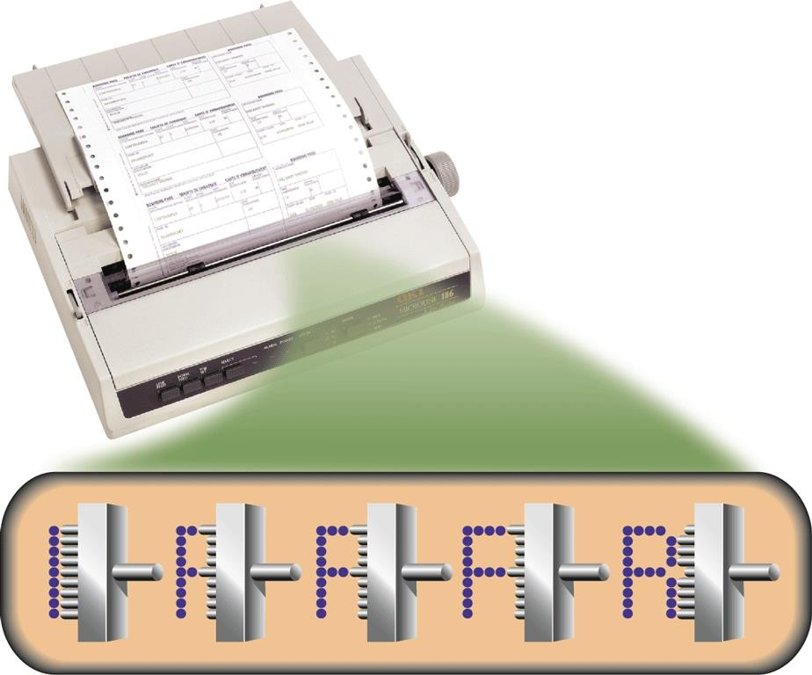

Many users attach surround sound **speakers** or speaker systems to their computers, game consoles, and mobile devices to generate higher-quality sounds



Other Output Devices

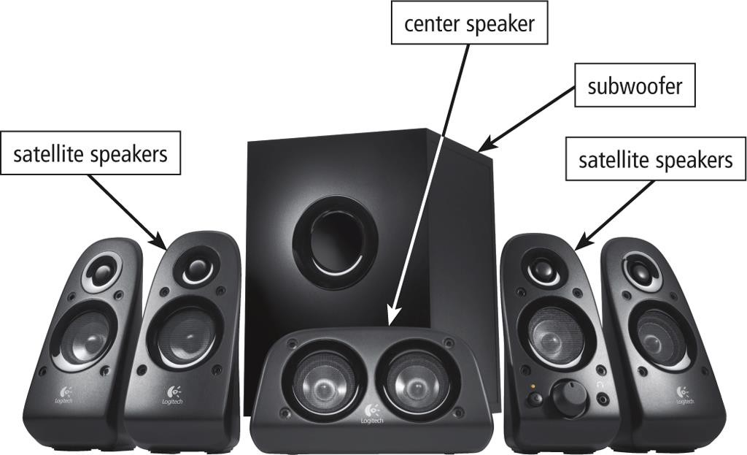

* 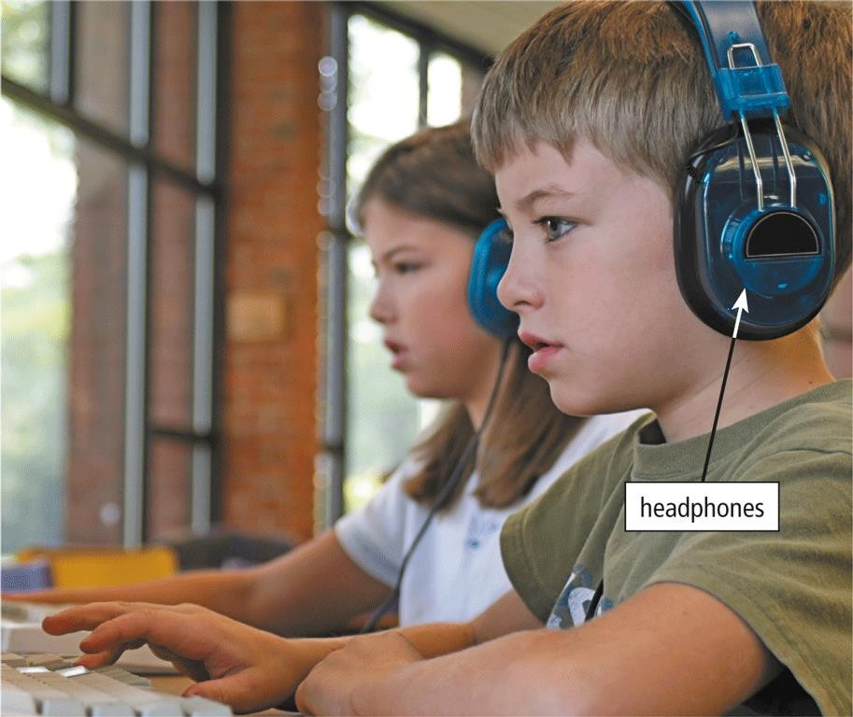**Headphones** are speakers that cover or are placed outside of the ear



Other Output Devices

* **Earbuds** (also called earphones) rest inside the ear canal
* 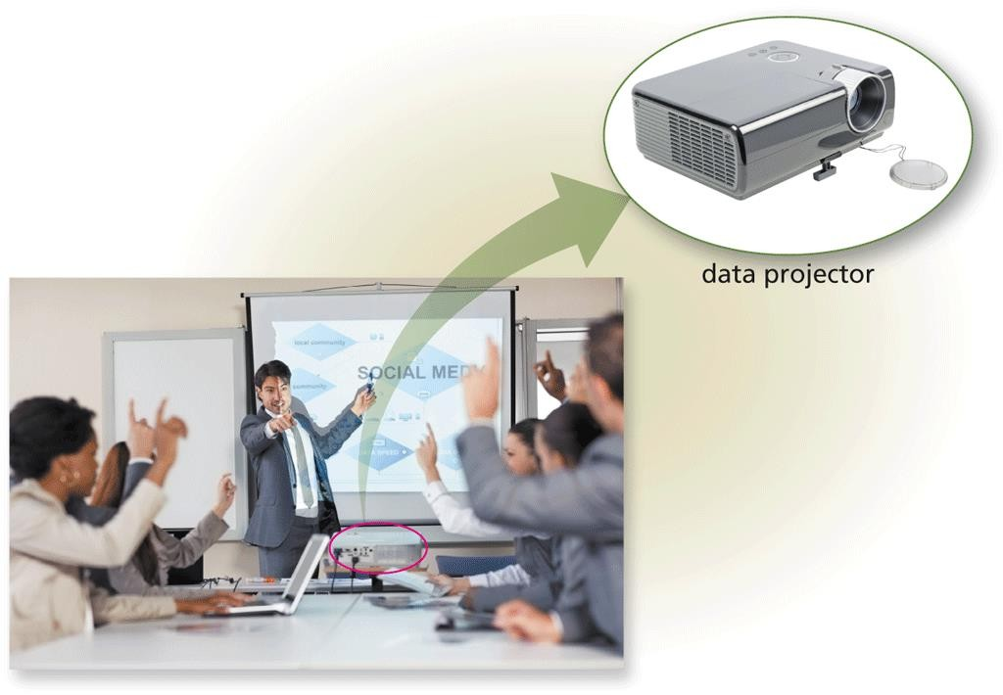A **data projector** is a device that projects the text and images displaying on a computer or mobile device screen on a larger screen so that an audience can see the image clearly



Other Output Devices

* 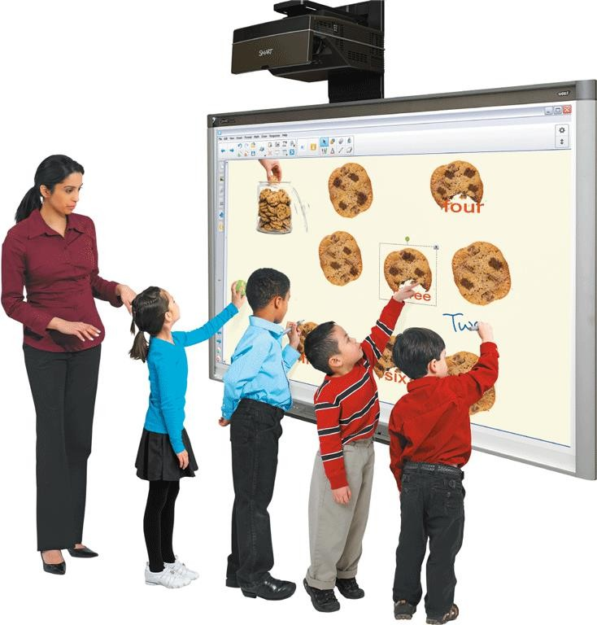An **interactive whiteboard** is a touch- sensitive device, resembling a dry-erase board, that displays the image on a connected computer screen



Other Output Devices

## Joysticks, wheels, gamepads, and motion-sensing game controllers can be considered output devices when they include force feedback



Other Output Devices

* + Technology that sends resistance to the device in response to

actions of the user

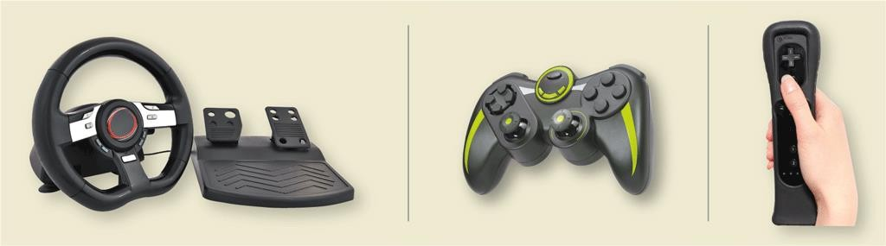

Assistive Technology Input and Output

**Head-mounted pointer Braille printer**

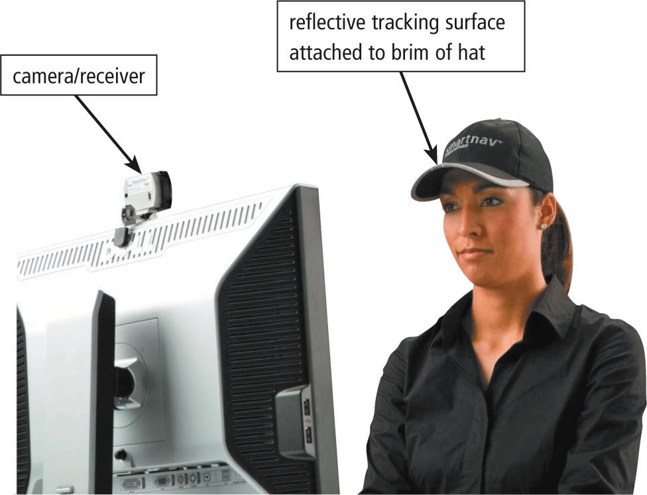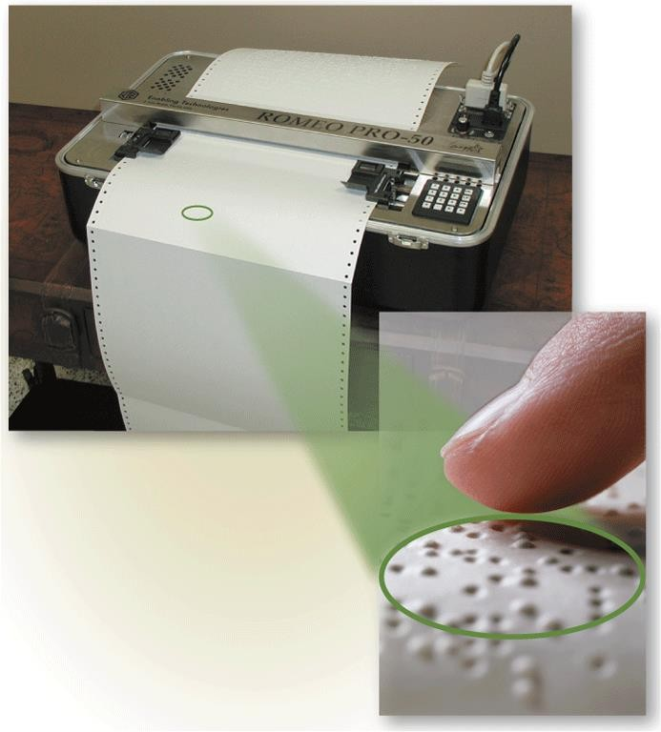

THANK YOU