

**Al-Mustaqbal University**  
**College of Education**  
**Department of English Language**  
**Subject: Reading**  
**Level: 1st Stage**

**التدريسي : م.م سجى زهير حامد** **اعداد**

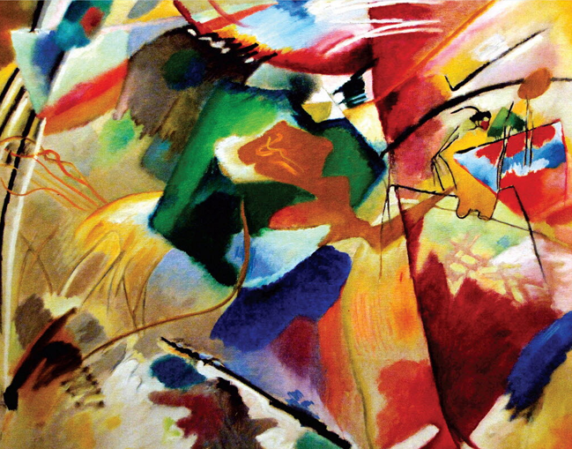 It's Not Always Black and White.

**Introduction:**

Have you ever noticed how colors are used in the English language? In English, many expressions include colors, but their meanings are not always about the actual color. These expressions can describe emotions, actions, or situations in fun and creative ways.

**Main Theme:**

The main theme is how colors in English expressions are used to show feelings, situations, or actions. Colors like red, blue, black, and white help people describe emotions and experiences in creative ways.

**Body :**

You can find the names of colors in a lot of English expressions. Many of these expressions, however, talk about colors in very different ways. For example, the expression black and white can have different meanings. If something is black and white, it means it is clear, easy to understand.

However, some people see everything in black and white, which means that they judge everything they see as either good or bad. Some people have to see something in black and white to know that it is true; this black and white talks about seeing something printed, as in a newspaper. If something is printed in a newspaper, it must be true, right

The color red is often used to talk about things that are hot or exciting. You can listen to red-hot jazz music or eat red-hot chili peppers. If you roll out the red carpet for someone, you are giving them a big welcome. On TV, you may see stars walking on the red carpet at the opening night! of a Hollywood movie or at the Academy

Awards. After a big night like this, the stars often paint the town red, which means that they celebrate and have fun, going to parties or nightclubs all over town. However, red isn't always fun.

If you do something embarrassing, like spill* coffee on your teacher's desk, perhaps your face is beet*-red. Your teacher's face might be

red with anger,’ too! Or if you see a person doing something bad on purpose,” like taking someones wallet, you can say that you caught the person red-handed. Whether it's good or bad, red usually means something interesting is happening. Blue is different. When people are blue, or

have got the blues, it means they feel sad. The might listen to blues music, which usually tells sad stories. Blue isnt always a sad color, though. If something good happens to you when youre not expecting it, like when you get a good idea, or if you run into an old friend, you can say it happened out of the blue.

**Home work:**

**1- What does "opening night" mean?**

A) The night before a holiday  
B) The last night of a movie  
C) The first night a new movie is shown  
D) A night with no electricity  
E) A night when actors go home

**2- What does "spill" mean?**

A) To eat something quickly  
B) To clean a table  
C) To fix a broken glass  
D) To drop something, usually liquid, by accident  
E) To cook soup

**3- What is a "beet"?**

A) A sweet fruit  
B) A kind of meat  
C) A small, round root vegetable that is often red  
D) A type of bread  
E) A big green leaf

**4- What does "with anger" mean?**

A) Happy and relaxed  
B) Laughing with friends  
C) Angry, mad, or upset  
D) Tired and bored  
E) Full of energy

**5- What does "on purpose" mean?**

A) By accident  
B) While sleeping  
C) Without thinking  
D) Intentionally, not by accident  
E) With help from a friend