

**Al-Mustaqbal University**  
**College of Education**  
**Department of English Language**  
**Subject: Reading**  
**Level: 1st Stage**

**التدريسي : م.م سجى زهير حامد** **اعداد**

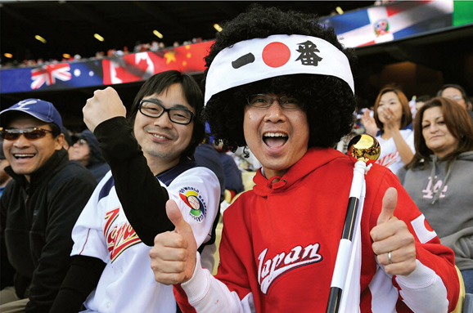**Baseball Fans around the World**

**Introduction:**

Baseball is a global sport enjoyed by millions, but while the rules of the game stay the same, the way fans enjoy and support their teams can vary a lot from country to country.

**Main Theme:**

The article compares baseball fan behavior in different countries, showing how cultural traditions influence how people cheer, celebrate, and experience the game.

**Body :**

Baseball is a very popular sport in Asia, North America, South America, and even Europe. While the rules of baseball are similar from country to country, the behavior of baseball fans is very different. Here's a look at some of the differences in fan behavior around the world.

In Japan

Baseball fans in Japan are loud—really loud. The sound of chants, cheering, drums, and trumpets continues nonstop throughout a baseball game in Japan. When a team goes to bat,! their fans sing a different song for each batter at the plate. And even when their team is losing badly,

Japanese fans continue to yell and scream. Foreign baseball players in Japan are often surprised that the fans never boo? a player. According to the American pitcher Brian Warren, baseball is more fun in Japan. “When I used to play in Venezuela,’ Warren said, “fans threw things at me when I didn't pitch well.’ This never happens in Japan.

When a Japanese player hits a home run, the fans give the biggest cheer of all—a banzai cheer. That's when the fans yell with both of their arms above their heads.

In Korea

Baseball fans in Korea are just as loud as the fans in Japan! In Korea, many fans use thundersticks to cheer their team on. Thundersticks are long plastic tubes that are sold in pairs. A fan hits the two thundersticks together to make a loud noise, encouraging their favorite players (or distracting the team they don't like). Cheerleaders are also a big part of baseball games in Korea. They lead the fans in songs, chants, and dances. When a player does well, the cheerleaders and the fans celebrate by doing a special dance created just for that player.

In the United States

Asian visitors to the United States are often surprised and disappointed by how quiet American baseball fans are. “When I went to a baseball game in San Francisco, everybody was just sitting there watching the game. It was kind of boring, says Barry Iwasa, a Japanese student at the University of California, Berkeley. “Baseball was invented in the United States,’ Iwasa says, “but Americans don’t seem very excited about their game:

It's true. Baseball fans in the United States are some of the quietest in the world. It's common to see baseball fans eating hot dogs and popcorn, and chatting with friends. “When I go to a baseball game,’ says Ginger Hanson from San Francisco, “I want to have fun with friends and catch up on? their lives. The real reason I go is for the social experience.”

In the Dominican Republic

Like the fans in Japan, the fans in the Dominican Republic cheer loudly throughout the game. They also sing and dance! Since music and dancing are an important part of Dominican culture, you might even find a merengue band moving through the stands at a baseball game.

Despite the music and dancing, many Dominican fans are very serious about baseball. Carol Parmenter, an American living in the Dominican Republic, says, “At Dominican games, you see groups of men drinking small cups of sweet coffee, carefully analyzing every pitch, every hit, every play. American fans don't usually follow the game that closely.”

**Home work:**

### ****1. What does “catch up on” mean?****

**A. Sleep  
B. Run  
C. Learn new things   
D. Argue  
E. Eat**

### ****2. What does “goes to bat” mean?****

**A. Leaves  
B. Cleans  
C. Hits the ball   
D. Sings  
E. Sits down**

### ****3. What does “boo” mean?****

**A. Smile  
B. Wave  
C. Show dislike   
D. Eat  
E. Sleep**

### ****4. What do Korean fans use to make noise?****

**A. Flags  
B. Radios  
C. Thundersticks   
D. Whistles  
E. Shoes**

### ****5. What do Dominican fans sometimes bring to games?****

**A. Dogs  
B. TVs  
C. Merengue bands   
D. Fireworks  
E. Drums only**

### ****6. Why do some Americans go to baseball games?****

**A. For food only  
B. To sleep  
C. For social time   
D. To sing  
E. To shop**