

**Al-Mustaqbal University**  
**College of Education**  
**Department of English Language**  
**Subject: Reading**  
**Level: 1st Stage**

**التدريسي : م.م سجى زهير حامد اعداد**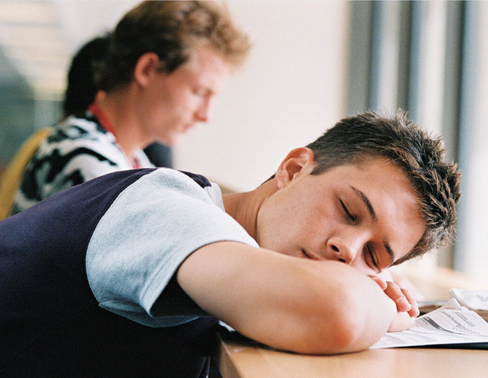

**What happens if you don’t get enough sleep?**

**Introduction:**

Have you ever wondered what happens to your body and mind when you don’t sleep? A high school student named Randy Gardner wanted to find out. He did a strange experiment where he stayed awake for many days without any sleep. What happened to him was surprising and even a little scary.

**Main Theme:**

The main theme of this text is the effects of not sleeping on the human body and mind. It shows how dangerous sleeplessness can be and why sleep is important for our health.

**Body :**

Randy Gardner, a high school student in the United States, wanted to find out. He designed an experiment! on the effects of sleeplessness? for a school science project. With Dr. William C. Dement from Stanford University and two friends

watching him carefully, Gardner stayed awake for 264 hours and 12 minutes. That's eleven days and nights without sleep! What effect did sleeplessness have on Gardner? After 24 hours without sleep, Gardner started having trouble reading and watching television. The words

and pictures were too blurry. By the third day, he was having trouble doing things with his hands. By the fourth day, Gardner was hallucinating. For example, when he saw a street sign, he thought it was a person. He also imagined he was a famous football player.

Over the next few days, Gardner's speech? became so slurred that people couldn’t understand him. He also had trouble remembering things. By the eleventh day, Gardner couldn’t pass a counting test.4 In the middle of the test he simply stopped counting. He couldn’t

remember what he was doing. When Gardner finally went to bed, he slept for 14 hours and 45 minutes. The second night he slept for twelve hours, the third night he slept for ten and one-half hours, and by the fourth night, he had returned to his normal sleep schedule.

Even though Gardner recovered quickly, scientists believe that going without sleep can be dangerous. They say that people should not repeat Randy’s experiment. Tests on white rats have shown how serious sleeplessness can be. After a few weeks without sleep, the rats started losing fur.” And even though the rats ate more food than usual, they lost 30 weight. Eventually, ® the rats died.

Has anyone stayed awake longer than Randy Gardner? Yes! According to The Guinness Book of World Records, Maureen Weston from the United Kingdom holds the record for staying awake the longest. She went 449 hours without sleep in 1977. That's 18 days and 17 hours!

During your lifetime, you will likely spend 25 years or more sleeping. But why? What is the purpose of sleep? Surprisingly, scientists don’t know for sure.’ Scientists used to think we “turned our brains off” when we went to sleep. Sleep researchers now know, however, that our brains are very active when we sleep. Some scientists think we sleep in order

to replenish® brain cells. Other scientists think that sleep helps the body to grow and relieve stress.? Whatever the reason, we know that it is important to get enough sleep.

**Home work:**

1. **What is the meaning or a synonym of the word )experiment(?**

A) A type of food  
B) A scientific test  
C) A school subject  
D) A kind of sport  
E) A sleeping problem

**2- What is the meaning of )effects of sleeplessness(?**

A) Ways to sleep better  
B) Foods that help you sleep  
C) Things that happen when you don’t get enough sleep  
D) Dreams you have at night  
E) The number of hours people sleep

**3- What is the meaning or a synonym of the word )speech(?**

A) A kind of food  
B) A way of walking  
C) A way of talking  
D) A place to sleep  
E) A type of dream

**4- What is a )counting test(?**

A) A test about spelling words  
B) A test of saying numbers in order: 1, 2, 3, 4, etc.  
C) A test of writing a story  
D) A test of reading fast  
E) A test of drawing shapes

**5- What is the meaning of the word )fur(?**

A) Food for animals  
B) Hair on an animal’s body  
C) A kind of tail  
D) An animal’s foot  
E) A place where animals sleep

**6- What is the meaning of the word )eventually(?**

A) Very quickly  
B) Before something happens  
C) Right now  
D) After some time  
E) Never