

**Al-Mustaqbal University**  
**College of Education**  
**Department of English Language**  
**Subject: Reading**  
**Level: 1st Stage**

**التدريسي : م.م سجى زهير حامد** **اعداد**

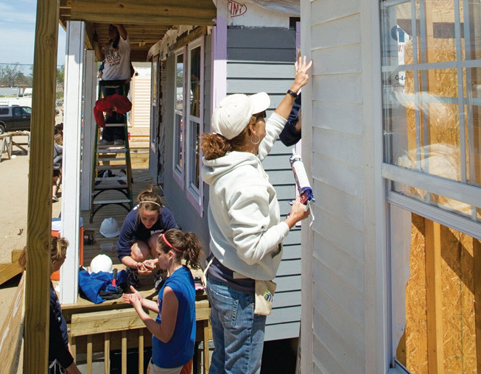 Helping Others

**By Mariko Asano**

**Introduction:**

Many people around the world do not have safe or comfortable homes. Habitat for Humanity is an organization that helps these people by building houses. Volunteers from different countries come together to help. In this article, Mariko Asano, a volunteer from Japan, shares her story about helping build homes in the Philippines.

**Main Theme:**

Helping others through volunteering can change lives — both for the people who receive help and for the people who give it.

**Body :**

Habitat for Humanity International—or Habitat—is a nonprofit organization that helps people in need! build houses. Since 1976, volunteers for Habitat have served more than 600,000 families worldwide. According to Habitat, however, there are still more than 1.6 billion people in the world

without decent housing. In the article below, Mariko Asano talks about her experience as a Habitat volunteer. She has traveled to the Philippines three times to help build houses for people who need them.

I am 24 years old, and I grew up in Nishinomiya, Japan. Several years ago, I went to Negros Island in the Philippines as a Habitat volunteer.

This was the first of three trips I have taken to the Philippines as volunteer. For me, the idea of building somebody's house abroad was very exciting. The next year I returned to Negros Island as a Habitat volunteer. This time I went as a student leader with 28 classmates from Kyoto University of Foreign Studies.

Both the staff and the families on Negros Island became dear friends of the work team I led.* Meeting these people was wonderful for each of us. Their lifestyle reminded us of the meaning and value of life. The people also helped us appreciate the more valuable things in life, such as spending time with your family, friends, and neighbors; developing close

relationships; helping each other; and appreciating what you do have. These things are sometimes forgotten in an affluent? country like Japan. We thought we came to the Philippines to help the Filipino people, but they helped us to see something valuable. They generously offered their food, space, and hearts? in a way we were unaccustomed to. (Would you

give up your bed for a stranger and sleep on the uncomfortable cement floor at your own house?)

When I took my third trip to the Philippines as a Habitat volunteer, I was assigned to® a house with young people from around the world. In my group, there were Filipinos, Americans, Indians, Koreans, and Japanese.

We worked together to complete a house for a family we met on the site. ‘On the last day, all of us stood inside a room we had built in just a week, feeling a sense of fulfillment.’ Even now we keep in touch across the world. Some of us are actively involved in Habitat in different countries. Habitat brings people together and helps us realize that people all

over the world care about each other. Habitat sends the very important message that we can all be friends. Being involved with Habitat for Humanity has changed my life. I've learned that I can make a difference? In the world.

**Home work:**

**1- What does "the work team I led" mean?**

A) The people who cleaned the house  
B) The workers I was in charge of  
C) The group who watched me  
D) The team who cooked for me  
E) The people I met at school

**2- What does "affluent" mean?**

A) Funny  
B) Tall  
C) Rich  
D) Loud  
E) Sleepy

**3- What does "offered their food, space, and hearts" mean?**

A) Let us take pictures  
B) Showed us around the city  
C) Gave us food, a place, and care  
D) Let us clean the kitchen  
E) Asked us to leave

**4- What does "assigned to" mean?**

A) Told to go play  
B) Asked to sleep  
C) Sent to a job  
D) Invited to a party  
E) Allowed to leave early

**5- What does "on the site" mean?**

A) On vacation  
B) In a classroom  
C) At the work location  
D) In the office  
E) On the phone

**6- What does "sense of fulfillment" mean?**

A) Feeling hungry  
B) Feeling cold  
C) Feeling successful  
D) Feeling sleepy  
E) Feeling confused

**7- What does "make a difference" mean?**

A) Make someone laugh  
B) Fix your hair  
C) Do something important  
D) Go shopping  
E) Tell a joke