

**Al-Mustaqbal University**  
**College of Education**  
**Department of English Language**  
**Subject: Reading**  
**Level: 1st Stage**

**التدريسي : م.م سجى زهير حامد** **اعداد**

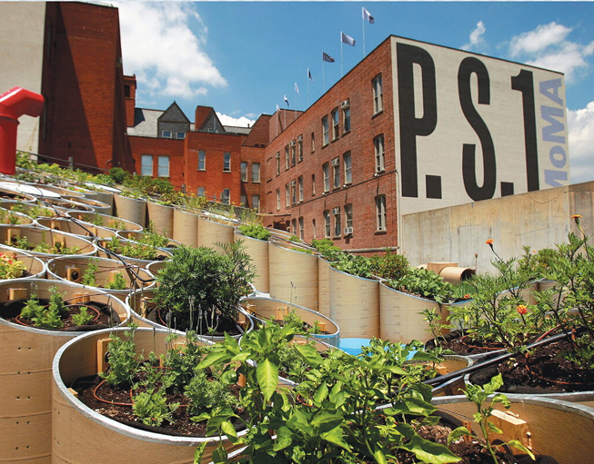 **The Growth Of Urban Farming**

**Introduction:**

Most people buy fruits and vegetables from supermarkets, but many of these foods travel thousands of kilometers before reaching the store. This uses a lot of energy and is not good for the environment. Now, more people around the world are trying something different—they are growing their own food, even in big cities.

**Main Theme:**

Urban farming helps people grow fresh food in cities and reduces the use of energy. It also brings people and communities together.

**Body :**

For most people living in cities, buying fresh vegetables and fruits means a trip to the supermarket. But how far does the produce! Have to travel to get to the store? In the United States, the average American produce has to travel 2,400 km to reach the supermarket where it is

sold. And many other kinds of produce in the supermarkets are imported? from other countries, especially in the winter. It isn't hard to find fresh strawberries in the middle of January in Chicago. They have been flown in’ from South America.

The United States isn't the only country that imports food. Most 10 countries do. In fact, in Japan, 60 percent of supermarket food comes from overseas. In the United Kingdom, some studies? say that 40 percent of food is imported. The city of London alone imports 80 percent of its food from as close as Europe and as far away as South Africa and New Zealand. If your bananas traveled 5,000 km to reach you, are they 15 still “fresh?”

A lot of oil is used to grow and ship the food you find in the supermarket. Many studies say that ten calories of carbon energy are used to make and deliver every one calorie of food we eat, and not

everyone is happy about this. Some people want to use less energy because it's better for the environment. Others want to use less energy because they are worried that oil prices will rise in the future.

Recently, the answer for more and more people is to grow their own food—even if they live in crowded cities. This trend, called urban agriculture, or urban farming, can be found all over the world. In Tokyo, Japan, for example, the recruitment company’ Pasona has been growing food inside its office building for several years. They started with a rice paddy inside their building. Recently, they moved their urban farm, called Pasona O2, to a new building, where they are growing not only rice, but 200 other kinds of plants, including many vegetables. In other parts of Tokyo, some restaurants are growing food in roof gardens, or even on the outside walls of their buildings.

In Frankfurt, Germany, there is a popular community-based group that rents small pieces of land for people to grow their own food. Office workers can now become “farmers” by coming to take care of their plants once or twice a week and enjoy eating their own fresh produce as well.

Another community-based group, called Brooklyn Grange, grows vegetables on New York City rooftops and sells them to people and businesses around the city. Brooklyn Grange welcomes people to volunteer with them and learn more about farming. In addition to learning some useful skills, they say volunteering is a good way for people to get to know other people in their neighborhoods.

How much food can people grow in small spaces? In the city of Pasadena, California, the Dervaes family grows almost all of the food it eats in an area that is only about 400 square meters. They started this project in the 1980s because they wanted to live their lives using very little or no carbon energy. They also have an online journal and blog to teach other people how to grow their own food.

In fact, it’s easy to find blogs by urban farmers who are sharing their stories and farming tips’ with people all over the world. Urban farming isn’t just helping people grow fresh food. It is also helping communities to develop and grow in city neighborhoods and online around the world.

**Home work:**

**1. What does "produce" mean?**  
A) A kind of meat  
B) Fresh vegetables and fruits  
C) A famous movie  
D) A factory machine  
E) A winter coat

**2. What does "imported" mean?**  
A) Thrown away  
B) Grown in your garden  
C) Brought in from another country  
D) Cooked at home  
E) Bought from a friend

**3. What does "flown in" mean?**  
A) Grown under the sea  
B) Sent by bicycle  
C) Brought in by airplane  
D) Found in the desert  
E) Cooked in a restaurant

**4. What does "studies" mean?**  
A) Birthday gifts  
B) Computer parts  
C) Reports or research  
D) Funny cartoons  
E) Vacation photos

**5. What does "ship" mean?**  
A) To eat loudly  
B) To sing a song  
C) To send or move something  
D) To paint a picture  
E) To wear something

**6. What does "carbon energy" mean?**  
A) Juice from fruits  
B) Light from a candle  
C) Energy from oil or fuel  
D) Music from a radio  
E) Wind from a fan