

**Al-Mustaqbal University**  
**College of Education**  
**Department of English Language**  
**Subject: Reading**  
**Level: 1st Stage**

**التدريسي : م.م سجى زهير حامد** **اعداد**

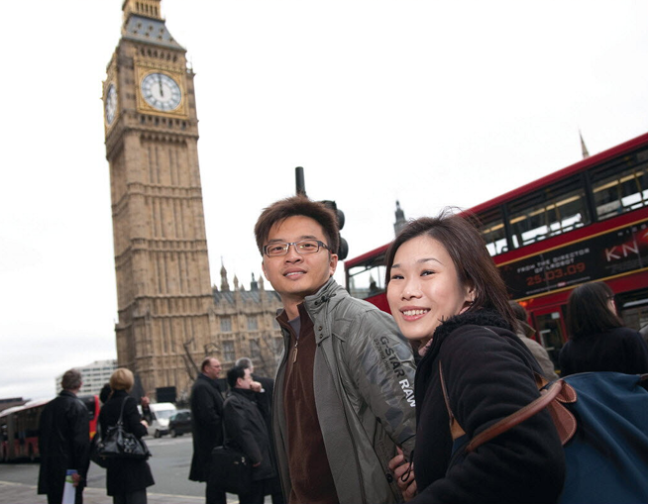Mika’s Homestay’ in London

By Mika Tanaka

**Introduction:**

Have you ever wanted to travel to another country and live with a local family? Mika Tanaka, a college student from Japan, got this chance. For her 19th birthday, her parents gave her a one-month homestay in London. She was nervous at first, but it turned out to be a great experience.

**Main Theme:**

The main theme of this text is Mika’s homestay experience in London. It shows how living in a different country and staying with a local family can help someone improve their language, learn about new cultures, and become more open-minded.

**Body :**

Mika Tanaka, a college student from Japan, had a wonderful home stay in London. She lived with a British family and studied English for a month. “What do you want for your 19" birthday?” my parents asked me. “A ring, I replied. However, instead of a ring, my parents gave me a one-

month homestay in London.

On February 11, I left Japan. On the plane, I worried about being all s alone there—a stranger to London. But when I met the Flannery family (my host family), their warm welcome made me feel at ease. Both my father and mother were very kind and treated me like their own daughter .

Getting Ready to Go

Before going to London, I did some research on English schools in London and chose Oxford House College, mainly because it had reasonable fees. Also, there weren’t many Japanese students at Oxford

House. I took my parents advice and requested that my homestay family have both a mother and a father, be native-born, non-smoking, middle-class British people, and live near a subway station. I later found that this was very good advice, since some of my friends at the English school were

having problems with their host families. Living in London Potatoes! It took me a little time to get used to the many kinds of potato dishes served: fried potatoes, steamed potatoes, sliced potatoes,

and different-colored potatoes. My host mother was a good cook. She

made delicious pasta and chicken dishes and even cooked rice for me.

Nadiege, a French girl, was another homestay student living with us, and we went around London together. On Saturdays, my host family would have a party at home with friends or family. When we returned from touring London, Nadiege and I would join the party. On Saturday

evenings, Mr. and Mrs. Flannery would go to their favorite pub to spend time together.

Although I selected a school with few Japanese students, there were still at least two in each class. In class, I tried to speak a lot, but many Japanese students didn't use their English very much (even if they had large

vocabularies), and spoke only Japanese with their friends. Sometimes, I asked other people their impressions of Japan. “Japanese people work too hard,’ said my French friend. My teacher thought that Japanese people were very rich. I did not agree with these points,° but I was interested in knowing what foreign people thought. One month

in London made me realize that speaking English was very important because it is the language that people from many countries use the most. I would like to be more open-minded about people from different countries, like my host family is.

**Home work:**

**1- What is a "pub"?**

A) A place to buy clothes  
B) A school for language students  
C) A park for children  
D) A place where people drink and sometimes eat  
E) A shop for newspapers

**2- What is a "homestay"?**

A) A kind of hotel for students  
B) A short trip to a museum  
C) A time when a person stays in their own home  
D) A period when a visitor lives with a local family  
E) A type of food from another country

**3- What does "all alone" mean?**

A) With many people  
B) In a busy street  
C) By myself, without someone I know  
D) With family members  
E) At a party

**4- What does "warm welcome" mean?**

A) A cold hello  
B) A very quick goodbye  
C) A friendly greeting  
D) A long speech  
E) A loud noise

**5- What does "treated me like their own daughter" mean?**

A) They were angry with me  
B) They made me do chores  
C) They were kind and good to me, like I was family  
D) They ignored me  
E) They taught me math