Grammar: Modals (Intermediate: Unit 4, 7)

Vocabulary: Permissions and Possibilities

(Intermediate: Unit 4, 7; Upper-Intermediate: Unit 7)  
Reading: "Doing the Right Thing" (Intermediate: Unit 4;   
Upper-Intermediate: Unit 7 "Getting on Together")  
  
  
**Unit 8**

**8.1. Starter**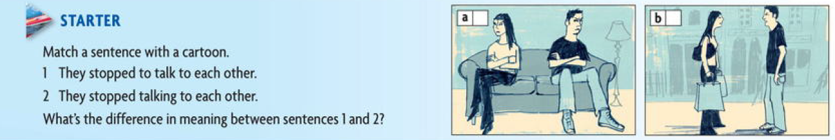

8.1. Answer :   
a- 2  
b- 1  
**8.2. Don’t worry MUM !**  
Verb pattern   
Read the following e- mails , What has happened that gives their parents reasons to worry ?  
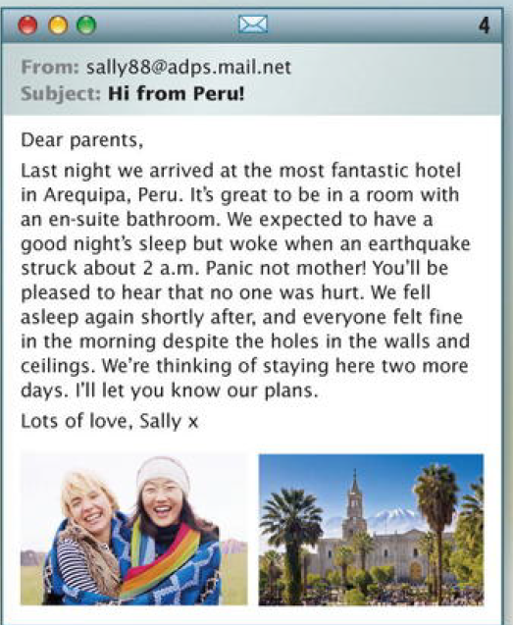 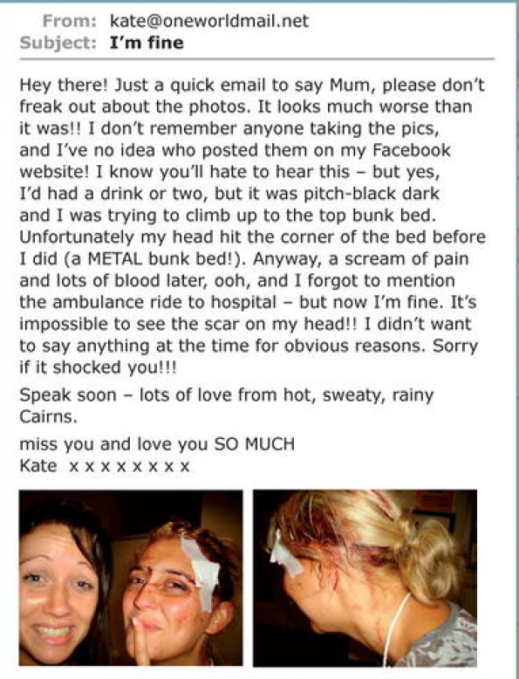

**8.3 Read these sentences , Which verbs or phrases can fill the gap ?**

1. Kate didn't ------------ anyone taking the photos.

a- see b- ask c- remember  
2. She --------- to climb up to the top bunk bed.

a – wanted b- tried c - remembered  
3. She forgot ---------- the hospital.  
a mentioning b - to mention c- mention  
4 . Dan asked his mum --------------- his Australian friends.

a- put up b- putting up c- to put up

5. His Australian friends --------- to go to London.  
a - want b - are hoping c- are looking forward at home.  
6. He thinks his mum will make them  
a - feel b - to feel c- feeling  
7. William ----------- to catch piranha fish.

a - didn't succeed in b - didn't manage c - tried  
8 . They stopped. --------------- on the river bank.

a - camping b -to camp c- to spend the night  
9. Sally ------------------- having an en-suite bathroom.  
a- loved b- wanted c -hoped  
10. She is ------------------ staying two more days  
a – planning b- looking forward to c- thinking of

**8.4. Grammar spot**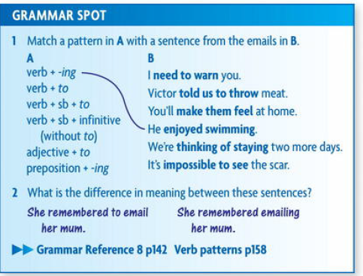  
**8.5. Listening and Speaking   
8.5.1. Fears and Phobia**   
- Some people have a strange phobias . Listen to Jodie , Gavin , and Meissa talking about their .  
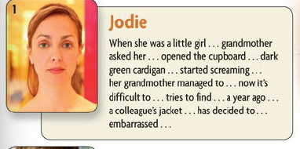 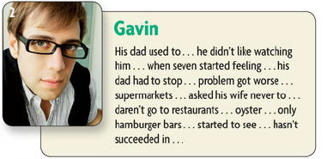

**8.5.2. Mat ch the phobias in the chart with their definitions :** 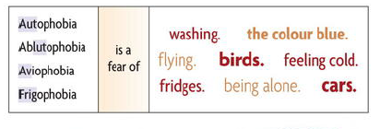

**8.6. Reading and Speaking   
8.6.1 Two famous leaders , Hannibal Barca and Mao Zedong**

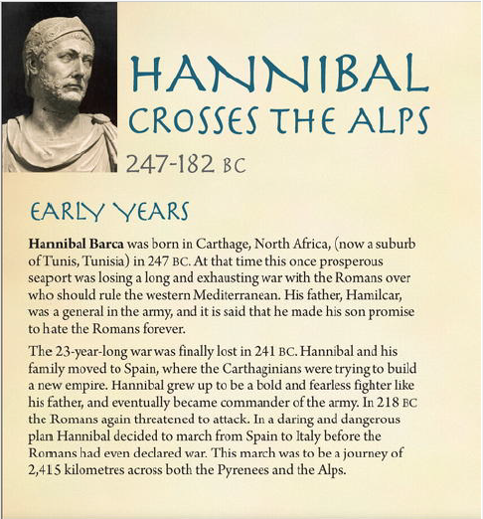 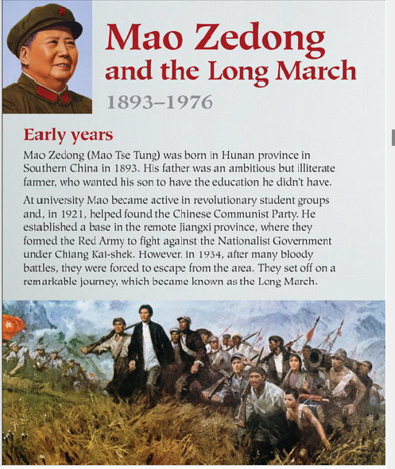

**8.6.3. After reading above two texts carefully write the answers of the following questions :**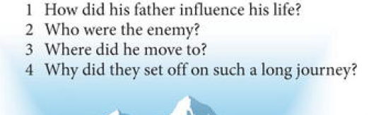

**8.7. Vocabulary and Idiom  
Body language   
 - 8.7.1. Which parts of the body do you use to do the following things ?**

**8.7.2. Which verbs in exercise 2 go with these nouns and phrases ?  
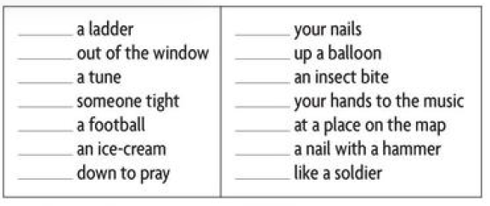  
8.8.Every day English   
-8.8.1 . Numbers and Travel   
 Read a loud these numbers , When do we say and ?  
8.8.2 Listen and Check   
**

**8.8.3 match the question with the numbers?**

**8.9. Homework no. 8**   
**The Verb Patterns – The infinitive and The - ing Form   
8.9.1. underline to each base given in bold line ( Infinitive Bases) , the suitable example related to :**   
**1. The infinitive is used after some verbs :**   
a. We’ve decided to move abroad .   
b. I’m trying to phone Pete.  
**2. Some verbs are followed by a person + the infinitive**a. They sked me to help them   
b. He told me to apply for the job.  
**3. Make and let followed by person + infinitive without to**   
a. She’ll make you feel welcome   
b. I’ll let you know when I’m coming   
**4. The infinitive is udsed after some adjectives**

a. It's impossible to save money   
b. it was good to hear your news

**8.9.2. Underline to each base given in bold line ( The - ing form) , the suitable example related to :**

**1. The – ing form is used after some verbs**   
 a. I enjoy reading history boos   
 b. I don’t mind helping you .  
c. He goes fishing at weekends.  
**2. some verbs are followed by an object + - ing**a. I hate people telling me what to do   
b. I can hear someone calling   
c. You can’t stop me doing what I want. **3. The – ing form is used after preposition**a. I’m good at finding things   
b. He’s afraid of being mugged .  
c. I’m looking forward to meeting you .

**References   
1.** 1. New edition , New Head way , Intermediate Student book -   
2. Oxford English for electrical and mechanical engineering.