1

**(Static)**

**Equilibrium of a Rigid Body: Conditions for Rigid Body Equilibrium/ Free-Body Diagrams/ Equations of Equilibrium**

1. **Conditions for Rigid Body Equilibrium**

* 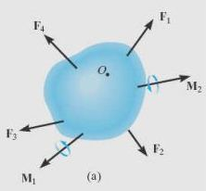The body is subjected to an external force and couple moment system.

Figure 1

* If the resultant force and couple moment resultant are both equal to zero, then the body is said to be in equilibrium .Mathematically, the equilibrium of a body is:

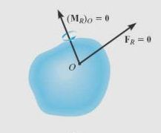Sum of the forces= ∑F=FR=0

Sum of the moments of the forces + couple moments= ∑MO= (MR)O=0

Figure 1

1. **Free-Body Diagrams**

* This diagram represented the body being isolated or "free" from its surroundings, i.e. "free body".
* Necessary to show all the forces and couple moments that exert on the body and can be accounted.

**Support Reactions**

Before draw free body diagram, first consider the various types of reactions that occur at supports shown in figures (3). As a general rule,

* If a support prevents the translation of a body in a given direction, then a force is developed on the body in that direction.
* If rotation is prevented, a couple moment is exerted on the body



Figure 3

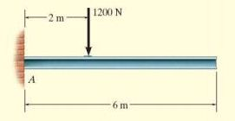**Example 1**

Draw free body diagram of uniform beam shown in the figure, beam has mass of 100 kg.

Solution Figure 4

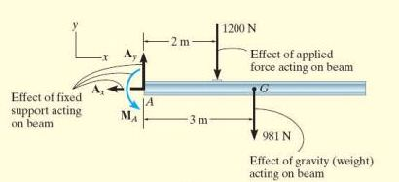Ax , Ay , MA , three reactions at A (fixed)

Their magnitudes are unknown and their sense assumed.

Weight of beam, W=100 * 9.81 = 981N acts through beam's center.

Figure 5

**Example 2 :**

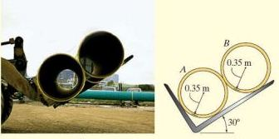Two smooth pipes , each having mass of 300 kg, support by tractor as shown in figure, draw free body diagram for each pipe and both pipes together.

Solution Figure 6

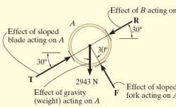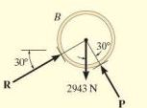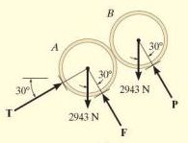Weight of each pipe=300 kg * 9.81=2943 N, reactions forces are T , F, R

Figure 7

1. **Equations of Equilibrium**

The body is subjected to a system of forces, lie in the (x–y) plane, then the forces can be resolved into their x and y components.

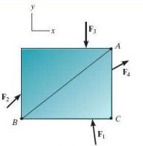Two equations for the equilibrium of a rigid body, namely:

∑Fx=0 , ∑Fy=0 , ΣMO = 0

Alternative Sets of Equilibrium Equations:

∑Fx=0 , ΣMA = 0, ΣMB = 0 Figure 8

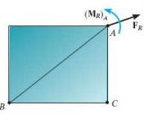A second alternative set of equilibrium equations is:

ΣMA = 0, ΣMB = 0 , ΣMC = 0

Points A, B , and C do not lie on the same line.

For equilibrium, consider the freebody diagram in Figure 9 .

If ΣMA = 0, then (MR)A = 0.

Figure 9

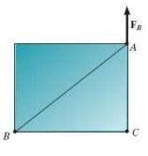

ΣMC = 0 , FR passes through point C as shown in Figure c . Finally, if we require ΣMB = 0, it is necessary that FR = 0, and so the plate in Figure ( 10) must then be in equilibrium.

Figure 10

**Example 1**

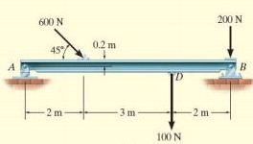Determine the horizontal and vertical components of reaction for the beam loaded. Neglect the weight of the beam in the calculations.

pin at B and the rocker at A

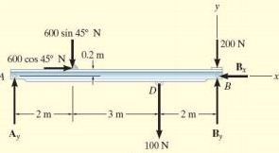 Figure 11

Solution :

+→ ∑Fx=0 , 600 cos45oN-Bx=0

Bx=424 N

Evaluate Ay by applying ∑MB=0 at point B. Figure 12

C:\Users\Aseel\AppData\Local\Microsoft\Windows\Temporary Internet Files\Content.Word\dscxds.jpg 100N (2 m) + (600 sin 45o N) (5m)-(600 cos 45o N) (0.2 m)-Ay(7 m)=0

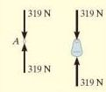Ay=319N

Evaluate By by applying ∑Fy=0

319N-600 sin 45oN-100N-200N+By=0 By=405N

**Tutorial**

**Example 1**

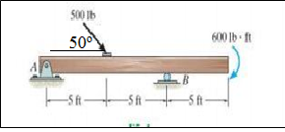Determine the horizontal and vertical components of reaction at the supports. Neglect the thickness of the beam.

**Solution :**

Assume: Figure 13

Two vertical reaction forces upward are : RA​ at support A,  RB​ at support B

+→ ∑Fx=0 → 500 cos50 - Ax=0 → Ax = 500cos 50o → Ax =320 Ib

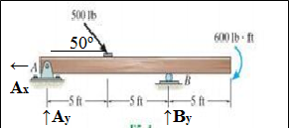+↑ ∑Fy=0 → Ay + By-500Ib sin50o =0 → Ay=500 sin 50o - By → Ay= 500Ib * 0.76-By

Then : Ay= 380 -By …..(1)

Figure 14

**+** ∑MA=0 → By*10 – 600 – 500 sin50o* 5 = 0

By*10 – 600 – 500 * 0.76 * 5=0 → By==250Ib…..(2)

Substitute eq. (2) in eq. (1):

Ay= 380 -By=380-250=130 Ib

**Example 2**

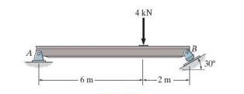Determine the horizontal and vertical components of reaction at the pin A and the reaction of the rocker B on the beam.

**Solution :**

Figure 15

θ =90-30=60

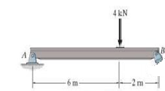**For Y-axis**

+↑∑Fy=0 FBy+FAy-4kN=0

FAx

**θ**

**30**

FBy=4kN-FAy ………(1)

**θ**

FBx

FBy

FAy

**30**

+ ∑MB=0 4*2-FAy * 8=0

FAy=8/8=1kN substitute in eq. (1) Figure 16

FBy=4kN-FAy=4-1=3Kn

But FBy= FB sin θ

FBy = FB sin60o=F * √3 /2 → FB=2*FBy/√3=2*3/√3 → FB =3.46 kN

Then

**For X-axis**

+→∑Fx=0 FAx-FBx=0 → FAx=FBx …..(2)

FBx=FBcos60o =3.46 * 0.5= 1.73 kN substitute in eq. (2) → FAx=1.73 kN