1

**(Static)**

**Structural Analysis: The Method of Sections/ Space Trusses/ Frames and Machines**

**The Method of Sections**

**Space Trusses**

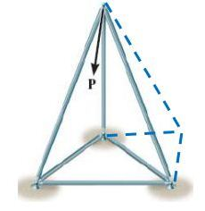6 bars joined at their ends to form the edges of a tetrahedron as the basic non-collapsible unit - 3 additional concurrent bars whose ends are attached to three joints on the existing structure are required to add a new rigid unit to extend the structure.

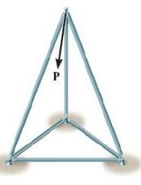

A space truss formed in this way is called a Simple Space Truss, each member under Compression or Tension

**Method of Joints**

Scalar equation (force) at each joint • Σ Fx = 0, Σ Fy = 0, Σ Fz = 0

**Method of Sections**

Vector equations (force and moment) • ΣF = 0, ΣM = 0

Space Truss: Example

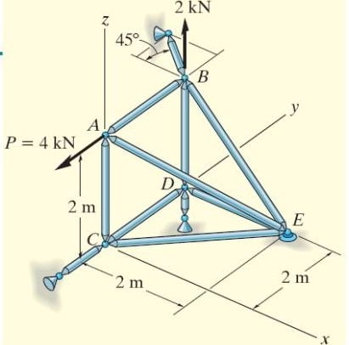Determine the forces acting in members of the space truss.

Solution:

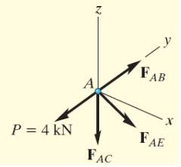Start at joint A: Draw free body diagram Express each force in vector notation

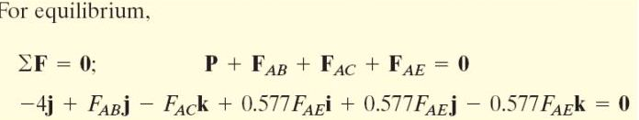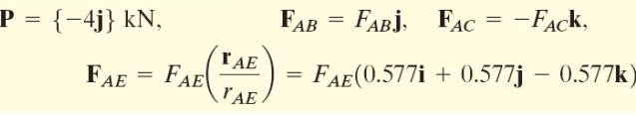

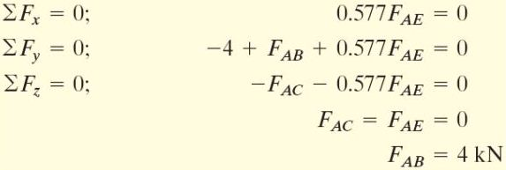Rearranging the terms and equating the coefficients of i, j, and k unit vector to zero will give:

**Free Body Diagram**

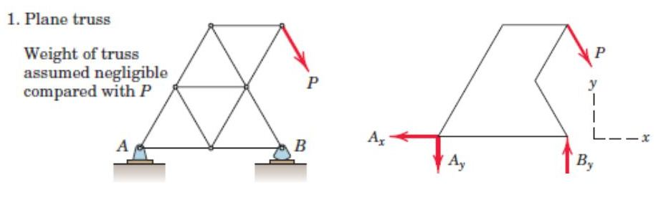

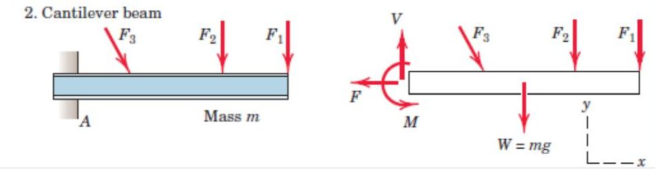

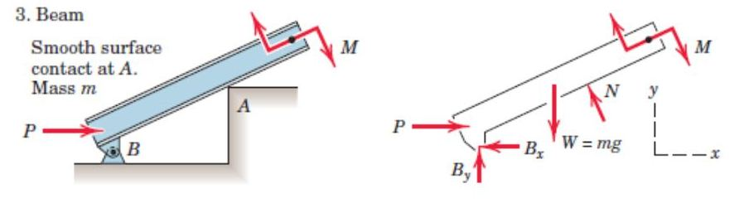

**Method of Sections**

Draw free body diagram by section method

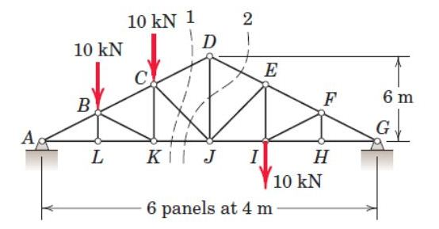

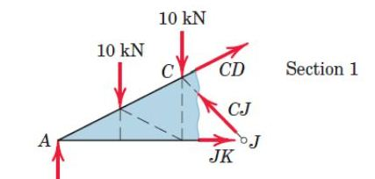 Solution:

**Frames and Machines**

A structure is called a Frame or Machine if at least one of its individual members is a multi-force member.

Frames: generally stationary and are used to support loads

Machines: contain moving parts and are designed to transmit and alter the effect of forces acting.

Multi-force members: the forces in these members in general will not be along the directions of the members

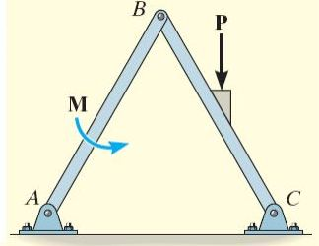**Example: Free Body Diagrams**

Draw FBD of

(a) Each member (b) Pin at B, and (c) Whole system

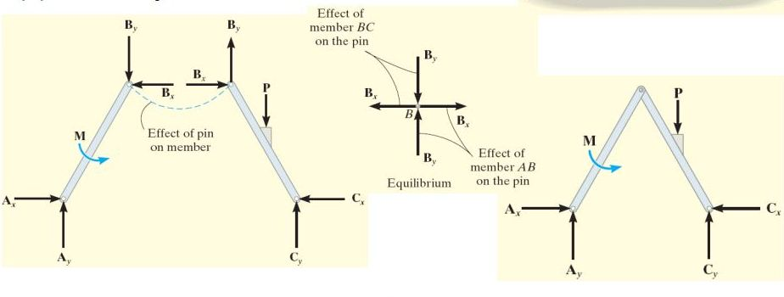

Example :

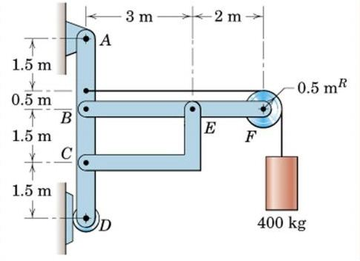Compute the horizontal and vertical components of reaction forces acting on points A and D.

Ax

Ay

D

Solution

