1

**(Static)**

**Structural Analysis: Simple Trusses/ The Method of Joints/ Zero Force Members**

**Simple Trusses**

* A truss is a structure composed of slender members joined together at their end points.
* Members consist of wood or metal.
* Trusses lie in a single plane used to support roofs and bridges.

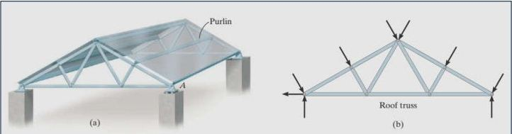

Figure 1

In the case of a bridge, such as shown in Fig. 2, the load on the deck is first transmitted to stringers, then to floor beams, and finally to the joints of the two supporting side trusses.

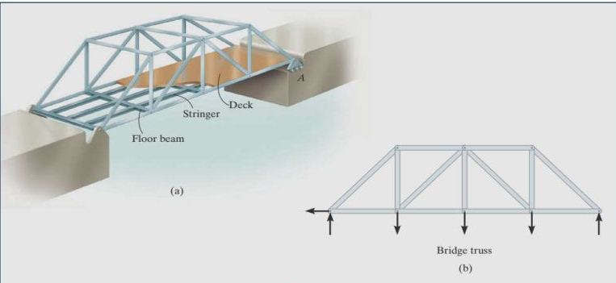

Figure 2

Rocker or roller allows freedom for expansion or contraction of the members due to a change in temperature or application of loads. All Loadings are applied at the joints, and members are joined together by smooth pins.

If the force elongate member → it is a tensile force (T), Fig. a,

If the force shorten member → it is compressive force (C), Fig. 6-4b.

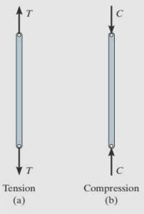

Figure 3

**The Method of Joints**

In order to analyze or design a truss, it is necessary to determine the force in each of its members. One way to do this is to use the method of joints.

The basis of method:

* If the entire truss is in equilibrium → each of its joints in equilibrium.
* Free–body diagram of each joint is drawn
* The force equilibrium equations can then be used to obtain the member forces acting on each joint

Two-force members lying in a single plane (concurrent - coplanar force system)

Equilibrium → ΣFx = 0 and ΣFy = 0

Example:

Consider pin at joint B of the truss in Fig. 3a. Three forces act on the pin, namely, 500-N force and forces exerted by members BA and BC, draw free body diagram.

Solution:

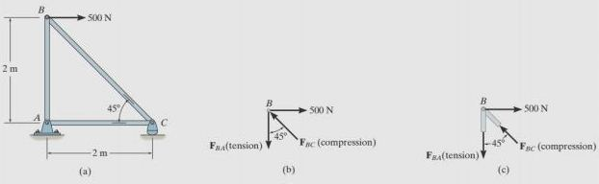The free-body diagram of the pin is shown in Fig. 3b. Here, FBA is “pulling” on the pin, which means that member BA is in tension; whereas FBC is “pushing” on the pin, and consequently member BC is in compression. These effects are clearly demonstrated by isolating the joint with small segments of the member connected to the pin, Fig.3c. The pushing or pulling on these small segments indicates the effect of the member being either in compression or tension. apply ΣFx = 0 and ΣFy = 0 which can be solved for the two unknowns.

Figure 3

Analyzing of a truss :

1. Draw free body diagram for the forces at join and support.
2. Use one of the methods ( simple truss , method of joint) to establish sense of unknown force.
3. Resolved in x and y axis to compute the components and apply the two force equilibrium equations ΣFx = 0 and ΣFy = 0 , and solve unknown force.
4. Continue to analyze each of joints , remember , compression is pushes on joint and tension is pulls on joint.

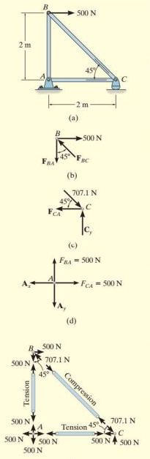C:\Users\Aseel\AppData\Local\Microsoft\Windows\Temporary Internet Files\Content.Word\Capture.jpgExample : 1

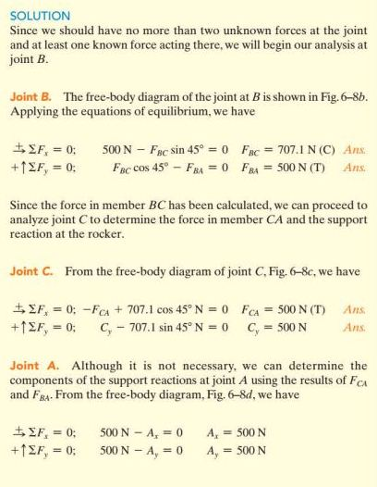

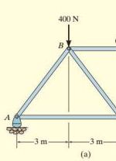Example 2

C:\Users\Aseel\AppData\Local\Microsoft\Windows\Temporary Internet Files\Content.Word\Capture.jpg

Ay=600N

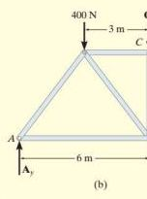Solution :

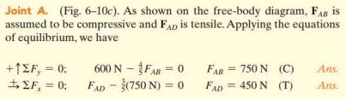

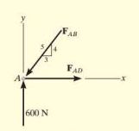

**Zero-Force Members:**

Truss analysis using the method of joints is greatly simplified if we can first identify those members which support no loading. These zero-force members are used to increase the stability of the truss during construction and to provide added support if the loading is changed.