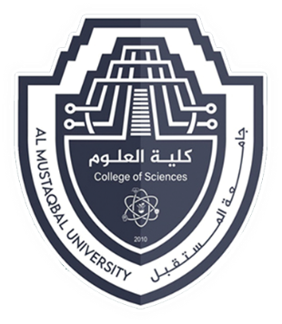

**Department of biology**

**BOTANY (PLANT BIOLOGY)**

**First stage**

**(6)**

**Plant Tissues**

**By**

**Prof. Dr. Dhurgham Ali Al-Sultany**

Different types of plants are made of different types of cells differ in size, shape etc. Tissue: A group of similar or dissimilar cells having a common origin and performing a similar function. Plant tissues are classified into two main groups:

A. Meristematic Tissues

B. Permanent Tissues

**Characteristics of meristematic cell:**

1. Living cells found in vegetative regions of the plant
2. They have thin walls of cellulose.
3. Cells are normally isodiametric, oval, polygonal or rectangular
4. Abundant cytoplasm is present, vacuoles are either absent or very small, large nucleus is present and their plastids are in proplastid stage.
5. Cells are compactly arranged and lack intercellular spaces.
6. Cells have the capacity to divide.

**Classification of meristematic tissue**

Meristematic tissues may be classified on the basis of:

1. Origin and development
2. Position in the plant body
3. Plane of division
4. Functions

**a) Meristems based on origin and development: -**

1- Promeristem (primordial meristem):

A group of cells which represent primary stages of meristematic cells. They are present in a small region at the apices of shoots and roots. They give rise to primary meristems.

2- Primary meristem.

The meristematic cells that originate from promeristem are primary meristems. In most monocots and herbaceous dicots, only primary meristem is present.

3- Secondary meristem:

They are the meristems developed from primary permanent tissue.

They are not present from the very beginning of the formation of an organ but develop at a later stage and give rise to secondary permanent tissues. Examples: Cambium of roots, interfascicular cambium of stem and cork cambium.



**b) Meristems based on position in plant body:**

1- Apical meristem:

It is found at the apex of growing points of root and shoot. it divides continuously and brings about growth in length of shoot and root. The apical meristem includes promeristem as well as primary meristem.

2- Intercalary meristem:

It is present away from apical meristem. It is present at the base of internodes e.g.; in grasses and wheat (Gramineae) or at the base of leaves e.g.; in Pinus or at the base of nodes e.g mint or Mentha (Labiatac). It is responsible for increase in length.

3- Lateral meristem:

They are located parallel to the long axis of the plant organs. Their activity results in increase of the diameter of the plant organs, e.g.; Cork cambium and Vascular cambium.



**c) Meristems based on function:**

1. Protoderm:

It is the outermost layer of the young growing region which develops the epidermal tissue system

1. Procambium:

It is composed of narrow, elongated cells that give rise to the vascular tissue system that is xylem and phloem.

1. Ground meristem:

It consists of large, thin-walled cells which develop to form ground tissue system that is hypodermis, cortex and pith.

**Characteristics of Permanent tissues**

1. It is formed due to division and differentiation in meristematic tissue.
2. The cells of this tissue may be living or dead thin-walled or thick-walled.
3. The thin-walled tissues are generally living whereas the thick-walled tissues may be living or dead
4. The cells may have intercellular spaces. In these spaces, air water, latex etc. are found.

**Types of permanent tissues**

(a) Simple tissue

(b) Complex tissue

(c) Special tissue