**Series and Parallel AC Circuits**

**7.1 Response of Basic R, L, and C Elements to a Sinusoidal Voltage or Current:**

**7.1.1 Resistor:**

For power-line frequencies and frequencies up to a few hundred kilohertz, resistance is, for all practical purposes, unaffected by the frequency of the applied sinusoidal voltage or current. For this frequency region, the resistor R in Figure (7.1) can be treated as a constant, and Ohm’s law can be applied, as follows.

For $v=V_{m}\sin{ωt}$,

$$i=\frac{v}{R}=\frac{V_{m}\sin{ωt}}{R}=\frac{V_{m}}{R}\sin{ωt}=I_{m}\sin{ωt}$$

where

$$I_{m}=\frac{V_{m}}{R}$$

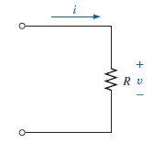

**Figure (7.1): Determining the sinusoidal response for a resistive element.**

In addition, for a given $i$,

$$v=iR=\left(I_{m}\sin{ωt}\right)R=I_{m}R \sin{ωt}=V_{m}\sin{ωt}$$

where

$$V_{m}=I_{m}R$$

A plot of $v$ and $i$ in Figure (7.2) reveals that: ***For a purely resistive element, the voltage across and the current through the element are in phase, with their peak values related by Ohm’s law.***

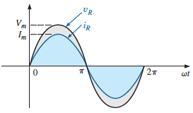

**Figure (7.2): The voltage and current of a resistive element are in phase.**

If we now write both the voltage and current in phasor form, we find that the phase angle associated with the voltage and current is zero degrees. That is:

$$v_{R}=V_{m}\sin{ωt}⇒V_{R}=V∠0°$$

$$i_{R}=I_{m}\sin{ωt}⇒I_{R}=I∠0°$$

If we apply phasor algebra as follows:



Now since we know the angle associated with the current must also be zero degrees, the angle $θ_{R}$ must be zero degrees.

$$I_{R}=\frac{V_{R}}{R}=\frac{V∠0°}{R∠0°}=\frac{V}{R}∠0°$$

so that in the time domain:

$$i_{R}=\sqrt{2}\left(\frac{V}{R}\right)\sin{ωt}$$

For the future, therefore, whenever we encounter a resistor in the ac domain, we will assign an angle of zero degrees to form a complex number notation. The standard format will therefore be:

$$Z_{R}=R∠0°$$

The quantity has both magnitude and angle, called the impedance of the resistive element and measured in ohms, it is a measure of how much the element will “impede” the flow of charge through the circuit.

**Example 1:** Using complex algebra,

1. Find the current $i_{R}$ for the circuit in Figure below.

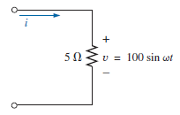

1. Sketch the waveforms of $i_{R}$ and $V_{R}$.

**Solution:**

$v=100 sin ωt⇒phasor form V=70.71 V ∠0°$

$$I_{R}=\frac{V_{R}}{Z_{R}}=\frac{V∠0°}{R∠0°}=\frac{70.71 V ∠0°}{5 Ω ∠0°}=14.14 A ∠0°$$

And $i_{R}=12(14.14) sin ωt=20 sin ωt$

1. Note Figure below.

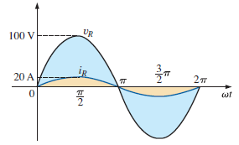

**7.1.2 Inductor:**

The voltage across the inductor of Figure (7.3) is directly related to the inductance of the coil and the rate of change of current through the coil. by the following equation:

$$v_{L}=L\frac{di_{L}}{dt}$$

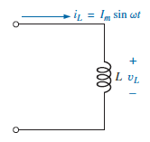

**Figure (7.3): Investigating the sinusoidal response of an inductive element.**

Consequently, the higher the frequency, the greater is the rate of change of current through the coil, and the greater is the magnitude of the voltage. In addition, the higher the inductance, the greater is the rate of change of the flux linkages, and the greater is the resulting voltage across the coil.

For a sinusoidal current defined by:

$$i_{L}=I_{m}\sin{ωt}$$

we can calculate the voltage across the coil by differentiating the current through the coil and substituting into the basic equation above. That is:

$$v_{L}=L\frac{di_{L}}{dt}=L\frac{d}{dt}\left(I_{m}\sin{ωt}\right)=LI_{m}\frac{d}{dt}\left(\sin{ωt}\right)=LI_{m}(ω\cos{ωt})$$

with the final solution of:

$$v_{L}=ωLI_{m}\sin{(ωt+90°)}$$

The peak value of the resulting voltage is therefore directly related to the applied frequency ($ω=2πf$), the inductance of the coil $L$, and the peak value of the applied current $I_{m}$. A plot of $v_{L}$ and $i_{L}$ in Figure (7.4) reveals that for an inductor, $v_{L}$ leads $i_{L}$ by 90°, or $i_{L}$ lags $v_{L}$ by 90°.

The opposition to an applied voltage can be determined by simply substituting the peak values for $V_{m}$ and $I_{m}$, as follows:

$$Opposition=\frac{cause}{effect}=\frac{V_{m}}{I_{m}}=\frac{ωLI_{m}}{I_{m}}=ωL$$

revealing that the opposition established by an inductor in an ac sinusoidal network is directly related to the product of the angular velocity ($ω=2πf$) and the inductance.

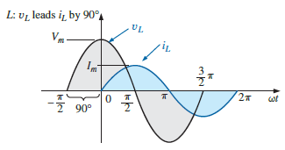

**Figure (7.4): For a pure inductor, the voltage across the coil leads the current through the coil by 90°.**

The quantity $ωL$, called the **reactance** (from the word reaction) of an inductor, is symbolically represented by $X_{L}$ and is measured in ohms; that is:

$$X_{L}=ωL$$

(ohms, Ω)

In an Ohm’s law format, its magnitude can be determined from:

$$X_{L}=\frac{V_{m}}{I_{m}}$$

(ohms, Ω)

Inductive reactance is the opposition to the flow of current, which results in the continual interchange of energy between the source and the magnetic field of the inductor.

Once the reactance is known, the peak value of the voltage or current can be found from the other by simply applying Ohm’s law, as follows:

$$I_{m}=\frac{V_{m}}{X_{L}}$$

and

$$V_{m}=I_{m}X_{L}$$

$$v_{L}=V_{m}\sin{ωt}⇒phase form V=V∠0°$$

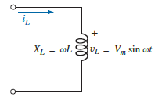

Applying Ohm’s law, we find that:



Since $v_{L}$ leads $i_{L}$ by $90°$, $i_{L}$ must have an angle of $-90°$ associated with it. To satisfy this condition, $θ_{L}$ must equal $+90°$. Substituting $θ_{L}=+90°$, we obtain:



so that in the time domain:

$$i_{L}=\sqrt{2}\left(\frac{V}{X_{L}}\right)\sin{(ωt-90°)}$$

We use the fact that $θ_{L}=90°$ in the following polar format for inductive reactance to ensure the proper phase relationship between the voltage and current of an inductor:

$$Z_{L}=X_{L} ∠90°$$

$Z_{L}$, having both magnitude and an associated angle, is referred to as the impedance of an inductive element. It is measured in ohms and is a measure of how much the inductive element “controls or impedes” the level of current through the network.

**Example 2:** Using complex algebra,

1. Find the current $i_{L}$ for the circuit in Figure below.

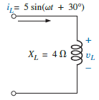

1. Sketch the waveforms of $v_{L}$ and $i_{L}$.

**Solution:**

$v_{L}=24 sin ωt⇒phasor form V_{L}=16.968 V ∠0°$

$$I=\frac{V_{L}}{Z_{L}}=\frac{V∠θ°}{X_{L}∠90°}=\frac{16.968 V ∠0°}{3 Ω ∠90°}=5.656 A ∠-90°$$

and $i=\sqrt{2}\left(5.656\right)sin \left(ωt-90°\right)=8.0 sin (ωt-90°)$

1. Note Figure below.

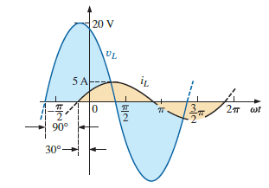

**7.1.3 Capacitor:**

For capacitive networks, the voltage across the capacitor is limited by the rate at which charge can be deposited on, or released by, the plates of the capacitor during the charging and discharging phases, respectively. In other words, an instantaneous change in voltage across a capacitor is opposed by the fact that there is an element of time required to deposit charge on (or release charge from) the plates of a capacitor, and $V=Q/C$.

Since capacitance is a measure of the rate at which a capacitor will store charge on its plates, ***for a particular change in voltage across the capacitor, the greater the value of capacitance, the greater is the resulting capacitive current.***

For the capacitor of Figure (7.5),

$$i_{C}=C\frac{dv_{C}}{dt}$$

Substituting:

$$v_{C}=V_{m}\sin{ωt}$$

and, applying differentiation, we obtain:

$$i_{C}=C\frac{dv_{C}}{dt}=C\frac{d}{dt}\left(V_{m}\sin{ωt}\right)=ωCV_{m}\cos{ωt}$$

so that:

$$i_{C}=ωCV_{m}\sin{(ωt+90°)}$$

Note that the peak value of $i_{C}$ is directly related to $ω(=2πf)$, $C$, and the peak value of the applied voltage.

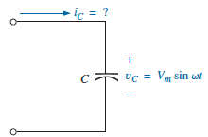

**Figure (7.5): Investigating the sinusoidal response of a capacitive element.**

A plot of $v_{C}$ and $i_{C}$ in Figure (7.6) reveals that:

$$For a capacitor, i_{C} leads v_{C} by 90°, or v_{C} lags i_{C} by 90°.$$

Applying:

$$Opposition=\frac{cause}{effect}$$

and substituting values, we obtain:

$$Opposition=\frac{V_{m}}{I_{m}}=\frac{V_{m}}{{ωC V}_{m}}=\frac{1}{ωC}$$

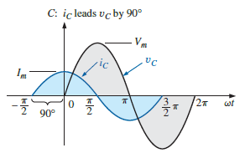

**Figure (7.6): The current of a purely capacitive element leads the voltage across the element by 90°.**

The quantity $1/ωC$, called the **reactance** of a capacitor, is symbolically represented by $X_{C}$ and is measured in ohms; that is:

$$X_{C}=\frac{1}{ωC}$$

(ohms, Ω)

In an Ohm’s law format, its magnitude can be determined from:

$$X_{C}=\frac{V_{m}}{I_{m}}$$

(ohms, Ω)

Capacitive reactance is the opposition to the flow of charge, which results in the continual interchange of energy between the source and the electric field of the capacitor. Like the inductor, the capacitor does not dissipate energy in any form (ignoring the effects of the leakage resistance). The peak value of the voltage or current can be found from the other by simply applying Ohm’s law as follows:

$$I_{m}=\frac{V_{m}}{X_{C}}$$

and

$$V_{m}=I_{m}X_{C}$$

In the inductive circuit,

$$v_{L}=L\frac{di_{L}}{dt}$$

and through integration:

$$i_{L}=\frac{1}{L}\int{v_{L}}dt$$

In the capacitive circuit,

$$i_{C}=C\frac{dv_{C}}{dt}$$

and through integration:

$$v_{C}=\frac{1}{C}\int{i_{C}}dt$$

***If the source current leads the applied voltage, the network is predominantly capacitive, and if the applied voltage leads the source current, it is predominantly inductive.***

$$v_{C}=V_{m}\sin{ωt}⇒phase form V=V∠0°$$

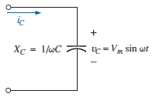

Applying Ohm’s law, we find:



Since $i_{C}$ leads $v_{C}$ by 90°, $i_{C}$ must have an angle of +90° associated with it. To satisfy this condition, $θ_{C}$ must equal -90°. Substituting $θ_{C}=-90°$ yields:



so, in the time domain:

$$i_{C}=\sqrt{2}\left(\frac{V}{X_{C}}\right)\sin{(ωt+90°)}$$

We use the fact that $θ_{C}=-90°$ in the following polar format for capacitive reactance to ensure the proper phase relationship between the voltage and current of a capacitor:

$$Z_{C}=X_{C} ∠-90°$$

$Z_{C}$, having both magnitude and an associated angle, is referred to as the impedance of a capacitive element. It is measured in ohms and is a measure of how much the capacitive element “controls or impedes” the level of current through the network.

**Example 3:** The voltage across a resistor is provided below. Findthe sinusoidal expression for the current if the resistor is 10 Ω. Sketchthe curves for $v$ and $i$*.*

$v= 100\sin{377t}$

$v=25 sin(377t + 60°)$

**Solution:**

$$I_{m}=\frac{V_{m}}{R}=\frac{100 V}{10 Ω}=10 A$$

( $v$ and $i$ are in phase), resulting in:

$$i=10 sin 377t$$

The curves are sketched in Figure below.

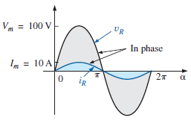

$$I_{m}=\frac{V_{m}}{R}=\frac{25 V}{10 Ω}=2.5 A$$

( $v$ and $i$ are in phase), resulting in:

$$i=2.5 sin(377t+60°)$$

The curves are sketched in Figure below.

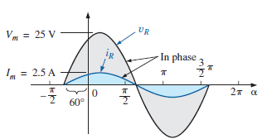

**Example 4:** The current through a 0.1 H coil is provided. Find thesinusoidal expression for the voltage across the coil. Sketch the $v$ and $i$ curves.

$i=10 sin 377t$

$i=7 sin(377t - 70°)$

**Solution:**

$$X_{L}=ωL=(377 rad/s)(0.1 H)=37.7 Ω$$

$$V_{m}=I_{m}X_{L}=(10 A)(37.7 Ω) = 377 V$$

and we know that for a coil $v$ leads $i$ by 90°. Therefore,

$$v=377 sin(377t+90°)$$

The curves are sketched in Figure below.

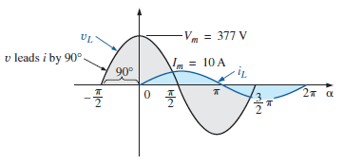

$X_{L} remains at 37.7 Ω.$

$$V_{m}=I_{m}X_{L}=(7 A)(37.7 Ω) = 263.9 V$$

and we know that for a coil $v$ leads $i$ by 90°. Therefore,

$$v=263.9 sin(377t-70°+90°)$$

and

$$v=263.9 sin(377t +20°)$$

The curves are sketched in Figure below.

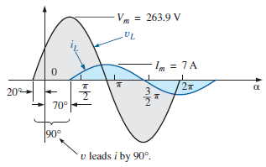

**Example 5:** The voltage across a 0.5 H coil is provided below.What is the sinusoidal expression for the current?

$$v=100 sin 20t$$

**Solution:**

$$X_{L}=ωL=(20 rad/s)(0.5 H)=10 Ω$$

$$I_{m}=\frac{V_{m}}{X_{L}}=\frac{100 V}{10 Ω}=10 A$$

and we know the $i$ lags $v$ by 90°. Therefore,

$$i=10 sin(20t-90°)$$

**Example 6:** The voltage across a 1 µF capacitor is providedbelow. What is the sinusoidal expression for the current? Sketch the $v$ and $i$ curves.

$$v=30 sin 400t$$

**Solution:**

$$X_{C}=\frac{1}{ωC}=\frac{1}{(400 rad/s)(1×{10}^{-6} F)}=\frac{{10}^{6} Ω}{400}=2500 Ω$$

$$I_{m}=\frac{V_{m}}{X_{C}}=\frac{30 V}{2500 Ω}=0.0120 A=12 mA$$

and we know that for a capacitor $i$ leads $v$ by 90°. Therefore,

$$i=12 ×{10}^{_3} sin(400t +90°)$$

The curves are sketched in Figure below.

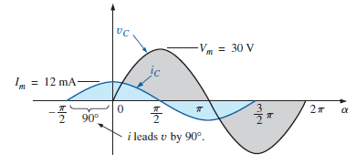

**Example 7:** For the following pairs of voltages and currents,determine whether the element involved is a capacitor, an inductor, or aresistor. Determine the value of *C*, *L*, or *R* if sufficient data are provided(Figure below):















$v=100 sin(ωt+40°)$

$i=20 sin(ωt+40°)$

$v=1000 sin(377t+10°)$

$i=5 sin(377t-80°)$

$v=500 sin(157t+30°)$

$i=1 sin(157t+120°)$

$v=50 cos(ωt+20°)$

$i=5 sin(ωt+110°)$

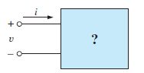

**Solution:**

1. Since $v$ and $i$ are *in phase,* the element is a *resistor,* and:
$$R=\frac{V_{m}}{I_{m}}=\frac{100 V}{20 A}=5 Ω$$

2. Since $v$*leads $i$* by 90°, the element is an *inductor,* and:

$$X_{L}=\frac{V_{m}}{I_{m}}=\frac{1000 V}{5 A}=200 Ω$$

so that:

$$X_{L}=ωL=200 Ω or$$

$$L=\frac{X_{L}}{ω}=\frac{200 Ω}{377 rad/s}=0.53 H$$

1. Since $i$*leads $v$*  by 90°, the element is a *capacitor,* and:

$$X_{C}=\frac{V_{m}}{I_{m}}=\frac{500 V}{1 A}=500 Ω$$

so that:

$$X_{C}=\frac{1}{ωC}=500 Ω or$$

$$C=\frac{1}{ω X_{C}}=\frac{1}{157 rad/s×500 Ω}=12.74 F$$

$v=50 cos\left(ωt+20°\right)=50 sin\left(ωt 20°+90°\right)= 50 sin(ωt+110°)$

Since $v$ and $i$ are in phase, the element is a resistor, and:

$$R=\frac{V_{m}}{I_{m}}=\frac{50 V}{5 A}=10 Ω$$

**Example 8:** Using complex algebra,

1. Find the current $i_{C}$ for the circuit in Figure below.

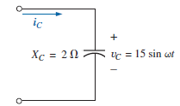

1. Sketch the waveforms of $v_{C}$ and $i_{C}$.

**Solution:**

$v_{C}=15 sin ωt⇒phasor notation V_{L}=10.605 V ∠0°$

$$I_{C}=\frac{V_{C}}{Z_{C}}=\frac{V∠θ°}{X_{C}∠-90°}=\frac{10.605 V ∠0°}{2 Ω ∠-90°}=5.303 A ∠90°$$

and $i_{C}=\sqrt{2}\left(5.303\right)sin \left(ωt+90°\right)=7.5 sin (ωt+90°)$

1. Note Figure below.

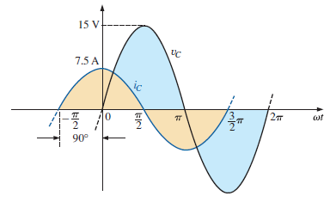

**7.2 Impedance Diagram:**

Now that an angle is associated with resistance, inductive reactance, and capacitive reactance, each can be placed on a complex plane diagram, as shown in Figure (7.7). For any network, the resistance will always appear on the positive real axis, the inductive reactance on the positive imaginary axis, and the capacitive reactance on the negative imaginary axis. The result is an impedance diagram that can reflect the individual and total impedance levels of an ac network.

networks combining different types of elements will have total impedances that extend from -90° to +90°. If the total impedance has an angle of 0°, it is said to be resistive in nature. If it is closer to 90°, it is inductive in nature. If it is closer to -90°, it is capacitive in nature.

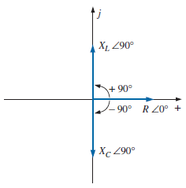

**Figure (7.7):** **Impedance diagram.**

**Example 9:** Sketch the impedance diagram for a 22 ohm resistor.

**Solution:** Note Figure below.

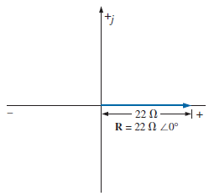

**Example 10:** Sketch the impedance diagram of a 2 KΩ capacitive

**Solution:** Note Figure below.

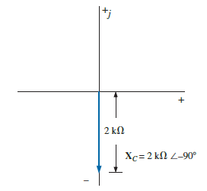

**7.3 Series Configuration:**

The overall properties of series ac circuits (Figure (7.8)) are the same as those for dc circuits. For instance, the total impedance of a system is the sum of the individual impedances and the current I is the same through each impedance.

$$Z_{T}=Z_{1}+ Z_{2}+Z_{3}+…+Z_{N}$$

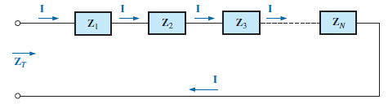

**Figure (7.8): Series impedances.**

For the representative **series ac configuration** in Figure (7.9) having two impedances, *the current is the same through each element* and is determined by Ohm’s law:

$$I=\frac{E}{Z_{T}}$$

$$Z_{T}=Z_{1}+ Z_{2}$$

and

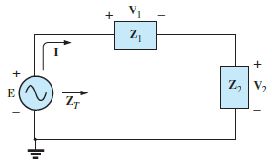

**Figure (7.9): Series ac circuit.**

The voltage across each element can then be found by another application of Ohm’s law:

$$V_{1}=I Z_{1}$$

$$V_{2}=I Z_{2}$$

**7.3.1 Kirchhoff’s Voltage Law (KVL):**

Kirchhoff’s voltage law can then be applied in the same manner as it is employed for dc circuits. We have:

$$E-V_{1}-V_{2}=0$$

or

$$E=V_{1}+V_{2}$$

The power to the circuit can be determined by:

$$P=EI\cos{θ_{T}}$$

where $θ_{T}$ is the phase angle between $E$ and $I$.

**7.3.2 Voltage Divider Rule (VDR):**

The basic format for the **voltage divider rule** in ac circuits is exactly the same as that for dc circuits:

$$V_{x}=\frac{Z_{x} E}{Z_{T}}$$

where $V_{x}$ is the voltage across one or more elements in a series that have total impedance $Z_{x}$, $E$ is the total voltage appearing across the series circuit, and $Z_{T}$ is the total impedance of the series circuit.

**Example 11:** For the circuit in Figure below,

1. Calculate $I$, $V_{R}$, $V_{L}$, and $V_{C}$ in phasor form.
2. Calculate the total power factor.
3. Calculate the average power delivered to the circuit.
4. Draw the phasor diagram.
5. Obtain the phasor sum of $V_{R}$, $V_{L}$, and $V_{C}$, and show that it equals the input voltage $E$.

f. Find $V_{R}$ and $V_{C}$ using the voltage divider rule.

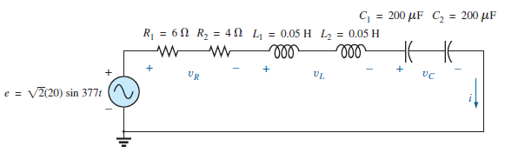

**Solution:**

1. Combining common elements and finding the reactance of the inductor and capacitor, we obtain:

$$R_{T}=6 Ω+ 4 Ω=10 Ω$$

$$L_{T}=0.05 H+0.05 H=0.1 H$$

$$C_{T}=\frac{200 µF}{2}=100 µF$$

$$X_{L}=ωL=(377 rad/s)(0.1 H)=37.70 Ω$$

$$X_{C}=\frac{1}{ωC}=\frac{1}{(377 rad/s)(100 ×{10}^{-6} F)}=\frac{{10}^{6} Ω}{37,700}=26.53 Ω$$

Redrawing the circuit using phasor notation results in Figure below.

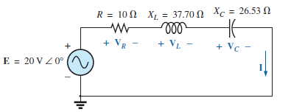

For the circuit in Figure above:

$$Z_{T}=R ∠0°+ {X }_{L} ∠90° + X_{C} ∠-90°$$

$$Z_{T}=10 Ω+ j 37.70 Ω- j 26.53 Ω=10 Ω+ j 11.17 Ω= 15 Ω ∠48.16°$$

The current $I$ is:

$$I=\frac{E}{Z_{T}}=\frac{20 V ∠0°}{15 Ω ∠48.16°}=1.33 A ∠-48.16°$$

The voltage across the resistor, inductor, and capacitor can be found using Ohm’s law:

$$V_{R}=IZ_{R}=(I ∠θ)(R ∠0°)=(1.33 A ∠-48.16°)(10 Ω ∠0°)$$

$$V_{R}=13.30 V ∠-48.16°$$

$$V_{L}=IZ_{L}=(I ∠θ)(X_{L} ∠90°)=(1.33 A ∠-48.16°)(37.70 Ω ∠90°)$$

$$V_{L}=50.14 V ∠41.84°$$

$$V_{C}=IZ_{C}=(I ∠θ)(X_{C} ∠-90°)=(1.33 A ∠-48.16°)(26.53 Ω ∠-90°)$$

$$V_{C}=35.28 V V ∠-138.16°$$

1. The total power factor, determined by the angle between the applied voltage **E** and the resulting current **I,** is 48.16°:

$$F_{P}=\cos{θ}=cos 48.16°=0.667 lagging$$

or

$$F_{P}=\cos{θ}=\frac{R}{Z_{T}}=\frac{10 Ω}{15 Ω}= 0.667 lagging$$

1. The total power in watts delivered to the circuit is:
$$P=EI\cos{θ_{T}}=(20 V)(1.33 A)(0.667)=17.74 W$$

2. The phasor diagram appears in Figure below.

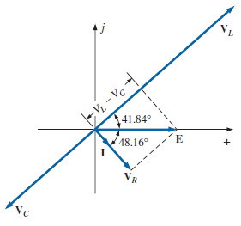

1. The phasor sum of $V_{R}$, $V_{L}$, and $V_{C}$ is:

$$E=V_{R}+V_{L}+V_{C}=13.30 V∠-48.16°+50.14 V∠41.84°+35.28 V ∠-138.16°$$

$$E=13.30 V ∠-48.16°+14.86 V ∠41.84°$$

Therefore,

$$E=\sqrt{{\left(13.30 V\right)}^{2}+{\left(14.86 V\right)}^{2}}=20 V$$

and

$$θ_{E}=0° (from phasor diagram)$$

and

$$E=20 V ∠0°$$

$$V_{R}=\frac{Z_{R} E}{Z_{T}}=\frac{(10 Ω ∠0°)(20 V ∠0°)}{15 Ω ∠48.16°}=\frac{200 V ∠0°}{15 ∠48.16°}=13.3 V ∠-48.16°$$

$$V_{C}=\frac{Z_{C} E}{Z_{T}}=\frac{\left(26.5 Ω ∠-90°\right)\left(20 V ∠0°\right)}{15 Ω ∠48.16°}=\frac{530.6 V ∠-90°}{15 ∠48.16°}$$

$$V_{C}=35.37 V ∠-138.16°$$

**7.4 Parallel AC Elements:**

For the network of Figure (7.10) with any number of parallel elements the total impedance has the same format as encountered for dc networks:

$$\frac{1}{Z_{T}}=\frac{1}{Z_{1}}+ \frac{1}{Z_{2}}+\frac{1}{Z_{3}}+…+\frac{1}{Z_{N}}$$

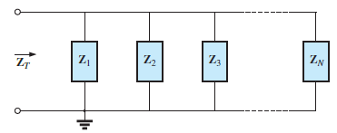

**Figure (7.10): Parallel impedances.**

which can be written in the following form:

$$Z_{T}=\frac{1}{\frac{1}{Z_{1}}+ \frac{1}{Z_{2}}+\frac{1}{Z_{3}}+…+\frac{1}{Z_{N}}}$$

For two impedances in parallel:

$$\frac{1}{Z_{T}}=\frac{1}{Z_{1}}+ \frac{1}{Z_{2}}$$

which will become the following after a few mathematical manipulations:

$$Z_{T}=\frac{Z_{1} Z_{2}}{Z_{1}+Z_{2}}$$

For three impedances in parallel the resulting equation is the following:

$$Z_{T}=\frac{Z_{1} Z_{2} Z_{3}}{Z_{1} Z_{2}+Z_{2} Z_{3}+Z_{1} Z_{3}}$$

And for any number of impedances in parallel of the same content the following equation can be applied:

$$Z_{T}=\frac{Z_{1}}{N}$$

**Example 12:** For the network in Figure below:

1. Determine the input impedance.
2. Draw the impedance diagram.

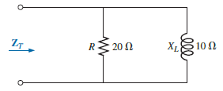

**Solution:**

$$Z_{T}=\frac{Z_{R} Z_{L}}{Z_{R}+Z_{L}}=\frac{(20 Ω ∠0°)(10 Ω ∠90°)}{20 Ω+j10 Ω }=\frac{200 Ω ∠90°}{22.361 ∠26.57°}=8.93 Ω ∠63.43°$$

$$= 4.00 Ω+j7.95 °=R_{T}+jX_{L}=8.93 Ω ∠63.43°$$

1. The impedance diagram appears in Figure below.

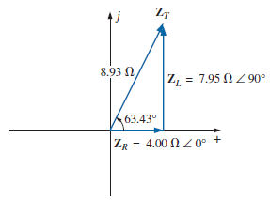

**Example 13:** For the network in Figure below:

1. Determine the total impedance.
2. Sketch the impedance diagram.

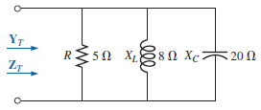

**Solution:**

$$Z_{T}=\frac{1}{\frac{1}{Z_{R}}+ \frac{1}{Z_{L}}+\frac{1}{Z_{C}}}=\frac{1}{\frac{1}{5 Ω ∠0°}+ \frac{1}{8 Ω ∠90°}+\frac{1}{20 Ω ∠-90°}}$$

$$Z_{T}=\frac{1}{0.2 S ∠0°+0.125 S ∠-90°+0.05 S ∠90°}=\frac{1}{0.2 S-j 0.075 S}$$

$$Z_{T}=\frac{1}{0.2136 S ∠-20.56°}=4.68 Ω ∠20.56°$$

**or**

$$Z_{T}=\frac{Z_{R} Z_{L} Z_{C}}{Z_{R} Z_{L}+Z_{L} Z_{C}+Z_{R} Z_{C}}$$

$$=\frac{(5 Ω ∠0°)(8 Ω ∠90°)(20 Ω ∠-90°)}{\left(5 Ω ∠0°\right)\left(8 Ω ∠90°\right)+\left(8 Ω ∠90°\right)\left(20 Ω ∠-90°\right)+(5 Ω ∠0°)(20 Ω ∠-90°)}$$

$$=\frac{800 Ω ∠0°}{40 ∠90° + 160 ∠0° + 100 ∠-90°}=\frac{800 Ω}{160 + j 40 - j 100}=\frac{800 Ω}{160 - j 60}$$

$$Z_{T}=\frac{800 Ω}{170.88 ∠-20.56°}=4.68 Ω ∠20.56°=4.38 Ω+j1.64 Ω$$

1. The impedance diagram appears in Figure below.

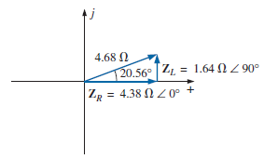

**7.5 Total Admittance:**

In ac circuit, admittance (Y) is a measure of how well an ac circuit will admit, or allow, current to follow in the circuit.

For ac parallel circuits the terminology applied is **admittance**, which has the symbol **Y** and is measured in **siemens (S)**.

* **Resistive Elements:** For resistors the admittance is defined by:

$$Y_{R}=\frac{1}{Z_{R}}=\frac{1}{R∠0°}=G∠0°$$

(siemens, S)

* **Inductive Elements:** For inductive elements the admittance is defined by:

$$Y_{L}=\frac{1}{Z_{L}}=\frac{1}{X_{L}∠90°}=\frac{1}{X_{L}}∠-90°$$

(siemens, S)

The ratio $1/X_{L}$ is called the **susceptance** of the inductive element, is given the symbol $B_{L}$, and is measured in **siemens (S)**. Therefore,

$$B_{L}=\frac{1}{X_{L}}$$

(siemens, S)

and

$$Y_{L}=B_{L}∠-90°$$

(siemens, S)

* **Capacitive Elements:** For capacitive elements the admittance is defined by:

$$Y_{C}=\frac{1}{Z_{C}}=\frac{1}{X_{C}∠-90°}=\frac{1}{X_{C}}∠90°$$

(siemens, S)

The ratio ${1/X}_{C}$ is also called the **susceptance** of the capacitive element, is given the symbol $B_{C}$, and is measured in **siemens (S)**. Therefore,

$$B_{C}=\frac{1}{X_{C}}$$

(siemens, S)

and

$$Y_{C}=B_{C}∠90°$$

(siemens, S)

For dc circuits with simply resistive elements we found that the total conductance of parallel resistive elements was simply the sum of the conductance values as shown below.

$$G_{T}=G_{1}+ G_{2}+G_{3}+…+G_{N}$$

(siemens, S)

For ac parallel networks, the total admittance is simply the sum of the admittance levels of all the parallel branches of Figure below. That is:

$$Y_{T}=Y_{1}+ Y_{2}+Y_{3}+…+Y_{N}$$

(siemens, S)

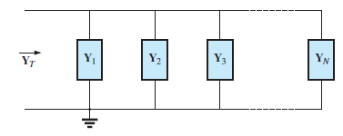

In any case, whether the total impedance or admittance is first found, the other can be found using the simple equation:

$$Y_{T}=\frac{1}{Z_{T}}$$

(siemens, S)

***For any configuration (series, parallel, series-parallel, and so on), the angle associated with the total admittance is the angle by which the source current leads the applied voltage. For inductive networks, $θ_{T}$ is negative, whereas for capacitive networks, $θ_{T}$ is positive.***

**7.6 Parallel AC Networks:**

For the representative parallel ac network in Figure (7.11), the source current is determined by Ohm’s law as follows:

$$I=\frac{E}{Z_{T}}{=E Y}_{T}$$

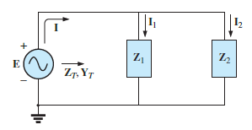

**Figure (7.11): Parallel ac network.**

Since the voltage is the same across parallel elements, the current through each branch can then be found through another application of Ohm’s law:

$$I_{1}=\frac{E}{Z_{1}}{=E Y}_{1}$$

$$I_{2}=\frac{E}{Z_{2}}{=E Y}_{2}$$

**7.6.1 Kirchhoff’s Current Law (KCL):**

Kirchhoff’s current law can then be applied in the same manner as used for dc networks. We have:

$$I=I_{1}+I_{2}$$

$$I-I_{1}-I_{2}=0$$

or

Although the product of the voltage and current is not always the power delivered, it is a power rating of significant usefulness in the description and analysis of sinusoidal ac networks and in the maximum rating of a number of electrical components and systems. It is called the **apparent power** and is represented symbolically by *S.* Since it is simply the product of voltage and current, its units are *volt-amperes* (VA). Its magnitude is determined by: (volt-amperes, VA)

$$S=V I^{*}$$

Therefore, the average power to the network can be determined by:

$$P=S\cos{θ_{T}}=EI\cos{θ_{T}}$$

and the power factor of the circuit is:

$$F_{P}=\frac{P}{S}=\cos{θ_{T}}$$

where $θ_{T}$ is the phase angle between $E$ and $I$**.**

**Example 14:** For the circuit of figure below:

1. Calculate the total impedance and draw the admittance diagram.
2. Calculate $I$, $I_{R}$, $I_{L}$, and $I_{C}$ in phasor form and draw the phaser diagram.
3. Sketch the waveforms for the parallel R-L-C network.
4. Calculate the average power delivered to the circuit and the total power factor.
5. Find the input current $I$ using Ohm’s law.

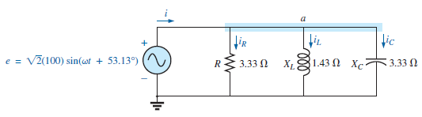

**Solution:** Phasor notation: As shown in Figure below.

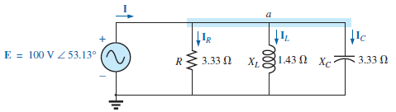

$$Y_{T}=Y_{R}+ Y_{L}+Y_{C}=G∠0°+B_{L} ∠-90°+B_{C} ∠90°$$

$$Y_{T}=\frac{1}{3.33 Ω}∠0°+\frac{1}{1.43 Ω} ∠-90°+\frac{1}{3.33 Ω} ∠90°$$

$$Y_{T}= 0.3 S ∠0°+ 0.7 S ∠-90°+ 0.3 S ∠90°= 0.3 S-j 0.7 S+j 0.3 S$$

$$Y_{T}=0.3 S-j 0.4 S=0.5 S ∠-53.13°$$

$$Z_{T}=\frac{1}{Y_{T}}=\frac{1}{0.5 S ∠-53.13°}=2 Ω ∠53.13°$$

***Admittance diagram:***As shown in Figure below.

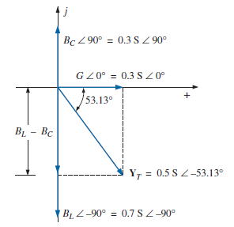

$$I=\frac{E}{Z_{T}}{=E Y}_{T}=(100 V ∠53.13°)(0.5 S ∠-53.13°) = 50 A ∠0°$$

$$I_{R}=(E ∠θ)(G ∠0°)=(100 V ∠53.13°)(0.3 S ∠0°)= 30 A ∠53.13°$$

$$I_{L}=\left(E ∠θ\right)\left(B_{L} ∠-90°\right)$$

$$I_{L}=\left(100 V ∠53.13°\right)\left(0.7 S ∠-90°\right)=70 A ∠-36.87°$$

$$I_{C}=\left(E ∠θ\right)\left(B_{C} ∠90°\right)=(100 V ∠53.13°)(0.3 S ∠+90°) = 30 A ∠143.13°$$

*Kirchhoff’s current law:* At node *a*,

$$I-I_{R}-I_{L}-I_{C}=0$$

or

$$I=I_{R}+I_{L}+I_{C}$$

***Phasor diagram:***The phasor diagram in Figure below indicates that the impressed voltage $E$ is in phase with the current $I_{R}$ through the resistor, leads the current $I_{L}$ through the inductor by 90°, and lags the current $I_{C}$ of the capacitor by 90°.

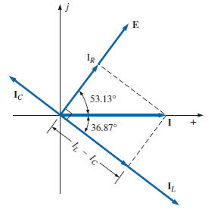

1. ***Time domain:***

$$i=\sqrt{2}\left(50\right)\sin{ωt}=70.70 sin ωt$$

$$i_{R}=\sqrt{2}\left(30\right)\sin{(ωt}+53.13°)=42.42 sin(ωt+ 53.13°)$$

$$i_{L}=\sqrt{2}\left(70\right)\sin{(ωt}-36.87°)=98.98 sin(ωt- 36.87°)$$

$$i_{C}=\sqrt{2}\left(30\right)\sin{(ωt}+143.13°)=42.42 sin(ωt+ 143.13°)$$

A plot of all of the currents and the impressed voltage appears in Figure below.

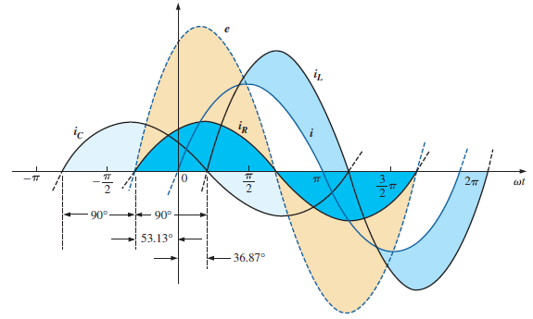

1. ***Power:***The total power in watts delivered to the circuit is

$$P_{T}=EI\cos{θ_{T}}=\left(100 V\right)\left(50 A\right)cos 53.13°=\left(5000\right)\left(0.6\right)=3000 W$$

or

$$P_{T}=E^{2} G={\left(100 V\right)}^{2}\left(0.3 S\right)=3000 W$$

or, finally,

$$P_{T}=P_{R}+P_{L}+P_{C}=EI_{R}\cos{θ_{R}}+EI_{L}\cos{θ_{L}}+EI_{C}\cos{θ_{C}}$$

$$=(100 V)(30 A) cos 0° + (100 V)(70 A) cos 90°+ (100 V)(30 A) cos 90°$$

$$P_{T}=3000 W + 0 + 0=3000 W$$

***Power factor:***The power factor of the circuit is:

$$F_{P}=\cos{θ_{T}}=cos 53.13°=0.6 lagging$$

or

$$F_{P}=\cos{θ_{T}}=\frac{G}{Y_{T}}=\frac{0.3 S}{0.5 S}=0.6 lagging$$

1. ***Impedance approach:***The input current **I** can also be determined by first finding the total impedance in the following manner:

$$Z_{T}=\frac{Z_{R} Z_{L} Z_{C}}{Z_{R} Z_{L}+Z_{L} Z_{C}+Z_{R} Z_{C}}=2 Ω ∠53.13°$$

and, applying Ohm’s law, we obtain:

$$I=\frac{E}{Z_{T}}=\frac{100 V∠53.13°}{2 Ω ∠53.13°}=50 A ∠0°$$

**7.6.2 Current Divider Rule (CDR):**

The basic format for the **current divider rule** in ac circuits is exactly the same as that for dc circuits; that is, for two parallel branches with impedances $Z_{1}$ and $Z_{2}$ as shown in Figure below.

$$I_{1}=\frac{ Z_{2} I_{T}}{Z_{1}+Z_{2}} or I_{1}=\frac{ Z_{1} I_{T}}{Z_{1}+Z_{2}}$$

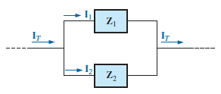

**Example 15:**  Using the current divider rule, find the current through each parallel branch in Figure below.

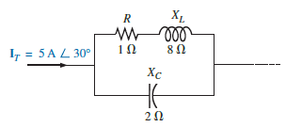

**Solution:**

$$I_{R-L}=\frac{ Z_{C} I_{T}}{Z_{C}+Z_{R-L}}=\frac{\left(2 Ω ∠-90°\right)\left(5 A ∠30°\right)}{-j 2 Ω+1 Ω+j 8 Ω}=\frac{10 A ∠-60°}{1+j 6}$$

$$I_{R-L}=\frac{10 A ∠-60°}{6.083 ∠80.54°}≅1.64 A ∠-140.54°$$

$$I_{C}=\frac{ Z_{R-L} I_{T}}{Z_{C}+Z_{R-L}}=\frac{\left(1 Ω+j 8 Ω\right)\left(5 A ∠30°\right)}{6.083 ∠80.54°}=\frac{\left(8.06 ∠82.87°\right)\left(5 A ∠30°\right)}{6.083 ∠80.54°}$$

$$I_{C}=\frac{40.30 A ∠112.87°}{6.083 ∠80.54°}=6.63 A ∠32.33°$$

**7.7 Series-Parallel Networks:**

In general, when working with series-parallel ac networks, consider the following approach:

1. Redraw the network, using block impedances to combine obvious series and parallel elements, which will reduce the network to one that clearly reveals the fundamental structure of the system.
2. Study the problem and make a brief mental sketch of the overall approach you plan to use. Doing this may result in time- and energy-saving shortcuts. In some cases, a lengthy, drawn-out analysis may not be necessary. A single application of a fundamental law of circuit analysis may result in the desired solution.
3. After the overall approach has been determined, it is usually best to consider each branch involved in your method independently before tying them together in series parallel combinations. In most cases, work back from the obvious series and parallel combinations to the source to determine the total impedance of the network. The source current can then be determined, and the path back to specific unknowns can be defined. As you progress back to the source, continually define those unknowns that have not been lost in the reduction process. It will save time when you have to work back through the network to find specific quantities.

**Example 16:** For the network in Figure below:

1. Calculate $Z_{T}$.
2. Determine $I_{S}$.
3. Calculate $V_{R}$ and $V_{C}$.
4. Find $I_{C}$..
5. Compute the power delivered.
6. Find $F_{P}$.of the network.

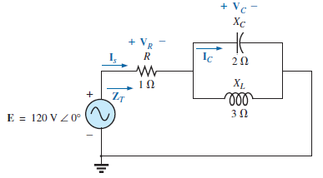

**Solution:**

As suggested in the introduction, the network has been redrawn with block impedances, as shown in Figure above. The impedance $Z_{1}$ is simply the resistor *R* of 1 Ω, and $Z_{2}$ is the parallel combination of $X_{C}$ and $X_{L}$. The network now clearly reveals that it is fundamentally a series circuit, suggesting a direct path toward the total impedance and the source current. For many such problems, you must work back to the source to find first the total impedance and then the source current. When the unknown quantities are found in terms of these subscripted impedances, the numerical values can then be substituted to find the magnitude and phase angle of the unknown. In other words, try to find the desired solution solely in terms of the subscripted impedances before substituting numbers. This approach will usually enhance the clarity of the chosen path toward a solution while saving time and preventing careless calculation errors. Note also in Figure below that all the unknown quantities except $I_{C}$ have been preserved, meaning that we can use Figure below to determine these quantities rather than having to return to the more complex network in Figure above.

The total impedance is defined by:

$$Z_{T}=Z_{1}+Z_{2}$$

with

$$Z_{1}=R ∠0° = 1 Ω ∠0°$$

$$Z_{2}=Z_{C}∥Z_{L}=\frac{(X_{C} ∠-90°)(X_{L} ∠90°)}{-jX_{C} + jX_{L} }=\frac{(2 Ω ∠-90°)(3 Ω ∠90°)}{-j 2 Ω+ j 3 Ω}$$

$$Z_{2}=\frac{6Ω ∠0°}{j1}=\frac{6Ω ∠0°}{1 ∠90°}=6Ω ∠-90°$$

and

$$Z_{T}=Z_{1}+Z_{2}=1 Ω-j 6 Ω= 6.08 Ω ∠-80.54°$$

$$I_{S}=\frac{E}{Z_{T}}=\frac{120 V ∠0°}{6.08 Ω ∠-80.54°}=19.74 A ∠80.54°$$

1. Referring to Network in Figure above after assigning the block impedances, we find that $V_{R}$ and $V_{C}$ can be found by a direct application of Ohm’s law:
$$V_{R}=I_{S}Z_{1}=(19.74 A ∠80.54°)(1 Ω ∠0°) = 19.74 V ∠80.54°$$

$$V_{C}=I_{S}Z_{2}=\left(19.74 A ∠80.54°\right)\left(6 Ω ∠-90°\right)=118.44 V ∠-9.46°$$

2. Now that $V_{C}$ is known, the current $I_{C}$ can also be found using Ohm’s law:

$$I_{C}=\frac{V_{C}}{Z_{C}}=\frac{118.44 V ∠-9.46°}{2 Ω ∠-90°}=59.22 A ∠80.54_$$

$$P_{del}=I_{S}^{2}R={(19.74 A)}^{2}(1 Ω) = 389.67 W$$

$$F_{P} = cos θ= cos 80.54° = 0.164 leading$$

The fact that the total impedance has a negative phase angle (revealing that $I_{S}$ leads $E$) is a clear indication that the network is capacitive in nature and therefore has a leading power factor. The fact that the network is capacitive can be determined from the original network by first realizing that, for the parallel *L-C* elements, the smaller impedance predominates and results in an *R*-*C* network.

**Example 17:** For the network in Figure below:

1. If **I** is 50 A ∠30°, calculate $I_{1}$ using the current divider rule.
2. Repeat part (A) for $I_{2}$.
3. Verify Kirchhoff’s current law at one node.

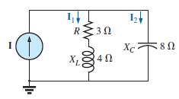

**Solution:**

1. Redrawing the circuit as in Figure below, we have:

$$Z_{1}=R+jX_{L}=3 Ω+ j 4 Ω= 5 Ω ∠53.13°$$

$$Z_{2}=-jX_{L}=- j 8 Ω= 8 Ω ∠-90°$$

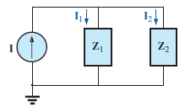

Using the current divider rule yields:

$$I_{1}=\frac{ Z_{2} I}{Z_{1}+Z_{2}}=\frac{(8 Ω ∠-90°)(50 A ∠30°)}{3 Ω+ j 4 Ω- j 8 Ω}=\frac{400 A ∠-60°}{3 - j4}$$

$$I_{1}=\frac{400 A ∠-60°}{5 ∠-53.13°}=80 A ∠-6.87°$$

$$I_{1}=\frac{ Z_{1} I}{Z_{1}+Z_{2}}=\frac{(5 Ω ∠53.13°)(50 A ∠30°)}{5 ∠-53.13°}=\frac{250 A ∠83.13°}{5 ∠-53.13°}=50 A ∠136.26°$$

$$I=I_{1}+I_{2}$$

$$50 A ∠30°=80 A ∠-6.87°+50 A ∠136.26°$$

$$= \left(79.43 - j 9.57\right)+ \left(-36.12 + j 34.57\right)=43.31 + j 25.0$$

$$50 A ∠30°=50 A ∠30° (checks)$$