**Connective tissue**

**Connective tissue is the most abundant and the most widely distributed of the tissues. Connective tissues perform a variety of functions including support and protection. All connective tissue consists of three main components: fibers, ground substance and cells.**

**Connective Tissue Fibers:**

1. **Collagen Fibers**
2. **Elastic Fibers**
3. **Reticular Fibers**

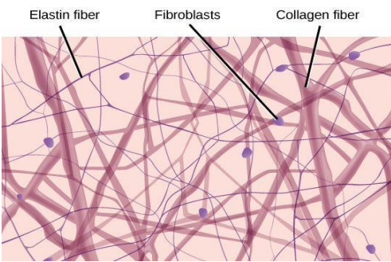

**Connective Tissue Matrix**

**The CT matrix contains variety of fibers (collagen and elastic), and ground substance that occupies the spaces between the cells and fibers. The ground substance is a viscous, clear with high water content. The matrix provides**

**mechanical and structural support as well as tensile strength for the tissues. It also provides pathways for cell migration, and cell differentiation. It facilitates cell communication (transmission of molecules and information across the plasma membranes).**

**Connective Tissue Cells:**

**Cells in connective tissue can be divided into two group:**

1. **The resident cells: Cells that develop and remain in the connective tissue (fibroblasts, Fat cells, Mast cells and Mesenchymal cells).**
2. **Transient cells: Cells that migrate from blood and stay transiently (Neutrophils, Eosinophil, Plasma cells, T-cells and Macrophages).**

**Types of Connective Tissues:**

1. **Loose connective tissue: This type of tissue has a relatively large proportion of ground substance or cells or both cells and ground substance. The fibers are very few. Adipose, or fat tissue, is an example of loose connective tissue.**

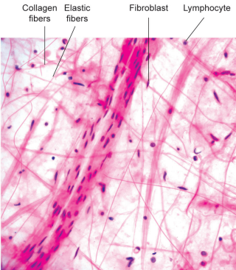

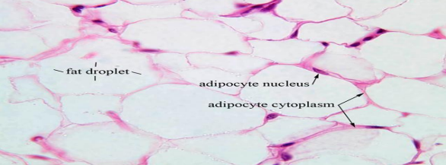

**2- Dense connective tissue: It has thicker, denser fibers and fewer cells. The matrix is made up mostly of collagen fibers, with fibroblasts arranged in rows. This type of connective tissue forms tendons and ligaments, which attach muscle to bone and bone to bone, respectively.**

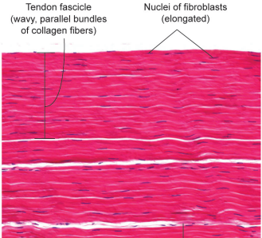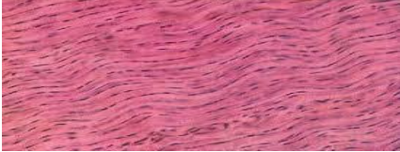

**There are 2 types of dense connective tissue: regular, and irregular. Dense Regular Connective Tissue: This type of tissue provides strong connection between different tissues. In dense regular connective tissue, the collagen fibers are bundled in a parallel fashion.**

**Dense Irregular Connective Tissue: This tissue has fibers that are not arranged in parallel bundles as in dense regular connective tissue. This type of connective tissue produces the tough coverings that package organs, such as the capsules of the kidneys and adrenal glands.**

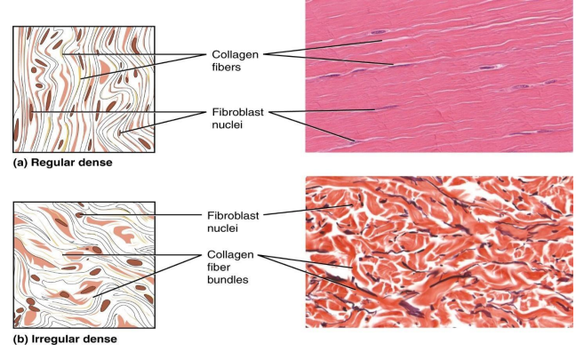

**3- Specialized Connective Tissue: The specialized connective tissues include supportive connective tissues or skeletal tissues (cartilage and bone) and vascular or fluid tissues (blood and lymph).**