**قــســــــــــم الامــــــــــــــــــــــــــن الــــــــــــــــــــــــــــــــــــسيبرانــــــــــــــــــــــــــــــــــــي**

**Department of Cyber Security**

**Subject:**

**COMPUTER ORGANIZATION & LOGIC DESIGN**

**Class:**

**First**

**Digital Logic Lab: (1)**

**Msc :Muntather AL-mussawee**

1. **NOR** Q = A + B (+ OR) (OR With NOT)

|  |  |  |  |
| --- | --- | --- | --- |
| A | B | A + B | Q |
| 0 | 0 | 0 | 1 |
| 0 | 1 | 1 | 0 |
| 1 | 0 | 1 | 0 |
| 1 | 1 | 1 | 0 |

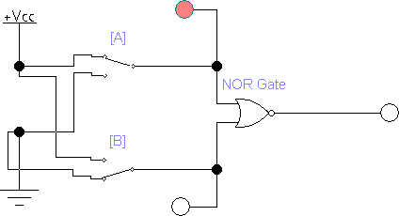

1. **NAND** Q = AB (AND With NOT)

|  |  |  |  |
| --- | --- | --- | --- |
| A | B | AB | Q |
| 0 | 0 | 0 | 1 |
| 0 | 1 | 0 | 1 |
| 1 | 0 | 0 | 1 |
| 1 | 1 | 1 | 0 |

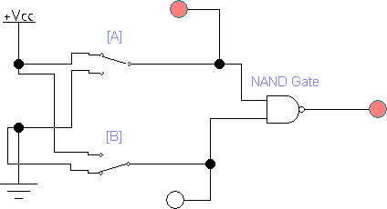

1. **XOR** Q = A⊕B (Exclusive OR) Q = AB + AB

|  |  |  |
| --- | --- | --- |
| A | B | Q |
| 0 | 0 | 0 |
| 0 | 1 | 1 |
| 1 | 0 | 1 |
| 1 | 1 | 0 |

|  |  |  |  |  |  |  |  |
| --- | --- | --- | --- | --- | --- | --- | --- |
| A | B | B‾ | AB‾ | Ā | ĀB | AB + AB | Q |
| 0 | 0 | 1 | 0 | 1 | 0 | 0 | 0 |
| 0 | 1 | 0 | 0 | 1 | 1 | 1 | 1 |
| 1 | 0 | 1 | 1 | 0 | 0 | 1 | 1 |
| 1 | 1 | 0 | 0 | 0 | 0 | 0 | 0 |

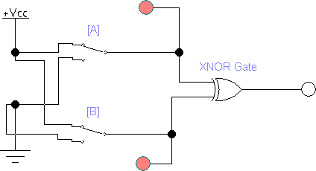

XOR Gate

1. **XNOR** Q = A⊕B (Exclusive NOR) Q = AB + AB

|  |  |  |  |
| --- | --- | --- | --- |
| A | B | A⊕B | Q |
| 0 | 0 | 0 | 1 |
| 0 | 1 | 1 | 0 |
| 1 | 0 | 1 | 0 |
| 1 | 1 | 0 | 1 |

XOR With NOT → **XNOR**

|  |  |  |  |  |  |  |  |  |
| --- | --- | --- | --- | --- | --- | --- | --- | --- |
| A | B | B | AB | Ā | AB | AB + AB | Not | Q |
| 0 | 0 | 1 | 0 | 1 | 0 | 0 | 1 | 1 |
| 0 | 1 | 0 | 0 | 1 | 1 | 1 | 0 | 0 |
| 1 | 0 | 1 | 1 | 0 | 0 | 1 | 0 | 0 |
| 1 | 1 | 0 | 0 | 0 | 0 | 0 | 1 | 1 |

Q =( A+B ) (A + B) → XNOR

|  |  |  |  |  |  |  |  |
| --- | --- | --- | --- | --- | --- | --- | --- |
| A | B | B | A+B | Ā | A+B | (A+B)(A+B) | Q |
| 0 | 0 | 1 | 1 | 1 | 1 | 1 | 1 |
| 0 | 1 | 0 | 0 | 1 | 1 | 0 | 0 |
| 1 | 0 | 1 | 1 | 0 | 0 | 0 | 0 |
| 1 | 1 | 0 | 1 | 0 | 1 | 1 | 1 |

