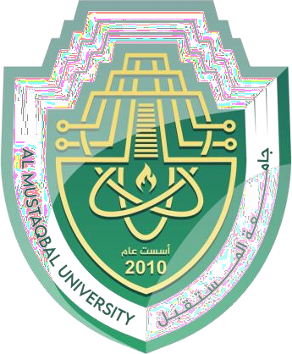

# AL-Mustaqbal University

**College of Medical Technology**

**Department of Medical Laboratory Technology**

**Practical Immunology 2023**

**LAB 🔬 3 Stage 3rd**

**A.Lecture :**

**M.Sc Ruqaya kareem abass M.Sc Zahraa Ahmad**

**Immune system sturcture**

The immune system is composed of organs\tissues, cells and processes that work together to protect the human body from catching infections and killing any microbe that is considered as foreign. The immune system tissues\organs are which are primary (generative) and secondary parts divided into two (peripheral).

**The primary lymphoid organs are:**

1. The bone marrow.
2. The thymus gland

**While the secondary are:**

1. Spleen.
2. Lymph vessels and nodes.
3. Epithelial and mucosa associated lymphoid tissues (e.g. Peyer patches in the small intestine). Thymus gland(located behind the breastbone above the heart), which plays a central role in the cellular immune system and bone marrow it is the site where blood cells are formed .



Only two pages were converted.

Please **Sign Up** to convert the full document.

[**www.freepdfconvert.com/membership**](https://www.freepdfconvert.com/membership)