

# AL-Mustaqbal University

**College of Medical Technology**

**Department of Medical Laboratory Technology Practical Immunology 2023**

**LAB 4**

**Stage 3rd**

**A.Lecture :**

**M.Sc Ruqaya kareem abass M.Sc Zahraa Ahmad**

# Phagocytosis

**Phagocytosis:** is the engulfment and degradation of microbes and other particulate matter by cells such as macrophages, dendritic cells, neutrophils and inactivated B cells.

During bacterial infection, the number of circulating phagocytic cells often increases. The main functions of phagocytic cells include migration, chemotaxis, ingestion, and microbial killing.

# Initiation of Phagocytosis

1. **Recognition and attachment of microbes by phagocytes**

Phagocytosis is initiated when a phagocyte binds a cell or molecules that has penetrated the body barriers. The binding occurs at various receptors on the phagocyte surface. These include

* + (PRRs and TLR) that recognize microbe related receptor,
  + complement receptor (CR) that recognize certain fragments of complement that adhere to microbial surface
  + Fc receptor that recognize immunoglobulins that have bound to microbial surfaces or other

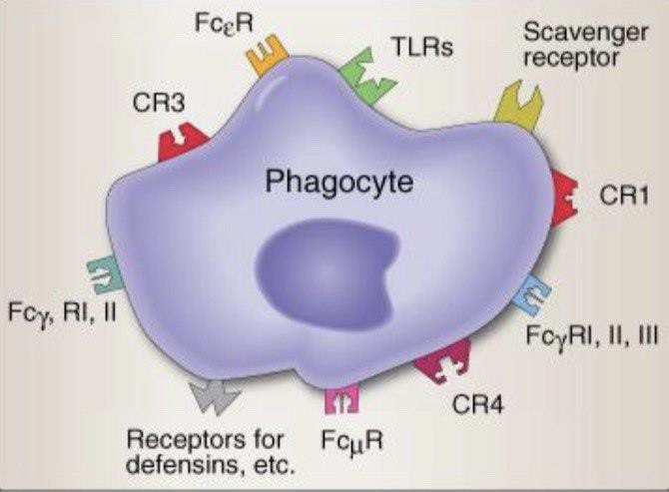

Figure (1): Phagocyte receptors

1. **Ingestion of microbes and other materials**

Fallowing attachments to the cell membrane, a microorganism is engulfed by extensions of the cytoplasm and cell membrane called pseudopodia and is drawn into the cell by internalization or endocytosis.

The attachment and ingestion of microbes trigger changes within phagocytes. It increases the size, become more aggressive in seeking additional microbes to bind and ingest, and elevates production of certain molecules

1. **Destruction of microbes and other materials**

The phagosome fuse with lysosomes to form phagolysosomes. Lysosomes employ several mechanisms for killing and degrading ingested matter.

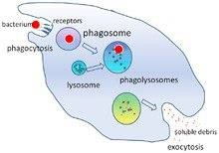

Figure (2): Steps of phagocytosis

1. **Secretion of cytokines and chemokines**

Once activated, phagocytes secrete cytokines and chemokines that attract and activate other cells of the innate immune response. Cytokines or (chemical messenger) induce the production of proteins that lead to elevation body temperature and other cytokines increase the permeability of local vascular epithelial to enhance the movement of cells and soluble molecules from vasculature into the tissue.