**AL-Mustaqbal University College of Medical Technology**

**Department of Medical Laboratory Technology Practical Immunology 2023**

**LAB ** **8**

**Stage 3rd**

**A.Lecture :**

**M.Sc Ruqaya kareem abass M.Sc Zahraa Ahmed**

**Widal test**

# Introduction:

It is agglutination test employed for the serological diagnosis of Typhoid (Enteric fever).

Enteric fever occurs when pathogenic bacteria like Salmonella typhi (S. typhi), S.paratyphi A, and B infect the human body and through disease course, the body responds to bacterial antigenic stimulus by producing antibodies.

Widal test is an advanced way to check for antibodies that your body makes against the salmonella .It looks for O and H antibodies in a patient’s sample blood (serum).

A person with typhoid fever will experience symptoms like fatigue, high fever, headache, diarrhoea or constipation, abdominal pain, weight loss, and red spots.

***Principle*:**

*Salmonella* antigen suspensions are mixed with patient serum; if anti-*Salmonella* antibodies are present in the patient serum react with antigen suspensions to give agglutination.

***Specimen*:** freshly or stored serum may be used to this test. **Reagents: Widal test kit should be containing set of the following:** S.typhi (H)

S.typhi (O) S.paratyphi A (H) S.paratyphi A (O) S.paratyphi B (H) S.paratyphi B (O) S.paratyphi C (H) S.paratyphi C (O)

1

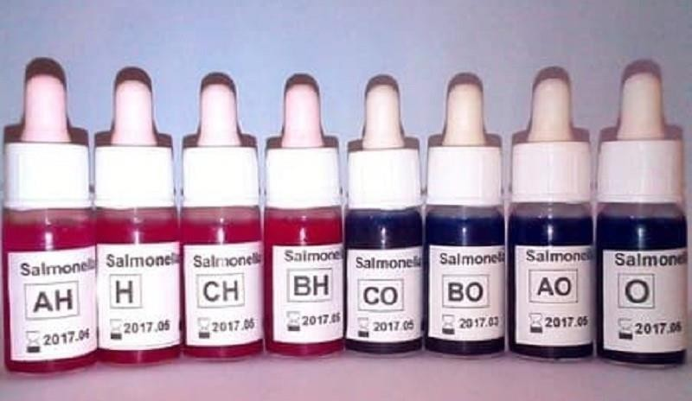

# Procedure:

* Slide screen test (qualitative):

1. Place one drop (~50μl) of patient serum to be tested onto eight reaction circles of the glass slide.
2. Add one drop each of O, H, AO, AH, BO, BH, CO, and CH antigens onto serum drops in the eight reaction circles.
3. Mix contents of each circle uniformly by mixing sticks.
4. Rock the slide, gently and observed of agglutination macroscopically within one minute.

** Rapid slide titration (Slide semi quantitative method):

1. Using a pipette, place 80, 40, 20, 10 and 5μl of undiluted patient serum to be tested on five circle reactions on the glass slide (which showed agglutination with the test sample in the screening method).
2. Shake the reagent and add one drop of undiluted antigen suspension to each serum aliquot on the circle reactions.
3. Mix contents of each circle uniformly over the reaction circles by mixing sticks.
4. Read the observe agglutination within one minute.

2

# Result

* + Slide screen method:

**Agglutination** is a positive test result and indicates presence of clinically significant levels of the corresponding antibody in the patient serum.

No agglutination is a negative test result and indicates absence antibody in the patient serum.

**Slide semi quantitative method:

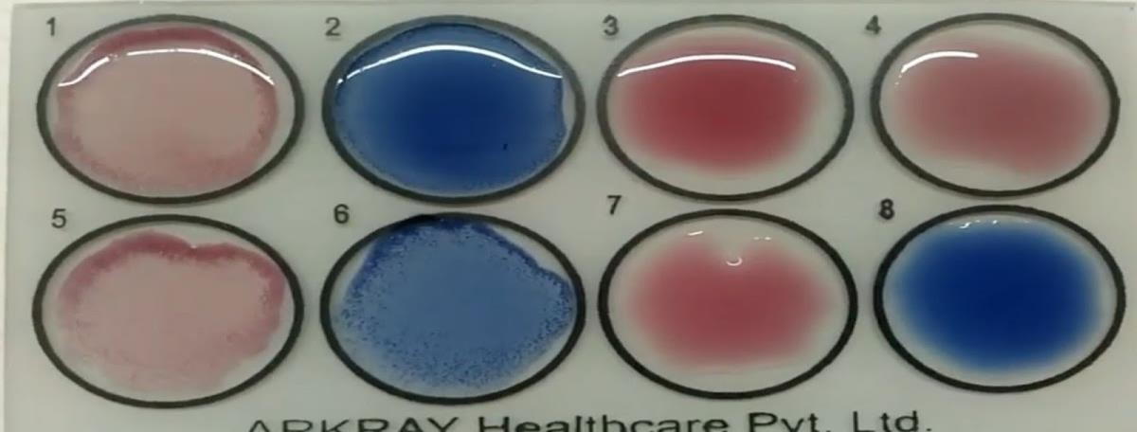**Agglutination** is a positive test result. The titer of serum patient corresponds to the visible agglutination with the smallest amount of serum specimen (Titer obtained by this method will be 1:20, 1:40, 1:80, 1:160, and 1:320).

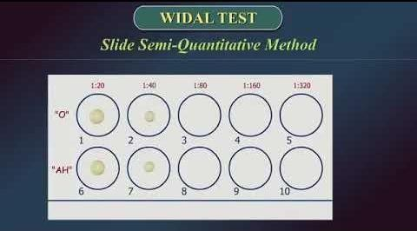

3

**Rose Bengal test**

# Introduction:

Human brucellosis fever is a common febrile illness caused by infection either by

Brucella abortus or Brucella melitensis. This fever is associated with symptoms which are chills, fever, sweats and anorexia.

The human body responds to the antigenic bacterial by producing specific antibody, which can be detectable with a few weeks after exposure and are importance in the diagnosis of brucellosis. The Brucella infection and titer Ab. can be obtained by used of **Rose Bengal test**

# Principle:

The colored and killed Brucella Ag suspension is mixed with patient serum, agglutination may be observed if specific Ab. is present in patient serum which can react with the Ag suspension while no agglutination indicates the absence of detectable levels of specific Abs. to Brucella infect.

# Reagent:

The Brucella reagent kit contains specific killed suspension of Brucella Ag colored with rose Bengal stain having specific reactivity towards anti-Brucella Ab. With positive and negative controls.

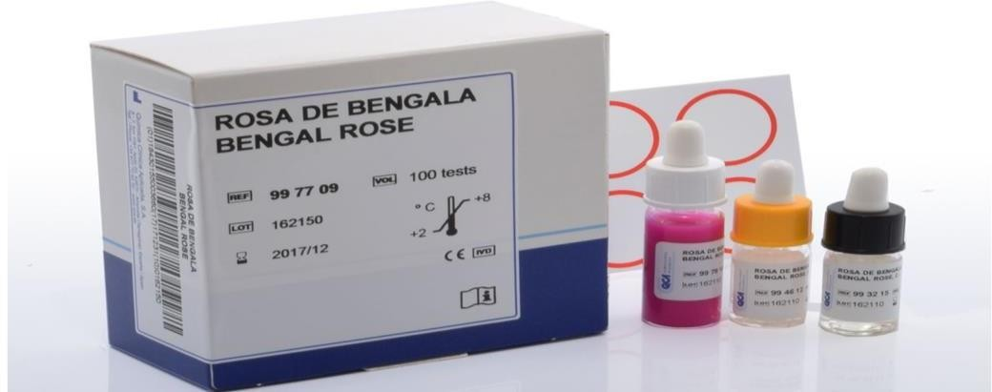

4

# Specimen:

Serum may require for this test.

# Procedure:

* Slide screen test (qualitative):

1. Place 50μl of patient serum to be tested onto reaction circle.
2. Add one drop of Brucella Ag suspension above circle containing serum patient.
3. Mix contents of circle uniformly by mixing stick.
4. Gently rock the slide and observe agglutination macroscopically at 1- 4 min.

** Rapid slide titration (Slide semi quantitative method):

1. Using a pipette, place 80, 40, 20, 10, and 5μl of serum patient to be tested on 5 different circles on the glass slide.
2. Place one drop of Brucella Ag suspension above each circles containing serum.
3. Mix contents of each circle uniformly by mixing stick.
4. Gently rock the slide and observe agglutination macroscopically at 1- 4 min.

# Results:

* + Slide screen method:

Agglutination is a positive test result and indicates to presence

of specific Ab. against Brucella in patient serum. But No agglutination is a negative test result and indicates absence of specific Ab. to Brucella in serum.

** Slide semi quantitative method:

Agglutination is a positive test result. The minimum

amount of serum sample that gives agglutination represent the titer of Abs. in patient

5

serum can react with Brucella Ag suspension.

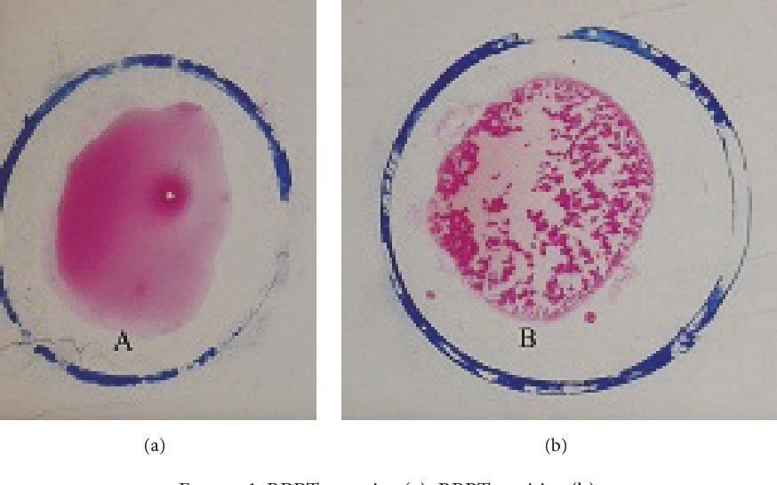

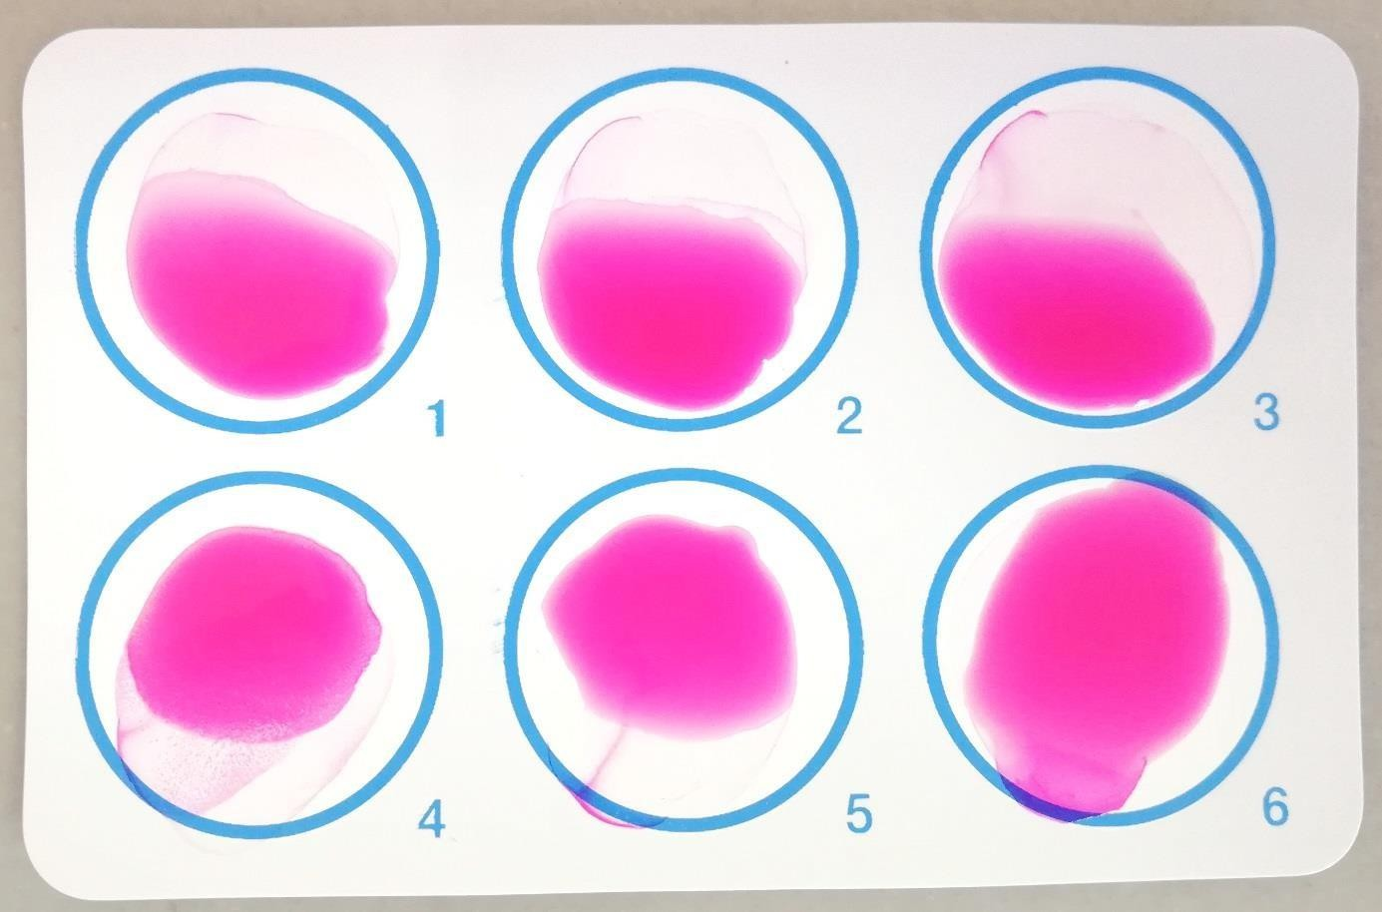

6