**Practical Immunology Lab : 7**



**AL-Mustaqbal University College of Medical Technology**

**Department of Medical Laboratory Technology Practical Immunology 2023**

**LAB ** **7**

**Stage 3rd**

**A.Lecture :**

**M.Sc Ruqaya kareem abass M.Sc Zahraa Ahmed**

# Human Chorionic Gonadotropin (HCG) test

**HCG test:** is a classic example of agglutination used for early detected of the presence of HCG.

**HCG** is a glycoprotein hormone secreted by developing placenta shortly after fertilization and reaches detectable levels in urine and serum about 1 week after implantation attachment of the early embryo to the uterine lining.

**HCG** consists of two subunits, alpha and beta. The ß subunit is the most sensitive and specific test for early pregnancy.

# Latex agglutination test:

Is one of agglutination test, based on using synthetic particles called **latex beads** (polystyrene material); they act as carrier for soluble antigen in agglutination tests. **Latex particles coated with monoclonal antibodies anti-HCG are agglutinated when mixed with specimen containing HCG.**

# Principle

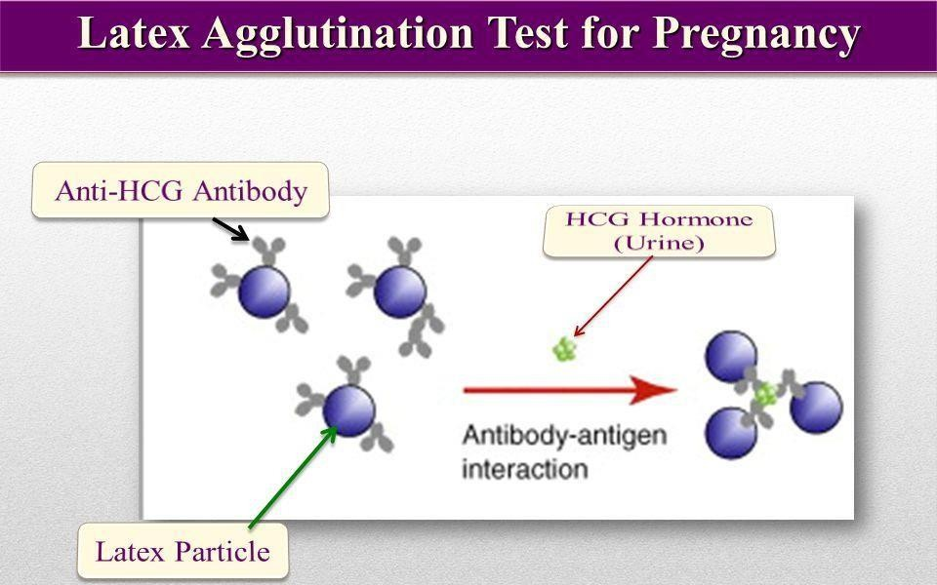The HCG-latex is a slide agglutination test for direct qualitative detection of HCG in urine and serum.

1

# Reagents:

1. Latex particles coated with monoclonal antibodies anti-HCG,
2. Control positive (Red cap).
3. Control negative (Blue cap).

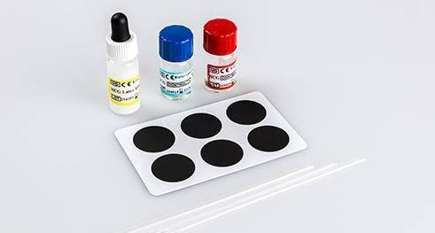

**Samples:** Urine or fresh serum can be used.

# Procedure

* 1. Place one drop of (urine or serum) sample (50µL) on to the reaction area of the slide using a disposable pipette.
  2. Shake the latex reagent, then add one drop and mix using a stirrer.
  3. Gently and evenly rock and rotate the test slide for 2 minutes and under direct strong light source examine the slide for agglutination.

A **positive result** is indicated by the obvious agglutination of the latex in clear solution

# 2. Pregnancy Strip Test:

The Pregnancy Test Strip is a rapid, one-step lateral flow immunoassay for the qualitative detection of HCG in urine/serum to detection of pregnancy women.

2

# Principles:

the (HCG) present in urine or serum bind to anti-HCG on strip test and this binding give color product (positive result), but if this binding don’t give color (negative result)..

# Procedure:

**Collection and preparation of specimen:**

* **Urine:** Firstly morning urine specimen should be collected in clean container.
* **Serum**: can be obtained by separated it from centrifuged of blood specimen.

# Procedure:

1. Remove test strip from its foil pouch.
2. Carefully immerse strip vertically into (urine/serum) specimen.
3. The strip left specimen when full absorbance.
4. Interpret test results at 3-5 min. and do not interpret test results after 5 minutes.

# Results Interpretations:

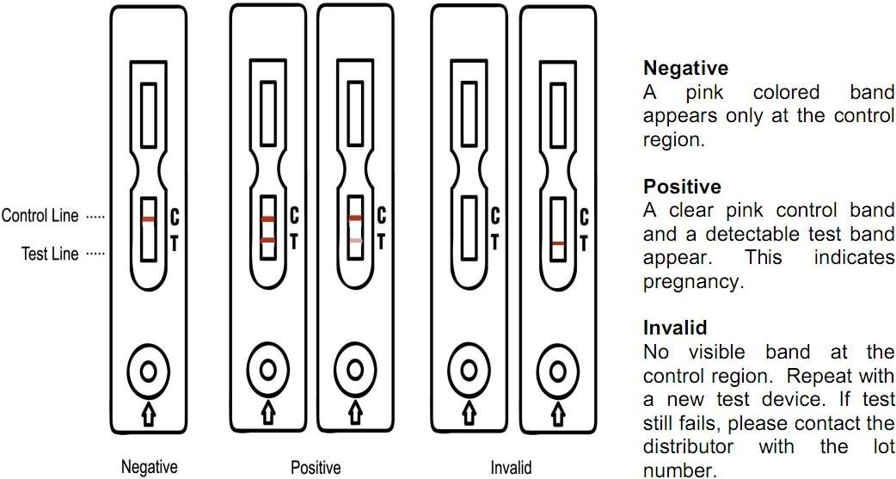

3

**Clinical Implications:**

1. **Positive result:** indicates pregnancy

# False-positive result:

-ectopic pregnancies

-ovarian cysts

-fertility drugs containing HCG

-prostate cancer, breast cancer and lung cancer

1. **Negative result**: probably not pregnant.

# False-negative result:

**-**The test is past its expiration date.

**-**use the test the wrong way.

* tested too soon.
* the urine sample is too dilute

4