**كلية العلوم**

**قــســــــــــم الانظمة الطبية الذكية**

**Lecture: (9)**

**Subject:** **Medical image processing**

**Level:** **Third**

**Lecturer:** **Asst. Lecturer Qusai AL-Durrah**

**2.1 Image Resolution**

The resolution has to do with ability to separate two adjacent pixels as being separate, and then we can say that we can resolve the two. The concept of resolution is closely tied to the concepts of spatial frequency.

Spatial frequency concept, frequency refers to how rapidly the signal is changing in space, and the signal has two values for brightness-0 and maximum. If we use this signal for one line (row) of an image and then repeat the line down the entire image, we get an image of vertical stripes. If we increase this frequency the stripes get closer and closer together, until they finally blend together.

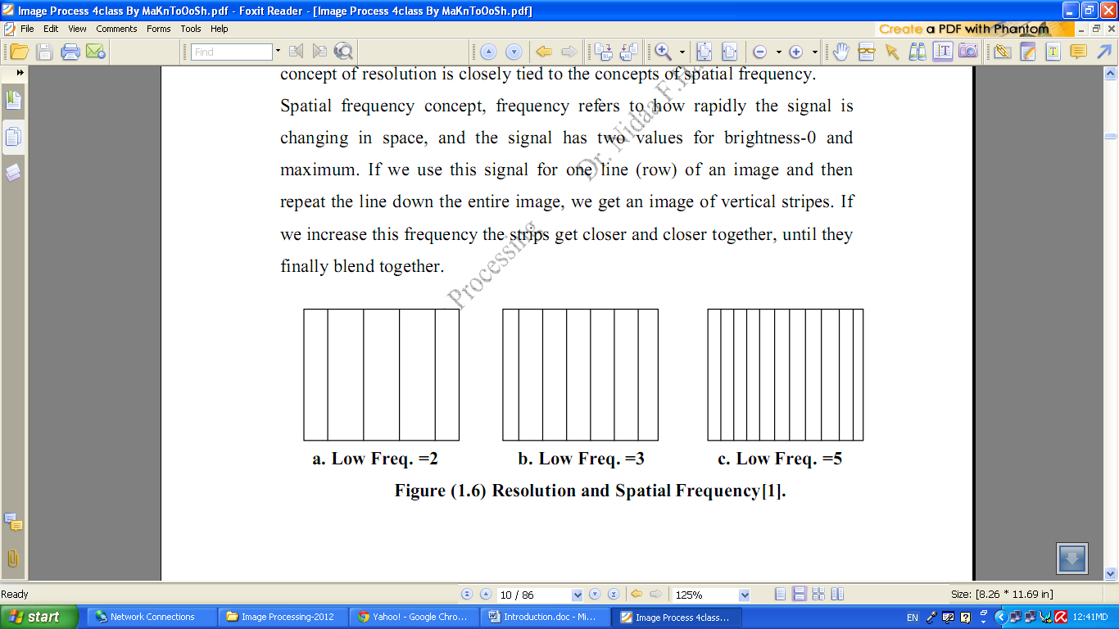

a. Low Freq. =2 b. Low Freq. =3 c. Low Freq. =5

Figure (2.1) Resolution and Spatial Frequency.

**2.2 Image brightness Adaption**

In image we observe many brightness levels and the vision system can adapt to a wide range. If the mean value of the pixels inside the image is around Zero gray level then the brightness is low and the images dark but for mean value near the 255 then the image is light. If fewer gray levels are used, we observe false contours bogus lines resulting from gradually changing light intensity not being accurately represented.

**2.3 Image Representation**

We have seen that the human visual system (HVS) receives an input image as a collection of spatially distributed light energy; this is form is called an optical image. Optical images are the type we deal with every day –cameras captures them, monitors display them, and we see them [we know that these optical images are represented as video information in the form of analog electrical signals and have seen how these are sampled to generate the digital image I(r , c).

The digital image I (r, c) is represented as a two- dimensional array of data, where each pixel value corresponds to the brightness of the image at the point (r, c). in linear algebra terms, a two-dimensional array like our image model I( r, c ) is referred to as a matrix , and one row ( or column) is called a vector.

The image types we will consider are:

**1. Binary Image**

Binary images are the simplest type of images and can take on two values, typically black and white, or ‘0’ and ‘1’. A binary image is referred to as a 1 bit/pixel image because it takes only 1 binary digit to represent each pixel.

These types of images are most frequently in computer vision application where the only information required for the task is general shapes, or outlines information.

Binary images are often created from gray-scale images via a threshold value is turned white (‘1’), and those below it are turned black (‘0’).

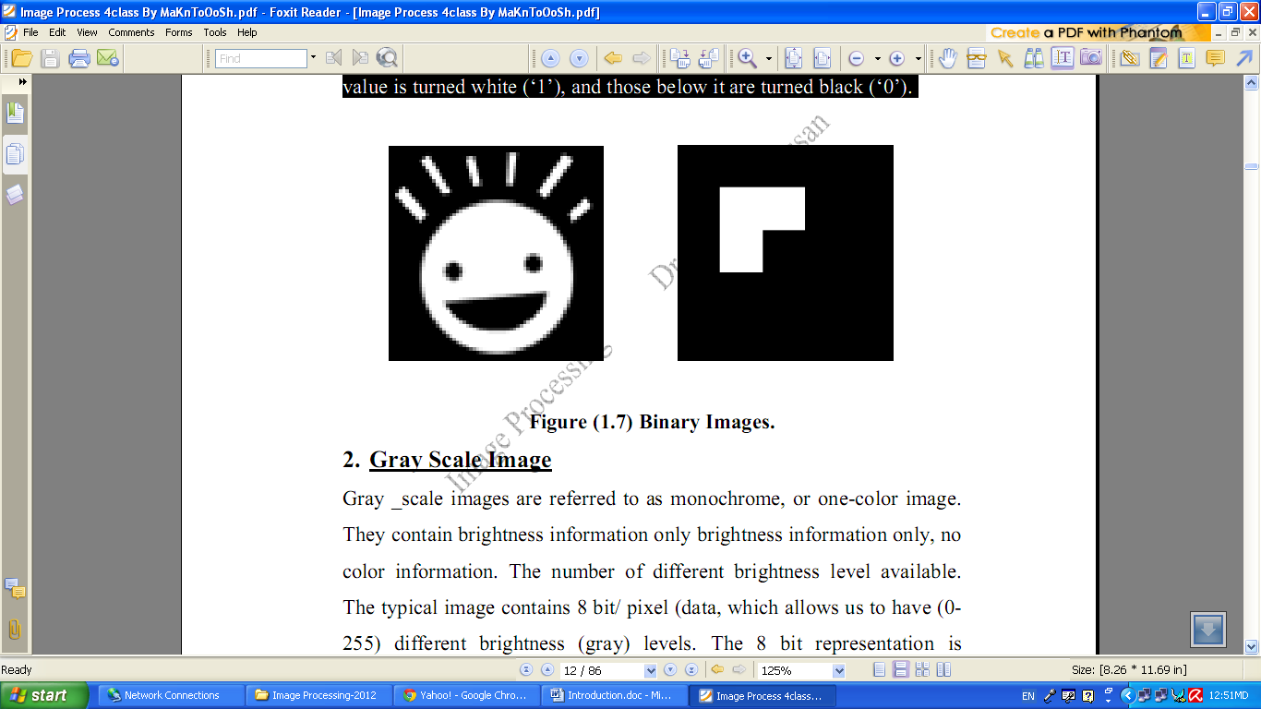

Figure (2.2) Binary Images.

**2. Gray Scale Image**

Gray _scale images are referred to as monochrome, or one-color image. They contain brightness information only brightness information only, no color information. The number of different brightness level available. The typical image contains 8 bit/ pixel (data, which allows us to have (0-255) different brightness (gray) levels. The 8 bit representation is typically due to the fact that the byte, which corresponds to 8-bit of data, is the standard small unit in the world of digital computer.

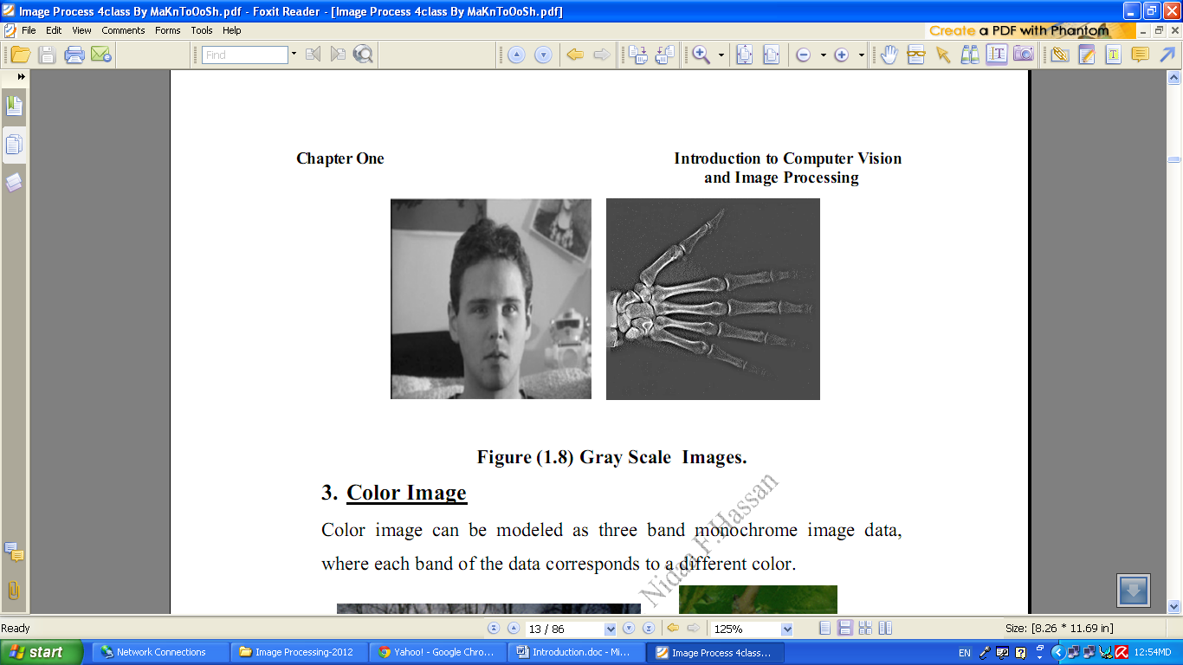

Figure (2.3) Gray Scale Images.

**2.4 Color Image**

Color image can be modeled as three band monochrome image data, where each band of the data corresponds to a different color.

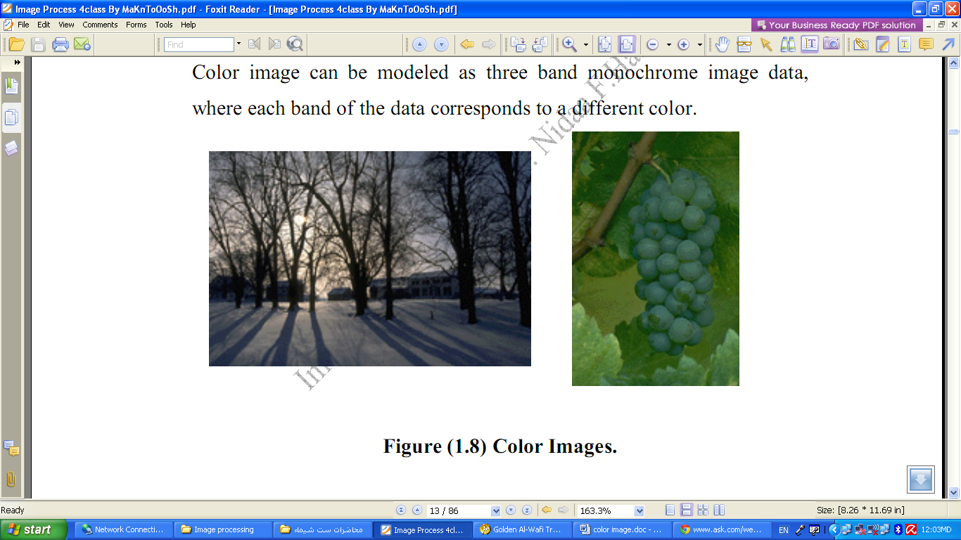

Figure (2.4) Color Images.

The actual information stored in the digital image data is brightness information in each spectral band. When the image is displayed, the corresponding brightness information is displayed on the screen by picture elements that emit light energy corresponding to that particular color.

RGB Typical color images are represented as red, green, and blue or images. using the 8-bit monochrome standard as a model, the corresponding color image would have 24 bit/pixel – 8 bit for each color bands (red, green and blue). The following figure we see a representation of a typical RGB color image.

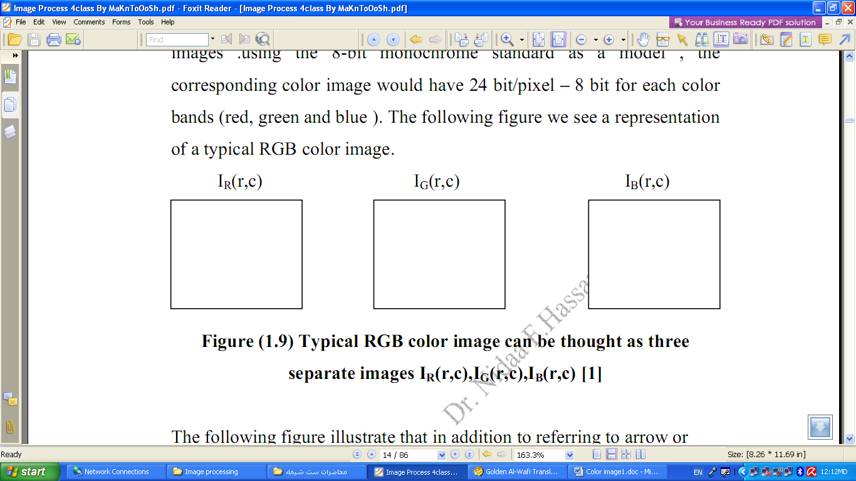

Figure (2.5) Typical RGB color image can be thought as three

separate images IR(r,c),IG(r,c),IB(r,c)

The following figure illustrate that in addition to referring to arrow or column as a vector, we can refer to a single pixel red ,green, and blue values as a color pixel vector –(R,G,B ).

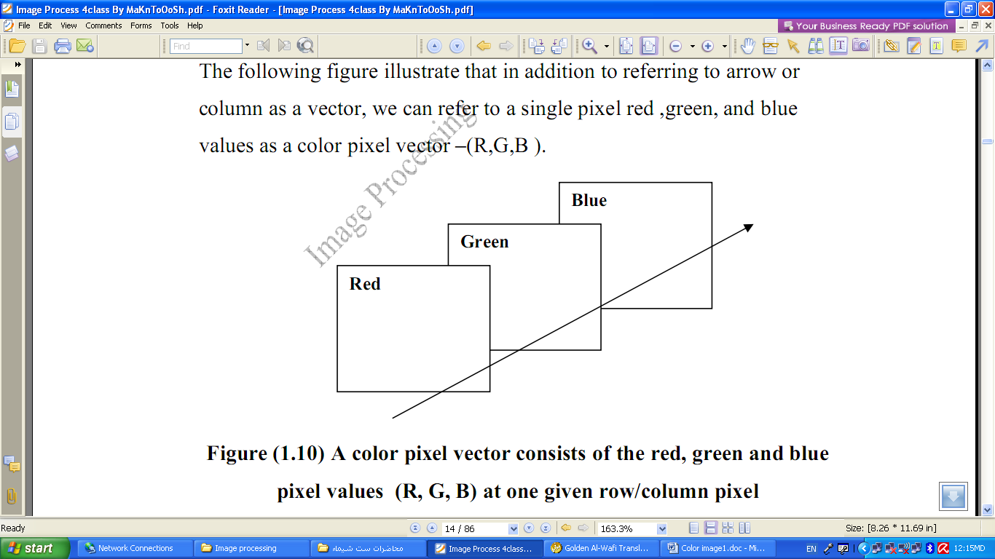

Figure (2.6) A color pixel vector consists of the red, green and blue pixel values (R, G, B) at one given row/column pixel coordinate( r , c).

For many applications, RGB color information is transformed into mathematical space that decouples the brightness information from the color information.

The hue/saturation /lightness (HSL) color transform allows us to describe colors in terms that we can more readily understand.

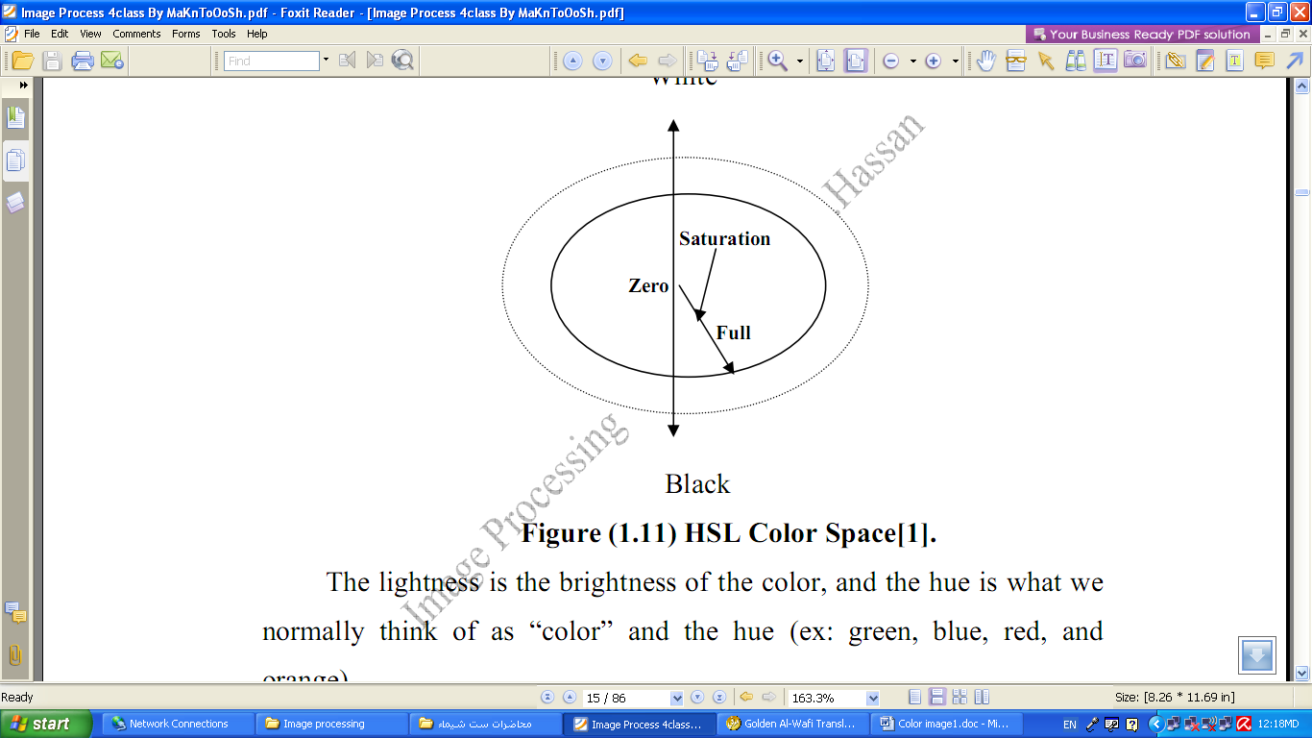

Figure (1.12) HSL Color Space.

The lightness is the brightness of the color, and the hue is what we normally think of as “color” and the hue (ex: green, blue, red, and orange).

The saturation is a measure of how much white is in the color (ex: Pink is red with more white, so it is less saturated than a pure red).

[Most people relate to this method for describing color}.

Example: “a deep, bright orange” would have a large intensity (“bright”), a hue of “orange”, and a high value of saturation (“deep”).we can picture this color in our minds, but if we defined this color in terms of its RGB components, R=245, G=110 and B=20.

Modeling the color information creates a more people oriented way of describing the colors.

**4. Multispectral Images**

Multispectral images typically contain information outside the normal human perceptual range. This may include infrared, ultraviolet, X-ray, acoustic or radar data. Source of these types of images include satellite systems underwater sonar systems and medical diagnostics imaging systems.

**2.5 Digital Image File Format**

Why do we need so many different types of image file format?

• The short answer is that there are many different types of images and application with varying requirements.

• A more complete answer, also considers market share proprietary information, and a lack of coordination within the imaging industry.

Many image types can be converted to one of other type by easily available image conversion software. Field related to computer imaging is that computer graphics.

**Computer Graphics:**

Computer graphics is a specialized field within that refers to the computer science realm that refers to the reproduction of visual data through the use of computer.

In computer graphics, types of image data are divided into two primarily categories:

1. Bitmap image (or raster image): can represented by our image model I(r, c), where we have pixel data and corresponding brightness values stored in file format.

2. Vector images: refer to the methods of representing lines, curves shapes by storing only the key points. These key points are sufficient to define the shapes, and the process of turning theses into an image is called rendering after the image has been rendered, it can be thought of as being in bit map format where each pixel has specific values associated with it.

Most the type of file format fall into category of bitmap images. In general, these types of images contain both header information and the raw pixel data. The header information contain information regarding

1. The number of rows (height)

2. The number of columns (Width)

3. The number of bands.

4. The number of bit per pixel.

5. The file type

6. Additionally, with some of the more complex file formats, the header may contain information about the type of compression used and other necessary parameters to create the image, I(r,c).

**Image File Format:**

**1. BMP format:**

It is the format used by the windows, it’s a compressed format and the data of image are located in the field of data while there are two fields, one for header (54 byte) that contains the image information such as (height ,width , no. of bits per pixel, no of bands , the file type).

The second field is the color map or color palette for gray level image, where its length is 0-255).

**2. Bin file format:**

It is the raw image data I(r,c) with no header information.

**3. PPM file format:**

It contain raw image data with simplest header, the PPM format, include PBM(binary),PGM(gray),PPM (color), the header contain a magic number that identifies the file.

**4. TIFF (Tagged Image File Format) and GIF(Graphics Interchange Format):**

They are used on World Wide Web (WWW). GIF files are limited to a maximum of 8 bits/pixel and allows for a type of compression called LZW. The GIF image header is 13 byte long & contains basic information.

**5. JPEG (Joint photo Graphic Experts Group):**

It is simply becoming standard that allows images compressed algorithms to be used in many different computer platforms. JPEG images compression is being used extensively on the WWW. It’s, flexible, so it can create large files with excellent image equality.

**6. VIP(visualization in image processing )formats:**

It is developed for the CVIP tools software, when performing temporary images are created that use floating point representation which is beyond the standard 8 bit/pixel. To represent this type of data the remapping is used, which is the process of taking original image and adding an equation to translate it to the rang (0-225).