***Lacture 2***



***Is a group of organs in the body concerned with filtering out excess fluid and other substances from the blood stream.***

The **Urinary** organs include the: 1- **Kidneys**.

2-ureters.



3-Bladder. 4- Urethra

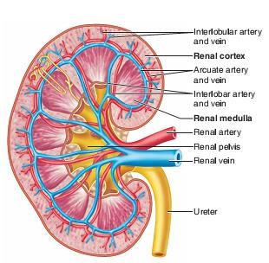



The paired kidneys lie on either side of the vertebral column. Each adult kidney weighs about 160 g and is about 11 cm long A coronal section of the kidney shows two distinct regions

1. The outer cortex is reddish brown.
2. The deeper region, or medulla, is striped in appearance.

The medulla is composed of 8 to 15 conical renal pyramids separated by renal columns.

***The Functions :***

1. **Regulation of plasma ionic composition.**
2. **Regulation of plasma osmolality.** .
3. **Regulation of plasma volume.**
4. **Regulation of plasma hydrogen ion concentration (pH).**
5. **Removal of metabolic waste products and foreign substances from the plasma.**
6. **Secretion of Hormones** e.g.

*A- Renin is released by the kidneys.*

*B- Erythropoietin.*

*C- The Vitamin D from the skin is also activated with help from the kidneys. Calcium (Ca+) absorption from the digestive tract is promoted by vitamin D.*

***Nephrons:***

A nephron is the basic structural and functional unit of the kidney***. Responsible for the formation of urine.***

Each kidney contains more than a ***million*** nephrons.

***A nephron consists of:***

1. **Small tubes *or tubules***.
2. A***ssociated small blood vessels.*** Nephron Tubules

***The tubular portion of a nephron consists of:***

A- A glomerular capsule.

B- A proximal convoluted tubule.

C- A descending limb of the loop of Henle, an ascending limb of the loop of Henle.

D-A distal convoluted tubule.

The (***glomerular renal***) corpuscle filters out large solutes from the blood, delivering water and small solutes to the renal tubule for modification.

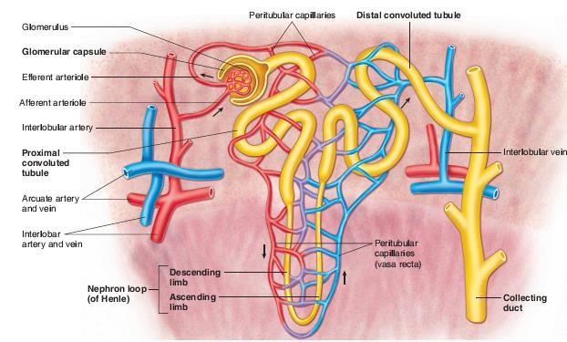 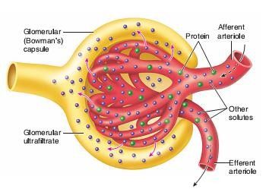

***Glomerulus:***

The glomerulus is a capillary tuft that receives its blood supply from an ***afferent***

arteriole of the renal circulation.

The ***glomerular*** blood pressure provides the driving force for fluid and solutes to be filtered out of the blood and into the space made by ***Bowman's capsule***. The remainder of the blood not filtered into the glomerulus passes into the ***narrower efferent arteriole***.

It then moves into the ***vasa recta***, which are collecting capillaries intertwined with ***the convoluted tubules*** through the interstitial space, where the reabsorbed substances will also enter.

This then combines ***with efferent venules*** from other nephrons into the renal vein, and rejoins with the main bloodstream.

***Formation of Urine :***

Urine is formed in three steps:

1. Filtration.
2. Reabsorption.
3. Secretion.

***Filtration:***

Blood enters the afferent arteriole and flows into the glomerulus. Blood in the glomerulus has both:

***Filterable blood components*** and ***non-filterable blood components***. ***Filterable blood components***:

Move toward the inside of the glomerulus.

While ***non-filterable blood components*** bypass the filtration process by exiting through the efferent arteriole.

Filterable Blood components will then take plasma like form called ***glomerular filtrate***.

***NORMAL GFR (Glomerular filtration rate )***

The GFR in a healthy adult of average size is approximately 125 mL/min. Its magnitude correlates fairly well with surface area, but values in women are 10% lower than those in men even after correction for surface area. A rate of 125 mL/min is 7.5 L/h, or 180 L/d, whereas the normal urine volume is about 1 L/d. Thus, 99% or more of the filtrate is normally reabsorbed. At the rate of 125 mL/min, in 1 day the kidneys filter an amount of fluid equal to four times the

total body water, 15 times the ECF volume, and 60 times the plasma volume.

***A few of the filterable blood components are:***

1. water.
2. nitrogenous waste.
3. Nutrients and salts (ions).

No filterable blood components include formed elements such as:

***Blood cells and platelets along with plasma proteins***.

The glomerular filtrate is not the same consistency as urine, as much of it is reabsorbed into the blood as the filtrate passes through the tubules of the nephron.

***Reabsorption:***

Within the peritubular capillary network, **molecules** and ***ions*** are reabsorbed back into the blood.

***Sodium Chloride*** reabsorbed into the system increases the osmolarity of blood in ***comparison*** to the ***glomerular filtrate***.

This reabsorption process allows water (***H2O***) to pass from the glomerular filtrate back into the circulatory system.

***Glucose and various amino acids*** also are reabsorbed into the circulatory system.

These nutrients have carrier molecules that claimتطلب the glomerular molecule and release it back into the circulatory system. If all of the carrier molecules are used up, ***excess glucose or amino acids are set free into the urine.***

A complication of diabetes is the inability of the body to reabsorb glucose. If too much glucose appears in the glomerular filtrate it increases the osmolarity of the filtrate, causing water to be released into the urine rather than reabsorbed by the circulatory system.

***Frequent urination and unexplained thirst are warning signs of diabetes, due to water not being reabsorbed.***

***Secretion:***

Some substances are removed from blood through the peritubular capillary network into the ***distal convoluted tubule or collecting duct***.

These substances are ***Hydrogen ions***, ***creatinine***, and ***drugs***.

***Urine is a collection of substances that have not been reabsorbed during glomerular filtration or tubular reabsorption.***

***Urine Daily Volume*** :

The normal range for 24-hour urine volume is **800 to 2,000 milliliters per day** (with a normal fluid intake of about 2 liters per day).

***Factors Affecting***:

* Average results are based on your **age and sex**.
* Typically, urine flow runs from 10 ml to 21 ml per second.
* Women range closer to 15 ml to 18 ml per second.
* A slow or low flow rate may mean there is an obstruction at the bladder neck or in the urethra, an enlarged prostate, or a weak bladder.
* ***Maintaining Water-Salt Balance:***

It is the job of the ***kidneys to maintain the water-salt balance of the blood***. They also maintain ***blood volume*** as well as ***blood pressure***.

Simple examples of ways that this balance can be changed ***include ingestion of water, dehydration, blood loss and salt ingestion.***

