6Th ***Lecture***



There are three different types of muscles in the body :

1. Skeletal muscles.
2. Cardiac muscles.
3. Smooth muscles

Based on certain distinctive features the muscles can be grouped as follows.

* + Striated versus non-striated muscles Striated muscle cells show large number of cross-striations at regular intervals when seen under light microscope .
  + Skeletal and cardiac muscles are striated.
  + Non-striated muscle cells do not show any striations .
  + Smooth muscles or the so-called plain muscles are non-striated.
  + All skeletal muscles are voluntary muscles. These are supplied by the somatic motor nerves.
  + Cardiac and all smooth muscles are involuntary muscles .
  + These are innervated by the autonomic nerves.

***Skeletal muscles:***

The skeletal muscles, as the name indicates, are attached with the bones of the body skeleton and their contraction.

***Structural organization of muscle:***

Structurally, the skeletal muscle consists of a large number of muscle fibers and a connective tissue framework organized.

1. Each *muscle fiber* is surrounded by a delicate connective tissue called ***endomysium*,** which contains large quantity of elastic tissue arranged longitudinally.
2. The muscle fibers are grouped into a number of bundles called ***fasciculi****.*
3. Each fasciculus is surrounded by a stronger sheath of connective tissue called

***perimysium.***

1. All the fasciculi collectively form the *muscle belly.*

The connective tissue that surrounds the entire muscle belly is called

*epimysium.*

1. At the junction of the muscle with its tendon, the fibers of endomysium, perimysium and epimysium become continuous with the fibers of the tendon.
2. ***Tendons*** are fibrous terminal ends of the muscles made up of collagen fibers

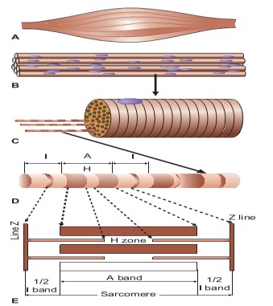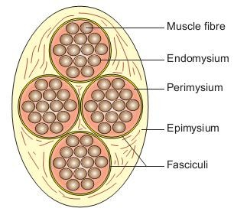

.

***Structure of muscle fiber:***

Each muscle fiber is basically:

* 1. A long (1–40 mm).
  2. Cylindrical ( **111**–**11**( μm in diameter).
  3. Multinucleated cell.
  4. Its cell membrane is called sarcolemma and the cytoplasm is called Sarcoplasm.
  5. Like any other cell, in the sarcoplasm are embedded many structures, the nuclei, Golgi apparatus, mitochondria, sarcoplasmic reticulum, ribosomes, and glycogen and occasional lipid droplets.
  6. In addition, the sarcoplasm mainly contains number of myofibrils which form the main structure of a muscle fiber.
  7. The sarcolemma along with the band the thick (myosin) filaments line up the thin filaments.
  8. In the center of each **A band** there is a lighter **H zone** where thin filaments do not overlap the thick filaments .

(The word H either represents the discoverer, Henson or the hell, which in German means light).

* 1. In the center of each H zone is seen an M line, which is more pronounced , واضحي during muscle contraction.
  2. The light band is called **I band** because it is isotropic to polarized light. It is about 1 μm in length. This area contains only thin (actin) filaments.
  3. Each **I band** is bisected by a narrow **dark Z line** (the word **Z** has been taken from Z Wischenscheibe, which in German means between discs).

The portion of myofibril between two successive **Z lines is called a sarcomere**.

The sarcomere is the structural and functional unit of the muscle fiber. During muscle contraction the sarcomere reduces in length to 1.5 μm and during stretching of the muscle it increases in length to 3.5 μm.

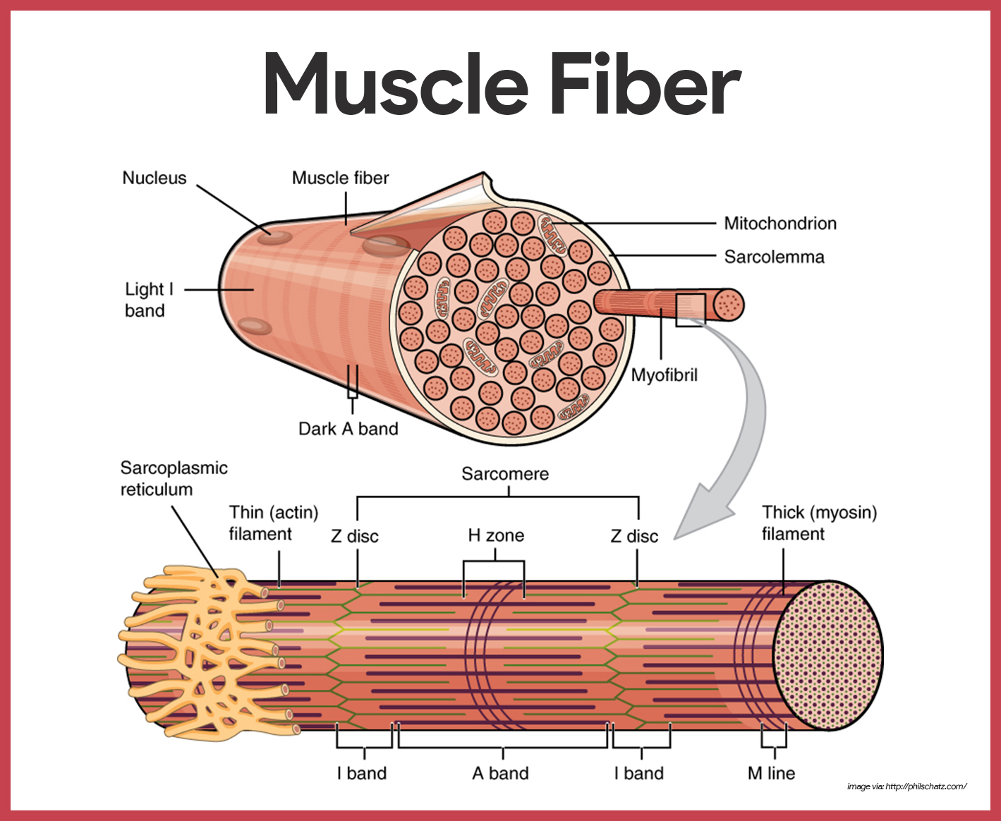

***Process of muscle excitation and contractility:***

* + - As we know, the muscle is an excitable tissue, i.e. when stimulated an action potential is produced (electrical phenomenon).
    - The skeletal muscle responds to stimulus by contracting (***mechanical phenomenon).***
    - The events which link the electrical phenomenon with the mechanical phenomenon is called excitation–contraction coupling phenomenon .

***Skeletal muscle blood flow :***

At rest the blood flow to the skeletal muscle is about 2–4 mL/ 100 g/min of muscle tissue.

During strenuous exercise muscle blood flow can increase up to 20 times, i.e. about 50–80 mL/ 100 g/min muscle tissue.

This is called *exercise hyperaemia.*

This tremendous increase in the muscle blood flow during exercise is made possible by:

1. Arteriolar dilatation.
2. Opening up of the closed capillaries which greatly increase the surface area and the rate of blood.

***Smooth muscle :***

***Characteristic of smooth muscle:***

Certain characteristic features of smooth muscle contraction are as follows: 1- Plasticity

A smooth muscle exhibits the property of plasticity, i.e. it can readjust its resting length (the length at which a muscle generates maximum active tension).

**2**- Latch phenomenon

***It refers to the mechanism by which a smooth muscle can maintain a high tension without actively contracting***.

This phenomenon allows long-term maintenance of tone in many smooth muscle organs. In such a state muscle cannot generate active tension but can effectively resist passive stretching.

***Cardiac muscles:***

Properties of cardiac muscle

1-Automaticity.

1. Rhythmicity.
2. Conductivity.
3. Excitability.
4. Contractility.

***Cardio vascular responses to exercise :***

To meet the increased energy demand of muscles during exercise the primary cardiovascular response is in the form of:

1. Increase in the skeletal muscle blood flow.
2. Redistribution of blood flow in the body.
3. Increase in the cardiac output.
4. Blood pressure changes.
5. Changes in the blood volume.