**4th lecture**

***Reproductive Physiology***

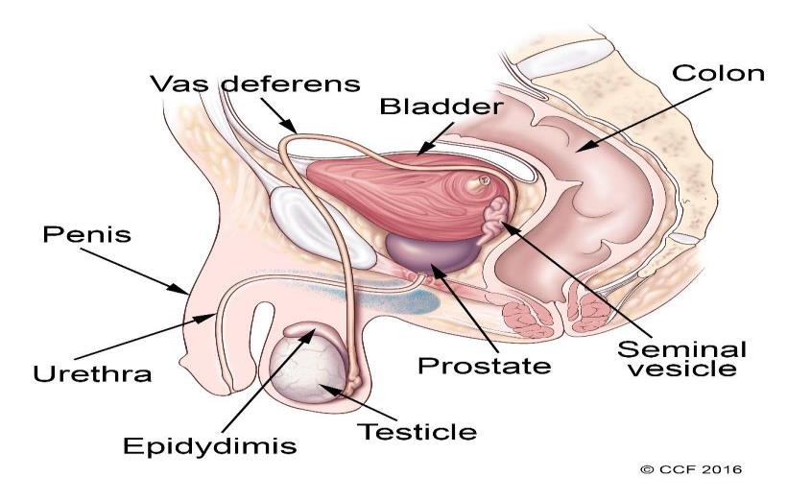

The male reproductive system includes a group of organs that make up a man’s reproductive and urinary system.

These organs do the following jobs within your body:

* + 1. They produce, maintain and transport sperm (the male reproductive cells) and semen (the protective fluid around sperm).
    2. They discharge sperm into the female reproductive tract.
    3. They produce and secrete male sex hormones.

The male reproductive system is made up of:

1. internal (inside your body). **(Vas deferens, prostate and urethra)**.
2. External (outside your body) parts **(penis, scrotum and testicles).**

**REPRODUCTIVE HORMONES FUNCTIONS :**

The entire male reproductive system is dependent on hormones.

The primary hormones involved in the functioning of **the male reproductive system are:**

1. Follicle-stimulating hormone (FSH).

Is necessary for sperm production (spermatogenesis 2- Luteinizing hormone (LH).

LH stimulates the production of testosterone 3- Testosterone.

A- is necessary to continue the process of spermatogenesis.

B- is also important in the development of male characteristics, including muscle mass and strength, fat distribution, bone mass and sex drive.

**The testes:**

1. Secrete large amounts of androgens, principally **testosterone.**
2. They also secrete small amounts of estrogens.

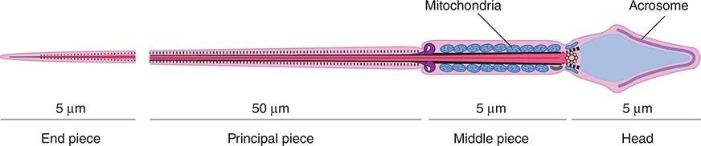



Each sperm is an intricate motile cell, rich in DNA, with a head that is made Up mostly of chromosomal material covering the head like a cap is the **acrosome,** a lysosome-like organelle rich in enzymes involved in sperm Penetration of the ovum and other events associated with fertilization.

The motile tail of the sperm is wrapped in its proximal portion by a sheath holding numerous mitochondria.

**Semen:**

The fluid that is ejaculated at the time of orgasm, The **semen functions:**

1. contains sperm.
2. Secretions of the seminal vesicles.
   * An average volume per ejaculate is 2.5–3.5 mL after several days of abstinence from sexual activity.
   * The volume of semen and the sperm count decrease rapidly with repeated ejaculation.
   * Even though it takes only one sperm to fertilize the ovum, each milliliter of semen normally contains about 100 million sperm.
   * Reduction in sperm production is associated with infertility:

50% of men with counts of 20–40 million/mL and essentially all of those with counts under 20 million/mL are sterile.

* + The presence of many morphologically abnormal or immotile spermatozoa also correlates with infertility.
  + The **prostaglandins** in semen: Which come from the seminal vesicles

Are at high concentrations, but their function in semen is unknown.

The causes of male infertility, as well as the underlying mechanisms of sperm in fertilization, are used as clues in developing male contraception.

***The Female reproductive system:***

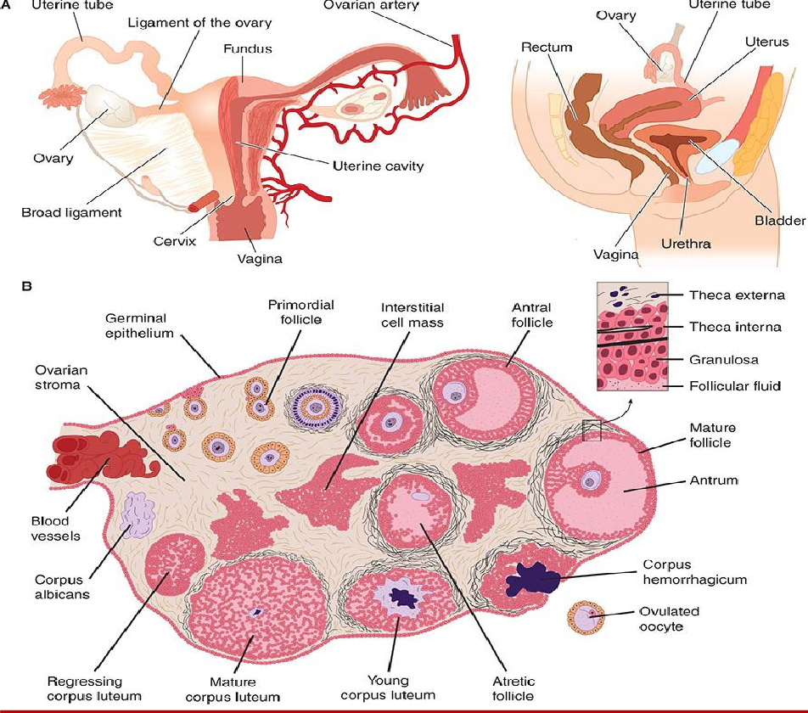

***The menstrual cycle:***

The reproductive system of women shows regular cyclic changes that teleological may be regarded as periodic preparations for fertilization and pregnancy.

* + In humans and other primates, the cycle is a **menstrual cycle**, and its most conspicuous feature is the periodic vaginal bleeding that occurs with the shedding of the uterine mucosa **(menstruation).**
  + The length of the cycle is notoriously variable in women, but an average figure is 28 days from the start of one menstrual period to the start of the next.
  + By common usage, the days of the cycle are identified by number, starting with the first day of menstruation.

**Ovarian Cycle :**

From the time of birth, there are many **primordial follicles** under the ovarian Capsule.

Each contains an immature ovum, at the start of each cycle, several of these follicles enlarge, and a cavity forms around the ovum **(antrum formation).** This cavity is filled with follicular fluid.

In humans;

* Usually one of the follicles in one ovary starts to grow rapidly on about the sixth day and becomes the **dominant follicle,**
* While the others regress, forming **atretic follicles.** It seems to be related to the ability of the follicle to secrete the estrogen inside it that is needed for final maturation.
* When women are given human pituitary gonadotropin preparations by injection, many follicles develop simultaneously.
* The structure of a maturing ovarian **(graafian)** follicle is shown in the primary source of circulating estrogen is the granulosa cells of the ovaries;
* At about the 14th day of the cycle, the distended follicle ruptures, and the Ovum is extruded into the abdominal cavity; this is the process of **ovulation.**
* The ovum is picked up by the oviducts.
* It is transported to the uterus and, unless fertilization occurs, out through the vagina.
* The follicle that ruptures at the time of ovulation promptly fills with blood, forming what is sometimes called a **corpus hemorrhagicum.**
* Minor bleeding from the follicle into the abdominal cavity may cause peritoneal irritation and fleeting lower abdominal pain (mittelschmerz).
* The granulosa and theca cell of the follicle lining promptly begin to proliferate, and the clotted blood is rapidly replaced with yellowish, lipid- rich **luteal cells,** forming the **corpus luteum.**
* This initiates the **luteal phase** of the menstrual cycle, during which the Luteal cells secrete estrogen and progesterone.
* Growth of the corpus luteum depends on its developing an adequate blood supply.
* If pregnancy occurs, the corpus luteum persists and usually there are no more periods until after delivery.
* If pregnancy does not occur, the corpus luteum begins to degenerate about 4 days before the next menses (24th day of the cycle) and is eventually replaced by scar tissue, forming a **corpus albicans.**
* The ovarian cycle in other mammals is similar, except that in many species more than one follicle ovulates and multiple births are the rule.Corpora lutea form in some sub mammalian species but not in others.
* In humans, no new ova are formed after birth.
* During fetal development, the ovaries contain over 7 million primordial follicles.
* However, many undergo atresia (involution) before birth and others are lost after birth.
* At the time of birth, there are 2 million ova, but 50% of these are atretic.
* The million that are normal undergo the first part of the first meiotic division at about this time and enter a stage of arrest in prophase in which those that survive persist until adulthood.
* Atresia continues during development, and the number of ova in both of the ovaries at the time of puberty is less than **300,000**.
* Only one of these ova per cycle (or about 500 in the course of a normal reproductive life) normally reaches maturity; the remainder degenerate.
* Just before ovulation, the first meiotic division is completed. One of the daughter cells.
* the **secondary oocyte,** receives most of the cytoplasm, while the other, the **first polar body,** fragments and disappears.
* The secondary oocyte immediately begins the second meiotic division, but this division stops at metaphase and is completed only when a sperm penetrates the oocyte. At that time,
* The **second polar body** is cast off and the fertilized ovum proceeds to form a new individual. The arrest in metaphase is due, at least in some species, to formation in the ovum of the protein **pp39mos**, which is encoded by the **cmos** protooncogene. When fertilization occurs, the pp39mos is destroyed within 30 min by **calpain,** a calcium-dependent cysteine protease.