**Drawing a Blood Specimen(Phlebotomy)**

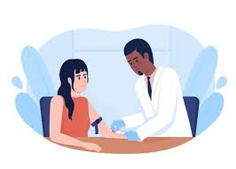

**Define** it: to take blood from a person's body for medical reasons .

**blood :**The circulatory system includes the heart, which pumps blood through the arteries to all parts of the body and returns the blood to the heart

Vein path. Blood is a red, viscous liquid that circulates in the blood vessels. Its volume in adults is about 5-6 liters, depending on the person’s weight.

**Blood is composed of**

1- A pale yellow liquid called plasma, which constitutes 55% of the blood volume.

2- Red and white blood cells and platelets swim in this fluid. These cells make up about 45% of the blood volume.

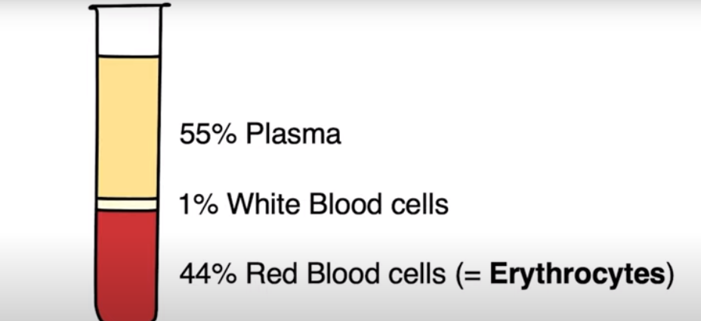

**General information about blood sampling**

-Drawing blood samples is one of the most important procedures that take place in the laboratory, clinic or hospital

-It is not a simple matter, but rather requires a lot of theoretical information and practical skills.

-It is necessary for any person who specializes in the field of medical analysis or nursing to circulate the blood draw Well, because drawing blood is the first step to perform the analysis, and therefore it represents the laboratory's dutyواجب any mistake in drawing blood may lead to a negative result ,Wrong analysis can negatively, affect the diagnosis, treatment and recovery of the patient, i.e. an error in drawing.

Drawing blood must be done with all care and caution to avoid contracting infectious diseases through the blood.

**Reasons for drawing blood**

1. Disease diagnosis

2. Follow-up of the patient's condition -

3. Conducting اجراءsome tests to detect some diseases at an early stage

4. Conducting a compatibility مطابقةtest to ensure the compatibility of the donor's blood

**types of blood samples :-**

There are three types

1- Whole blood sample

**Whole blood sample**

2- serum sample: The normal color of serum or plasma is clear and pale yellow. The difference from the normal color may affect the results of the tests, such as:

A- The breakdown (degeneration) of red blood cells (Hemolysis) makes the color pink to red

B- The increased concentration of bilirubin makes the color dark yellow

C- The increased concentration of fats (Lipid) makes the color milky and cloudy (Lipoic).

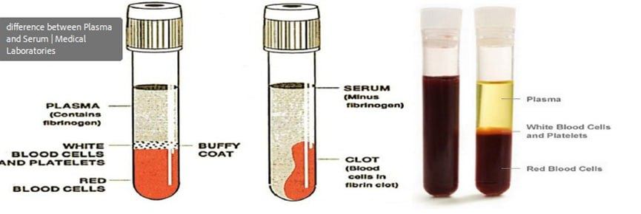

3- plasma sample It is to put the blood in a tube with an anticoagulant, then we inverted the tube several times

immediately after the withdrawal to mix anticoagulant with blood

The blood does not clot and retains all its components in a normal state, i.e.

-Some tests are generally done with a sample of whole blood, such as complete blood count (CBC) and sedimentation rate red blood cells ESR and cumulative glucose H.

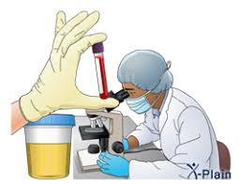

**General rules for drawing blood**

1-A patient is not allowed to eat or keep a lump or fever in his mouth while drawing blood, for fear of suffocationخوف من الاختناق .

2- It is not allowed to keep the thermometer that measures the temperature in the patient's mouth during withdrawal.

3- The patient must be greeted, welcomed and circulated with respect and dignityاحترام وكرامة

**Where to perform the withdrawal in the laboratory**

There must be a place designated for a pull-out for patients who can walk. Conditions must be met next in place For blood draw .To be clean and tidyمرتب To be isolated from the rest of the laboratory and the public, to give privacy to those whose blood is drawn The lighting should be good. And the place should be air conditioned.

**Blood can be drawn from the following areas of the body**

1- Vein

2- Artery

3- capillaries.

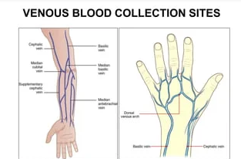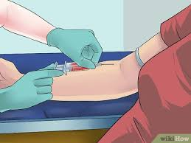 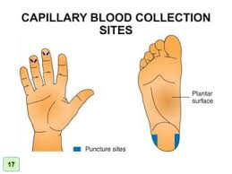

**There are two methods for taking blood samples or (Phlebotomy) from a vein:**

1**-**A Syringe & Needle.

2-Vacuum tube method.

**Requirements required to withdraw blood from a vein in this way:**

1-blood drawing chair. 2**-**Needle 3-Syringe 4-loading tubes.

5-Tube rack. 6-medical alcohol 7-Gloves 8-sterile gauze. 9-Tourniquet

**Steps for taking blood samples from a vein using a needle and syringe**

1-Read a good download request form

2-Confirmationتاكيد of the patient's identity هوية.

3-Reassureطمأنة the patient and obtain his consent for the withdrawal.

4-Make sure the patient is fasting before performing some tests

5-Wash hands and wear gloves

6-Placing the patient and the hand in an appropriate position

7-Put the patient and the hand in the appropriate position.

8-Finding a suitable vein for a tractionسحب.



**Types veins**

There are three types of veins :

**1- Median Cubital Vein**:- The first option is considered: It is located in the neighborhood closest to a patient.

-It is often the largest vein, and there are muscles that help to stabilize it, and it is less painful, which is why

it is considered a vein Best to pull.

**2- Cephalic Vein**: The second option is considered: It is located in the farthest side of the patient (Side big finger)

**3- There is a third vein present in this area, which is Basilic Vein** It is located in the nearest .They should only be used as a last resort because of the difficulty of reaching it and its proximity From an artery,nerves, and tendons that make the possibility of injury more likely

The best place to pull is from the veins in the front of the elbowالمرفق (elbow), which form the letter Y.



**Reasons for withdrawing from the above mentioned places**

-The veins in this place are large and close to the surface

-Do not twist too much when the needle is inserted .

9-Wrapلف the compression bandage and find a suitable vein

10-Clearing the place of withdrawal

11-Insert the needle and start drawing the blood sample.

12-Stirringرج tubes containing an anticoagulant.

13-Write the complete data on the download tube.

14-Medical adhesive mode.

15- Elimination of contaminated substances.

16- Poisoningتسمية the loading tubes and ordering the loading to the concerned department.