**?. ./Characteristics of good technician**

Medical laboratory technician requires experience in different technical fields. Individuals employed in this area must use computers and electronics. The skills include general computer hardware, software, and electronics knowledge. Required medical software expertise includes knowledge in Electronic Medical Record (EMR) software, test-routing software, test result distribution software, and laboratory Information System (LIS) software. Knowledge of databases, spreadsheets and word processing programs are often required.

**What does a Laboratory Technician do?**

1- Prepare and carry out diagnostc laboratory tests

2- Operate and maintain laboratory standard equipment such as centrifuges, titrates , pipetting machines and pH meters.

3- Prepare specimens

4- Supervise experiments as they run.

5- Clean lab equipment and keep it in serviceable condition.

6-Mix compounds during the manufacturing process 

**How To avoid contamination of Specimen**

1- Wear proper protective equipment

Most labs require individuals to follow certain protocols regarding personal protective equipment. Wearing gloves, hairnets, lab coats, and close-toed shoes. This equipment protects both the person wearing it and reduces contamination. Personnel should never reuse disposable gloves and they should always change them when moving between samples to further reduce the risk of contamination

**2- Clean and sterilize equipment**

Maintaining a sterile work environment is crucial to avoiding contamination. Be sure to thoroughly clean and sterilize every piece of lab equipment regularly. For some pieces of equipment, such as glassware, this may be as frequent as every day.

**3- Check your water supply**

If all of your samples including your negative control have been contaminated then it could be your water supply. In the lab, deionized water and distilled water are normally used to prevent contamination

**4- Use air filters and laminar flow hoods**

When you are transferring samples it is critical to work in an environment where the air will not interfere with your sample. You should work in a hood that keeps air moving, preventing microbes in the air from landing. Air filters trap contaminates in the air, keeping your environment sterile.

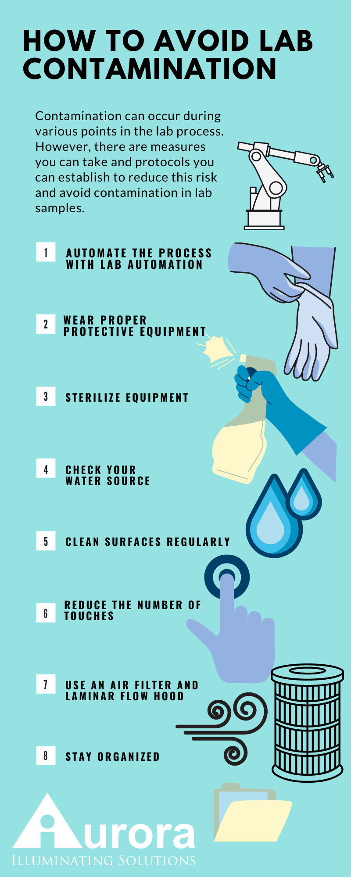

***Human Physiology***

***Specimen collection***

***Lab. 2***



**What is Specimen Collection?**

Collecting specimens is the process of acquiring tissue or fluids for laboratory

Analysis . Some of the samples collected may include serum samples, virology

swab samples, biopsy and necropsy tissue, cerebrospinal fluid, whole blood

for PCR, and urine samples. Medical Assistants collect these samples and then

place them in specific contain

**What is the Purpose of Specimen Collection?**

Specimen collection is vital for acquiring an accurateدقيق and timely laboratory test result. To properly collect specimens, they must be obtained through designated containers, correctly labeled, and promptly transported to the lab.

**Specimen Collection Procedure**

With these steps, you can start to learn more about the process of collecting

specimens. Of course, just like any other skillمهاره , specimen collection requires a

little time and practice to get it right. Remember to follow the rules of your

facility and ask for help whenever necessary.

**Specimen Collection Preparation**

While most collections don’t require much prep, there are some guidelines

that must be followed. These include reviewing the appropriate information, such as

the indicated specimen type, the volume, the procedure, the collection materials,

patient prep, and storage instructions.

**Specimen Collection Steps**

Here are some of the general guidelines you should follow when collecting

specimens from a patient:

1- Verifyتحقق the patient’s identityهويه . Some examples of acceptable identifiers

the patient’s name, date of birth, and hospital number

include

2- Acquire a sample from the patient. Treat all biological material as potentially

hazardous and follow your facility’s guidelines.

3- Process the specimen as required by your facility or صاحب العمل employer.

4- Store the specimen. Appropriate storage is critical to maintaining the integrity

of the specimen and, therefore, the test results.

**Necessary Equipment for Specimen Collection**

Typically, the suggested supplies for specimen collection include but are not

limited to the following items:

Gloves

Hand sanitizer

Specimen container

Body material sample

Incubator

Refrigerator or freezer

**Potential Risks or Complications of Specimen Collection**

Specimen collection is often safe and relatively painless for patients.

Although there may be pain associated with blood draws, it should not be

significant or cause any lasting damage.

**Preparing the Patient**.

Provide the patient, in advance, with appropriate collection instructions and information

on fasting, diet, and medication restrictions when indicated for the specific test.

**Avoiding Common Problems**

Careful attentionالانتباه بحذر to routine procedures can eliminate most of the potential problems

related to specimen collection.