**Lecture 1**

**Digestive system**

**Function:**

The alimentary tract provides the body with a continual supply of water, electrolytes, vitamins, and nutrients ,which requires:

**These functions of the digestive system include:**

1. **Motility:** This refers to the movement of food through the digestive tract through the processes of:

**A**- **Ingestion**: Taking food into the mouth.

**B**- **Mastication**: Chewing the food and mixing it with saliva .

**C**- **Deglutition**: Swallowing food .

**D**- **Peristalsis and segmentation**: Rhythmic, wavelike contractions (peristalsis), and mixing contractions in different segments (segmentation), move food through the gastrointestinal tract .

**2—Secretion:** This includes both exocrine and endocrine secretions:

**A- Exocrine secretions**:

Water, hydrochloric acid, bicarbonate, and many digestive enzymes are secreted into the lumen of the gastrointestinal tract.

The stomach alone, for example, secretes 2 to 3 liters of gastric juice a day .

**B- Endocrine secretions**:

The stomach and small intestine.

Secrete a number of hormones that help to regulate the digestive system .

1. **Digestion:** This refers to the breakdown of food molecules into their smaller subunits, which can be absorbed .
2. A**bsorption**:

This refers to the passage of digested end products into the blood or lymph.

1- **Storage and elimination**:

**This refers to the temporary storage and subsequent elimination of indigestible food molecules**.

1. **Immune barrier**:

The simple columnar epithelium that lines the intestine, with its tight junctions between cells, provides a physical barrier to the penetration of pathological organisms and their toxins. Also, cells of the immune system reside in the connective tissue located just under the epithelium.

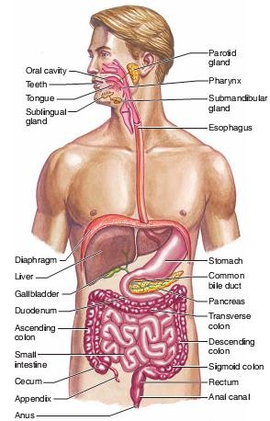

**The anatomy of digestive system:**

The digestive system can be divided into the:

1. **Tubular gastrointestinal (GI) tract, or alimentary canal**.
2. **Accessory digestive organs**.

The GI tract is approximately **9 m (30 ft)** long and extends from the mouth to the anus. It traverses the thoracic cavity and enters the abdominal cavity at the level of the diaphragm. The anus is located at

the inferior portion of the pelvic cavity.

**The organs of the GI tract include :**

**A**-The oral cavity.

**B**- Pharynx.

**C**-Esophagus.

**D-** Stomach.

**E**-small intestine.

**F**-Large intestine.

**The accessory digestive Organs**: Include the:

**A**-Teeth.

**B**- Tongue.

**C**-Salivary glands.

**D**- Liver.

**E**-Gallbladder.

**F**-Pancreas.

**The term viscera is**:

Frequently used to refer to the abdominal organs of digestion, but it can also refer to any organs in the thoracic and abdominal cavities.

**Food movement :**

Peristaltic contractions of the esophagus deliver food to the stomach, Which secretes **very acidic gastric juice** that is mixed with the food by gastric contractions.

Proteins in the resulting mixture ,called **chyme**, are partially digested by the enzyme pepsin.

**Mastication (chewing) of food mixes it with saliva, secreted by the salivary glands.**

**In addition to mucus and various anti-microbial agents, saliva contains salivary amylase, an enzyme that can catalyze the partial digestion of starch.**

**The phases of swallowing:**

Deglutition or swallowing: is divided into three phases:

1. Oral, pharyngeal.
2. Esophageal.

**Swallowing is a complex activity that requires the coordinated contractions of 25 pairs of muscles in the mouth ,pharynx, larynx, and esophagus**.

**The oral phase**:

Is under voluntary control, while the pharyngeal and esophageal phases are automatic and controlled by the **swallowing center in the brain stem** .

In the oral phase, **the muscles of the mouth and tongue mix the food** with **saliva and create a bolus** (a mass of a size to be allowed -of food that the tongue muscles move toward the oropharynx Receptors in the posterior portion of the oral cavity and oropharynx stimulate the pharyngeal phase of the **swallowing reflex.**

**The soft palate lifts to close off the nasopharynx from the oropharynx (so food does not go out the n**ose);

1. The vocal cords close off the opening to the larynx.
2. The epiglottis covers the vocal cords
3. The larynx is moved away from the pathway of the bolus toward the esophagus:

**These activities help prevent choking); and the upper esophageal sphincter relaxes**.

These complex activities of the pharyngeal phase take less than **1 second. In the esophageal phase of swallowing ,which lasts from 5 to 6 seconds,** the bolus of food is moved by peristaltic contractions toward the stomach .Once in the stomach, the ingested material is churned and mixed with hydrochloric acid and the protein-digesting enzyme pepsin. The mixture thus produced is pushed by muscular contractions of the stomach past the **pyloric sphincter**.

**Esophagus:**

The esophagus is the portion of the **GI** tract that connects the pharynx to the stomach **Swallowing reflex**:

The bolus is pushed from the oral to the anal end of the esophagus by a wavelike muscular contraction called **peristalsis**.

Movement of the bolus along the digestive tract occurs because the circular smooth muscle contracts behind, and relaxes in front of, the bolus.

This is followed by shortening of the tube by longitudinal muscle contraction.

These contractions progress from the superior end of the esophagus to the gastro esophageal junction at a rate of **2 to 4 cm per second** as they empty the contents of the esophagus into the cardiac region of the stomach.

**The lumen of the terminal portion of the esophagus is slightly narrowed because of a thickening of the circular muscle fibers in its wall**. This portion is referred to as the lower esophageal gastro esophageal **sphincter**. After food passes into the stomach, constrictions of the muscle fibers of this region help prevent the stomach contents from regurgitating into the esophagus.

This is not a true sphincter muscle in humans, and so we are able to regurgitate.

During inhalation there is greater pressure in the abdominal cavity than in the thoracic cavity that promotes regurgitation.

This requires our lower esophageal sphincter to stay closed until peristaltic waves during swallowing push food through the esophagus. If the acidic contents of the stomach do rise into the esophagus burning **sensation commonly called heartburn is produced**.

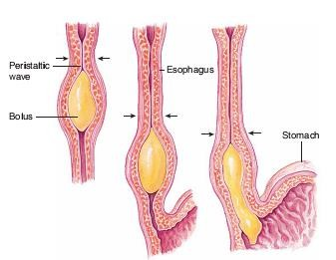

**Stomach:**

The J-shaped stomach is the most distensible part of the **GI tract**. It is continuous with the esophagus superiorly and empties into the duodenum of the small intestine inferiorly.

**functions of the stomach :**

1. Store food, to initiate the digestion of proteins, to kill bacteria with the strong acidity of gastric juice.
2. Move the food into the small intestine as a pasty material called **chime.**

**Gastric glands contain several types of cells that secrete different products:**

* 1. **Mucous neck cells**: which secrete mucus.
  2. **Parietal cells**: which secrete hydrochloric acid (HCl ) .
  3. **Chief (or zymogenic) cells**: which secrete pepsinogen, an Inactive form of the protein-digesting enzyme pepsin.
  4. **Enterochromaffin-like (ECL) cells**: found in the stomach

And intestine, which secrete histamine and 5-hydroxytryp-tamine (also called serotonin) as paracrine regulators of the GI tract.

**5-G cells:** which secrete the hormone gastrin into the blood ;

**6-D cells**: which secrete the hormone somatostatin.

**Digestion and Absorption in the Stomach** **:**

**Proteins are only partially digested in the stomach by the action of pepsin,**

While carbohydrates and fats are not digested at all by pepsin.

(Digestion of starch begins in the mouth with the action of salivary amylase and continues for a time when the food enters the stomach,

But amylase soon becomes inactivated by the strong acidity of gastric juice.

The complete digestion of food molecules occurs later, when chyme enters the small intestine adequately digest and absorb their food.

**Almost all of the products of digestion are absorbed through the wall of the small intestine;**

The only commonly ingested sub-stances that can be absorbed across the stomach wall are **alcohol and aspirin**.

Absorption occurs as a result of the lipid solubility of these molecules. Aspirin:

**Can promote damage to the gastric mucosa and cause bleeding**, and must be avoided in people with gastric ulcers.

**Small intestine:**

**The small intestine is the longest part of the GI tract,**

However it is approximately 3 m long in a living person, is formed of:

1. The first part extending from the pyloric sphincter is the duodenum.
2. The next **2/5** of the small intestine is the jejunum.
3. The last 1/3 is the **ileum**. The ileum empties into the large intestine through the ileocecal valve.

The mucosa of the small intestine is folded into:

Villi and microvilli:

**This arrangement greatly increases the surface area for absorption and improves digestion**.

Since digestive enzymes are embedded within the microvilli.

The products of digestion are absorbed across the epithelial lining of the intestinal mucosa.

Absorption of carbohydrates ,lipids, **amino acids**, calcium, and **iron** occurs primarily in **the duodenum and jejunum**.

Bile salts, vitamin B 12 ,water, and electrolytes are absorbed primarily in the

**ileum.**

**Intestinal Enzymes :**

In addition to providing a large surface area for absorption, the plasma membranes of the microvilli contain digestive enzymes that hydrolyze disaccharides, polypeptides, and other substrates.

These brush border enzymes are not secreted into the lumen, but instead remain attached to the plasma membrane with their active sites exposed to the chime.

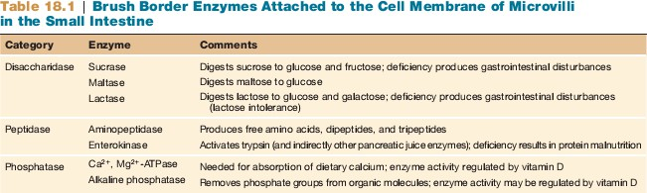

**Intestinal Contractions and Motility**:

Two major types of contractions occur in the small intestine :

1. peristalsis
2. segmentation.

Peristalsis is much weaker in the small intestine than in the esophagus and stomach.

**segmentation**:

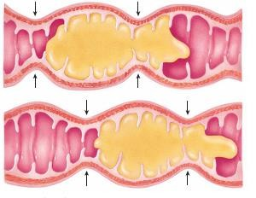**This term refers to muscular constrictions of the lumen, which occur simultaneously at different intestinal segments**.

**Segmentation of the small intestine**

**Large intestine** :

**The general features :**

1. The large intestine absorbs: Water**, electrolytes, and certain vitamins from the chyme it receives from the small intestine.**
2. The large intestine then passes waste products out of the body through the rectum and anal canal
3. **There are no villi in the large intestine, the intestinal mucosa therefore appears flat.**
4. **The large intestine has little or no digestive function, but it does Absorb water and electrolytes from the remaining chyme, as well as several B complex vitamins and vitamin K.**

**Fluid and Electrolyte Absorption in the Intestine :**

The **GI** tract receives about **1.5 L per day of water** from **food** and

**drink**; additionally.

The GI tract secretes **8–10 L/day of fluid into the lumen**.

This includes contributions from the:

* 1. Salivary glands.
  2. Stomach.
  3. Intestine.
  4. Pancreas.
  5. Liver.
  6. Gallbladder.

The **small intestine** both **secretes** and **absorbs** water accompanying different transport processes, but these are not in balance.

The small intestine secretes about **1 L per day** but absorbs most of the fluid in the chyme. As a result, only about **2 L per day** of fluid pass into the large intestine .

The **large intestine** absorbs about **90%** of this remaining volume , Leaving less than **200 ml** of fluid to be excreted in the feces .

Absorption of water in the intestine occurs **passively** as a result of the osmotic gradient created by the active transport of ions.

**Accessory organs:**

**Liver:**

Liver is the largest internal organ; it is, in a sense ,only one to two cells thick. This is because the liver cells, or **hepatocytes**, form hepatic plates that are one to two cells thick.

**The plates are separated from each other by large capillary spaces called sinusoids.**

**The liver has an amazing Functions of the Liver:**

1. Detoxication of Blood Phagocytosis by Kupffer cells .
2. Carbohydrate Metabolism Conversion of blood glucose to glycogen and fat Production of glucose from liver glycogen and from other molecules.
3. Lipid Metabolism Synthesis of triglycerides and cholesterol.
4. Protein Synthesis Production of albumin Production of plasma transport proteins Production of clotting factors.
5. Secretion of bile Synthesis of bile salts Conjugation and excretion of bile pigment (bilirubin).

**Pancreas** :

**The pancreas is a soft, glandular organ that has both exocrine and endocrine functions**.

The **endocrine function** is performed by clusters of cells called the pancreatic islets, or islets of Langerhans, which secrete the hormones **insulin and glucagon into the blood**.

As an **exocrine gland**, the pancreas secretes pancreatic juice through the pancreatic duct into the duodenum.

Within the lobules of the pancreas are the exocrine secretory units, called acini. Each acinus consists of a single layer of acinar epithelial cells surrounding a lumen, into which the constituents of pancreatic juice are secreted.

**Pancreatic Juice :**

Pancreatic juice contains bicarbonate and different **digestive enzymes**. These enzymes include:

(**1**)-A mylase, which digests starch.

(**2**)- Trypsin, which digests protein.

(**3**)-Lipase, which digests triglycerides.

