**7th lecture**



The nervous system is the body’s control center and communication network.

***Organization:***

The nervous system can be grouped into two major categories.

1. The first is the central nervous system (CNS), which is the control center for the whole system. It consists of the brain and spinal cord.
2. The peripheral nervous system (PNS), consists of all the nerves that connect the brain and spinal cord with sensory receptors, muscles, and glands.

The PNS can be divided into two subcategories:

**A**- The afferent peripheral system, which consists of afferent or **sensory neurons** that convey information from receptors in the periphery of the body to the brain and spinal cord,

**2**-The efferent peripheral system, which consists of **efferent or motor neurons**

that convey information from the brain and spinal cord to muscles and glands.

The efferent peripheral system can be further sub-divided into two subcategories.

**A**- The somatic nervous system:

Which conducts impulses from the brain and spinal cord to skeletal muscle, thereby causing us to respond or react to changes in our external environment.

**B-** The autonomic nervous system (ANS), which conducts impulses from the brain and spinal cord.

The ANS is considered to be involuntary. The organs affected by this system receive nerve fibers from two divisions of the ANS:

1. The sympathetic division:

Which stimulates or speeds up activity and thus involves energy expenditure and uses norepinephrine.

1. The parasympathetic.

It uses acetylcholine. As a neurotransmitter at nerve endings. Supporting network in the brain and spinal cord. They attach neurons to their blood vessels, thus ***helping regulate nutrients and ions that are needed by the nerve cells.***

**Nervous tissue:**

Structure and function of neurons.

***Neurons****;*

***Structural units of the nervous system***.

Composed of a **body**, **axon**, and **dendrites**. *There are about* ***100*** *billion neurons in the human brain.*

***The soma (cell body):***

Is the **central part of the neuron** It contains the nucleus of the cell.

Each nerve cell’s body contains a single nucleus. This nucleus is the control center of the cell. In the cytoplasm, contain many organelle especially **mitochondria** and a network of threads called ***neurofibrils*** that extend into the axon part of the cell, referred to as the ***fiber of the cell.*** In the cytoplasm of the cell body, there is extensive rough endoplasmic reticulum (ER).

In a neuron, **the rough ER has granular structures referred to as Nissl bodies**,

Also called ***chromatophilic substance***, and are where protein synthesis occurs.

***The axon*:**

Is a finer, cable-like projection, carries nerve signals away or to the soma. Many neurons have only one axon, the longest axon of a human motor neuron can be over a meter long, the (ex; Sensory neurons).

**The axon**:

Is a long process or fiber that begins singly but may branch and at its end has many fine extensions called:

**Axon terminals**:

That contact with **dendrites** of other neurons.

The large peripheral axons are enclosed in fatty myelin sheaths produced by the Schwann cells.

The portions of the **Schwann cell** that contain most of the cytoplasm of the cell

.The nucleus remain outside of the myelin sheath and make up a portion called the neurilemma. Narrow gaps in the sheath are the nodes of Ranvier. ***dendrites :***

Are cellular extensions with many branches, and are referred to as a dendritic tree .

***synapse:***

***The chemical part happens at a junction between two neurons .***

They use chemicals for communication called **neurotransmitters.**

The release of an excitatory *neurotransmitter* at the synapses will cause an inflow of positively charged sodium ions (Na+) making a localized depolarization of the membrane.

The current then flows to the resting (**polarized**) segment of the axon.

***Inhibitory synapse***: causes an inflow of **Cl−** or outflow of K+ making the synaptic membrane ***hyperpolarized.*** This increase prevents ***depolarization,*** causing a decrease in the possibility of an axon discharge. If they are both equal to their charges, then the operation will cancel itself out. This effect is referred to as ***summation.***

***The neurons of the brain release inhibitory neurotransmitters far more than excitatory neurotransmitters***, which helps explain why we are not aware of all memories and all sensory stimuli simultaneously. The majority of information stored in the brain is inhibited most of the time.

***Classification of nerve cells:***

Nervous tissue consists of groupings of nerve cells or neurons that transmit information called **nerve impulses** in the form of electrochemical changes.

Nerves a bundle of nerve cells or fibers.

Nervous tissue is also composed of **cells that perform support and protection.**

These cells are called ***neuroglia or glial*** cells Over **60%** of all brain cells are neuroglia cells.

***Neuroglia Cells:***

There are different kinds of neuroglia cells, and, unlike neurons, they do not conduct impulses.

1. **Astrocytes**:

Are star-shaped cells that wrap around nerve cells to form a supporting network in the brain and spinal cord? They attach neurons to their blood vessels, thus helping regulate nutrients and ions that are needed by the nerve cells.

1. ***Small astrocytes***.They also provide support by forming semi rigid connective-like tissue rows between neurons in the brain and spinal cord. They produce the fatty myelin sheath on the neurons of the brain and spinal cord of the CNS.
2. ***Microglia cells***: are small cells that protect the CNS and whose role is to engulf and destroy microbes like bacteria and cellular debris.
3. ***Ependymal cells*** :line the fluid-filled ventricles of the brain. Some produce cerebrospinal fluid and others with cilia move the fluid through the CNS.
4. ***Schwann cells*** form myelin sheaths around nerve fibers in the PNS.

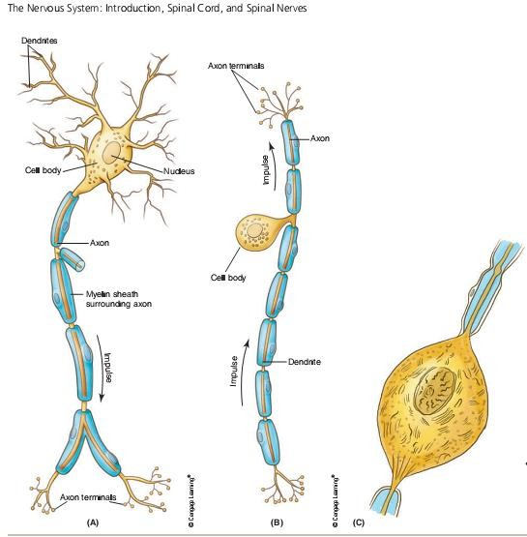

***Types of neurons.***

1. **Pseudo unipolar neurons**, :

Which are sensory, have one process that splits.

2- **Bipolar neurons,:**

have two processes. . They are found in only three areas of the body: the

***retina of the eye, the inner ear, and the olfactory area of the nose.***

1. **Multipolar neurons,**:

which are motor and association neurons, have many dendrites and one axon. . Most ***neurons in the brain and spinal cord are this type.*** As well as retina of

,the eye. Multipolar neurons, the most common type

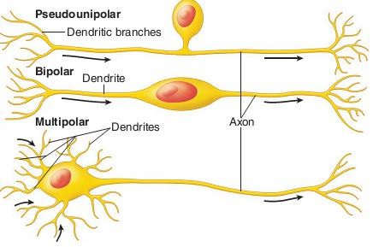

***The Physiology of the nerve Impulses***

A nerve cell is similar to a muscle cell in that there are concentrations of ions on the inside and the outside of the cell membrane.

**Positively charged sodium (Na1) ions are in greater concentration outside the cell than inside**.

There is a greater concentration of positively charged potassium (K1) ions

**inside** the cell than outside.

This situation is maintained by the cell membrane’s **sodium-potassium pump**.

In addition to the potassium ion, the inside of the **fiber has negatively charged chloride (Cl2**) ions and other negatively charged organic molecules.

Thus, **the nerve fiber has an electrical distribution as well such that the outside is positively charged while the inside is negatively charged .**

This condition is known as the membrane or ***resting potential****.*

Na1and K1ions:

Tend to diffuse across the membrane but the cell maintains the resting potential through the **channels of the sodium-potassium pump** that actively extrudes Na1and accumulates K1ions.

When a nerve impulse begins:

The permeability to the sodium (Na1) ions changes. Na1 rushes in, causing a change from a negative (2) to a positive (1) charge.

Inside the nerve membrane.

This reversal of electrical charge is called **depolarization** and creates the cell’s action potential.

The action potential moves in one direction down the nerve fiber.Now the potassium ions (K+) begin to move outside to restore the resting membrane potential.

The **sodium-potassium pump** begins to function.

Pumping out the sodium ions that rushed in and pulling back in the potassium ions (K+) that moved outside,

Thus restoring the original charges. This is called **repolarization.**

This process continues along the nerve fiber acting like an electrical current, carrying the nerve impulse along the fiber.

The nerve impulse is a self-propagating wave of depolarization followed by repolarization moving down the nerve fiber.

Unmyelinated nerve fiber conducts an impulse over its entire length, But the conduction is slower than that along a myelinated fiber.

A myelinated fiber is insulated by the myelin sheath, so transmission occurs only at the nodes of Ranvier between adjacent Schwann cells.

Action **potentials** and inflow of ions occur **only at these nodes**, allowing the nerve impulse to jump from node to node, and the impulse travels much faster.

An impulse on a myelinated motor fiber going to a skeletal muscle could

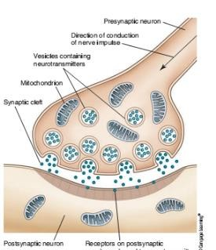travel about **120 meters per second**,

While an impulse on an unmyelinated fiber would travel only **0.5 meter per second**.

On any nerve fiber, the impulse will never vary in strength. If the stimulus or change in the environment is barely great enough to cause the fiber to carry the impulse>

The impulse will be the same strength as one excited by a stronger stimulus.

This is known as the **all-or-none law**, which states that if a nerve fiber carries any impulse, it will carry a full strength impulse.

